SAN JOSÉ STATE UNIVERSITY

Charles W. Davidson College of Engineering

DEPARTMENT OF ELECTRICAL ENGINEERING

**EE 271 – Advanced Digital System Design and Synthesis**

Fall 2015 Final Project Report

**Implement and Analyze Different Types of 64-bit Adders**

|  |  |  |  |
| --- | --- | --- | --- |
| Name | Pandya, Samvid Bhargav | SJSU ID | 010152610 |
| Email | samvid.pandya150@gmail.com | Phone | +1 (408) 455-2881 |

**Executive Summary**

The **main aim** of the project is **to** **implement** different types of **64-bit Adders** and then **optimize and analyze its timing, area and power.**

Four Different types of 64 bit adders are being used:

1. **R**ipple **C**arry **A**dder **(RCA)**
2. **C**arry **L**ook **A**head Adder with 4-bit group **2**-**L**evel P-G Generator **(CLA-2L)**
3. **C**arry **S**elect **A**dder with **Eq**ual **G**roups of 4-bits each **(CSAEQG)**

4. **C**arry **S**elect **A**dder with **U**n**eq**ual **g**rouping. **(CSAUEQG)**

* **Need to use 1 clock to complete the calculation**
* RTL level implementation **without** using arithmetic operators like ***+, -, *, and /*** for hardware implementation

## I. General Project Information

## Table I.1: List of EDA Tools Used

|  |  |  |  |  |
| --- | --- | --- | --- | --- |
| **Name** | **Company** | **Used for** | **Free? (Y/N)** | **Software Documents** |
| VCS | Synopsis | Simulation & test | No | VCS user_guide |
| Design Vision | Synopsys | Synthesis | No | Design Vision user_guide |

**Table I.2: List of Libraries Used**

|  |  |  |  |
| --- | --- | --- | --- |
| **Library file name** | **Company** | **Used with**  (EDA tool) | **The libraries are at**  (directories on eecad systems) |
| tc240c db_wccom25 | synopsys | VCS | apps/toshiba/sjsu/synopsys/tc240c/tc240c db_wccom25 |
| tc240c db_bccom25 | synopsys | VCS | /apps/toshiba/sjsu/synopsys/tc240c/tc240c db_bccom25 |
| tc240c.workview.sdb | synopsys | VCS | /apps/toshiba/sjsu/synopsys/tc240c/tc240c.workview.sdb |

**Table I.3: List of Verilog Modules (both design and test modules)**

|  |  |  |
| --- | --- | --- |
| **Module Name** | **Ports** | **Short Description** |
| RCA64 | **op1,op2,sum,crout,clock,reset** | 2 **operands** to the adder **are op1 & op2.** Initial cin is not there, **outputs are sum and crout.** **Clock and reset are controlling all the flipflops.** |
| CLA_64 | **op1,op2,sum,crout,clock,reset** | 2 **operands** to the adder **are op1 & op2.** Initial cin is not there, **outputs are sum and crout. Clock and reset are controlling all the flipflops.** |
| CSA64EQG | **op1,op2,sum,crout,clock,reset** | 2 **operands** to the adder **are op1 & op2.** Initial cin is not there, **outputs are sum and crout. Clock and reset are controlling all the flipflops.** |
| CSA64UEQG | **op1,op2,sum,crout,clock,reset** | 2 **operands** to the adder **are op1 & op2.** Initial cin is not there, **outputs are sum and crout. Clock and reset are controlling all the flipflops.** |
| RCA64_tb  RCA64_tb_1  RCA64_tb_2  RCA64_tb_3  RCA64_tb_4  RCA64_tb_5 |  | **Test Benches for Ripple Carry adder** |
| CLA_64_tb CLA_64_tb_1 CLA_64_tb_2 CLA_64_tb_3 CLA_64_tb_4 CLA_64_tb_5 |  | **Test Benches for Carry Look Ahead adder** |
| CSA64EQG_tb CSA64EQG_tb_1 CSA64EQG_tb_2 CSA64EQG_tb_3 CSA64EQG_tb_4 CSA64EQG_tb_5 |  | **Test Benches for Carry Select adder with Equal bits** |
| CSA64UEQG_tb  CSA64UEQG_tb_1 CSA64UEQG_tb_2 CSA64UEQG_tb_3 CSA64UEQG_tb_4 CSA64UEQG_tb_5 |  | **Test Benches for Carry Select Adder** |

## II. The Implementation Overview

**II. a BLOCK DIAGRAMS OF ADDERS**

**1. RCA:** In this adder, a group of **4-bit full-adder including one 1-bit half-adder** is instantiated for 16 times in which carry of each previous full adder is **rippled** to the next full adder.

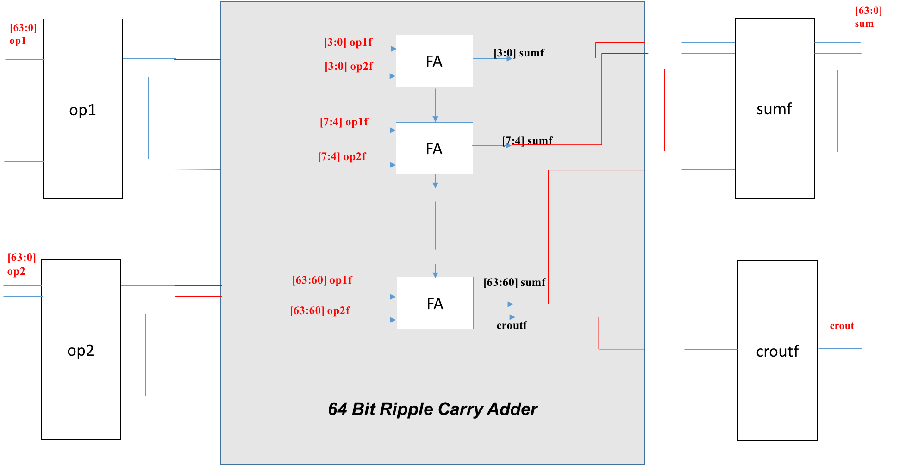

**Figure II.1: Overall Block Diagram of the 64-bit RCA**

**2.**     **CLA:** In this adder, a **2-level PG generator** is used which contains a **Group-1: 4-bit full adder with level-1 PG generator** and **16-bit adder containing level-2 PG generator containing 4 Group-1 circuits**.

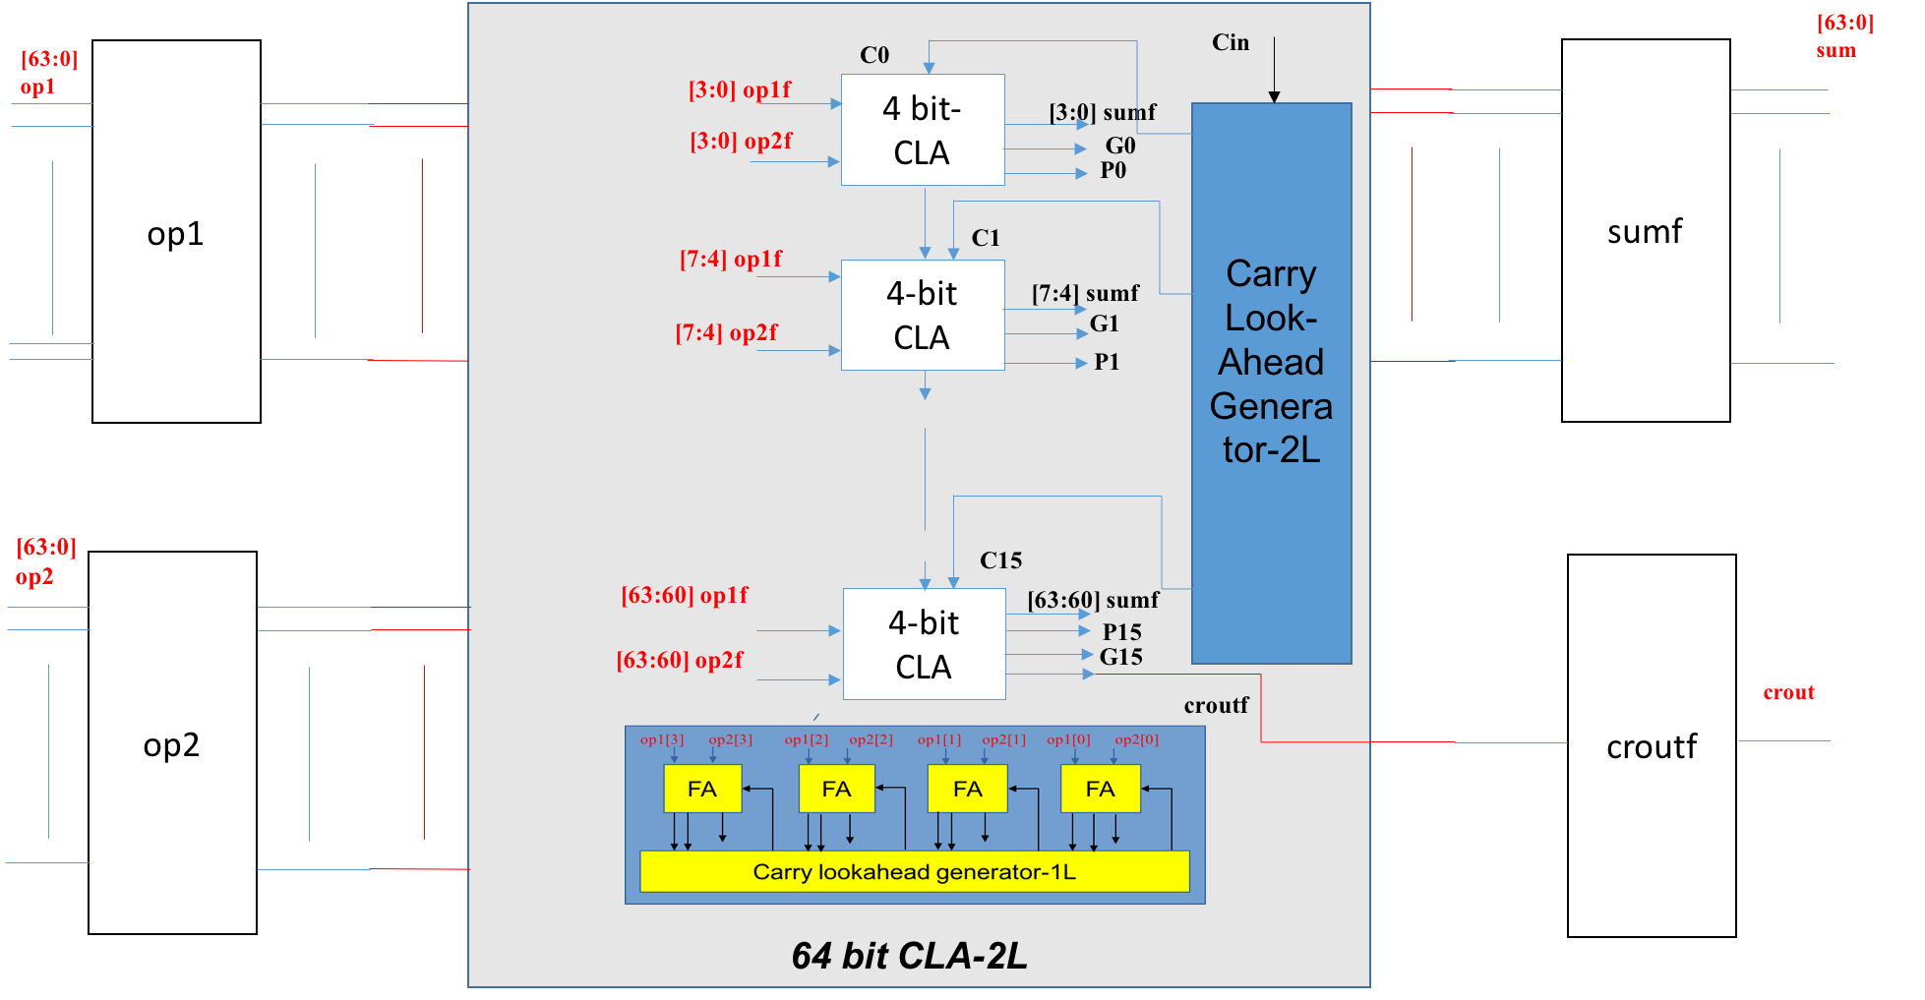

**Figure II.2: Overall Block Diagram of the 64-bit CLA-2L**

**3.** **CSA-EQG:** In this circuit, **equal group of two 4-bit full-adder with carry input 0 & 1** are being used in which other 3-bit receives carry input from 1st level PG generator and sum & carry output from these two adder group is selected by multiplexer based on carry input.

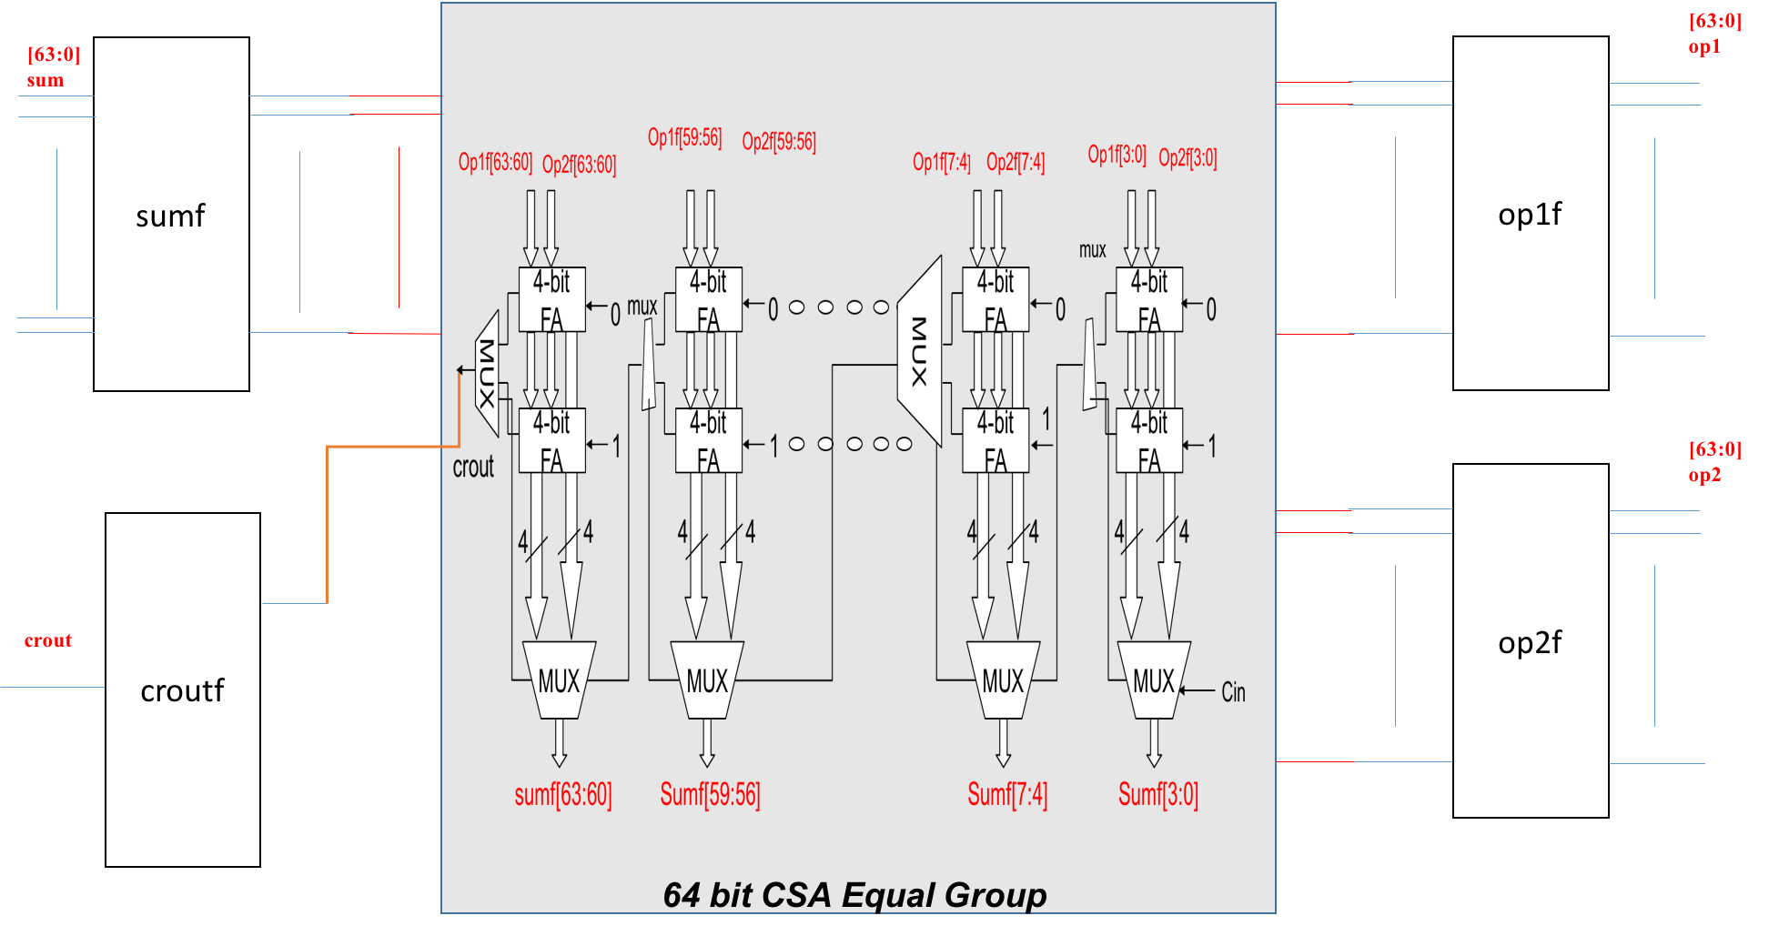

**Figure II.3: Overall Block Diagram of the 64-bit CSA-EQG**

1. **CSA-UNEQG:** In this circuit unequal group of two full adders having initial carry as **0 & 1 along with multiplexer for summation and carry out** are being used. The un equal groups are as 1-bit **full adder** then followed by group of **4-bit, 4-bit, 5-bit, 6-bit, 7-bit, 8-bit, 9-bit, 10-bit, and 11-bit Carry Select Adder** for the best case.

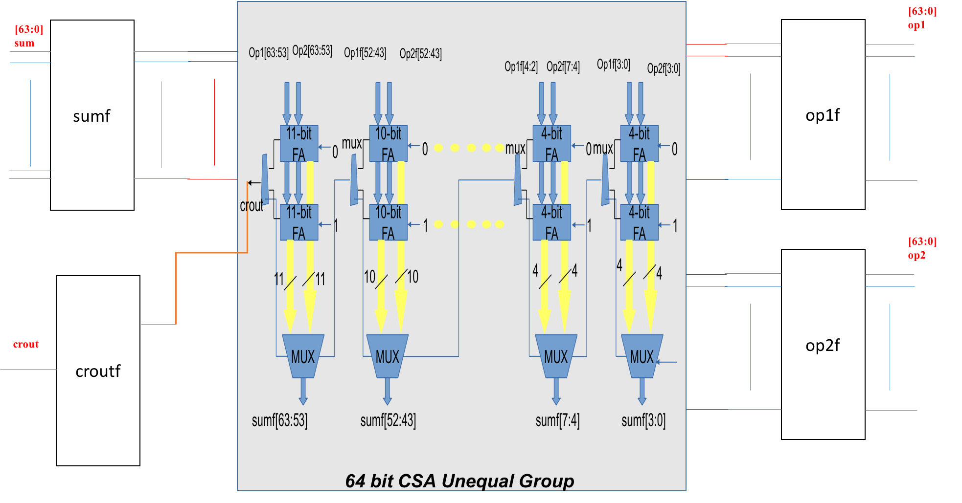

**Figure II.4: Overall Block Diagram of the 64-bit CSA-UEQG**

After Practical Implementation of the project there will be some difference comes in the time period of theoretical values and practical value because it depends upon maximum path taken by synthesis to find the data arrival time and slack.

Approximated delay based on theory and measured delays:

**\*\*\*Ripple carry adder:\*\*\***

-Approximated delay

tadd = tsetup + (n-1) tcarry + tlast_sum

tadd = 0.34 + (64 -1) (0.2+0.07) + (0.9+0.11+0.25)

tadd = **18.61 ns**

-Measured delay from synthesis

tadd = **20.78 ns**

***Carry look ahead adder: ***

-Approximated delay

tadd = 8*Tg

tadd = 8 * (+0.28+0.28+0.26)

tadd = **6.56 ns**

Using another Formula-

tadd= =  = **6ns**

-Measured delay from synthesis

tadd = **6.97 ns**

***Carry Select EQG adder: ***

-Approximated delay

tadd = tsetup + 4tcarry+(n/4)tmux + tectra_for_last_sum

tadd = 0.37 + 4(0.14+0.15+0.1) + 16(0.27) + 0.35

tadd = **6.60ns**

-Measured delay from synthesis

tadd = **6.7ns**

***Carry Select UNEQG adder: ***

-Approximated delay

tadd = tsetup + tcarry+16*tmux+tectra_for_last_sum

tadd = 0.34 + 0.18 + 16(0.27) + 0.33

**tadd = 5.17ns**

-Measured delay from synthesis

**tadd = 6.10 ns**

**III. RTL-Level (Pre-synthesis) Simulations/Tests**

In this project **six different cases and their test-benches** are being used each of them having different pairs of **input operands** to verify the design. To set initial conditions to “0” an active high reset signal is used. **To test timing and delay, appropriate clock frequency is set to observe the accurate operation of adders without any errors.** These six different values of inputs are selected in such a way that the complete functionality of these adders is achieved. These values help in verifying and observing gate level functionality, delay, glitches, behavior of circuit.

**Table III.1 – Six Selected Test Data**

|  |  |  |  |  |  |  |
| --- | --- | --- | --- | --- | --- | --- |
| **Test Case** | **op1** (hex) | **op2 (**hex) | **sum** (hex) | | | |
| **RCA** | **CLA-2L** | **CSA-EQG** | **CSA-UEQG** |
| **1** | f20f_ffff_ffff_ffff | ffff_ffff_ffff_ff50 | f20f_ffff_ffff_ff4f | f20f_ffff_ffff_ff4f | f20f_ffff_ffff_ff4f | f20f_ffff_ffff_ff4f |
| **2** | 1010_1010_1199_ffff | abcd_1100_1100_dddd | Bbdd_2110_229a_dddc | Bbdd_2110_229a_dddc | Bbdd_2110_229a_dddc | Bbdd_2110_229a_dddc |
| **3** | ffff_ffff_ffff_ffff | eeee_dddd_cccc_ffff | Eeee_dddd_cccc_fffe | Eeee_dddd_cccc_fffe | Eeee_dddd_cccc_fffe | Eeee_dddd_cccc_fffe |
| **4** | bbbb_cdcd_aaaa_1111 | ffff_ffff_ffff_dddd | Bbbb_cdcd_aaa9_eeee | Bbbb_cdcd_aaa9_eeee | Bbbb_cdcd_aaa9_eeee | Bbbb_cdcd_aaa9_eeee |
| **5** | 1234_ffff_dfff_eeee | dddd_dddd_dddd_dddd | f012_dddd_bddd_cccb | f012_dddd_bddd_cccb | f012_dddd_bddd_cccb | f012_dddd_bddd_cccb |
| **6** | 1234_5678_90ab_cdef | 5555_5555_5555_dddd | 6789_abcd_e601_abcc | 6789_abcd_e601_abcc | 6789_abcd_e601_abcc | 6789_abcd_e601_abcc |

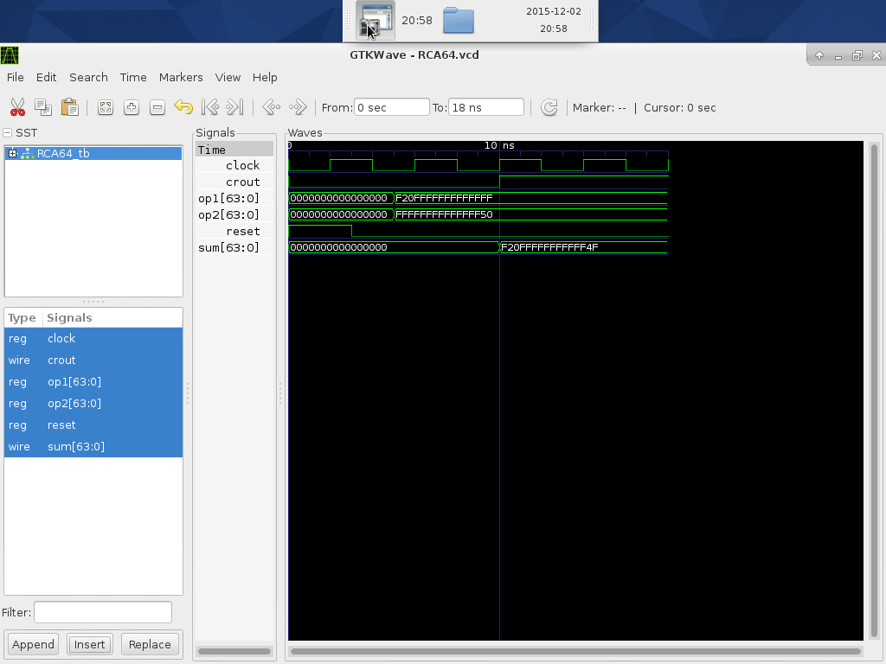

**Figure III.1a**: **RTL simulation waveform that contains test *case #1 for RCA***

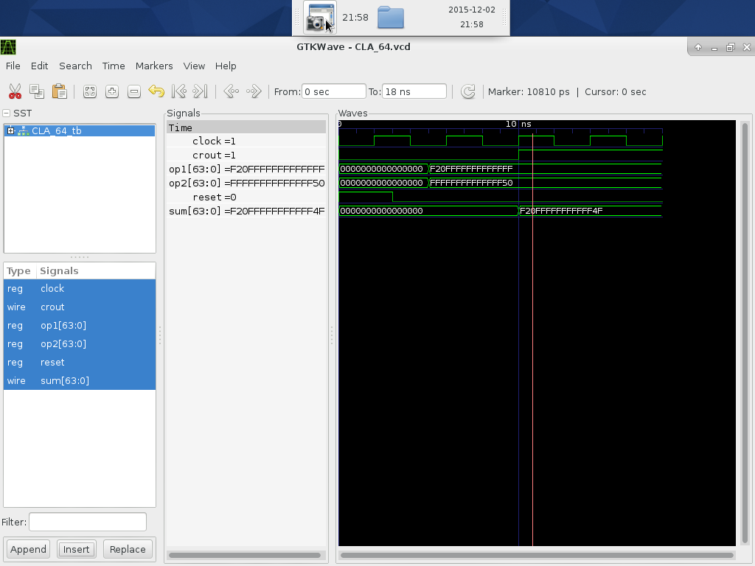

**Figure III.1b: RTL simulation waveform that contains test *case #1 for CLA-2L***

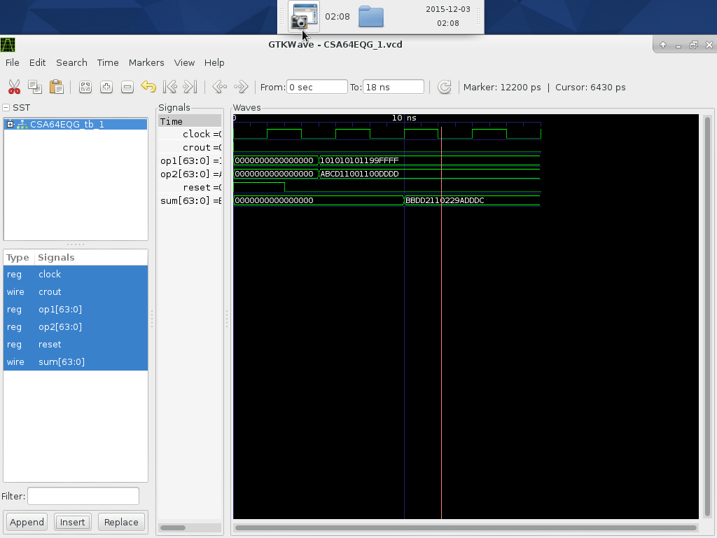

**Figure III.1c**: **RTL simulation waveform that contains test *case #1 for CSA-EQG***

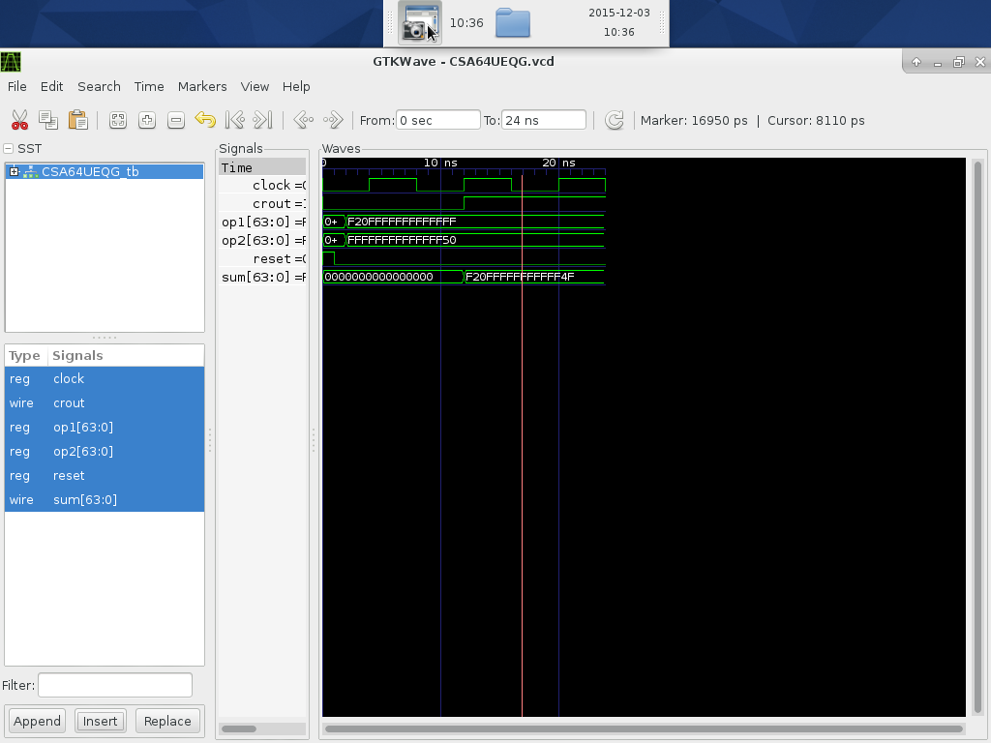

**Figure III.1d**: **RTL simulation waveform that contains test** ***case #1 for CSA-UEQG***

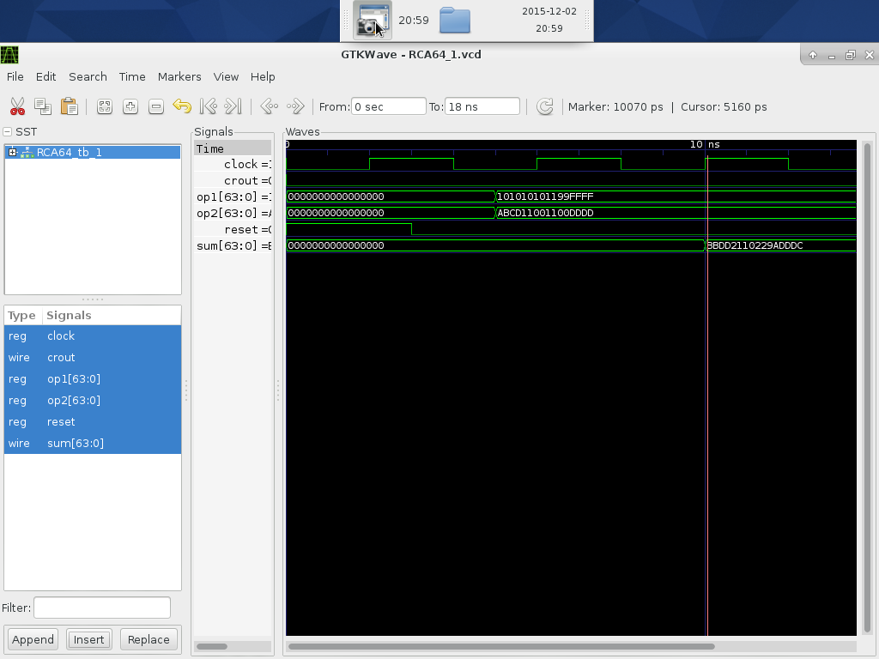

**Figure III.2a**: **RTL simulation waveform that contains test case #2 for RCA**

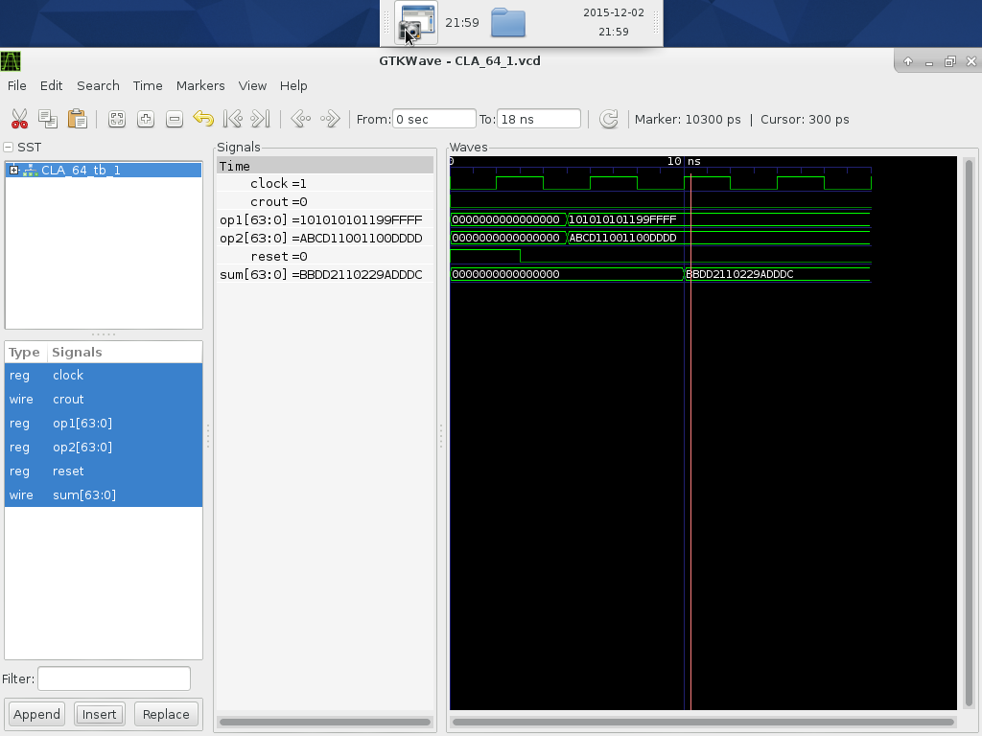

**Figure III.2b**: **RTL simulation waveform that contains test** **case #2 for CLA-2L**

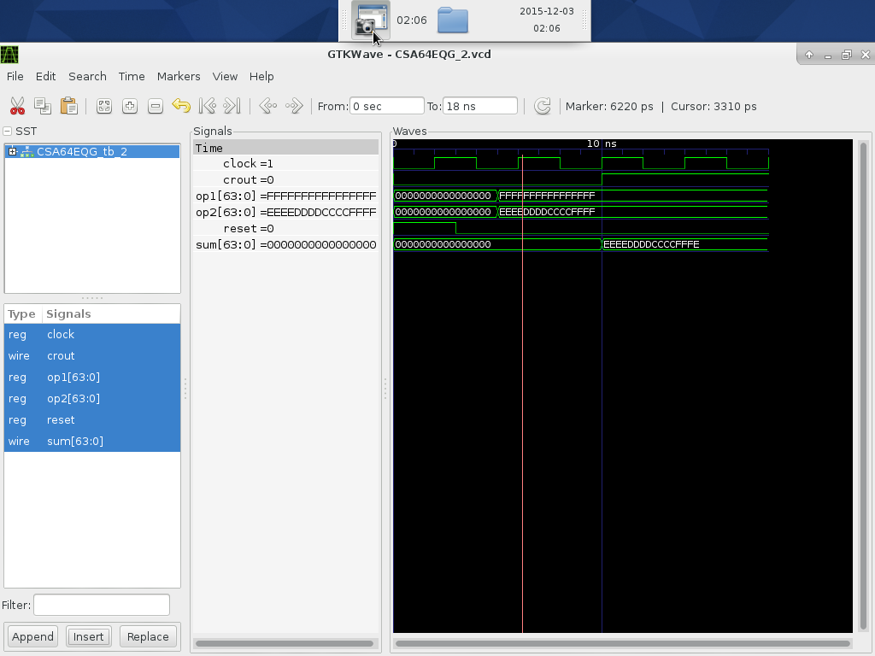

**Figure III.2c**: **RTL simulation waveform that contains test** **case #2 for CSA-EQG**

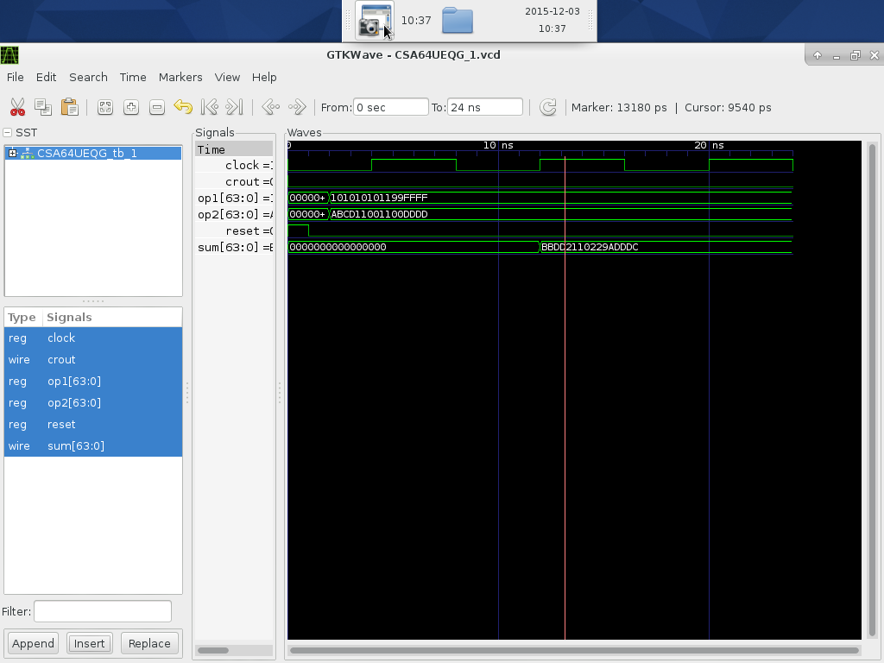

**Figure III.2d**: RTL simulation waveform that contains test case #2 for CSA-UEQG

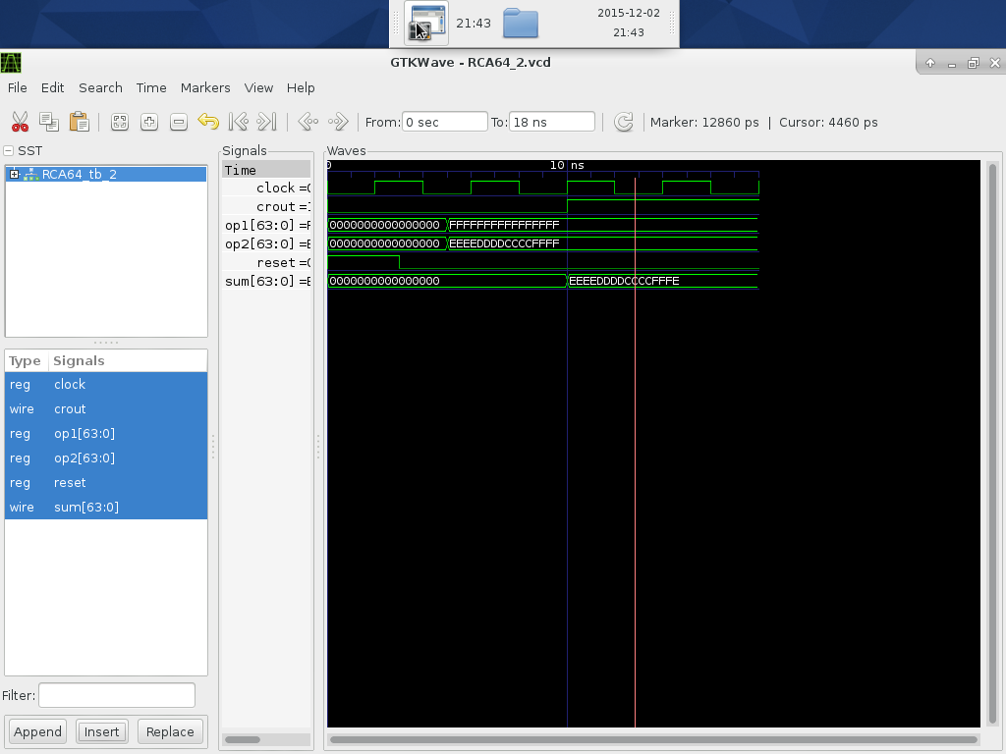

**Figure III.3a**: **RTL simulation waveform that contains test case #3 for RCA**

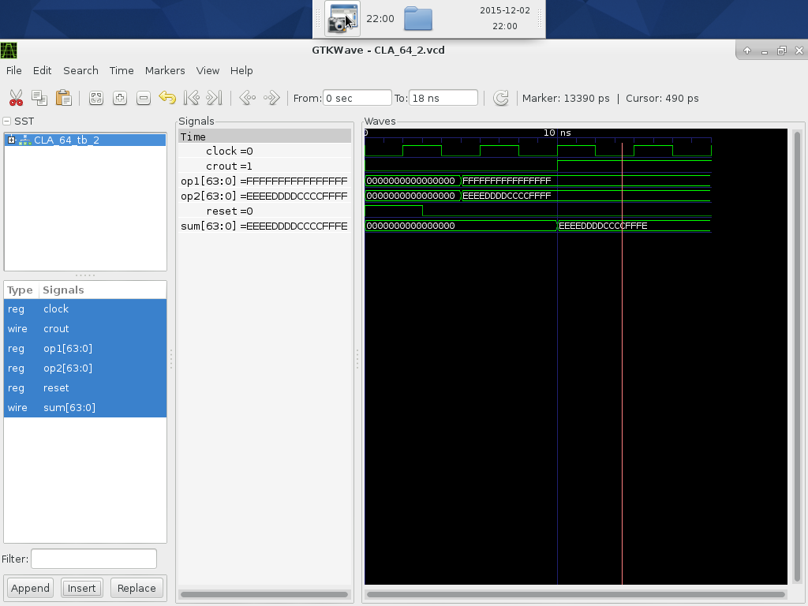

**Figure III.3b**: **RTL simulation waveform that contains test case #3 for CLA-2L**

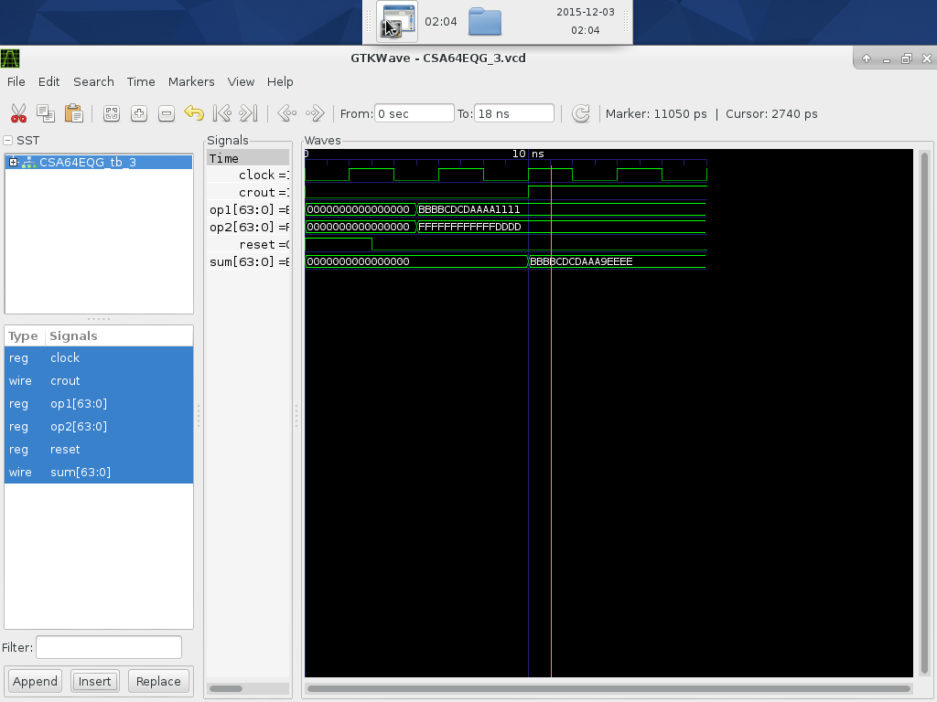

**Figure III.3c**: **RTL simulation waveform that contains test case #3 for CSA-EQG**

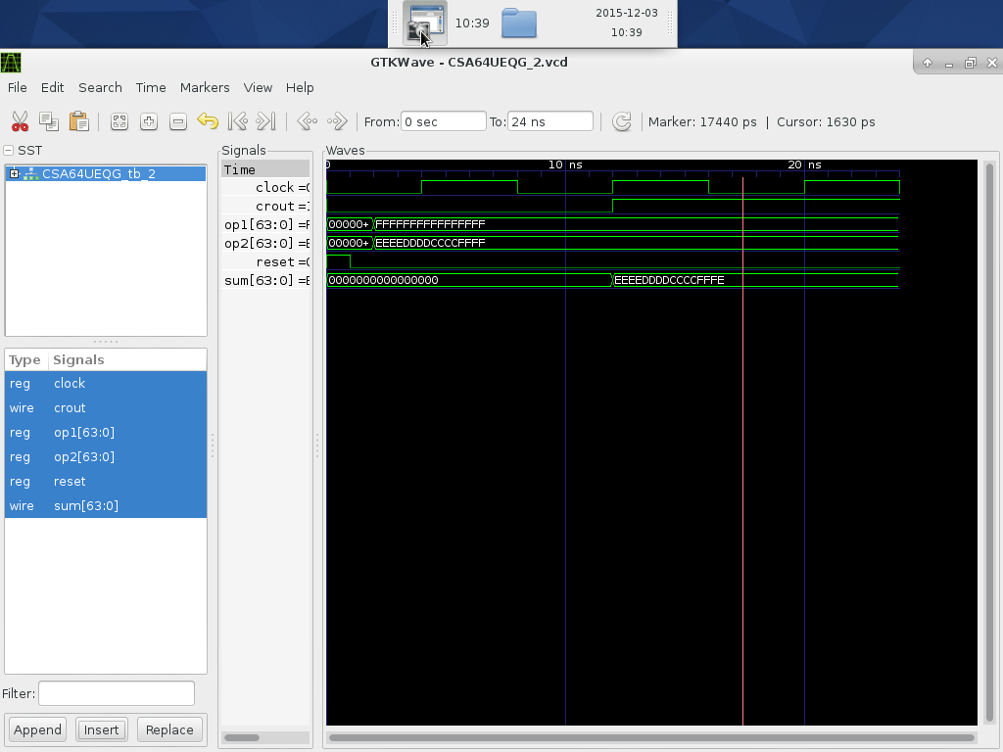

**Figure III.3d**: **RTL simulation waveform that contains test case #3 for CSA-UEQG**

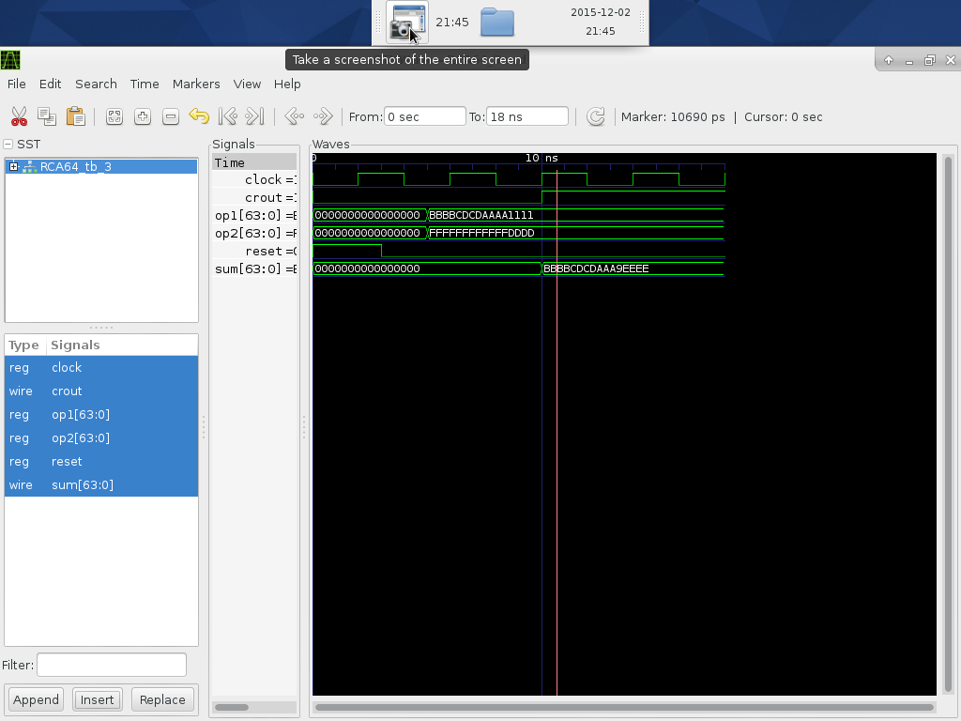

**Figure III.4a**: **RTL simulation waveform that contains test case #4 for RCA**

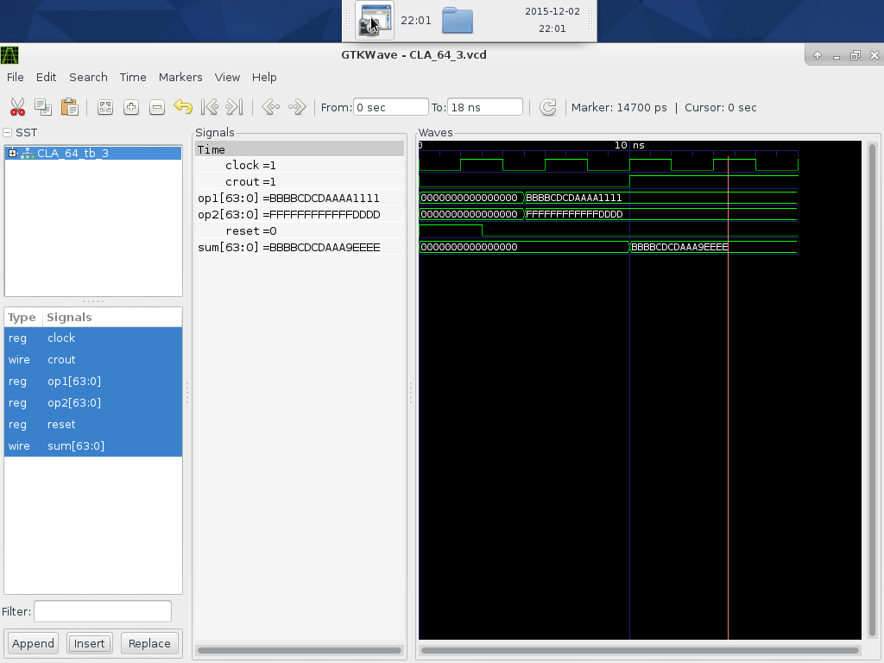

**Figure III.4b**: **RTL simulation waveform that contains test case #4 for CLA-2L**

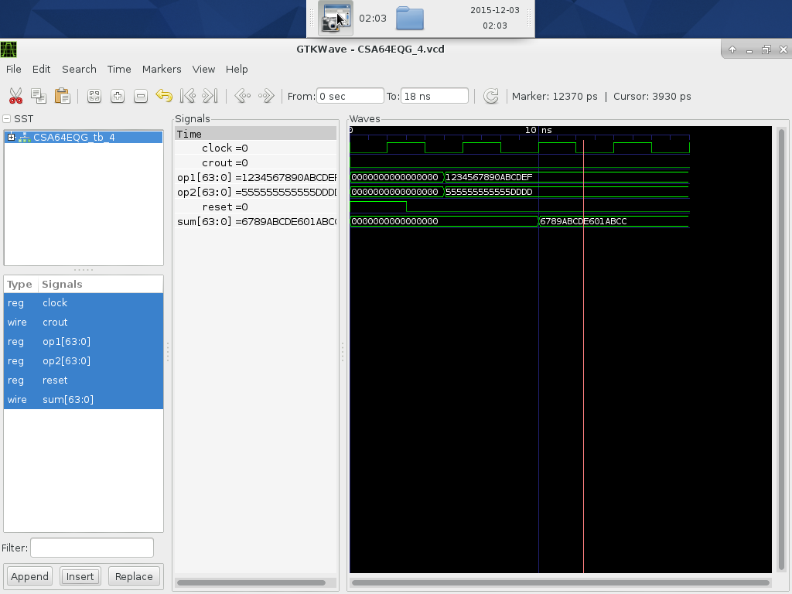

**Figure III.4c**: **RTL simulation waveform that contains test case #4 for CSA-EQG**

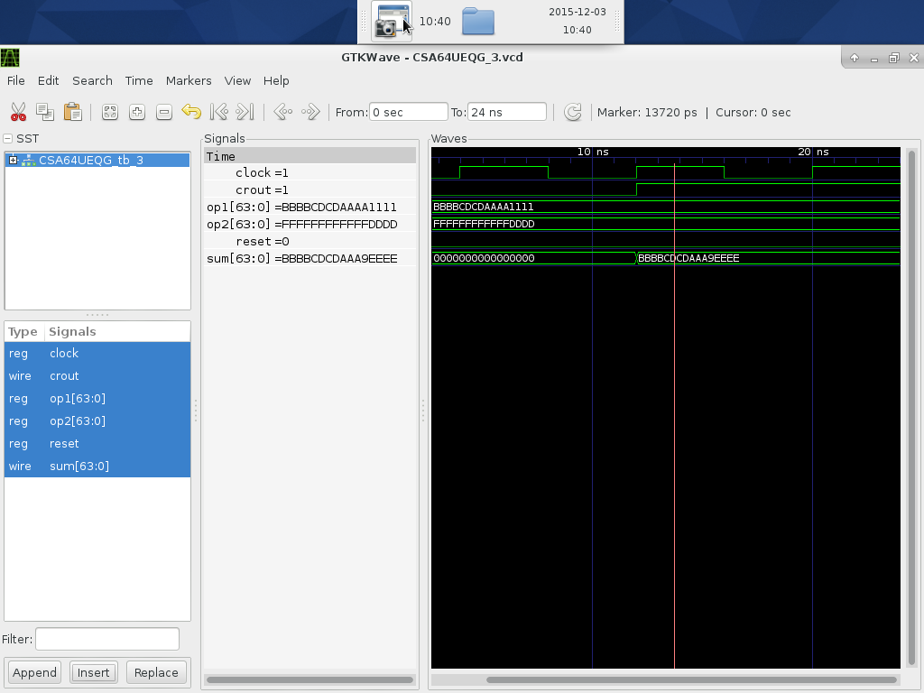

**Figure III.4d**: **RTL simulation waveform that contains test case #4 for CSA-UEQG**

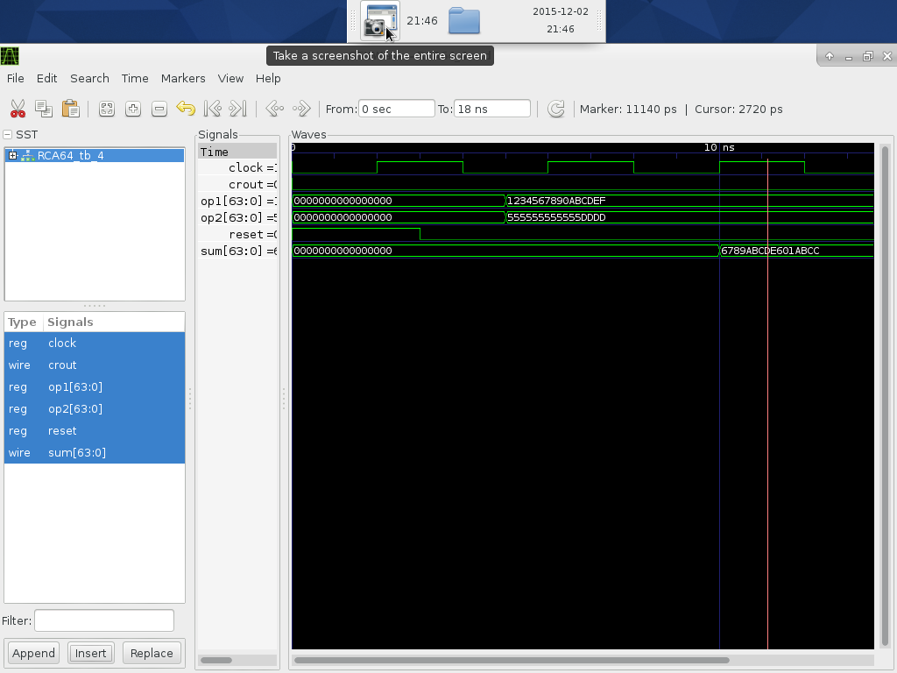

**Figure III.5a**: **RTL simulation waveform that contains test case #5 for RCA**

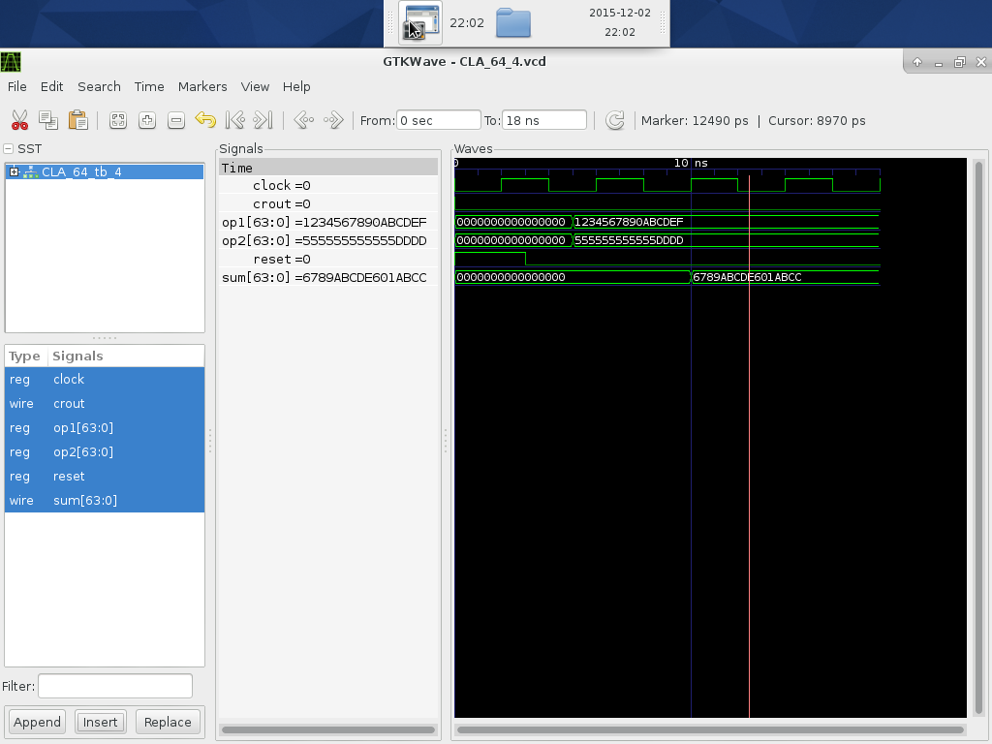

**Figure III.5b**: **RTL simulation waveform that contains test case #5 for CLA-2L**

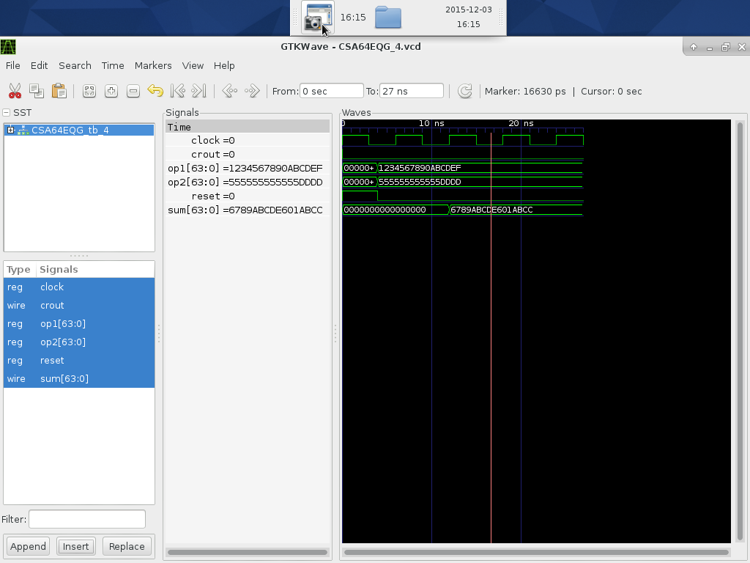

**Figure III.5c**: **RTL simulation waveform that contains test case #5 for CSA-EQG**

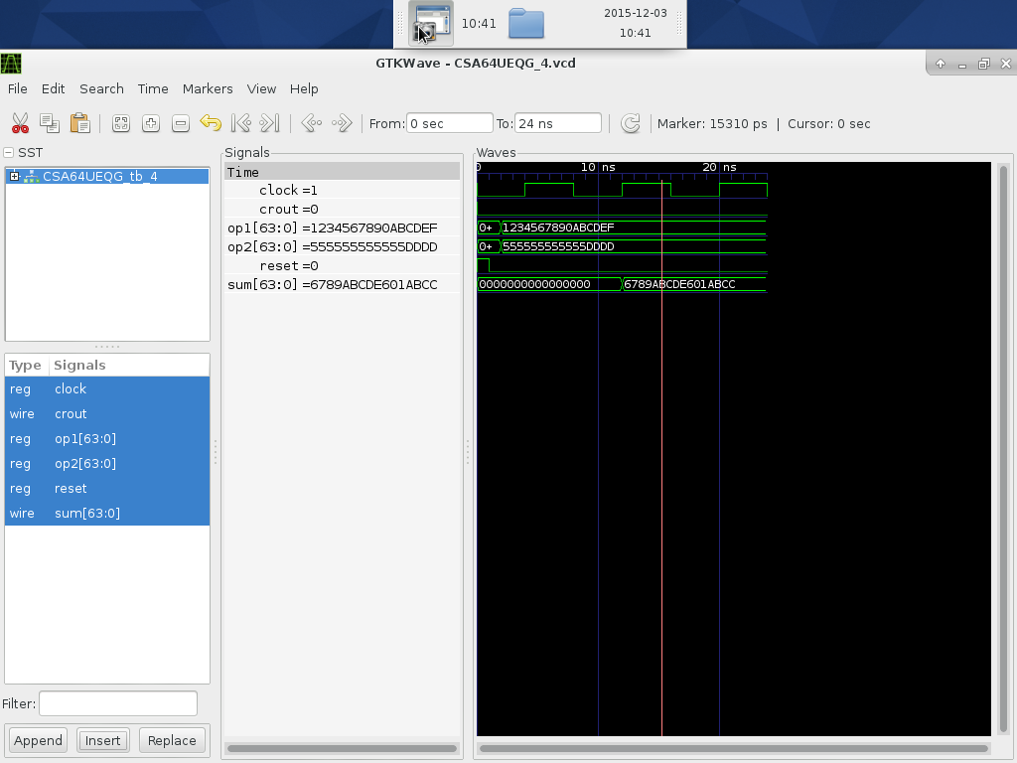

**Figure III.5d**: **RTL simulation waveform that contains test case #5 for CSA-UEQG**

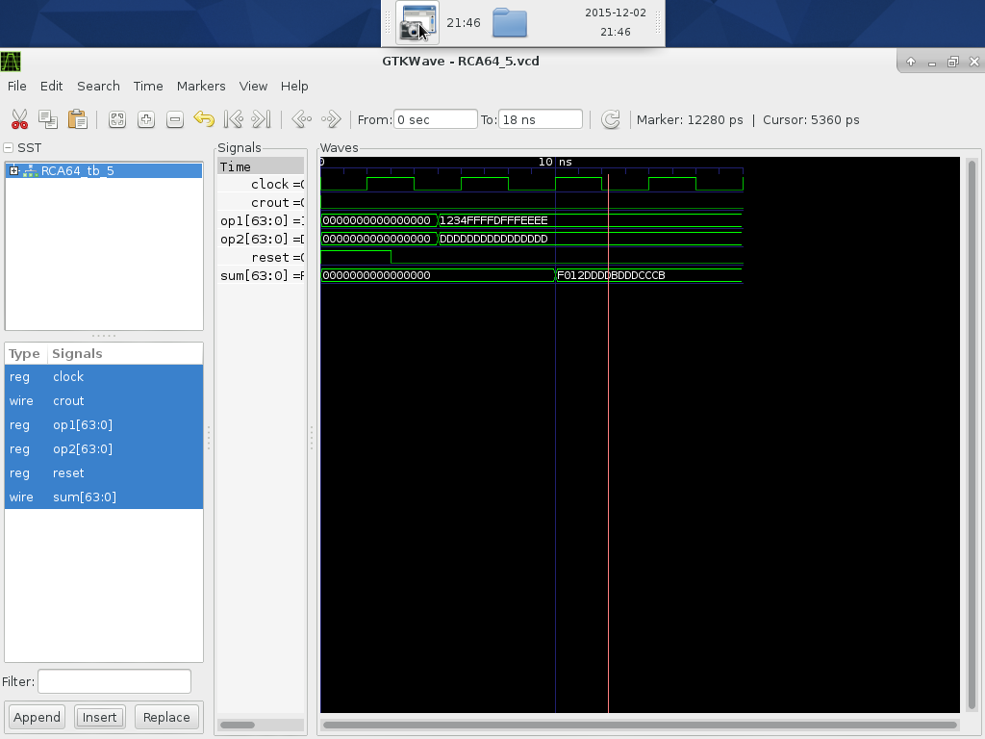

**Figure III.6a**: **RTL simulation waveform that contains test case #6 for RCA**

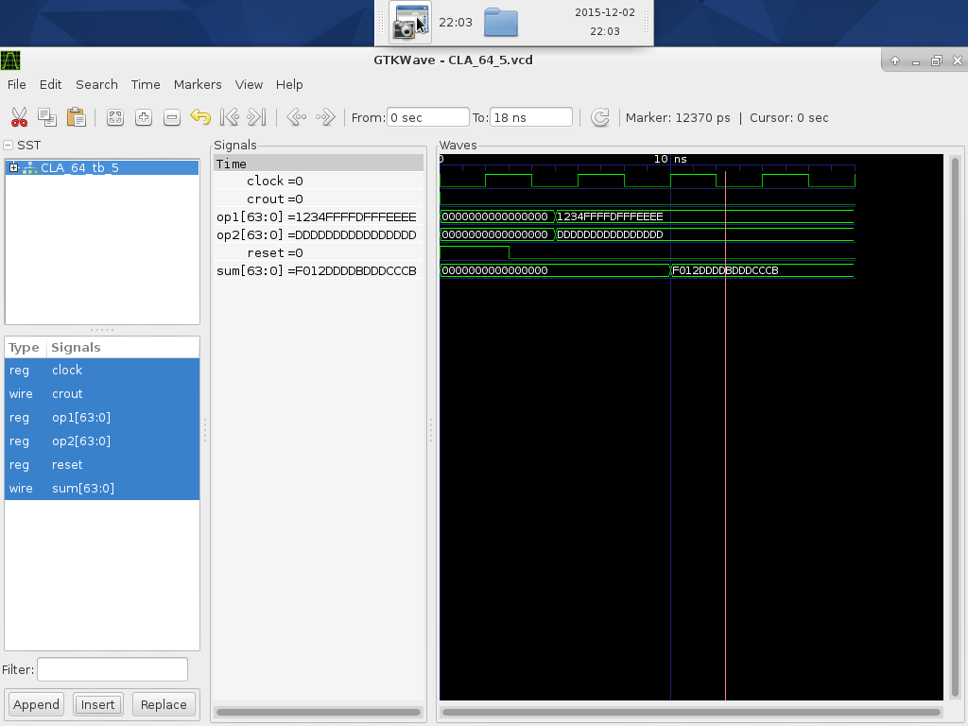

**Figure III.6b**: **RTL simulation waveform that contains test case #6 for CLA-2L**

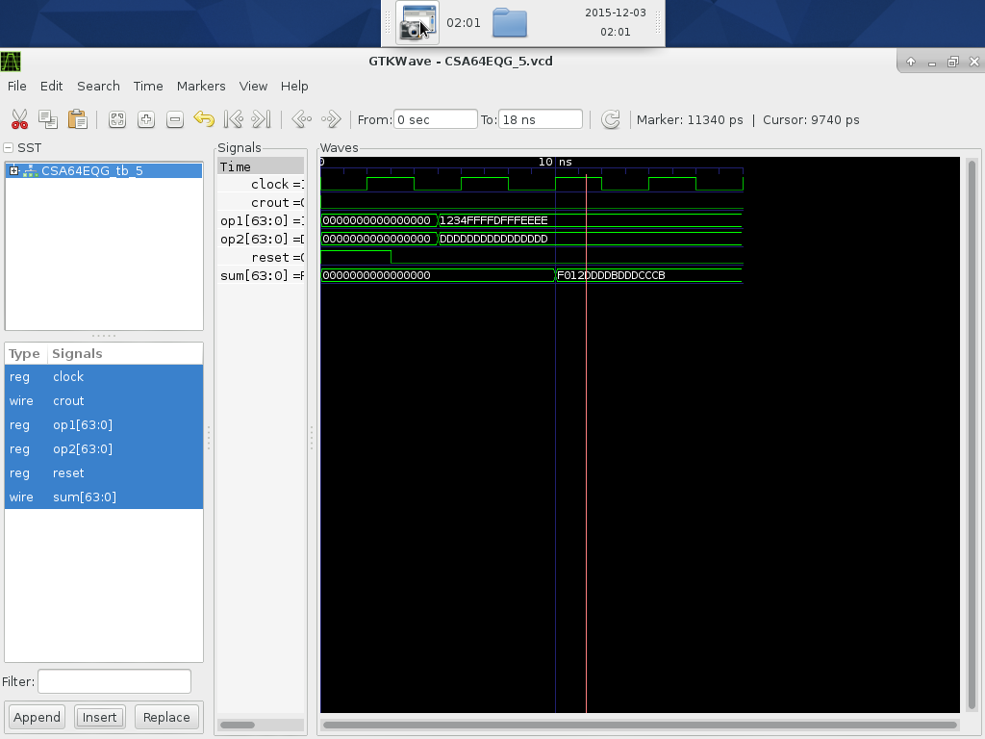

**Figure III.6c**: **RTL simulation waveform that contains test case #6 for CSA-EQG**

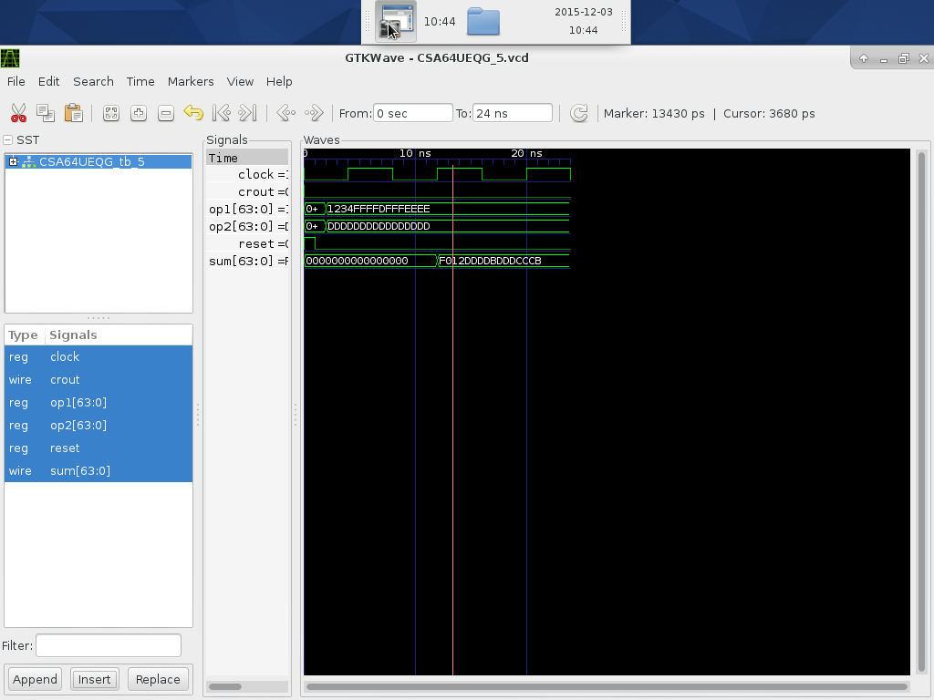

**Figure III.6d**: **RTL simulation waveform that contains test case #6 for CSA-UEQG**

**IV. Synthesis and Optimizations**

## Table IV.1: Synthesis Constraints and Results for RCA

|  |  |  |
| --- | --- | --- |
| **Trial #** | **Design Constraint Settings**  **Clock(ns), Area** | **Results after Synthesis**  **Slack, Area, Power(mw)** |
| 1 | Clock=17 ns, Area= 1500 | Slack= -3.77, Area=3765.00, Power=4.71 mW |
| 2 | Clock=19 ns, Area = 2700 | Slack= -1.79, Area=3693.00, Power=4.73 mW |
| 3 | Clock=23 ns, Area= 3500 | Slack= 2.21, Area=2900.00, Power=4.58 mW |
| 4 | Clock= 20 ns, Area= 3000 | Slack= -0.78, Area=3200.00, Power=4.70 mW |
| 5 | **Clock= 20.80 ns, Area= 3000** | **Slack= 0.01, Area=3039.20, Power=4.67 mW** |
| 6 | Clock =21 ns, Area= 3100 | Slack= 0.21, Area=2995.500, Power=4.60 mW |

## Table IV.2: Synthesis Constraints and Results for CLA-2L

|  |  |  |
| --- | --- | --- |
| **Trial #** | **Design Constraint Settings**  **Clock(ns), Area** | **Results after Synthesis**  **Slack, Area, Power(mw)** |
| 1 | Clock=5 ns, Area=2700 | Slack= -2, Area=2855.50, Power=17.16mW |
| 2 | Clock=6 ns, Area = 2800 | Slack= -1, Area=2820.00, Power=16.89 mW |
| 3 | Clock=6.5 ns, Area=3000 | Slack= -0.5, Area=2811.50, Power=16.50 mW |
| 4 | **Clock=7.3 ns, Area=3100** | **Slack= 0.01, Area=2776.00, Power=15.11 mW** |
| 5 | Clock=7.5 ns, Area=2900 | Slack= 0.51, Area=2730.50, Power=14.260 mW |
| 6 | Clock=8 ns, Area=2600 | Slack= 1.01, Area=2696.5.00, Power=13.31 mW |

## Table IV.3: Synthesis Constraints and Results for CSA-EQG

|  |  |  |
| --- | --- | --- |
| **Trial #** | **Design Constraint Settings**  **Clock(ns), Area** | **Results after Synthesis**  **Slack, Area, Power(mw)** |
| 1 | Clock=6 ns, Area=3100 | Slack= -0.93, Area=3653.00, Power=13.79 mW |
| 2 | Clock=6.5 ns, Area=3400 | Slack= -.43, Area=3576.00, Power=16.35 mW |
| 3 | Clock=7 ns, Area=3450 | Slack= -0.05, Area=3479.50, Power=14.79 mW |
| 4 | Clock=7.5 ns, Area= 3500 | Slack= 0.47, Area=3409.00, Power=15.28 mW |
| 5 | Clock=8 ns, Area=3300 | Slack= 0.93, Area=3351.50, Power=13.56 mW |
| 6 | **Clock=7.1 ns, Area=3400** | **Slack= 0.03, Area=3424.00, Power=16.23 mW** |

## Table IV.4: Synthesis Constraints and Results for CSA-UEQG

|  |  |  |
| --- | --- | --- |
| **Trial #** | **Design Constraint Settings**  **Clock(ns), Area** | **Results after Synthesis**  **Slack, Area, Power(mw)** |
| 1 | Clock=6 ns | Slack= -1.75, Area=3782.00, Power=14.46 mW |
| 2 | Clock=6.5 ns | Slack= -1.24, Area=3759.00, Power=13.95 mW |
| 3 | Clock=7 ns | Slack= -0.73, Area=3714.500, Power=11.50 mW |
| 4 | Clock=7.2 ns | Slack= -0.56, Area=3685.00, Power=13.379 mW |
| 5 | Clock=7.7 ns | Slack= -0.05, Area=3567.500, Power=13.99 mW |
| 6 | **Clock=7.8 ns** | **Slack= 0.05, Area=3538.00, Power=14.09 mW** |

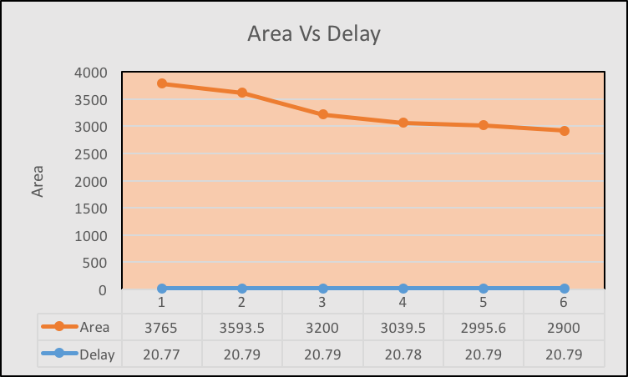

**Figure IV.1**: **Area versus Delay of RCA**

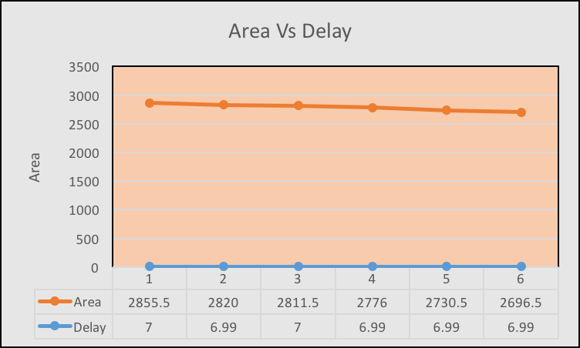

**Figure IV.2**: **Area versus Delay of CLA-2L**

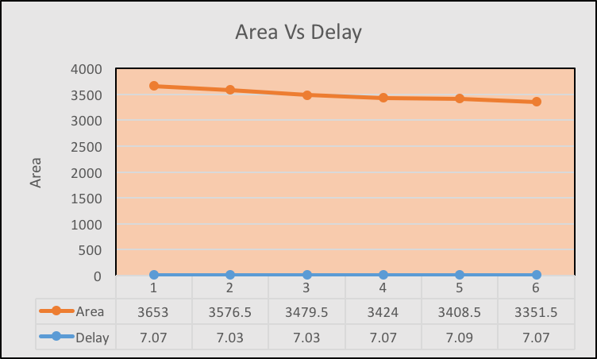

**Figure IV.3**: **Area versus Delay of CSA-EQG**

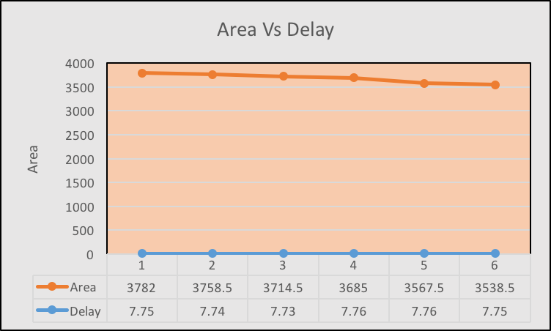

**Figure IV.4**: **Area versus Delay of CSA-UEQG**

From the graphs of Area Vs Delay, The area of the adder changes with change in time period. If clock period increases, then area will decrease. The area is inversely proportional to the clock period.

**V. Gate-Level (Post-synthesis) Dynamic Simulations/Tests**

**Table V.1** – **Performance of Six Selected Test Cases**

|  |  |  |  |  |  |  |
| --- | --- | --- | --- | --- | --- | --- |
| **Test Case** | **op1** (hex) | **op2 (**hex) | **Timings (Delays) ns** | | | |
| **RCA** | **CLA-2L** | **CSA-EQG** | **CSA-UEQG** |
| **1** | **f20f_ffff_ffff_ffff** | **ffff_ffff_ffff_ff50** | **2.89** | **1.54** | **2.2** | **1.95** |
| **2** | **1010_1010_1199_ffff** | **abcd_1100_1100_dddd** | **2.95** | **0.95** | **1.9** | **2.2** |
| **3** | **ffff_ffff_ffff_ffff** | **eeee_dddd_cccc_ffff** | **2.05** | **1.05** | **1.64** | **2.38** |
| **4** | **bbbb_cdcd_aaaa_1111** | **ffff_ffff_ffff_dddd** | **2.22** | **0.89** | **1.68** | **2.08** |
| **5** | **1234_ffff_dfff_eeee** | **dddd_dddd_dddd_dddd** | **2.55** | **2.23** | **2.11** | **2.50** |
| **6** | **1234_5678_90ab_cdef** | **5555_5555_5555_dddd** | **2.85** | **2.13** | **2.350** | **2.7** |

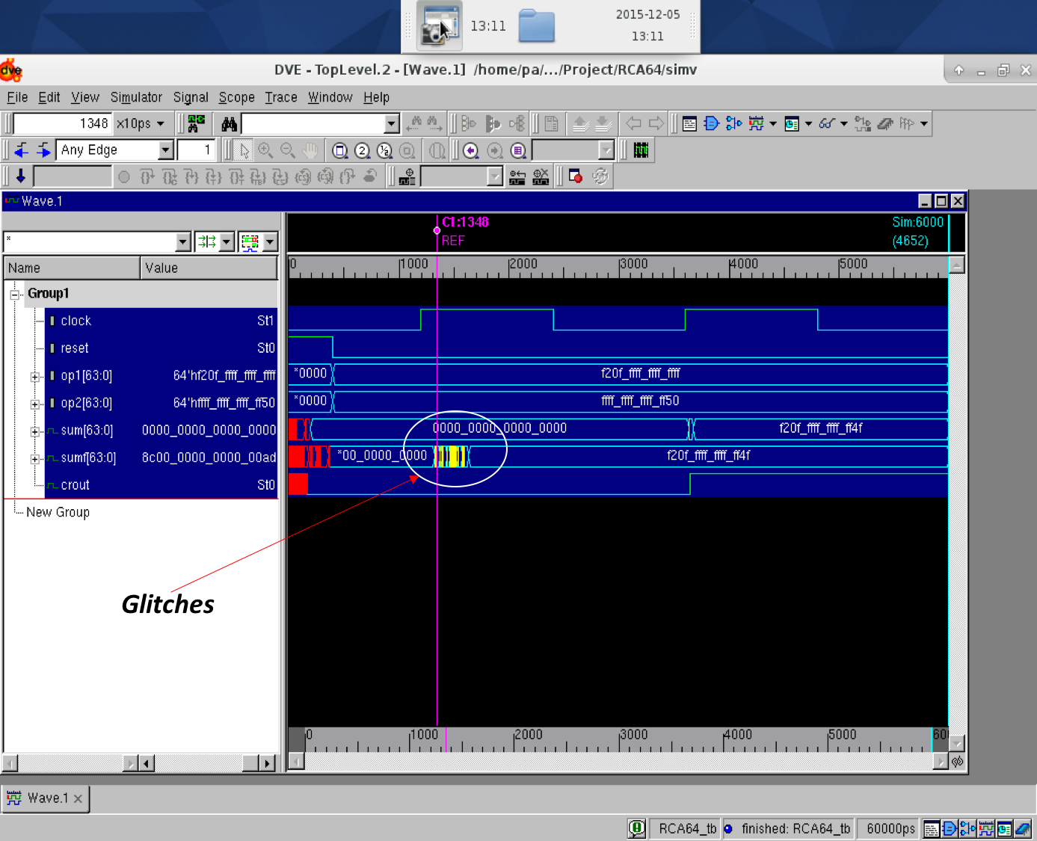

**Figure V.1a**: **Post-synthesis (dynamic) simulation waveform that contains test case #1 for RCA**

**The Glitches or fluctuation in circuit because of immediate data change in operands and wire delay. Glitch/Delay is 2.89 ns**

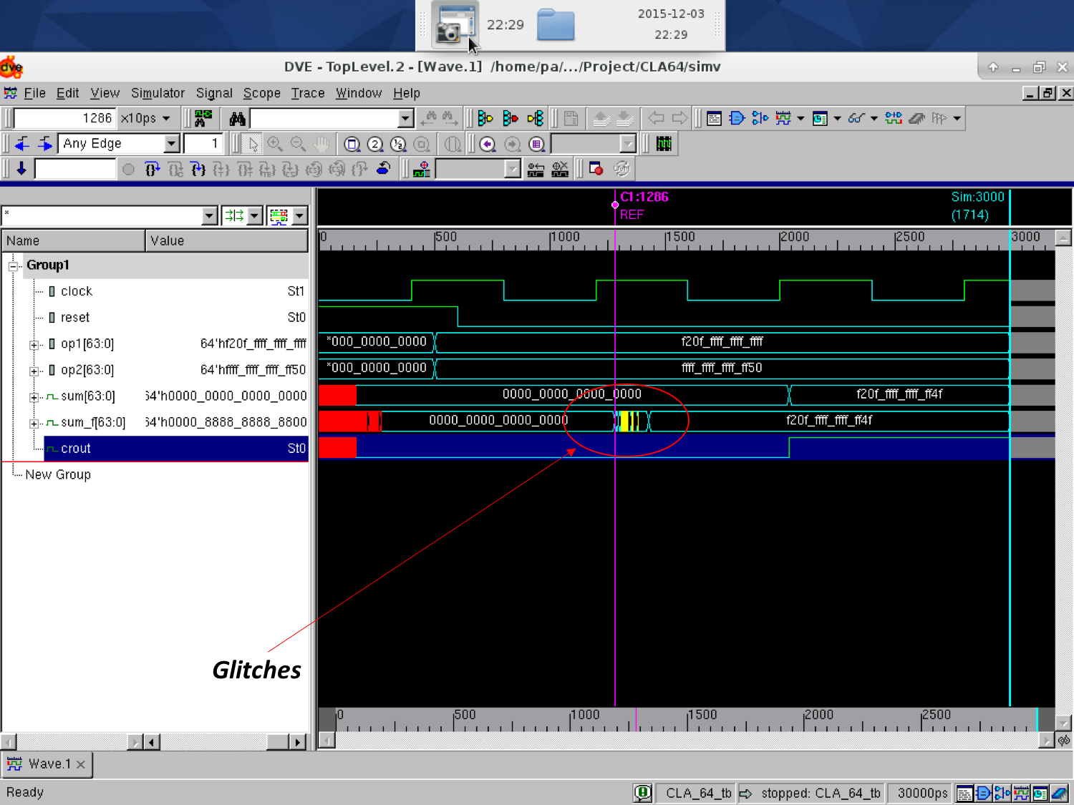

**Figure V.1b**: **Post-synthesis (dynamic) simulation waveform that contains test case #1 for CLA-2L**

**The Glitches or fluctuation in circuit because of immediate data change in operands and wire delay. Glitch/Delay is 1.54 ns**

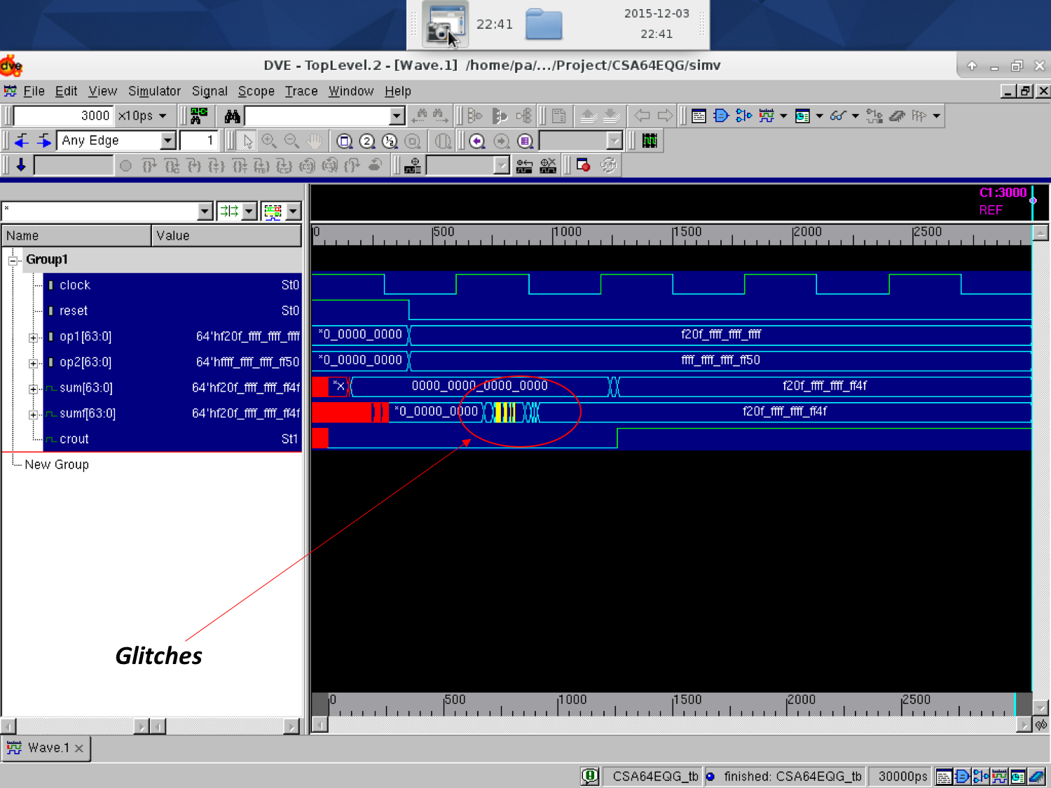

**Figure V.1c**: **Post-synthesis (dynamic) simulation waveform that contains test case #1 for CSA-EQG**

**The Glitches or fluctuation in circuit because of immediate data change in operands and wire delay. Glitch/Delay is 2.2 ns**

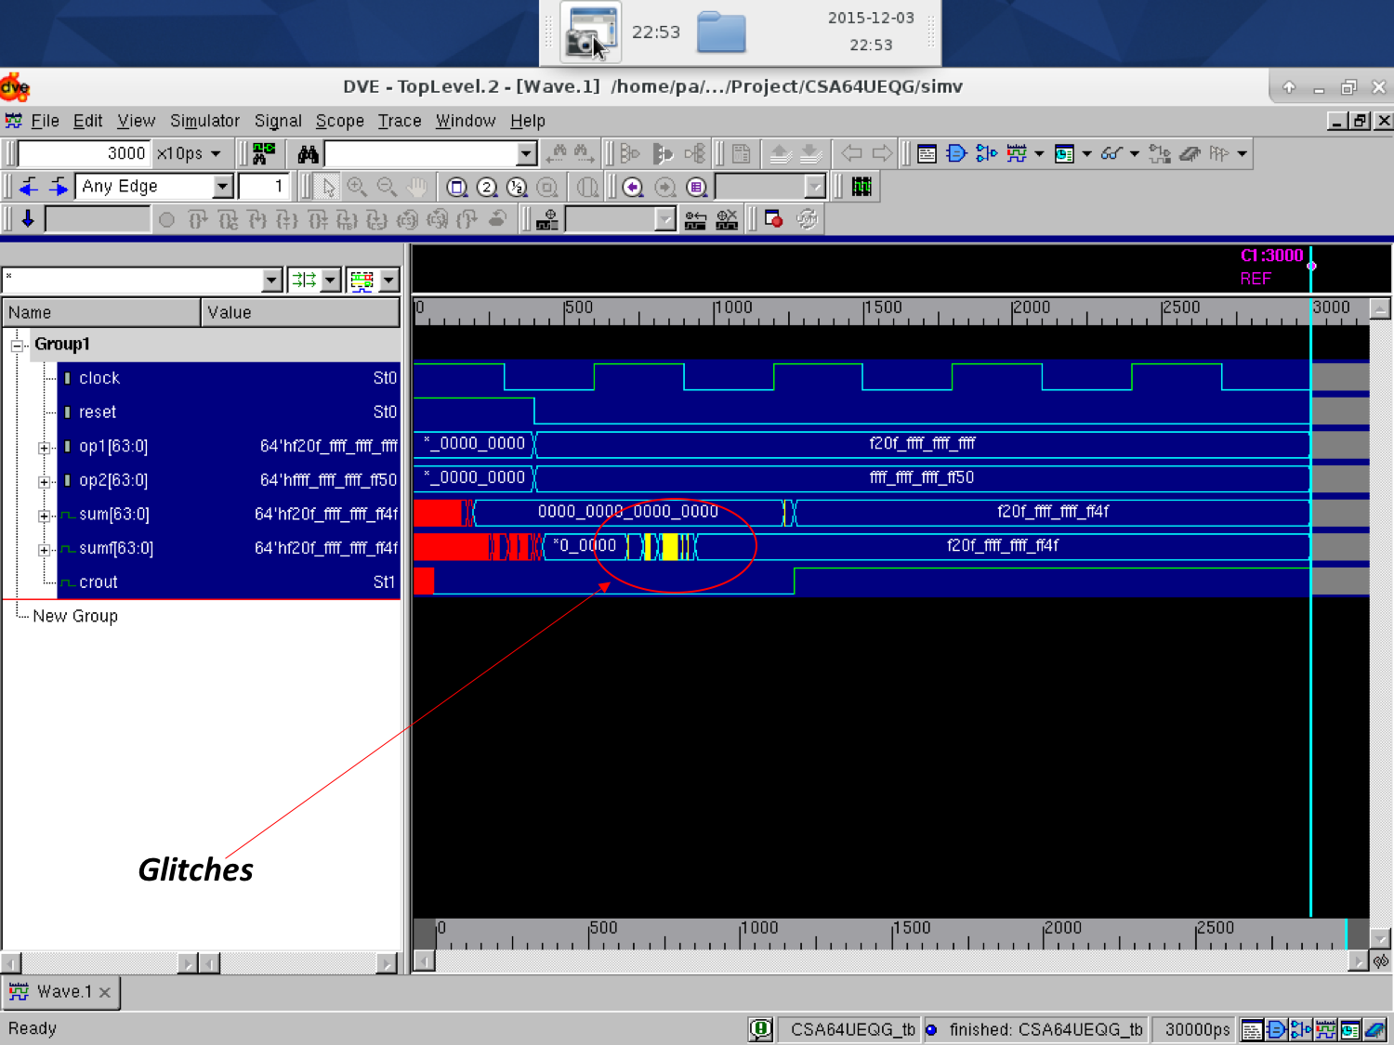

**Figure V.1d**: **Post-synthesis (dynamic) simulation waveform that contains test case #1 for CSA-UEQG**

**The Glitches or fluctuation in circuit because of immediate data change in operands and wire delay. Glitch/Delay is 1.95 ns**

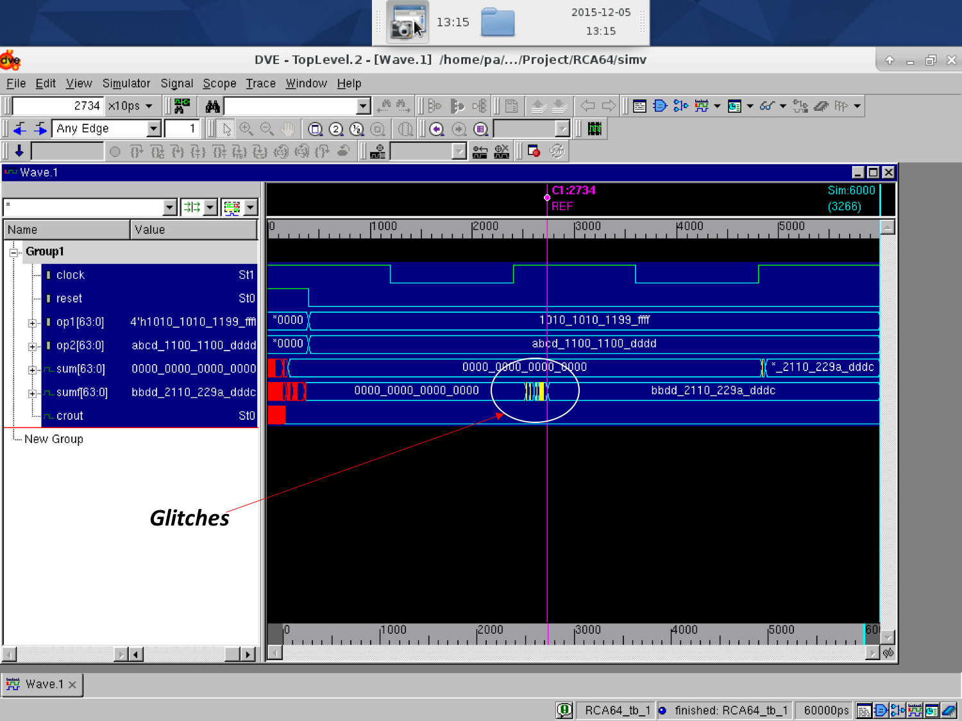

**Figure V.2a**: **Post-synthesis (dynamic) simulation waveform that contains test case #2 for RCA**

**The Glitches or fluctuation in circuit because of immediate data change in operands and wire delay. Glitch/Delay is 2.95 ns**

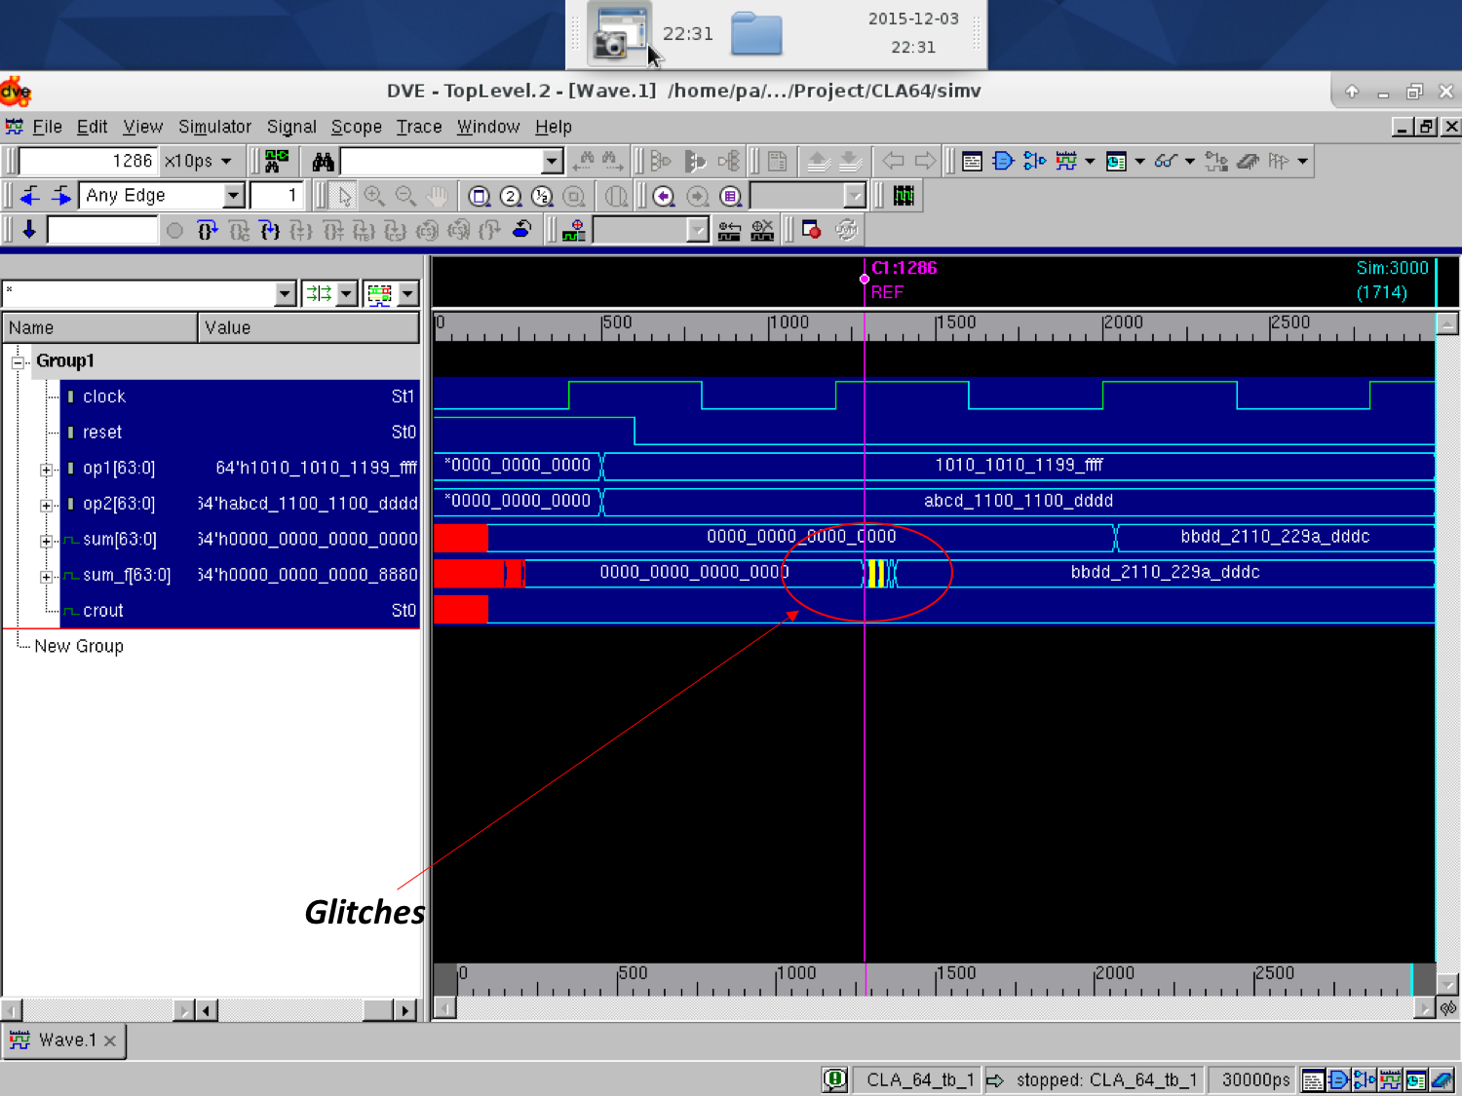

**Figure V.2b**: **Post-synthesis (dynamic) simulation waveform that contains test case #2 for CLA-2L**

**The Glitches or fluctuation in circuit because of immediate data change in operands and wire delay. Glitch/Delay is 0.95 ns**

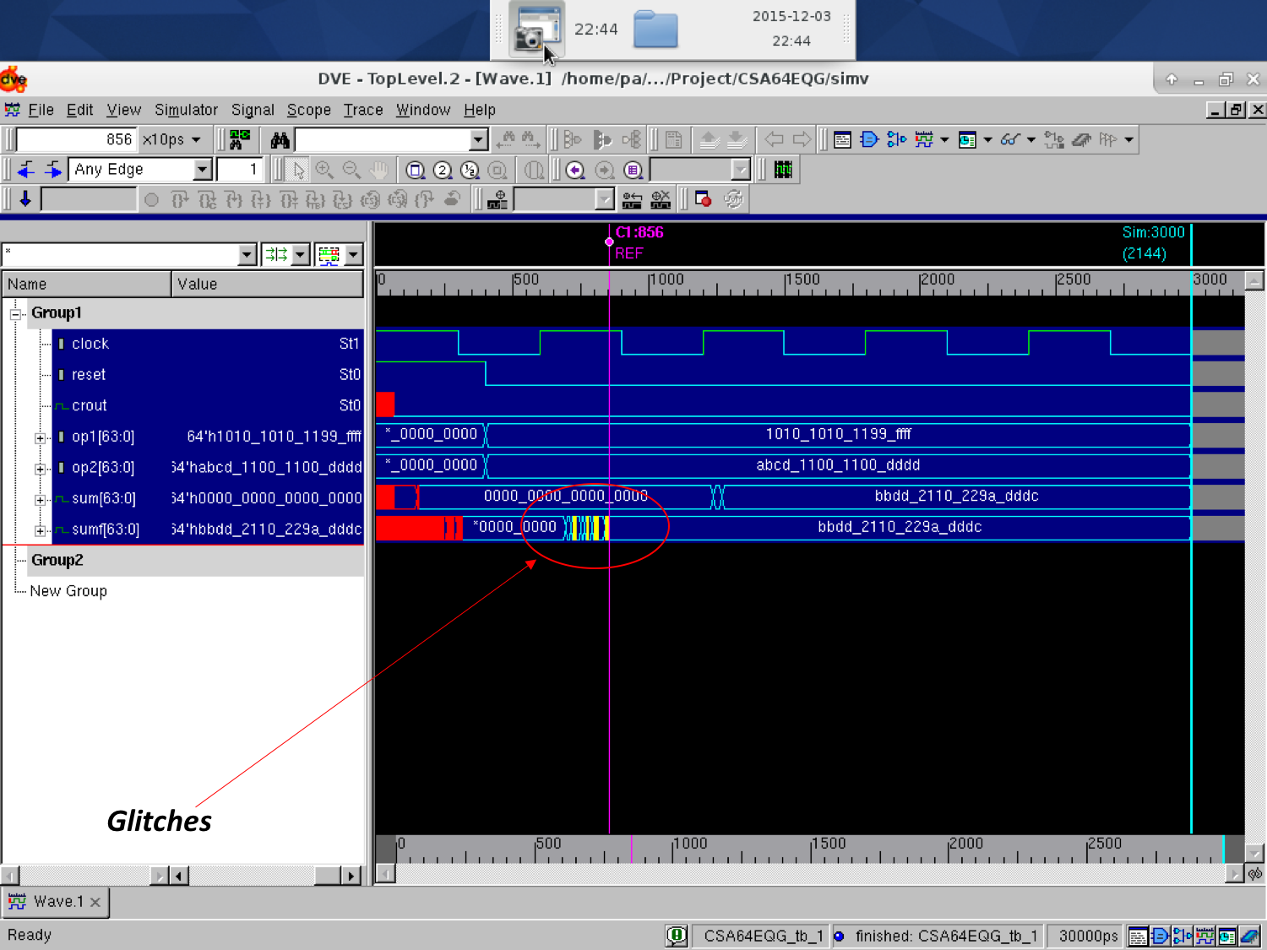

**Figure V.2c**: **Post-synthesis (dynamic) simulation waveform that contains test case #2 for CSA-EQG**

**The Glitches or fluctuation in circuit because of immediate data change in operands and wire delay. Glitch/Delay is 1.90 ns**

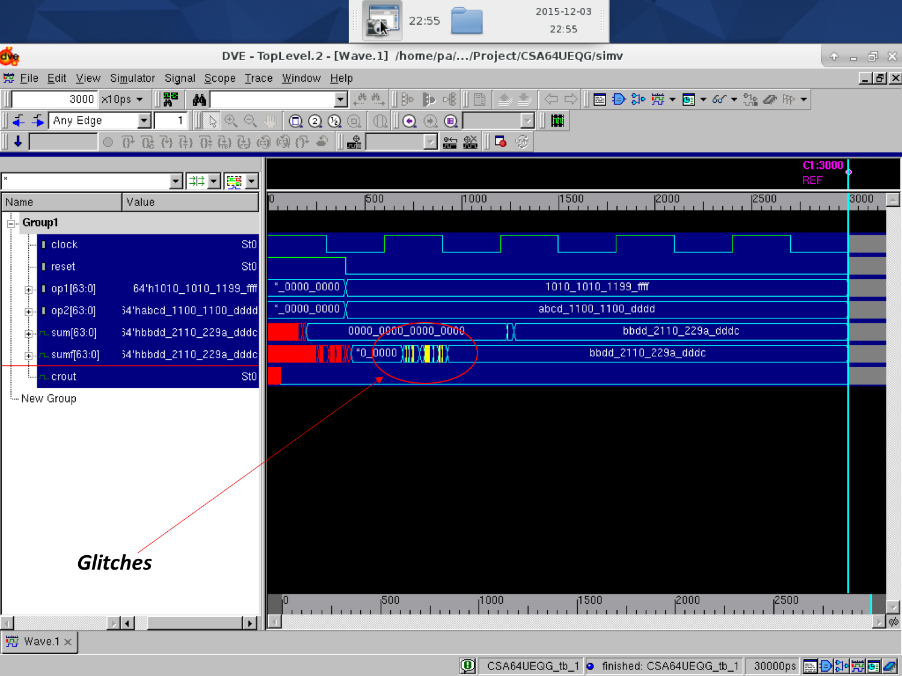

**Figure V.2d**: **Post-synthesis (dynamic) simulation waveform that contains test case #2 for CSA-UEQG**

**The Glitches or fluctuation in circuit because of immediate data change in operands and wire delay. Glitch/Delay is 2.2 ns**

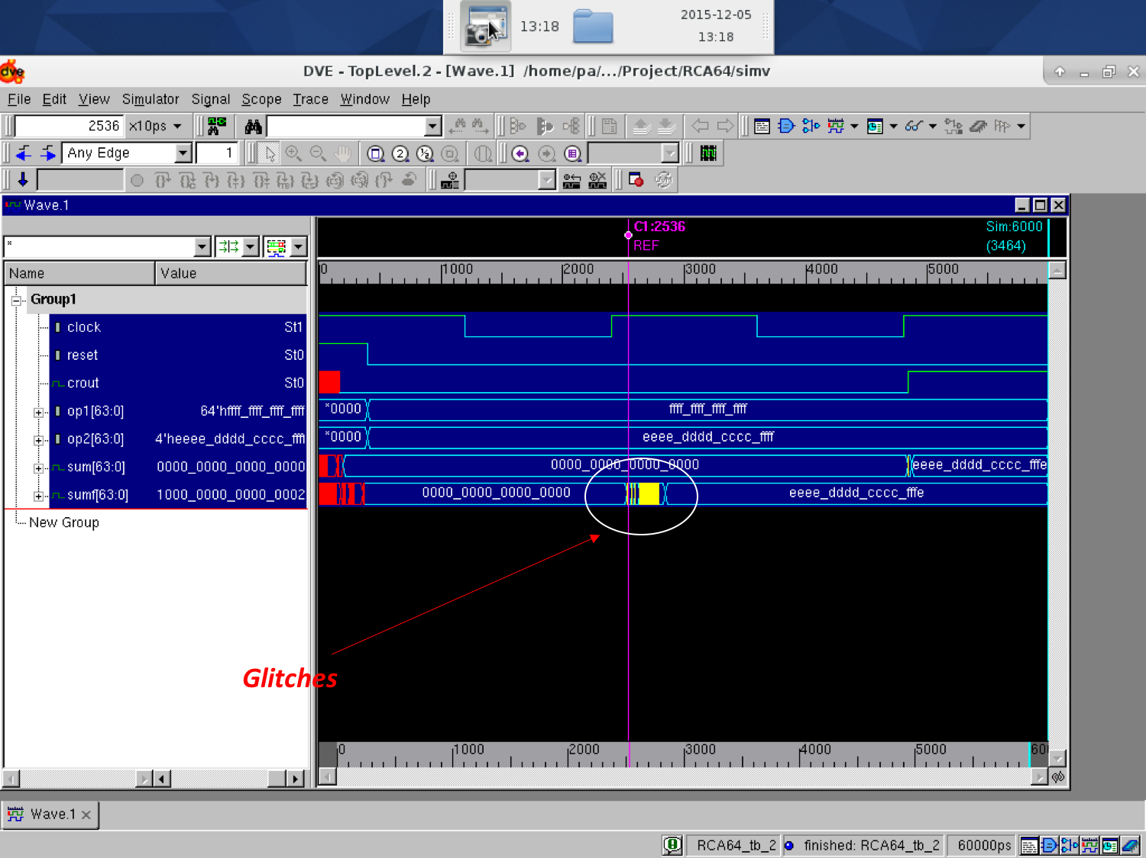

**Figure V.3a**: **Post-synthesis (dynamic) simulation waveform that contains test case #3 for RCA**

**The Glitches or fluctuation in circuit because of immediate data change in operands and wire delay. Glitch/Delay is 2.05 ns**

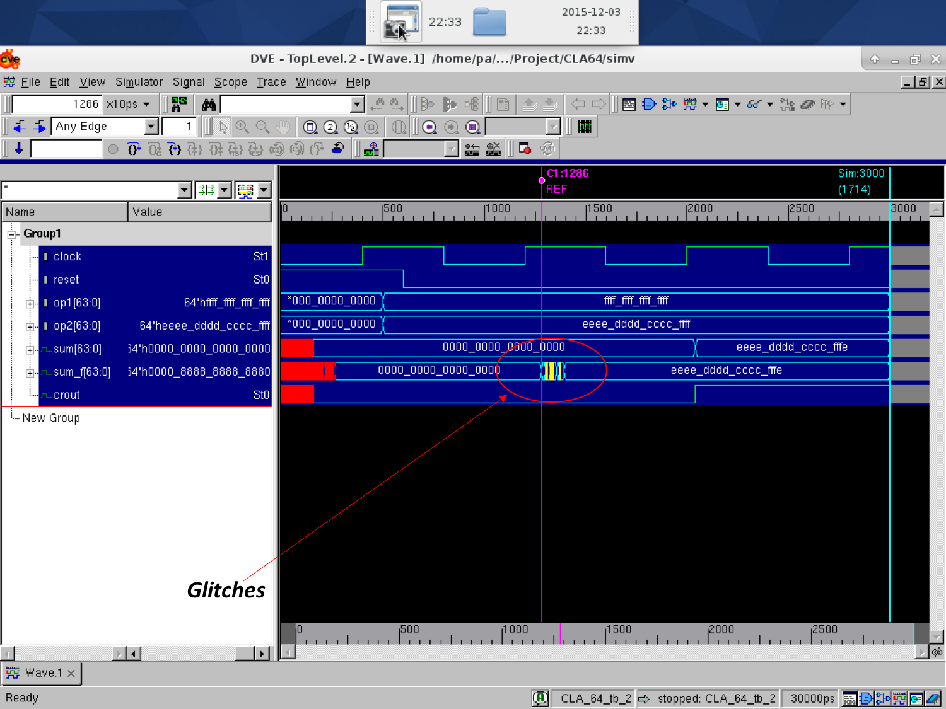

**Figure V.3b**: **Post-synthesis (dynamic) simulation waveform that contains test case #3 for CLA-2L**

**The Glitches or fluctuation in circuit because of immediate data change in operands and wire delay. Glitch/Delay is 1.05 ns**

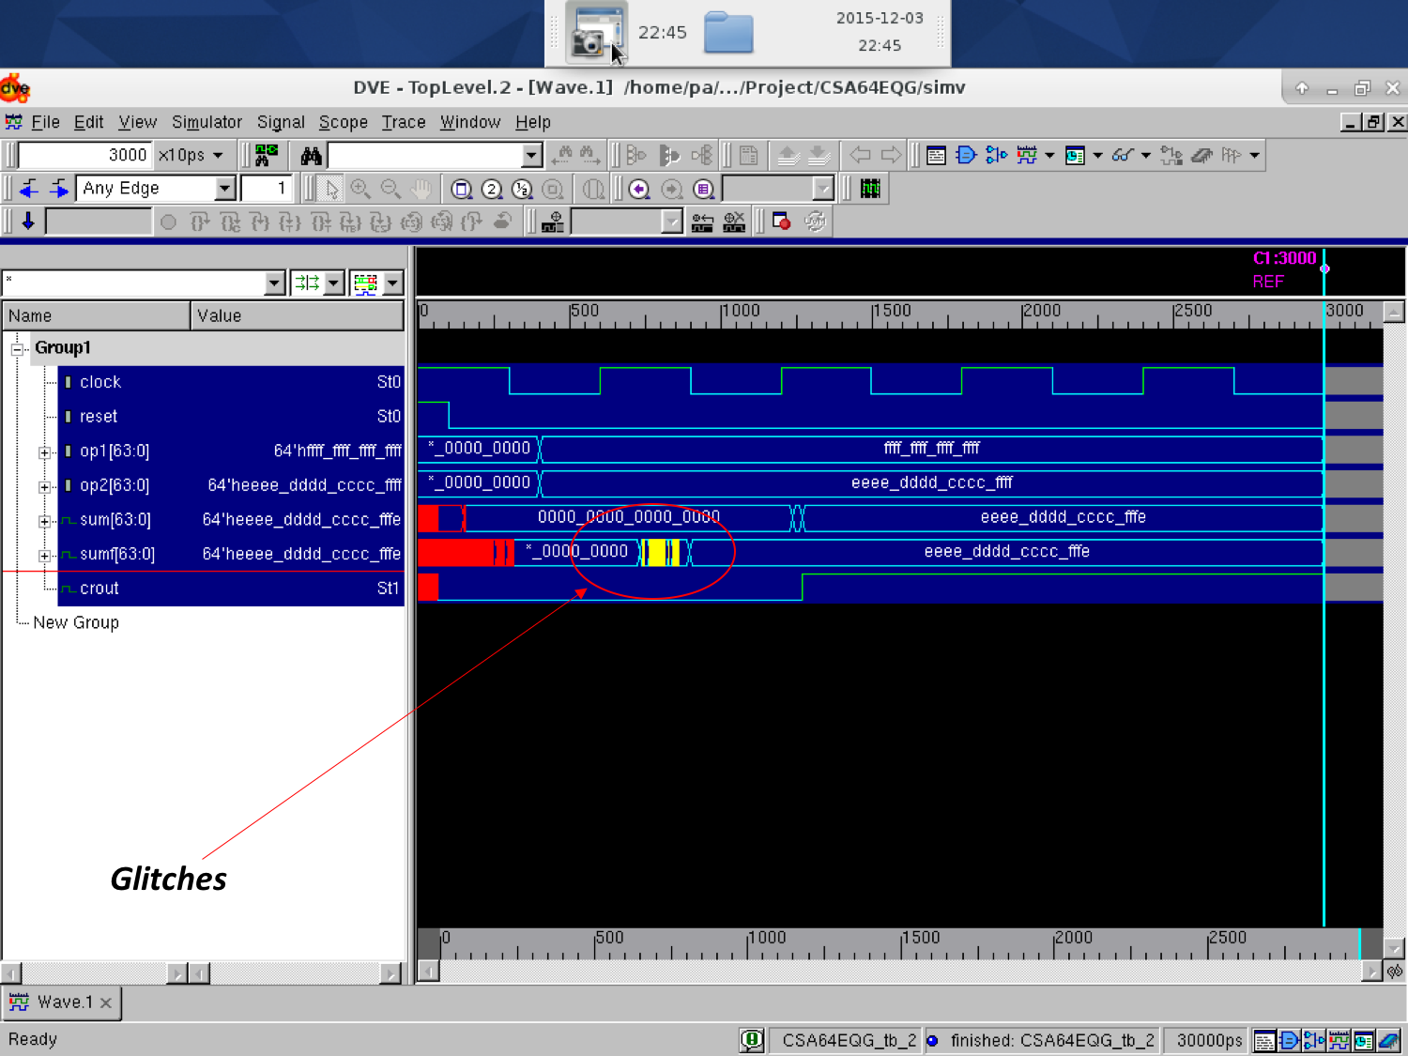

**Figure V.3c**: **Post-synthesis (dynamic) simulation waveform that contains test case #3 for CSA-EQG**

**The Glitches or fluctuation in circuit because of immediate data change in operands and wire delay. Glitch/Delay is 1.64 ns**

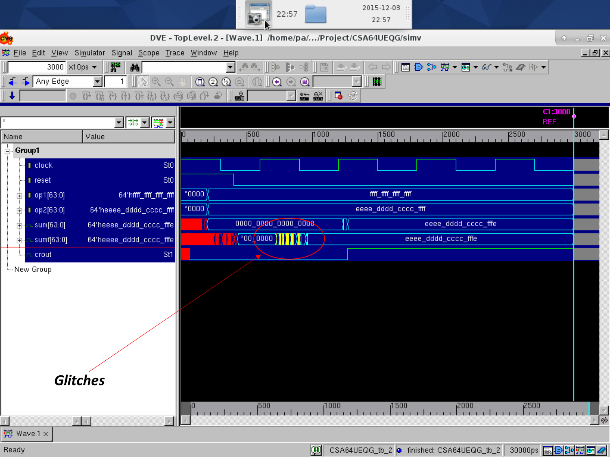

**Figure V.3d**: **Post-synthesis (dynamic) simulation waveform that contains test case #3 for CSA-UEQG**

**The Glitches or fluctuation in circuit because of immediate data change in operands and wire delay. Glitch/Delay is 2.38 ns**

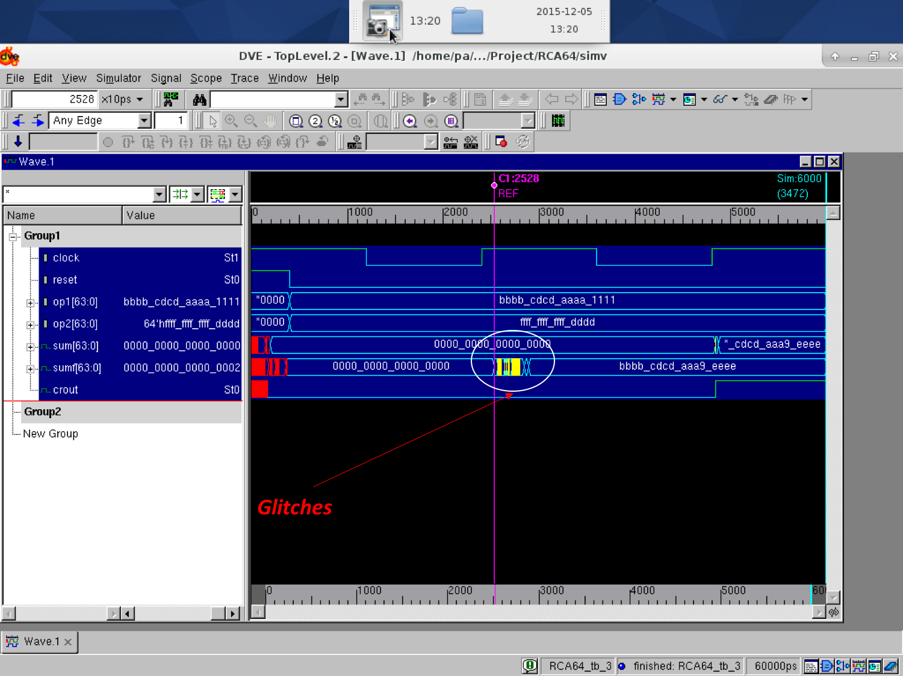

**Figure V.4a**: **Post-synthesis (dynamic) simulation waveform that contains test case #4 for RCA**

**The Glitches or fluctuation in circuit because of immediate data change in operands and wire delay. Glitch/Delay is 2.22 ns**

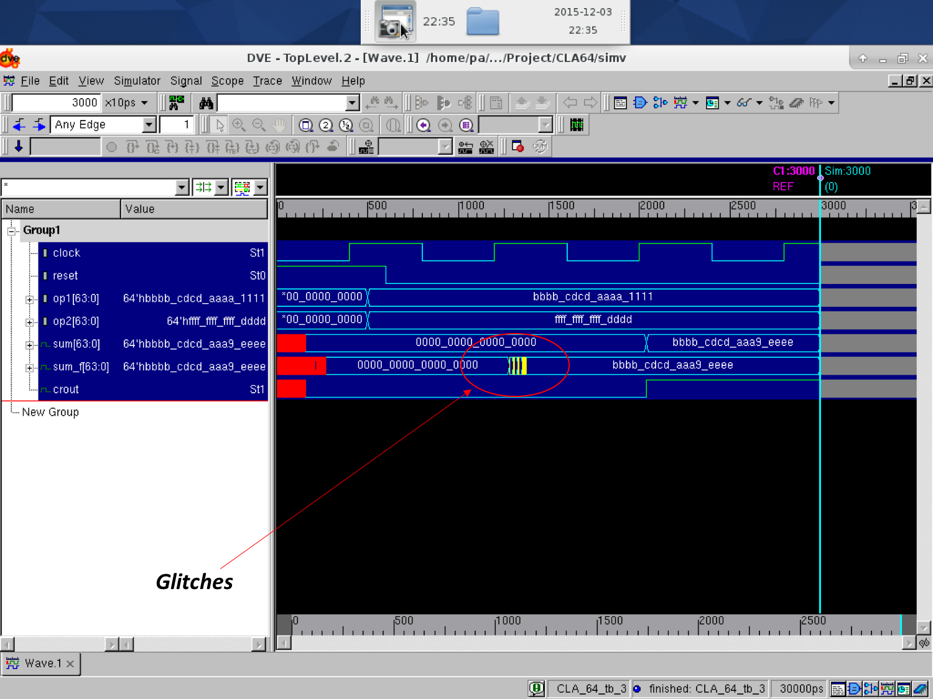

**Figure V.4b**: **Post-synthesis (dynamic) simulation waveform that contains test case #4 for CLA-2L**

**The Glitches or fluctuation in circuit because of immediate data change in operands and wire delay. Glitch/Delay is 0.89 ns**

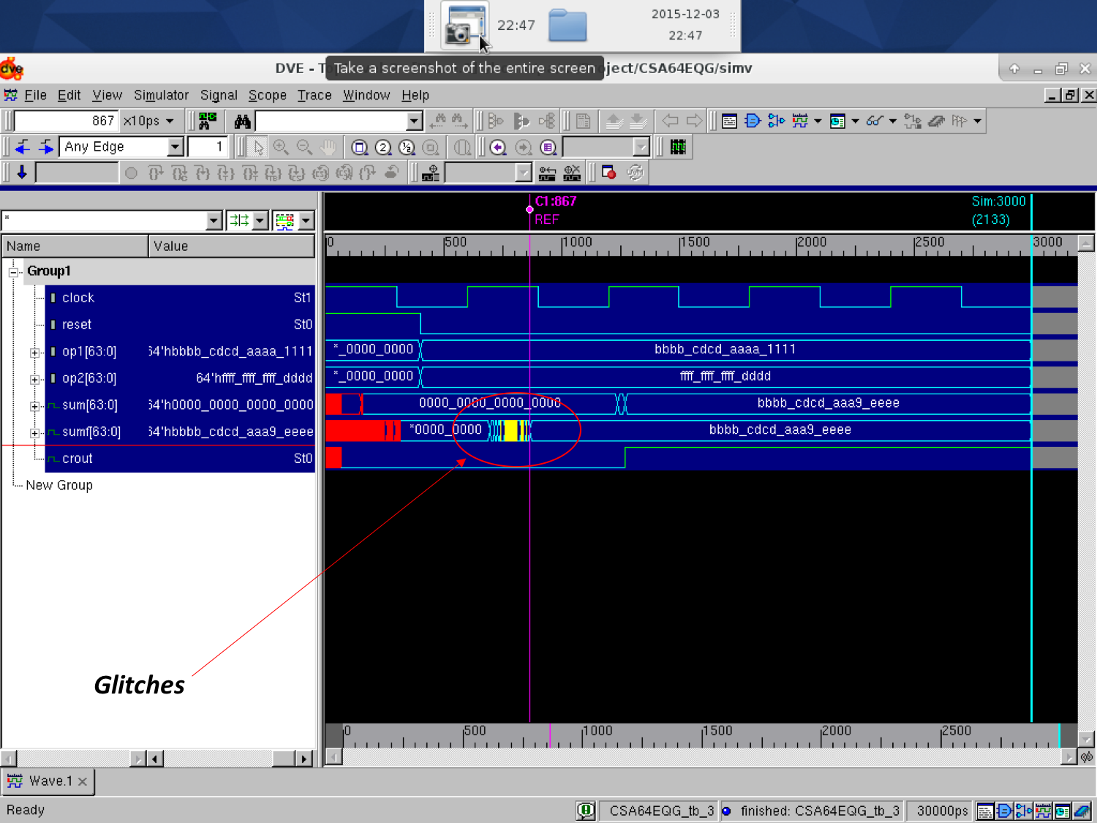

**Figure V.4c**: **Post-synthesis (dynamic) simulation waveform that contains test case #4 for CSA-EQG**

**The Glitches or fluctuation in circuit because of immediate data change in operands and wire delay. Glitch/Delay is 1.68 ns**

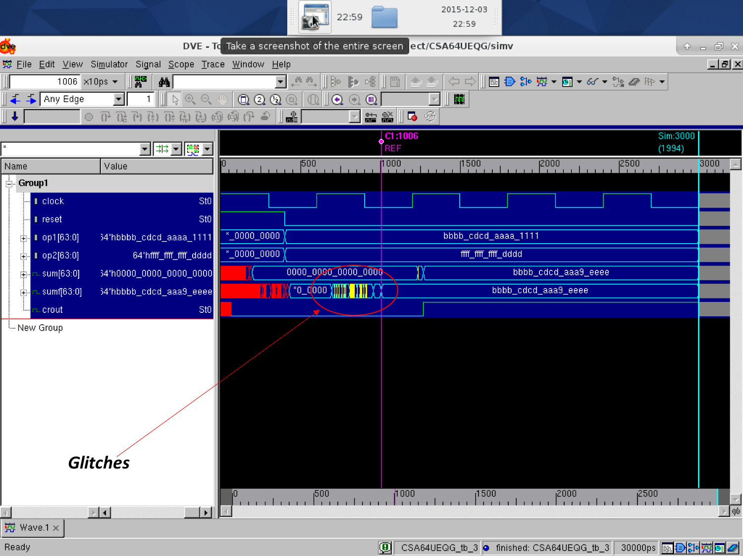

**Figure V.4d**: **Post-synthesis (dynamic) simulation waveform that contains test case #4 for CSA-UEQG**

**The Glitches or fluctuation in circuit because of immediate data change in operands and wire delay. Glitch/Delay is 2.08 ns**

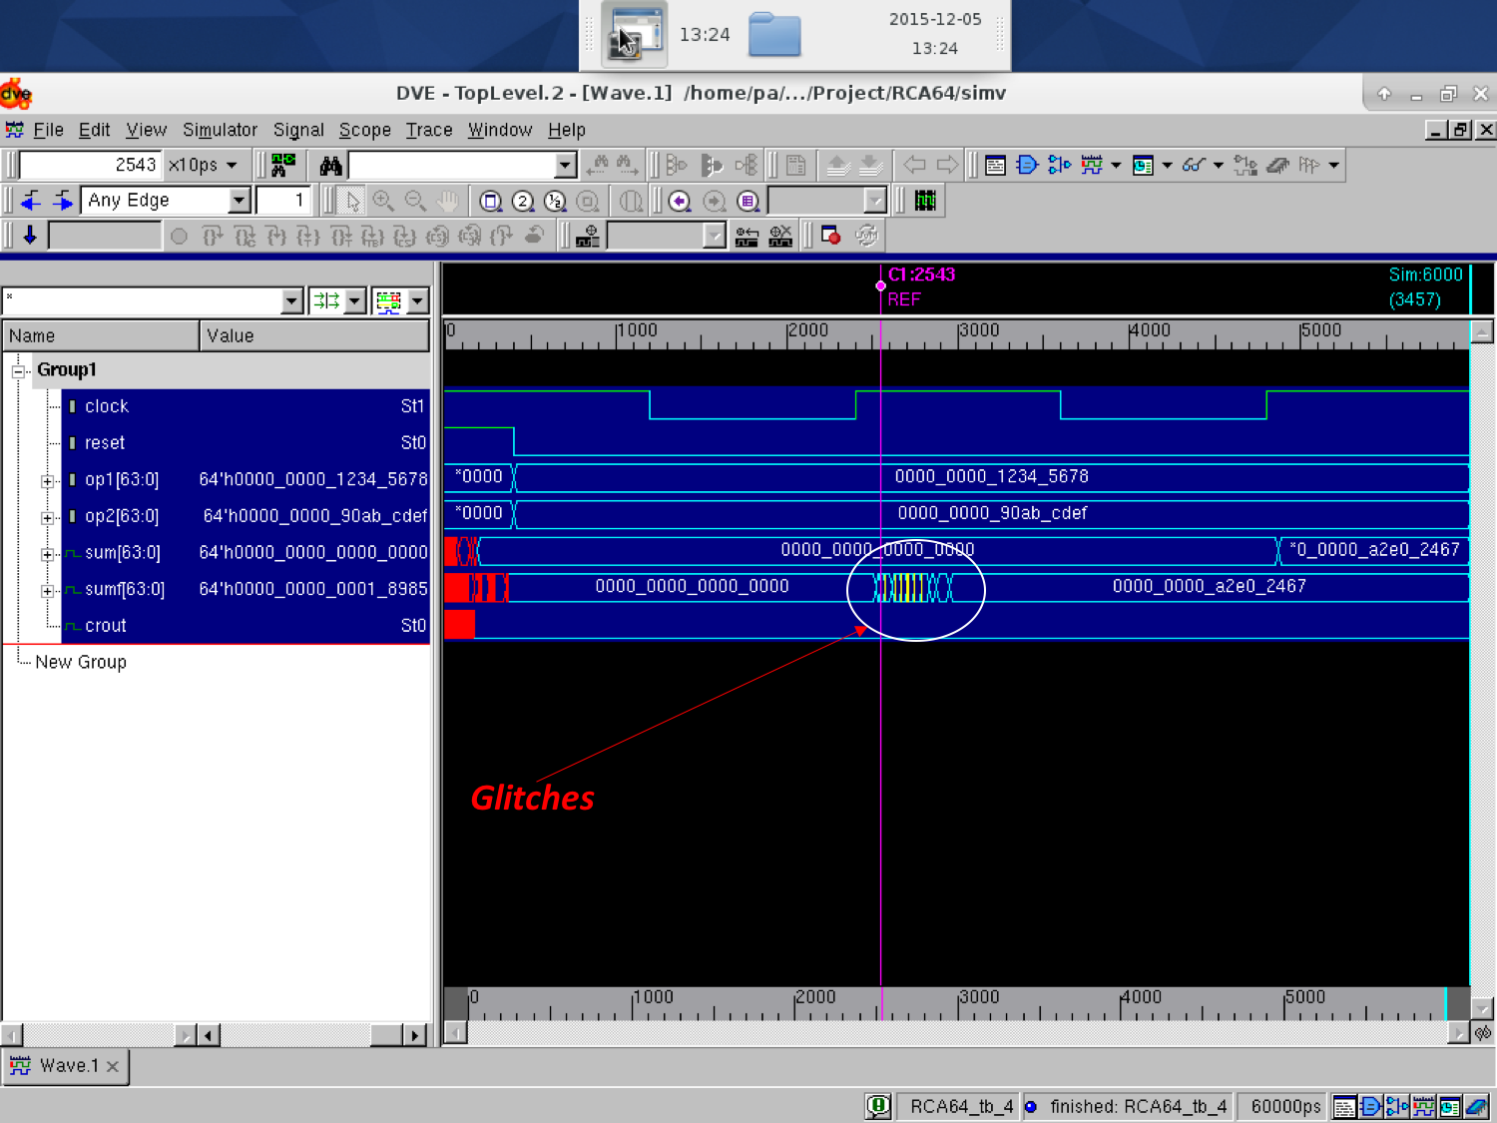

**Figure V.5a**: **Post-synthesis (dynamic) simulation waveform that contains test case #5 for RCA**

**The Glitches or fluctuation in circuit because of immediate data change in operands and wire delay. Glitch/Delay is 2.55 ns**

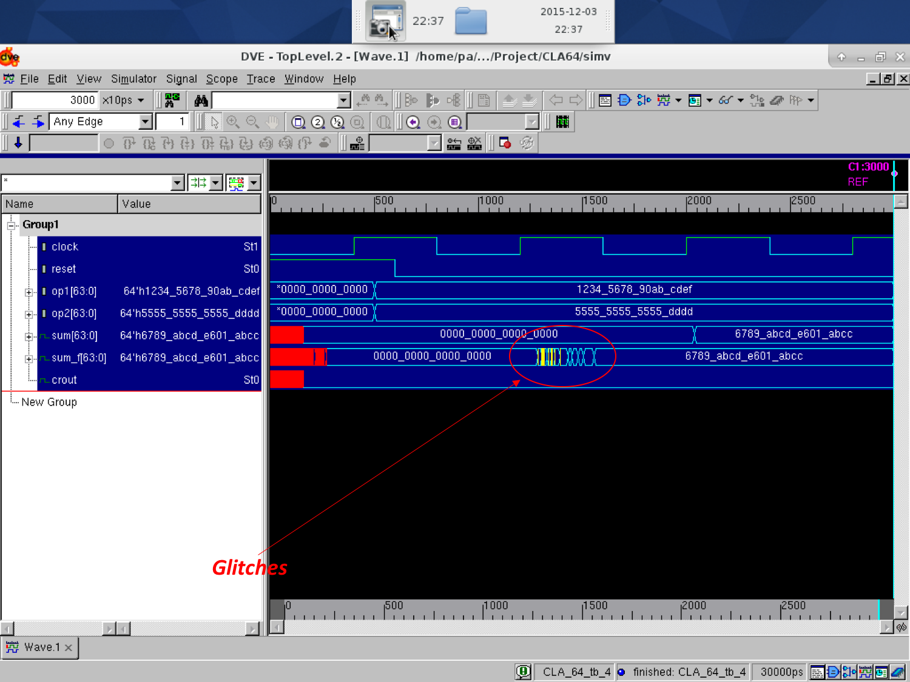

**Figure V.5b**: **Post-synthesis (dynamic) simulation waveform that contains test case #5 for CLA-2L**

**The Glitches or fluctuation in circuit because of immediate data change in operands and wire delay. Glitch/Delay is 2.23 ns**

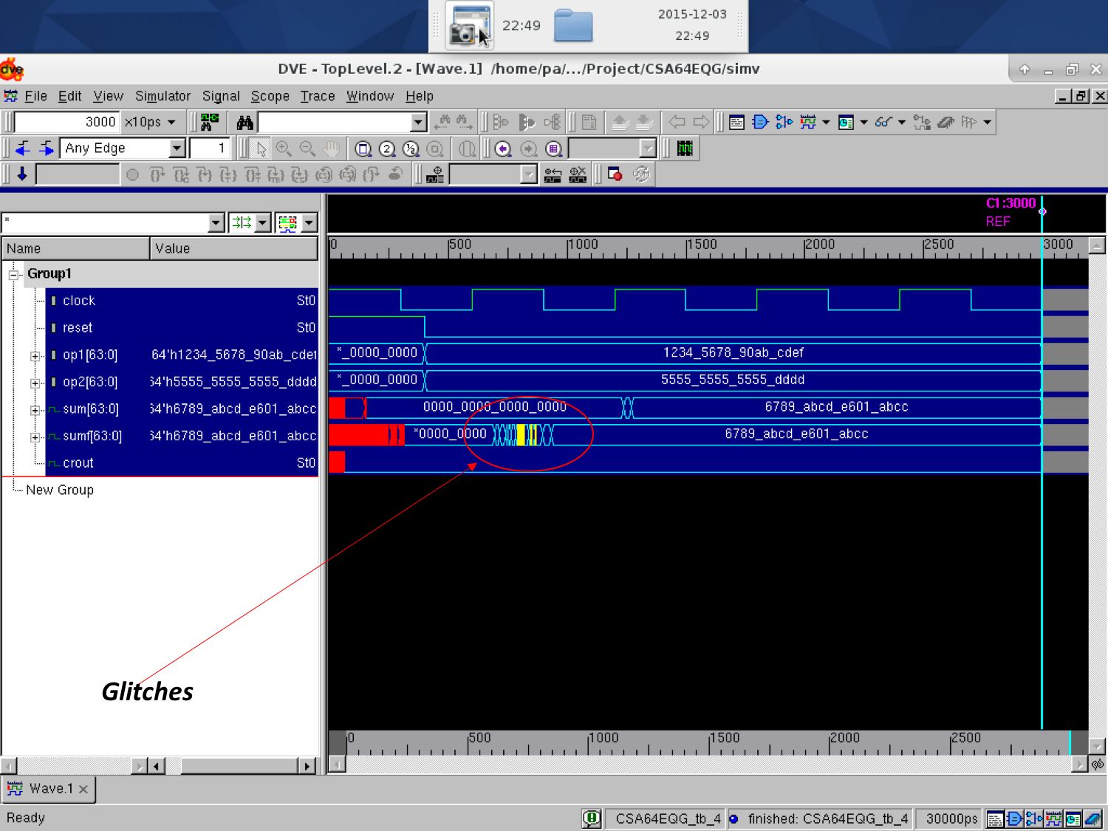

**Figure V.5c**: **Post-synthesis (dynamic) simulation waveform that contains test case #5 for CSA-EQG**

**The Glitches or fluctuation in circuit because of immediate data change in operands and wire delay. Glitch/Delay is 2.11 ns**

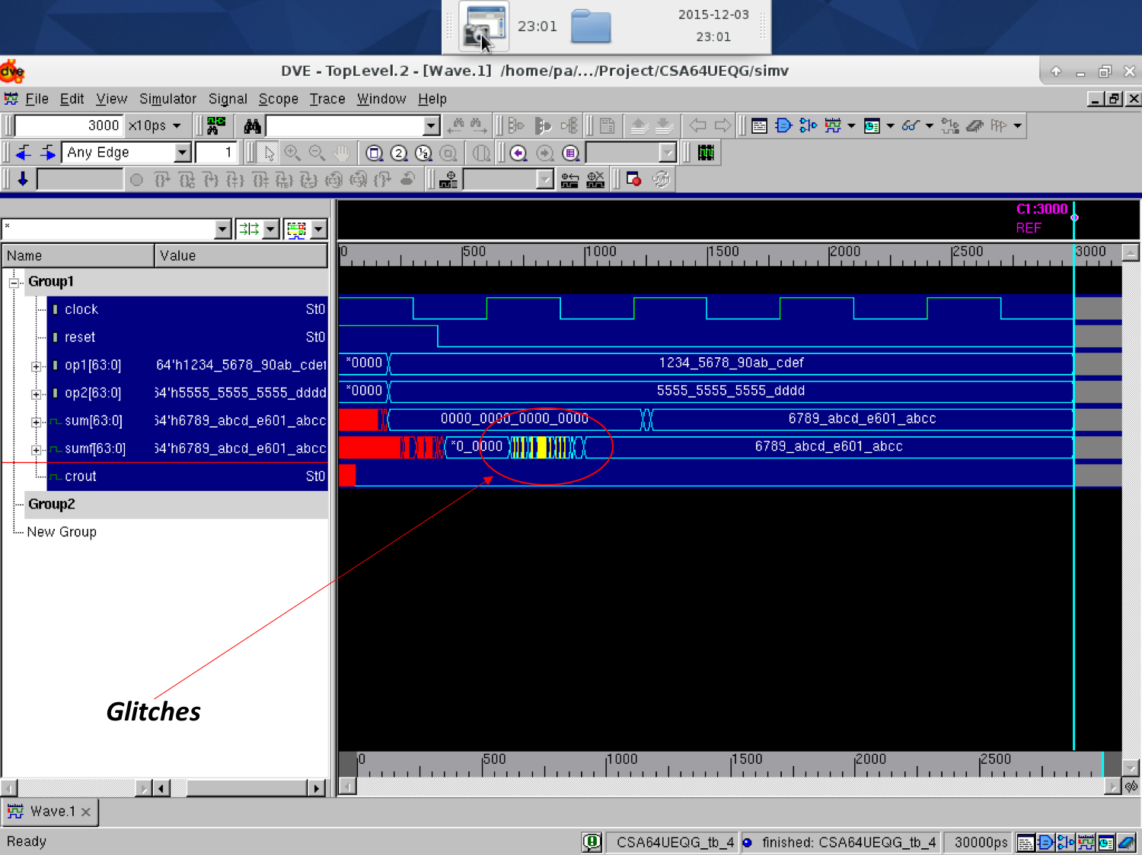

**Figure V.5d**: **Post-synthesis (dynamic) simulation waveform that contains test case #5 for CSA-UEQG**

**The Glitches or fluctuation in circuit because of immediate data change in operands and wire delay. Glitch/Delay is 2.5 ns**

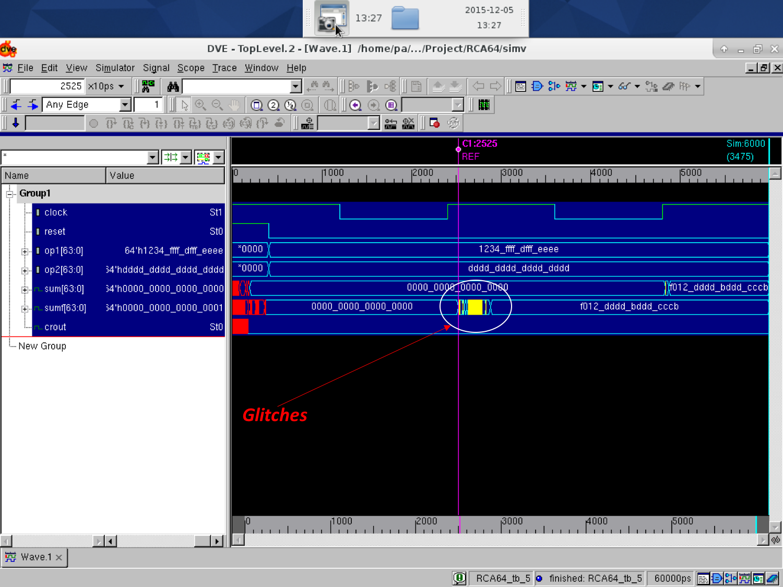

**Figure V.6a**: **Post-synthesis (dynamic) simulation waveform that contains test case #6 for RCA**

**The Glitches or fluctuation in circuit because of immediate data change in operands and wire delay. Glitch/Delay is 2.85 ns**

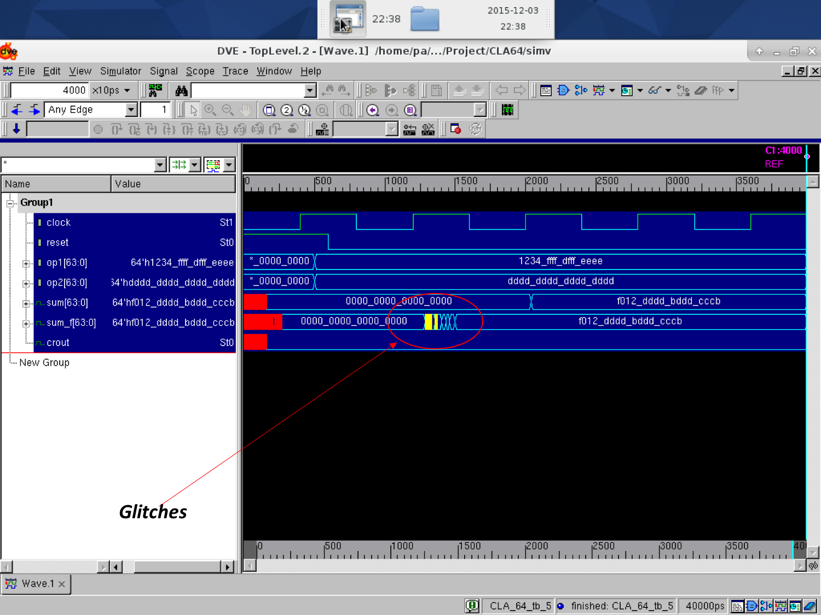

**Figure V.6b**: **Post-synthesis (dynamic) simulation waveform that contains test case #6 for CLA-2L**

**The Glitches or fluctuation in circuit because of immediate data change in operands and wire delay. Glitch/Delay is 2.13 ns**

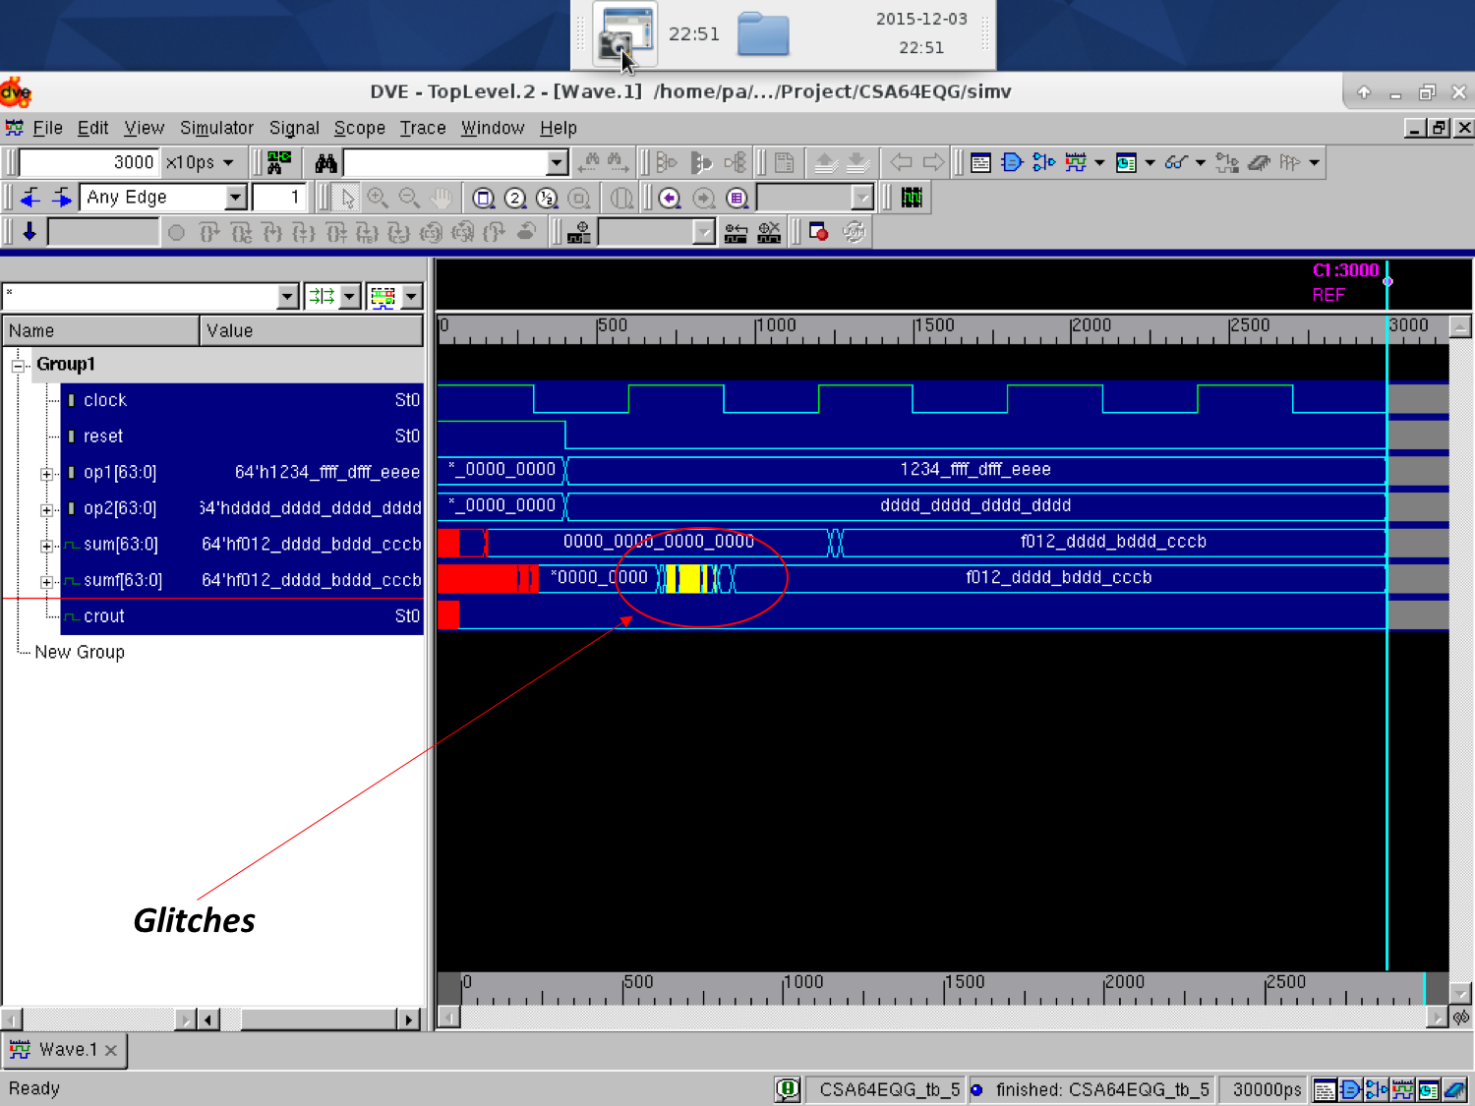

**Figure V.6c**: **Post-synthesis (dynamic) simulation waveform that contains test case #6 for CSA-EQG**

**The Glitches or fluctuation in circuit because of immediate data change in operands and wire delay. Glitch/Delay is 2.35 ns**

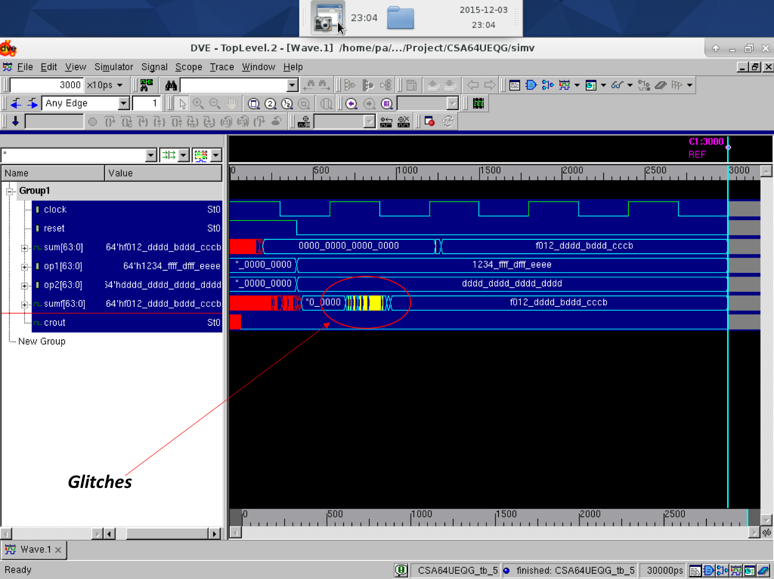

**Figure V.6d**: **Post-synthesis (dynamic) simulation waveform that contains test case #6 for CSA-UEQG**

**The Glitches or fluctuation in circuit because of immediate data change in operands and wire delay. Glitch/Delay is 2.70 ns**

From the post synthesis we got some delays in design that is because of gate delays and wire delays. To remove that glitches, we have to increase the clock period. Clock period will be more than half of time period i.e., **if time period is 8 ns then clock period must be around 5 ns.**

**VI. Conclusion**

After implementing and analyzing the different types of 64 bit adders, I observed that area of the circuit is inversely proportional to the time period. The power of the circuit is proportional to area of the circuit and inversely proportional to time period of the circuit. From analyzing the implementation, the carry select adder is fastest amongst all adders. Every adder has its own advantage. Ripple carry adder can be used for short bit length. Carry look ahead’s 2 level structure can be used for long bit length. Carry Select Adder has good performance in propagation delay compare other two 64 bit adders.

**Appendix A**

**A.1 Contents from EDA Tool Configurations and Setup Files**

VCS tool setup environment file content

setenv VCS_HOME /apps/synopsys/I-2014.03-2

source ${VCS_HOME}/bin/environ.csh

**A.2 Scripts and/or Commands Used for Simulation and Synthesis**

**RCA Synthesis Script**

Set link_library {/apps/toshiba/sjsu/synopsys/tc240c/tc240c.db_WCCOM25 /apps/synopsys/SYNTH/libraries/syn/dw02.sldb /apps/synopsys/SYNTH/libraries/syn/dw01.sldb}

Set_target_library {/apps/toshiba/sjsu/synopsys/tc240c/tc240c.db_WCCOM25}

read_verilog RCA64.v

current_design RCA64

check_design

create_clock clock -name clock -period 18.5600000

set_propagated_clock clock

set_clock_uncertainty 0.25 clock

set_propagated_clock clock

set_fix_hold [ get_clocks clock ]

compile -map_effort medium -incremental_mapping

update_timing

set_max_area 2500

report -cell

report_timing -max_paths 10

report_area

report_power

write -hierarchy -format verilog -output RCA64_1_nl.v

quit

**CLA-2L Synthesis.script**

set link_library {/apps/toshiba/sjsu/synopsys/tc240c/tc240c.db_WCCOM25 /apps/synopsys/SYNTH/libraries/syn/dw02.sldb /apps/synopsys/SYNTH/libraries/syn/dw01.sldb}

set target_library {/apps/toshiba/sjsu/synopsys/tc240c/tc240c.db_WCCOM25}

read_verilog {CLA4.v,CLA4_2.v,CLA16.v CLA16_2.v,CLA_64.v}

current_design CLA_64

check_design

create_clock clock -name clock -period 4.9500000

set_propagated_clock clock

set_clock_uncertainty 0.25 clock

set_propagated_clock clock

set_fix_hold [ get_clocks clock ]

compile -map_effort medium -incremental_mapping

update_timing

set_max_area 2500

report -cell

report_timing -max_paths 5

report_area

report_power

write -hierarchy -format verilog -output CLA_64_1_nl.v

quit

**CSAEQG Synthesis script**

set link_library {/apps/toshiba/sjsu/synopsys/tc240c/tc240c.db_WCCOM25 /apps/synopsys/SYNTH/libraries/syn/dw02.sldb /apps/synopsys/SYNTH/libraries/syn/dw01.sldb}

set target_library {/apps/toshiba/sjsu/synopsys/tc240c/tc240c.db_WCCOM25}

read_verilog {mux_carry.v,mux_sum.v,CSA64EQG.v}

current_design CSA64EQG

check_design

create_clock clock -name clock -period 5.200000

set_propagated_clock clock

set_clock_uncertainty 0.25 clock

set_propagated_clock clock

set_fix_hold [ get_clocks clock ]

compile -map_effort medium -incremental_mapping

update_timing

set_max_area 3100

report -cell

report_timing -max_paths 5

report_area

report_power

write -hierarchy -format verilog -output CSA64EQG_1_nl.v

quit

**CSAUEQG Synthesis.script**

set link_library {/apps/toshiba/sjsu/synopsys/tc240c/tc240c.db_WCCOM25 /apps/synopsys/SYNTH/libraries/syn/dw02.sldb /apps/synopsys/SYNTH/libraries/syn/dw01.sldb}

set target_library {/apps/toshiba/sjsu/synopsys/tc240c/tc240c.db_WCCOM25}

read_verilog {FA.v,CSA2.v,CSA3.v,CSA4.v,CSA5.v,CSA6.v,CSA7.v,CSA8.v,CSA9.v,CSA10.v,CSA11.v,CSA64UEQG.v}

current_design CSA64UEQG

check_design

create_clock clock -name clock -period 8.00000

set_propagated_clock clock

set_clock_uncertainty 0.25 clock

set_propagated_clock clock

set_fix_hold [ get_clocks clock ]

compile -map_effort medium -incremental_mapping

update_timing

set_max_area 3200

report -cell

report_timing -max_paths 5

report_area

report_power

write -hierarchy -format verilog -output CSA64UEQG_nl.v

quit

**Commands**

**Simulation command**

-        vcs +v2k –gui design_file.v tb.v

-        ./simv –gui

-        vcs +v2k –debug_all –gui –y /apps/toshiba/sjsu/verilog/tc240c +libext+.tsbvlibp tb.v design_netlist.v

-        dc_shell –f synthesis.script | tee log.txt

-        design_vision & DVE

**Appendix B**

**Completed Verilog Source Codes and Testbenches**

***Verilog Code RCA64***

`timescale 1ns/10ps

**Half Adder Block**

module HA(sum_ha, cout_ha, op1_ha, op2_ha);

output sum_ha, cout_ha;

input op1_ha, op2_ha;

assign sum_ha = op1_ha ^ op2_ha;

assign cout_ha = op1_ha & op2_ha;

endmodule

**1-bit full adder block**

module FA_1bit(sum_fa1, cout_fa1, op1_fa1, op2_fa1, cin);

output sum_fa1, cout_fa1;

input op1_fa1, op2_fa1, cin;

wire s1, c1, c2;

HA h1(.sum_ha(s1), .cout_ha(c1), .op1_ha(op1_fa1), .op2_ha(op2_fa1));

HA h2(.sum_ha(sum_fa1), .cout_ha(c2), .op1_ha(s1), .op2_ha(cin));

assign cout_fa1 = c1 | c2;

endmodule

**4-bit full adder 1st block**

module FA_4bit_1(sum_fa4, cout_fa4, op1_fa4, op2_fa4);

output [3:0]sum_fa4;

output cout_fa4;

input [3:0]op1_fa4;

input [3:0]op2_fa4;

wire cin1, cin2, cin3;

HA h1(.sum_ha(sum_fa4[0]), .cout_ha(cin1), .op1_ha(op1_fa4[0]), .op2_ha(op2_fa4[0]));

FA_1bit f1(.sum_fa1(sum_fa4[1]), .cout_fa1(cin2), .op1_fa1(op1_fa4[1]), .op2_fa1(op2_fa4[1]), .cin(cin1));

FA_1bit f2(.sum_fa1(sum_fa4[2]), .cout_fa1(cin3), .op1_fa1(op1_fa4[2]), .op2_fa1(op2_fa4[2]), .cin(cin2));

FA_1bit f3(.sum_fa1(sum_fa4[3]), .cout_fa1(cout_fa4), .op1_fa1(op1_fa4[3]), .op2_fa1(op2_fa4[3]), .cin(cin3));

endmodule

**4-bit full adder 2nd block**

module FA_4bit_2(sum_fa4_2, cout_fa4_2, op1_fa4_2, op2_fa4_2, cin_fa4);

output [3:0]sum_fa4_2;

output cout_fa4_2;

input [3:0]op1_fa4_2;

input [3:0]op2_fa4_2;

input cin_fa4;

wire cin1, cin2, cin3;

FA_1bit f1(.sum_fa1(sum_fa4_2[0]), .cout_fa1(cin1), .op1_fa1(op1_fa4_2[0]), .op2_fa1(op2_fa4_2[0]), .cin(cin_fa4));

FA_1bit f2(.sum_fa1(sum_fa4_2[1]), .cout_fa1(cin2), .op1_fa1(op1_fa4_2[1]), .op2_fa1(op2_fa4_2[1]), .cin(cin1));

FA_1bit f3(.sum_fa1(sum_fa4_2[2]), .cout_fa1(cin3), .op1_fa1(op1_fa4_2[2]), .op2_fa1(op2_fa4_2[2]), .cin(cin2));

FA_1bit f4(.sum_fa1(sum_fa4_2[3]), .cout_fa1(cout_fa4_2), .op1_fa1(op1_fa4_2[3]), .op2_fa1(op2_fa4_2[3]), .cin(cin3));

endmodule

**64 Bit Ripple Carry Adder**

module RCA64(sum, crout, op1, op2, clock, reset);

output [63:0]sum;

output crout;

input [63:0]op1;

input [63:0]op2;

input clock, reset;

reg [63:0]sum;

reg crout;

reg [63:0]op1f;

reg [63:0]op2f;

wire c1, c2, c3, c4, c5, c6, c7, c8, c9, c10, c11, c12, c13, c14, c15, croutf;

wire [63:0]sumf;

FA_4bit_1 F1(.sum_fa4(sumf[3:0]), .cout_fa4(c1), .op1_fa4(op1f[3:0]), .op2_fa4(op2f[3:0]));

FA_4bit_2 F2(.sum_fa4_2(sumf[7:4]), .cout_fa4_2(c2), .op1_fa4_2(op1f[7:4]), .op2_fa4_2(op2f[7:4]), .cin_fa4(c1));

FA_4bit_2 F3(.sum_fa4_2(sumf[11:8]), .cout_fa4_2(c3), .op1_fa4_2(op1f[11:8]), .op2_fa4_2(op2f[11:8]), .cin_fa4(c2));

FA_4bit_2 F4(.sum_fa4_2(sumf[15:12]), .cout_fa4_2(c4), .op1_fa4_2(op1f[15:12]), .op2_fa4_2(op2f[15:12]), .cin_fa4(c3));

FA_4bit_2 F5(.sum_fa4_2(sumf[19:16]), .cout_fa4_2(c5), .op1_fa4_2(op1f[19:16]), .op2_fa4_2(op2f[19:16]), .cin_fa4(c4));

FA_4bit_2 F6(.sum_fa4_2(sumf[23:20]), .cout_fa4_2(c6), .op1_fa4_2(op1f[23:20]), .op2_fa4_2(op2f[23:20]), .cin_fa4(c5));

FA_4bit_2 F7(.sum_fa4_2(sumf[27:24]), .cout_fa4_2(c7), .op1_fa4_2(op1f[27:24]), .op2_fa4_2(op2f[27:24]), .cin_fa4(c6));

FA_4bit_2 F8(.sum_fa4_2(sumf[31:28]), .cout_fa4_2(c8), .op1_fa4_2(op1f[31:28]), .op2_fa4_2(op2f[31:28]), .cin_fa4(c7));

FA_4bit_2 F9(.sum_fa4_2(sumf[35:32]), .cout_fa4_2(c9), .op1_fa4_2(op1f[35:32]), .op2_fa4_2(op2f[35:32]), .cin_fa4(c8));

FA_4bit_2 F10(.sum_fa4_2(sumf[39:36]), .cout_fa4_2(c10), .op1_fa4_2(op1f[39:36]), .op2_fa4_2(op2f[39:36]), .cin_fa4(c9));

FA_4bit_2 F11(.sum_fa4_2(sumf[43:40]), .cout_fa4_2(c11), .op1_fa4_2(op1f[43:40]), .op2_fa4_2(op2f[43:40]), .cin_fa4(c10));

FA_4bit_2 F12(.sum_fa4_2(sumf[47:44]), .cout_fa4_2(c12), .op1_fa4_2(op1f[47:44]), .op2_fa4_2(op2f[47:44]), .cin_fa4(c11));

FA_4bit_2 F13(.sum_fa4_2(sumf[51:48]), .cout_fa4_2(c13), .op1_fa4_2(op1f[51:48]), .op2_fa4_2(op2f[51:48]), .cin_fa4(c12));

FA_4bit_2 F14(.sum_fa4_2(sumf[55:52]), .cout_fa4_2(c14), .op1_fa4_2(op1f[55:52]), .op2_fa4_2(op2f[55:52]), .cin_fa4(c13));

FA_4bit_2 F15(.sum_fa4_2(sumf[59:56]), .cout_fa4_2(c15), .op1_fa4_2(op1f[59:56]), .op2_fa4_2(op2f[59:56]), .cin_fa4(c14));

FA_4bit_2 F16(.sum_fa4_2(sumf[63:60]), .cout_fa4_2(croutf), .op1_fa4_2(op1f[63:60]), .op2_fa4_2(op2f[63:60]), .cin_fa4(c15));

always @(posedge clock or posedge reset)

begin

if(reset == 1)

begin

op1f <= 64'b0;

op2f <= 64'b0;

sum <= 64'b0;

crout <= 64'b0;

end

else

begin

op1f <= op1;

$display ("op1f= %h",op1f);

op2f <= op2;

$display ("op2f= %h",op2f);

sum <= sumf;

$display ("sumf= %h",sumf);

crout <= croutf;

$display ("croutf= %h",croutf);

end

end

endmodule

***Testbench RCA64***

**CASE #1**

`timescale 1 ns/ 10 ps

module RCA64_tb();

reg [63:0]op1;

reg [63:0]op2;

reg clock;

reg reset;

wire [63:0]sum;

wire crout;

RCA64 A (sum,crout,op1,op2,clock,reset);

initial begin

op1= 64'b0;

op2= 64'b0;

clock= 1'b1;

#4;

op1= 64'hf20f_ffff_ffff_ffff;

op2= 64'hffff_ffff_ffff_ff50;

end

initial begin

reset= 1'b1;

#4;

reset= 1'b0;

end

initial begin

forever #12 clock=~clock;

end

initial begin

#60;

$finish;

end

initial begin

$dumpfile("RCA64.vcd");

$dumpvars(0,RCA64_tb);

end

endmodule

**CASE #2**

`timescale 1 ns/ 10 ps

module RCA64_tb_1();

reg [63:0]op1;

reg [63:0]op2;

reg clock;

reg reset;

wire [63:0]sum;

wire crout;

RCA64 A (sum,crout,op1,op2,clock,reset);

initial begin

op1= 64'b0;

op2= 64'b0;

clock= 1'b1;

#4;

op1= 64'h1010_1010_1199_ffff;

op2= 64'habcd_1100_1100_dddd;

end

initial begin

reset= 1'b1;

#4;

reset= 1'b0;

end

initial begin

forever #12 clock=~clock;

end

initial begin

#60;

$finish;

end

initial begin

$dumpfile("RCA64_1.vcd");

$dumpvars(0,RCA64_tb_1);

end

endmodule

**CASE #3**

`timescale 1 ns/ 10 ps

module RCA64_tb_2();

reg [63:0]op1;

reg [63:0]op2;

reg clock;

reg reset;

wire [63:0]sum;

wire crout;

RCA64 A (sum,crout,op1,op2,clock,reset);

initial begin

op1= 64'b0;

op2= 64'b0;

clock= 1'b1;

#4;

op1= 64'hffff_ffff_ffff_ffff;

op2= 64'heeee_dddd_cccc_ffff;

end

initial begin

reset= 1'b1;

#4;

reset= 1'b0;

end

initial begin

forever #12 clock=~clock;

end

initial begin

#60;

$finish;

end

initial begin

$dumpfile("RCA64_2.vcd");

$dumpvars(0,RCA64_tb_2);

end

endmodule

**CASE #4**

`timescale 1 ns/ 10 ps

module RCA64_tb_3();

reg [63:0]op1;

reg [63:0]op2;

reg clock;

reg reset;

wire [63:0]sum;

wire crout;

RCA64 A (sum,crout,op1,op2,clock,reset);

initial begin

op1= 64'b0;

op2= 64'b0;

clock= 1'b1;

#4;

op1= 64'hbbbb_cdcd_aaaa_1111;

op2= 64'hffff_ffff_ffff_dddd;

end

initial begin

reset= 1'b1;

#4;

reset= 1'b0;

end

initial begin

forever #12 clock=~clock;

end

initial begin

#60;

$finish;

end

initial begin

$dumpfile("RCA64_3.vcd");

$dumpvars(0,RCA64_tb_3);

end

endmodule

**CASE #5**

`timescale 1 ns/ 10 ps

module RCA64_tb_4();

reg [63:0]op1;

reg [63:0]op2;

reg clock;

reg reset;

wire [63:0]sum;

wire crout;

RCA64 A (sum,crout,op1,op2,clock,reset);

initial begin

op1= 64'b0;

op2= 64'b0;

clock= 1'b1;

#4;

op1= 64'h0000_0000_1234_5678;

op2= 64'h0000_0000_90ab_cdef;

end

initial begin

reset= 1'b1;

#4;

reset= 1'b0;

end

initial begin

forever #12 clock=~clock;

end

initial begin

#60;

$finish;

end

initial begin

$dumpfile("RCA64_4.vcd");

$dumpvars(0,RCA64_tb_4);

end

endmodule

**CASE #6**

`timescale 1 ns/ 10 ps

module RCA64_tb_5();

reg [63:0]op1;

reg [63:0]op2;

reg clock;

reg reset;

wire [63:0]sum;

wire crout;

RCA64 A (sum,crout,op1,op2,clock,reset);

initial begin

op1= 64'b0;

op2= 64'b0;

clock= 1'b1;

#4;

op1= 64'h1234_ffff_dfff_eeee;

op2= 64'hdddd_dddd_dddd_dddd;

end

initial begin

reset= 1'b1;

#4;

reset= 1'b0;

end

initial begin

forever #12 clock=~clock;

end

initial begin

#60;

$finish;

end

initial begin

$dumpfile("RCA64_5.vcd");

$dumpvars(0,RCA64_tb_5);

end

endmodule

***Verilog Code CLA64***

**4-bit block**

`timescale 1ns/10ps

module CLA4(sum,crout,P1,G1,op1,op2);

output [3:0]sum;

output crout;

output P1,G1;

input [3:0] op1,op2;

wire [3:0]G,P,C;

assign G = op1 & op2; //Generate

assign P = op1 ^ op2; //Propagate

assign C[0] = 0;

assign C[1] = G[0] | (P[0] & C[0]);

assign C[2] = G[1] | (P[1] & G[0]) | (P[1] & P[0] & C[0]);

assign C[3] = G[2] | (P[2] & G[1]) | (P[2] & P[1] & G[0]) | (P[2] & P[1] & P[0] & C[0]);

assign crout = G[3] | (P[3] & G[2]) | (P[3] & P[2] & G[1]) | (P[3] & P[2] & P[1] & G[0]) |(P[3] & P[2] & P[1] & P[0] & C[0]);

assign sum = P ^ C;

assign P1 = P[3] & P[2] & P[1] & P[0];

assign G1 = G[3] | (P[3] & G[2]) | (P[3] & P[2] & G[1]) | (P[3] & P[2] & P[1] & G[0]);

endmodule

**2nd 4-bit block**

`timescale 1ns/10ps

module CLA4_2(sum,crout,P2,G2,op1,op2,Cin);

output [3:0] sum;

output crout;

output P2,G2;

input [3:0]op1,op2;

input Cin;

wire [3:0]G,P,C;

assign G = op1 & op2; //Generate

assign P = op1 ^ op2; //Propagate

assign C[0] = Cin;

assign C[1] = G[0] | (P[0] & C[0]);

assign C[2] = G[1] | (P[1] & G[0]) | (P[1] & P[0] & C[0]);

assign C[3] = G[2] | (P[2] & G[1]) | (P[2] & P[1] & G[0]) | (P[2] & P[1] & P[0] & C[0]);

assign crout = G[3] | (P[3] & G[2]) | (P[3] & P[2] & G[1]) | (P[3] & P[2] & P[1] & G[0]) |(P[3] & P[2] & P[1] & P[0] & C[0]);

assign sum = P ^ C;

assign P2 = P[3] & P[2] & P[1] & P[0];

assign G2 = G[3] | (P[3] & G[2]) | (P[3] & P[2] & G[1]) | (P[3] & P[2] & P[1] & G[0]);

endmodule

**1st 16-bit block**

`timescale 1ns/10ps

module CLA16(sum_4,crout,op1_4,op2_4);

output [15:0]sum_4;

output crout;

input [15:0]op1_4,op2_4;

wire [15:0]sum_4;

wire p1,p2,p3;

wire [3:0]G,P;

CLA4 C1(.sum(sum_4[3:0]),.crout(p1),.P1(P[0]),.G1(G[0]),.op1(op1_4[3:0]),.op2(op2_4[3:0]));

CLA4_2 C2(.sum(sum_4[7:4]),.crout(p2),.P2(P[1]),.G2(G[1]),.op1(op1_4[7:4]),.op2(op2_4[7:4]),.Cin(p1));

CLA4_2 C3(.sum(sum_4[11:8]),.crout(p3),.P2(P[2]),.G2(G[2]),.op1(op1_4[11:8]),.op2(op2_4[11:8]),.Cin(p2));

CLA4_2 C4(.sum(sum_4[15:12]),.crout(),.P2(P[3]),.G2(G[3]),.op1(op1_4[15:12]),.op2(op2_4[15:12]),.Cin(p3));

assign crout = G[3] | (G[2] & P[3]) | (G[1] & P[2] & P[3]) | (G[0] & P[1] & P[2] & P[3]);

endmodule

**2nd 16-bit block**

`timescale 1ns/10ps

module CLA16_2(sum_16,crout_16,op1_16,op2_16,Cin);

output [15:0]sum_16;

output crout_16;

input [15:0]op1_16,op2_16;

input Cin;

wire p1,p2,p3;

wire [3:0]G,P;

CLA4_2 A1(.sum(sum_16[3:0]),.crout(p1), .P2(P[0]), .G2(G[0]), .op1(op1_16[3:0]),.op2(op2_16[3:0]), .Cin(Cin));

CLA4_2 A2(.sum(sum_16[7:4]),.crout(p2), .P2(P[1]),.G2(G[1]), .op1(op1_16[7:4]), .op2(op2_16[7:4]),.Cin(p1));

CLA4_2 A3(.sum(sum_16[11:8]),.crout(p3), .P2(P[2]),.G2(G[2]), .op1(op1_16[11:8]), .op2(op2_16[11:8]),.Cin(p2));

CLA4_2 A4(.sum(sum_16[15:12]),.crout(), .P2(P[3]),.G2(G[3]), .op1(op1_16[15:12]), .op2(op2_16[15:12]),.Cin(p3));

assign crout_16 = G[3] | (G[2] & P[3]) | (G[1] & P[2] & P[3]) | (G[0] & P[1] & P[2] & P[3]) | (Cin & P[0] & P[1] & P[2] & P[3]) ;

endmodule

**64 bit CLA**

`timescale 1ns/10ps

module CLA_64(sum, crout, op1, op2, clock, reset);

output [63:0]sum;

output crout;

input [63:0]op1;

input [63:0]op2;

input clock, reset;

reg [63:0]sum;

reg crout;

reg [63:0]op1f;

reg [63:0]op2f;

wire c1, c2, c3, croutf;

wire [63:0]sumf;

CLA16 A1(.sum_4(sum_f[15:0]), .crout(c1), .op1_4(op1_f[15:0]), .op2_4(op2_f[15:0]));

CLA16_2 A2(.sum_16(sum_f[31:16]), .crout_16(c2), .op1_16(op1_f[31:16]), .op2_16(op2_f[31:16]), .Cin(c1));

CLA16_2 A3(.sum_16(sum_f[47:32]), .crout_16(c3), .op1_16(op1_f[47:32]), .op2_16(op2_f[47:32]), .Cin(c2));

CLA16_2 A4(.sum_16(sum_f[63:48]), .crout_16(croutf), .op1_16(op1_f[63:48]), .op2_16(op2_f[63:48]), .Cin(c3));

always @(posedge clock or posedge reset)

begin

if(reset == 1)

begin

op1f <= 64'b0;

op2f <= 64'b0;

sum <= 64'b0;

crout <= 64'b0;

end

else

begin

op1f <= op1;

$display ("op1f= %h",op1f);

op2f <= op2;

$display ("op2f= %h",op2f);

sum <= sumf;

$display ("sumf= %h",sumf);

crout <= croutf;

$display ("croutf= %h",croutf);

end

end

endmodule

***Testbench CLA64***

**CASE #1**

`timescale 1 ns/ 10 ps

module CLA_64_tb();

reg [63:0]op1;

reg [63:0]op2;

reg clock;

reg reset;

wire [63:0]sum;

wire crout;

CLA_64 A (sum,crout,op1,op2,clock,reset);

initial begin

op1= 64'b0;

op2= 64'b0;

clock= 1'b0;

#5;

op1= 64'hf20f_ffff_ffff_ffff;

op2= 64'hffff_ffff_ffff_ff50;

end

initial begin

reset= 1'b1;

#6;

reset= 1'b0;

end

initial begin

forever #4 clock=~clock;

end

initial begin

#30;

$finish;

end

initial begin

$dumpfile("CLA_64.vcd");

$dumpvars(0,CLA_64_tb);

end

endmodule

**CASE #2**

`timescale 1 ns/ 10 ps

module CLA_64_tb_1();

reg [63:0]op1;

reg [63:0]op2;

reg clock;

reg reset;

wire [63:0]sum;

wire crout;

CLA_64 A (sum,crout,op1,op2,clock,reset);

initial begin

op1= 64'b0;

op2= 64'b0;

clock= 1'b0;

#5;

op1= 64'h1010_1010_1199_ffff;

op2= 64'habcd_1100_1100_dddd;

end

initial begin

reset= 1'b1;

#6;

reset= 1'b0;

end

initial begin

forever #4 clock=~clock;

end

initial begin

#30;

$finish;

end

initial begin

$dumpfile("CLA_64_1.vcd");

$dumpvars(0,CLA_64_tb_1);

end

endmodule

**CASE #3**

`timescale 1 ns/ 10 ps

module CLA_64_tb_2();

reg [63:0]op1;

reg [63:0]op2;

reg clock;

reg reset;

wire [63:0]sum;

wire crout;

CLA_64 A (sum,crout,op1,op2,clock,reset);

initial begin

op1= 64'b0;

op2= 64'b0;

clock= 1'b0;

#5;

op1= 64'hffff_ffff_ffff_ffff;

op2= 64'heeee_dddd_cccc_ffff;

end

initial begin

reset= 1'b1;

#6;

reset= 1'b0;

end

initial begin

forever #4 clock=~clock;

end

initial begin

#30;

$finish;

end

initial begin

$dumpfile("CLA_64_2.vcd");

$dumpvars(0,CLA_64_tb_2);

end

endmodule

**CASE #4**

`timescale 1 ns/ 10 ps

module CLA_64_tb_3();

reg [63:0]op1;

reg [63:0]op2;

reg clock;

reg reset;

wire [63:0]sum;

wire crout;

CLA_64 A (sum,crout,op1,op2,clock,reset);

initial begin

op1= 64'b0;

op2= 64'b0;

clock= 1'b0;

#5;

op1= 64'hbbbb_cdcd_aaaa_1111;

op2= 64'hffff_ffff_ffff_dddd;

end

initial begin

reset= 1'b1;

#6;

reset= 1'b0;

end

initial begin

forever #4 clock=~clock;

end

initial begin

#30;

$finish;

end

initial begin

$dumpfile("CLA_64_3.vcd");

$dumpvars(0,CLA_64_tb_3);

end

endmodule

**CASE #5**

`timescale 1 ns/ 10 ps

module CLA_64_tb_4();

reg [63:0]op1;

reg [63:0]op2;

reg clock;

reg reset;

wire [63:0]sum;

wire crout;

CLA_64 A (sum,crout,op1,op2,clock,reset);

initial begin

op1= 64'b0;

op2= 64'b0;

clock= 1'b0;

#5;

op1= 64'h1234_5678_90ab_cdef;

op2= 64'h5555_5555_5555_dddd;

end

initial begin

reset= 1'b1;

#6;

reset= 1'b0;

end

initial begin

forever #4 clock=~clock;

end

initial begin

#30;

$finish;

end

initial begin

$dumpfile("CLA_64_4.vcd");

$dumpvars(0,CLA_64_tb_4);

end

endmodule

**CASE #6**

`timescale 1 ns/ 10 ps

module CLA_64_tb_5();

reg [63:0]op1;

reg [63:0]op2;

reg clock;

reg reset;

wire [63:0]sum;

wire crout;

CLA_64 A (sum,crout,op1,op2,clock,reset);

initial begin

op1= 64'b0;

op2= 64'b0;

clock= 1'b0;

#5;

op1= 64'h1234_ffff_dfff_eeee;

op2= 64'hdddd_dddd_dddd_dddd;

end

initial begin

reset= 1'b1;

#6;

reset= 1'b0;

end

initial begin

forever #4 clock=~clock;

end

initial begin

#40;

$finish;

end

initial begin

$dumpfile("CLA_64_5.vcd");

$dumpvars(0,CLA_64_tb_5);

end

endmodule

***Verilog Code CSA64 Equal Group***

`timescale 1ns/10ps

**1 bit full adder**

module FA(sum_fa, cout_fa, op1_fa, op2_fa, cin);

output sum_fa, cout_fa;

input op1_fa, op2_fa, cin;

assign sum_fa = op1_fa ^ op2_fa ^ cin;

assign cout_fa = ((op1_fa ^ op2_fa) & cin) | (op1_fa & op2_fa);

endmodule

**4 bit CSA**

module CSA4(sum_4, cout_4, op1_4, op2_4, cin_4);

output [3:0]sum_4;

output cout_4;

input [3:0]op1_4,op2_4;

input cin_4;

wire [3:0]sum0,sum1;

wire cout0, cout1;

wire c1, c2, c3, c4, c5, c6;

//sum for carry 0

FA f1(.sum_fa(sum0[0]), .cout_fa(c1), .op1_fa(op1_4[0]), .op2_fa(op2_4[0]), .cin(1'b0));

FA f2(.sum_fa(sum0[1]), .cout_fa(c2), .op1_fa(op1_4[1]), .op2_fa(op2_4[1]), .cin(c1));

FA f3(.sum_fa(sum0[2]), .cout_fa(c3), .op1_fa(op1_4[2]), .op2_fa(op2_4[2]), .cin(c2));

FA f4(.sum_fa(sum0[3]), .cout_fa(cout0), .op1_fa(op1_4[3]), .op2_fa(op2_4[3]), .cin(c3));

//sum for carry 1

FA f5(.sum_fa(sum1[0]), .cout_fa(c4), .op1_fa(op1_4[0]), .op2_fa(op2_4[0]), .cin(1'b1));

FA f6(.sum_fa(sum1[1]), .cout_fa(c5), .op1_fa(op1_4[1]), .op2_fa(op2_4[1]), .cin(c4));

FA f7(.sum_fa(sum1[2]), .cout_fa(c6), .op1_fa(op1_4[2]), .op2_fa(op2_4[2]), .cin(c5));

FA f8(.sum_fa(sum1[3]), .cout_fa(cout1), .op1_fa(op1_4[3]), .op2_fa(op2_4[3]), .cin(c6));

mux_sum m1(.sum(sum_4), .sum0(sum0), .sum1(sum1), .Cin(cin_4));

mux_carry m2(.cout(cout_4), .cout0(cout0), .cout1(cout1), .Cin(cin_4));

endmodule

**64 bit CSA**

module CSA64EQG(sum, crout, op1, op2, clock, reset);

output [63:0]sum;

output crout;

input [63:0]op1;

input [63:0]op2;

input clock, reset;

reg [63:0]sum;

reg crout;

reg [63:0]op1f;

reg [63:0]op2f;

wire [63:0]sumf;

wire C1, C2, C3, C4, C5, C6, C7, C8, C9, C10, C11, C12, C13, C14, C15, croutf;

assign CIN = 0;

CSA4 s1(.sum_4(sumf[3:0]), .cout_4(C1), .op1_4(op1f[3:0]), .op2_4(op2f[3:0]), .cin_4(CIN));

CSA4 s2(.sum_4(sumf[7:4]), .cout_4(C2), .op1_4(op1f[7:4]), .op2_4(op2f[7:4]), .cin_4(C1));

CSA4 s3(.sum_4(sumf[11:8]), .cout_4(C3), .op1_4(op1f[11:8]), .op2_4(op2f[11:8]), .cin_4(C2));

CSA4 s4(.sum_4(sumf[15:12]), .cout_4(C4), .op1_4(op1f[15:12]), .op2_4(op2f[15:12]), .cin_4(C3));

CSA4 s5(.sum_4(sumf[19:16]), .cout_4(C5), .op1_4(op1f[19:16]), .op2_4(op2f[19:16]), .cin_4(C4));

CSA4 s6(.sum_4(sumf[23:20]), .cout_4(C6), .op1_4(op1f[23:20]), .op2_4(op2f[23:20]), .cin_4(C5));

CSA4 s7(.sum_4(sumf[27:24]), .cout_4(C7), .op1_4(op1f[27:24]), .op2_4(op2f[27:24]), .cin_4(C6));

CSA4 s8(.sum_4(sumf[31:28]), .cout_4(C8), .op1_4(op1f[31:28]), .op2_4(op2f[31:28]), .cin_4(C7));

CSA4 s9(.sum_4(sumf[35:32]), .cout_4(C9), .op1_4(op1f[35:32]), .op2_4(op2f[35:32]), .cin_4(C8));

CSA4 s10(.sum_4(sumf[39:36]), .cout_4(C10), .op1_4(op1f[39:36]), .op2_4(op2f[39:36]), .cin_4(C9));

CSA4 s11(.sum_4(sumf[43:40]), .cout_4(C11), .op1_4(op1f[43:40]), .op2_4(op2f[43:40]), .cin_4(C10));

CSA4 s12(.sum_4(sumf[47:44]), .cout_4(C12), .op1_4(op1f[47:44]), .op2_4(op2f[47:44]), .cin_4(C11));

CSA4 s13(.sum_4(sumf[51:48]), .cout_4(C13), .op1_4(op1f[51:48]), .op2_4(op2f[51:48]), .cin_4(C12));

CSA4 s14(.sum_4(sumf[55:52]), .cout_4(C14), .op1_4(op1f[55:52]), .op2_4(op2f[55:52]), .cin_4(C13));

CSA4 s15(.sum_4(sumf[59:56]), .cout_4(C15), .op1_4(op1f[59:56]), .op2_4(op2f[59:56]), .cin_4(C14));

CSA4 s16(.sum_4(sumf[63:60]), .cout_4(croutf), .op1_4(op1f[63:60]), .op2_4(op2f[63:60]), .cin_4(C15));

always @(posedge clock or posedge reset)

begin

if(reset == 1)

begin

op1f <= 64'b0;

op2f <= 64'b0;

sum <= 64'b0;

crout <= 64'b0;

end

else

begin

op1f <= op1;

$display ("op1f= %h",op1f);

op2f <= op2;

$display ("op2f= %h",op2f);

sum <= sumf;

$display ("sumf= %h",sumf);

crout <= croutf;

$display ("croutf= %h",croutf);

end

end

endmodule

**Carry Mux**

`timescale 1ns/10ps

//mux for carry

module mux_carry(cout, cout0, cout1, Cin);

output cout;

input cout0, cout1, Cin;

assign cout = Cin ? cout1 : cout0;

endmodule

**Sum Mux**

`timescale 1ns/10ps

//mux for sum;

module mux_sum(sum, sum0, sum1, Cin);

output [3:0]sum;

input [3:0]sum0, sum1;

input Cin;

assign sum = Cin ? sum1 : sum0;

endmodule

***Testbench CSA64 EQG***

**CASE #1**

`timescale 1 ns/ 10 ps

module CSA64EQG_tb();

reg [63:0]op1;

reg [63:0]op2;

reg clock;

reg reset;

wire [63:0]sum;

wire crout;

CSA64EQG A (sum,crout,op1,op2,clock,reset);

initial begin

op1= 64'b0;

op2= 64'b0;

clock= 1'b1;

#4;

op1= 64'hf20f_ffff_ffff_ffff;

op2= 64'hffff_ffff_ffff_ff50;

end

initial begin

reset= 1'b1;

#4;

reset= 1'b0;

end

initial begin

forever #3 clock=~clock;

end

initial begin

#30;

$finish;

end

initial begin

$dumpfile("CSA64EQG.vcd");

$dumpvars(0,CSA64EQG_tb);

end

endmodule

**CASE #2**

`timescale 1 ns/ 10 ps

module CSA64EQG_tb_1();

reg [63:0]op1;

reg [63:0]op2;

reg clock;

reg reset;

wire [63:0]sum;

wire crout;

CSA64EQG A (sum,crout,op1,op2,clock,reset);

initial begin

op1= 64'b0;

op2= 64'b0;

clock= 1'b1;

#4;

op1= 64'h1010_1010_1199_ffff;

op2= 64'habcd_1100_1100_dddd;

end

initial begin

reset= 1'b1;

#4;

reset= 1'b0;

end

initial begin

forever #3 clock=~clock;

end

initial begin

#30;

$finish;

end

initial begin

$dumpfile("CSA64EQG_1.vcd");

$dumpvars(0,CSA64EQG_tb_1);

end

endmodule

**CASE #3**

`timescale 1 ns/ 10 ps

module CSA64EQG_tb_2();

reg [63:0]op1;

reg [63:0]op2;

reg clock;

reg reset;

wire [63:0]sum;

wire crout;

CSA64EQG A (sum,crout,op1,op2,clock,reset);

initial begin

op1= 64'b0;

op2= 64'b0;

clock= 1'b1;

#4;

op1= 64'hffff_ffff_ffff_ffff;

op2= 64'heeee_dddd_cccc_ffff;

end

initial begin

reset= 1'b1;

#1;

reset= 1'b0;

end

initial begin

forever #3 clock=~clock;

end

initial begin

#30;

$finish;

end

initial begin

$dumpfile("CSA64EQG_2.vcd");

$dumpvars(0,CSA64EQG_tb_2);

end

endmodule

**CASE #4**

`timescale 1 ns/ 10 ps

module CSA64EQG_tb_3();

reg [63:0]op1;

reg [63:0]op2;

reg clock;

reg reset;

wire [63:0]sum;

wire crout;

CSA64EQG A (sum,crout,op1,op2,clock,reset);

initial begin

op1= 64'b0;

op2= 64'b0;

clock= 1'b1;

#4;

op1= 64'hbbbb_cdcd_aaaa_1111;

op2= 64'hffff_ffff_ffff_dddd;

end

initial begin

reset= 1'b1;

#4;

reset= 1'b0;

end

initial begin

forever #3 clock=~clock;

end

initial begin

#30;

$finish;

end

initial begin

$dumpfile("CSA64EQG_3.vcd");

$dumpvars(0,CSA64EQG_tb_3);

end

endmodule

**CASE #5**

`timescale 1 ns/ 10 ps

module CSA64EQG_tb_4();

reg [63:0]op1;

reg [63:0]op2;

reg clock;

reg reset;

wire [63:0]sum;

wire crout;

CSA64EQG A (sum,crout,op1,op2,clock,reset);

initial begin

op1= 64'b0;

op2= 64'b0;

clock= 1'b1;

#4;

op1= 64'h1234_5678_90ab_cdef;

op2= 64'h5555_5555_5555_dddd;

end

initial begin

reset= 1'b1;

#4;

reset= 1'b0;

end

initial begin

forever #3 clock=~clock;

end

initial begin

#30;

$finish;

end

initial begin

$dumpfile("CSA64EQG_4.vcd");

$dumpvars(0,CSA64EQG_tb_4);

end

endmodule

**CASE #6**

`timescale 1 ns/ 10 ps

module CSA64EQG_tb_5();

reg [63:0]op1;

reg [63:0]op2;

reg clock;

reg reset;

wire [63:0]sum;

wire crout;

CSA64EQG A (sum,crout,op1,op2,clock,reset);

initial begin

op1= 64'b0;

op2= 64'b0;

clock= 1'b1;

#4;

op1= 64'h1234_ffff_dfff_eeee;

op2= 64'hdddd_dddd_dddd_dddd;

end

initial begin

reset= 1'b1;

#4;

reset= 1'b0;

end

initial begin

forever #3 clock=~clock;

end

initial begin

#30;

$finish;

end

initial begin

$dumpfile("CSA64EQG_5.vcd");

$dumpvars(0,CSA64EQG_tb_5);

end

endmodule

***Verilog code of CSA 64 Unequal Group***

**64 bit Unequal Group Carry Select Adder**

`timescale 1ns/10ps

module CSA64UEQG(sum, crout, op1, op2, clock, reset);

output [63:0]sum;

output crout;

input [63:0]op1;

input [63:0]op2;

input clock, reset;

reg [63:0]sum;

reg crout;

reg [63:0]op1f;

reg [63:0]op2f;

wire [63:0]sumf;

wire C1, C2, C3, C4, C5, C6, croutf;

assign Cin = 0;

CSA4 P1(.sum_4(sumf[3:0]), .cout_4(C1), .op1_4(op1f[3:0]), .op2_4(op2f[3:0]), .cin_4(Cin));

CSA4 P2(.sum_4(sumf[7:4]), .cout_4(C2), .op1_4(op1f[7:4]), .op2_4(op2f[7:4]), .cin_4(C1));

CSA5 P3(.s(sumf[12:8]), .co(C3), .a(op1f[12:8]), .b(op2f[12:8]), .in(C2));

CSA6 P4(.s6(sumf[18:13]), .co6(C4), .a6(op1f[18:13]), .b6(op2f[18:13]), .in6(C3));

CSA7 P5(.s7(sumf[25:19]), .co7(C5), .a7(op1f[25:19]), .b7(op2f[25:19]), .in7(C4));

CSA8 P6(.s8(sumf[33:26]), .co8(C6), .a8(op1f[33:26]), .b8(op2f[33:26]), .in8(C5));

CSA9 P7(.s9(sumf[42:34]), .co9(C7), .a9(op1f[42:34]), .b9(op2f[42:34]), .in9(C6));

CSA10 P8(.s10(sumf[52:43]), .co10(C8), .a10(op1f[52:43]), .b10(op2f[52:43]), .in10(C7));

CSA11 P9(.s11(sumf[63:53]), .co11(croutf), .a11(op1f[63:53]), .b11(op2f[63:53]), .in11(C8));

always @(posedge clock or posedge reset)

begin

if(reset == 1)

begin

op1f <= 64'b0;

op2f <= 64'b0;

sum <= 64'b0;

crout <= 64'b0;

end

else

begin

op1f <= op1;

$display ("op1f= %h",op1f);

op2f <= op2;

$display ("op2f= %h",op2f);

sum <= sumf;

$display ("sumf= %h",sumf);

crout <= croutf;

$display ("croutf= %h",croutf);

end

end

endmodule

**Full Adder**

`timescale 1ns/10ps

//1 bit fulladder

module FA(sum_fa, cout_fa, op1_fa, op2_fa, cin);

output sum_fa, cout_fa;

input op1_fa, op2_fa, cin;

assign sum_fa = op1_fa ^ op2_fa ^ cin;

assign cout_fa = ((op1_fa ^ op2_fa) & cin) | (op1_fa & op2_fa);

endmodule

**2 bit CSA**

`timescale 1ns/10ps

module CSA2(sum_2, cout_2, op1_2, op2_2, cin_2);

output [1:0]sum_2;

output cout_2;

input [1:0]op1_2,op2_2;

input cin_2;

wire [1:0]sum0,sum1;

wire cout0, cout1;

wire crout1, crout2;

//sum for carry 0

FA f1(.sum_fa(sum0[0]), .cout_fa(crout1), .op1_fa(op1_2[0]), .op2_fa(op2_2[0]), .cin(1'b0));

FA f2(.sum_fa(sum0[1]), .cout_fa(cout0), .op1_fa(op1_2[1]), .op2_fa(op2_2[1]), .cin(crout1));

//sum for carry 1

FA f3(.sum_fa(sum1[0]), .cout_fa(crout2), .op1_fa(op1_2[0]), .op2_fa(op2_2[0]), .cin(1'b1));

FA f4(.sum_fa(sum1[1]), .cout_fa(cout1), .op1_fa(op1_2[1]), .op2_fa(op2_2[1]), .cin(crout2));

assign sum_2 = cin_2 ? sum1 : sum0;

assign cout_2 = cin_2 ? cout1 : cout0;

endmodule

**3 bit CSA**

`timescale 1ns/10ps

module CSA3(sum_3, cout_3, op1_3, op2_3, cin_3);

output [2:0]sum_3;

output cout_3;

input [2:0]op1_3,op2_3;

input cin_3;

wire [2:0]sum0,sum1;

wire cout0, cout1;

wire c1, c2, c3, c4;

//sum for carry 0

FA s1(.sum_fa(sum0[0]), .cout_fa(c1), .op1_fa(op1_3[0]), .op2_fa(op2_3[0]), .cin(1'b0));

FA s2(.sum_fa(sum0[1]), .cout_fa(c2), .op1_fa(op1_3[1]), .op2_fa(op2_3[1]), .cin(c1));

FA s3(.sum_fa(sum0[2]), .cout_fa(cout0), .op1_fa(op1_3[2]), .op2_fa(op2_3[2]), .cin(c2));

//sum for carry 1

FA s4(.sum_fa(sum1[0]), .cout_fa(c3), .op1_fa(op1_3[0]), .op2_fa(op2_3[0]), .cin(1'b1));

FA s5(.sum_fa(sum1[1]), .cout_fa(c4), .op1_fa(op1_3[1]), .op2_fa(op2_3[1]), .cin(c3));

FA s6(.sum_fa(sum1[2]), .cout_fa(cout1), .op1_fa(op1_3[2]), .op2_fa(op2_3[2]), .cin(c4));

assign sum_3 = cin_3 ? sum1 : sum0;

assign cout_3 = cin_3 ? cout1 : cout0;

endmodule

**4 bit CSA**

`timescale 1ns/10ps

module CSA4(sum_4, cout_4, op1_4, op2_4, cin_4);

output [3:0]sum_4;

output cout_4;

input [3:0]op1_4,op2_4;

input cin_4;

wire [3:0]sum0,sum1;

wire cout0, cout1;

wire c1, c2, c3, c4, c5, c6;

//sum for carry 0

FA f1(.sum_fa(sum0[0]), .cout_fa(c1), .op1_fa(op1_4[0]), .op2_fa(op2_4[0]), .cin(1'b0));

FA f2(.sum_fa(sum0[1]), .cout_fa(c2), .op1_fa(op1_4[1]), .op2_fa(op2_4[1]), .cin(c1));

FA f3(.sum_fa(sum0[2]), .cout_fa(c3), .op1_fa(op1_4[2]), .op2_fa(op2_4[2]), .cin(c2));

FA f4(.sum_fa(sum0[3]), .cout_fa(cout0), .op1_fa(op1_4[3]), .op2_fa(op2_4[3]), .cin(c3));

//sum for carry 1

FA f5(.sum_fa(sum1[0]), .cout_fa(c4), .op1_fa(op1_4[0]), .op2_fa(op2_4[0]), .cin(1'b1));

FA f6(.sum_fa(sum1[1]), .cout_fa(c5), .op1_fa(op1_4[1]), .op2_fa(op2_4[1]), .cin(c4));

FA f7(.sum_fa(sum1[2]), .cout_fa(c6), .op1_fa(op1_4[2]), .op2_fa(op2_4[2]), .cin(c5));

FA f8(.sum_fa(sum1[3]), .cout_fa(cout1), .op1_fa(op1_4[3]), .op2_fa(op2_4[3]), .cin(c6));

assign sum_4 = cin_4 ? sum1 : sum0;

assign cout_4 = cin_4 ? cout1 : cout0;

endmodule

**5 bit CSA**

`timescale 1ns/10ps

module CSA5(s,co,a,b,in);

output [4:0]s;

output co;

input [4:0]a,b;

input in;

wire [4:0]s;

wire c1;

CSA2 D1(.sum_2(s[1:0]),.cout_2(c1),.op1_2(a[1:0]),.op2_2(b[1:0]),.cin_2(in));

CSA3 D2(.sum_3(s[4:2]),.cout_3(co),.op1_3(a[4:2]),.op2_3(b[4:2]),.cin_3(c1));

endmodule

**6 bit CSA**

`timescale 1ns/10ps

module CSA6(s6,co6,a6,b6,in6);

output [5:0]s6;

output co6;

input [5:0]a6,b6;

input in6;

wire [5:0]s6;

wire c1;

CSA3 E1(.sum_3(s6[2:0]),.cout_3(c1),.op1_3(a6[2:0]),.op2_3(b6[2:0]),.cin_3(in6));

CSA3 E2(.sum_3(s6[5:3]),.cout_3(co6),.op1_3(a6[5:3]),.op2_3(b6[5:3]),.cin_3(c1));

endmodule

**7 bit CSA**

`timescale 1ns/10ps

module CSA7(s7,co7,a7,b7,in7);

output [6:0]s7;

output co7;

input [6:0]a7,b7;

input in7;

wire [6:0]s6;

wire c1;

CSA3 J1(.sum_3(s7[2:0]),.cout_3(c1),.op1_3(a7[2:0]),.op2_3(b7[2:0]),.cin_3(in7));

CSA4 J2(.sum_4(s7[6:3]),.cout_4(co7),.op1_4(a7[6:3]),.op2_4(b7[6:3]),.cin_4(c1));

endmodule

**8 bit CSA**

`timescale 1ns/10ps

module CSA8(s8,co8,a8,b8,in8);

output [7:0]s8;

output co8;

input [7:0]a8,b8;

input in8;

wire [7:0]s8;

wire c1;

CSA4 T1(.sum_4(s8[3:0]),.cout_4(c1),.op1_4(a8[3:0]),.op2_4(b8[3:0]),.cin_4(in8));

CSA4 T2(.sum_4(s8[7:4]),.cout_4(co8),.op1_4(a8[7:4]),.op2_4(b8[7:4]),.cin_4(c1));

endmodule

**9 bit CSA**

`timescale 1ns/10ps

module CSA9(s9,co9,a9,b9,in9);

output [8:0]s9;

output co9;

input [8:0]a9,b9;

input in9;

wire [8:0]s9;

wire c1,c2;

CSA3 V1(.sum_3(s9[2:0]),.cout_3(c1),.op1_3(a9[2:0]),.op2_3(b9[2:0]),.cin_3(in9));

CSA3 V2(.sum_3(s9[5:3]),.cout_3(c2),.op1_3(a9[5:3]),.op2_3(b9[5:3]),.cin_3(c1));

CSA3 V3(.sum_3(s9[8:6]),.cout_3(co9),.op1_3(a9[8:6]),.op2_3(b9[8:6]),.cin_3(c2));

endmodule

**10 bit CSA**

`timescale 1ns/10ps

module CSA10(s10,co10,a10,b10,in10);

output [9:0]s10;

output co10;

input [9:0]a10,b10;

input in10;

wire [9:0]s10;

wire c1,c2;

CSA2 J1(.sum_2(s10[1:0]),.cout_2(c1),.op1_2(a10[1:0]),.op2_2(b10[1:0]),.cin_2(in10));

CSA4 J2(.sum_4(s10[5:2]),.cout_4(c2),.op1_4(a10[5:2]),.op2_4(b10[5:2]),.cin_4(c1));

CSA4 J3(.sum_4(s10[9:6]),.cout_4(co10),.op1_4(a10[9:6]),.op2_4(b10[9:6]),.cin_4(c2));

endmodule

**11 bit CSA**

`timescale 1ns/10ps

module CSA11(s11,co11,a11,b11,in11);

output [10:0]s11;

output co11;

input [10:0]a11,b11;

input in11;

wire [10:0]s11;

wire c1,c2;

CSA3 R1(.sum_3(s11[2:0]),.cout_3(c1),.op1_3(a11[2:0]),.op2_3(b11[2:0]),.cin_3(in11));

CSA4 R2(.sum_4(s11[6:3]),.cout_4(c2),.op1_4(a11[6:3]),.op2_4(b11[6:3]),.cin_4(c1));

CSA4 R3(.sum_4(s11[10:7]),.cout_4(co11),.op1_4(a11[10:7]),.op2_4(b11[10:7]),.cin_4(c2));

endmodule

***TESTBENCH of CSA Unequal Group***

**CASE #1**

`timescale 1 ns/ 10 ps

module CSA64UEQG_tb();

reg [63:0]op1;

reg [63:0]op2;

reg clock;

reg reset;

wire [63:0]sum;

wire crout;

CSA64UEQG A (sum,crout,op1,op2,clock,reset);

initial begin

op1= 64'b0;

op2= 64'b0;

clock= 1'b1;

#4;

op1= 64'hf20f_ffff_ffff_ffff;

op2= 64'hffff_ffff_ffff_ff50;

end

initial begin

reset= 1'b1;

#4;

reset= 1'b0;

end

initial begin

forever #3 clock=~clock;

end

initial begin

#30;

$finish;

end

initial begin

$dumpfile("CSA64UEQG.vcd");

$dumpvars(0,CSA64UEQG_tb);

end

endmodule

**CASE #2**

`timescale 1 ns/ 10 ps

module CSA64UEQG_tb_1();

reg [63:0]op1;

reg [63:0]op2;

reg clock;

reg reset;

wire [63:0]sum;

wire crout;

CSA64UEQG A (sum,crout,op1,op2,clock,reset);

initial begin

op1= 64'b0;

op2= 64'b0;

clock= 1'b1;

#4;

op1= 64'h1010_1010_1199_ffff;

op2= 64'habcd_1100_1100_dddd;

end

initial begin

reset= 1'b1;

#4;

reset= 1'b0;

end

initial begin

forever #3 clock=~clock;

end

initial begin

#30;

$finish;

end

initial begin

$dumpfile("CSA64UEQG_1.vcd");

$dumpvars(0,CSA64UEQG_tb_1);

end

endmodule

**CASE #3**

`timescale 1 ns/ 10 ps

module CSA64UEQG_tb_2();

reg [63:0]op1;

reg [63:0]op2;

reg clock;

reg reset;

wire [63:0]sum;

wire crout;

CSA64UEQG A (sum,crout,op1,op2,clock,reset);

initial begin

op1= 64'b0;

op2= 64'b0;

clock= 1'b1;

#2;

op1= 64'hffff_ffff_ffff_ffff;

op2= 64'heeee_dddd_cccc_ffff;

end

initial begin

reset= 1'b1;

#4;

reset= 1'b0;

end

initial begin

forever #3 clock=~clock;

end

initial begin

#30;

$finish;

end

initial begin

$dumpfile("CSA64UEQG_2.vcd");

$dumpvars(0,CSA64UEQG_tb_2);

end

endmodule

**CASE #4**

`timescale 1 ns/ 10 ps

module CSA64UEQG_tb_3();

reg [63:0]op1;

reg [63:0]op2;

reg clock;

reg reset;

wire [63:0]sum;

wire crout;

CSA64UEQG A (sum,crout,op1,op2,clock,reset);

initial begin

op1= 64'b0;

op2= 64'b0;

clock= 1'b1;

#4;

op1= 64'hbbbb_cdcd_aaaa_1111;

op2= 64'hffff_ffff_ffff_dddd;

end

initial begin

reset= 1'b1;

#4;

reset= 1'b0;

end

initial begin

forever #3 clock=~clock;

end

initial begin

#30;

$finish;

end

initial begin

$dumpfile("CSA64UEQG_3.vcd");

$dumpvars(0,CSA64UEQG_tb_3);

end

endmodule

**CASE #5**

`timescale 1 ns/ 10 ps

module CSA64UEQG_tb_4();

reg [63:0]op1;

reg [63:0]op2;

reg clock;

reg reset;

wire [63:0]sum;

wire crout;

CSA64UEQG A (sum,crout,op1,op2,clock,reset);

initial begin

op1= 64'b0;

op2= 64'b0;

clock= 1'b1;

#2;

op1= 64'h1234_5678_90ab_cdef;

op2= 64'h5555_5555_5555_dddd;

end

initial begin

reset= 1'b1;

#4;

reset= 1'b0;

end

initial begin

forever #3 clock=~clock;

end

initial begin

#30;

$finish;

end

initial begin

$dumpfile("CSA64UEQG_4.vcd");

$dumpvars(0,CSA64UEQG_tb_4);

end

endmodule

**CASE #6**

`timescale 1 ns/ 10 ps

module CSA64UEQG_tb_5();

reg [63:0]op1;

reg [63:0]op2;

reg clock;

reg reset;

wire [63:0]sum;

wire crout;

CSA64UEQG A (sum,crout,op1,op2,clock,reset);

initial begin

op1= 64'b0;

op2= 64'b0;

clock= 1'b1;

#4;

op1= 64'h1234_ffff_dfff_eeee;

op2= 64'hdddd_dddd_dddd_dddd;

end

initial begin

reset= 1'b1;

#4;

reset= 1'b0;

end

initial begin

forever #3 clock=~clock;

end

initial begin

#30;

$finish;

end

initial begin

$dumpfile("CSA64UEQG_5.vcd");

$dumpvars(0,CSA64UEQG_tb_5);

end

endmodule

**Appendix C**

**Reports and Circuits from EDA Tools**

**C.1 Reports from RTL (Pre-synthesis) Simulations**

***Pre Synthesis Report of Ripple Carry Adder***

Chronologic VCS simulator copyright 1991-2014

Contains Synopsys proprietary information.

Compiler version I-2014.03-2; Runtime version I-2014.03-2; Dec 4 07:44 2015

op1f= 0000000000000000

op2f= 0000000000000000

sumf= 0000000000000000

croutf= 0

op1f= 0000000000000000

op2f= 0000000000000000

sumf= 0000000000000000

croutf= 0

op1f= 0000000000000000

op2f= 0000000000000000

sumf= 0000000000000000

croutf= 0

op1f= 0000000000000000

op2f= 0000000000000000

sumf= 0000000000000000

croutf= 0

op1f= 0000000000000000

op2f= 0000000000000000

sumf= 0000000000000000

croutf= 0

op1f= 0000000000000000

op2f= 0000000000000000

sumf= 0000000000000000

croutf= 0

op1f= f20fffffffffffff

op2f= ffffffffffffff50

sumf= f20fffffffffff4f

croutf= 1

op1f= 101010101199ffff

op2f= abcd11001100dddd

sumf= bbdd2110229adddc

croutf= 0

op1f= ffffffffffffffff

op2f= eeeeddddccccffff

sumf= eeeeddddccccfffe

croutf= 1

op1f= bbbbcdcdaaaa1111

op2f= ffffffffffffdddd

sumf= bbbbcdcdaaa9eeee

croutf= 1

op1f= 0000000012345678

op2f= 0000000090abcdef

sumf= 00000000a2e02467

croutf= 0

op1f= 1234ffffdfffeeee

op2f= dddddddddddddddd

sumf= f012ddddbdddcccb

croutf= 0

op1f= f20fffffffffffff

op2f= ffffffffffffff50

sumf= f20fffffffffff4f

croutf= 1

op1f= 101010101199ffff

op2f= abcd11001100dddd

sumf= bbdd2110229adddc

croutf= 0

op1f= ffffffffffffffff

op2f= eeeeddddccccffff

sumf= eeeeddddccccfffe

croutf= 1

op1f= bbbbcdcdaaaa1111

op2f= ffffffffffffdddd

sumf= bbbbcdcdaaa9eeee

croutf= 1

op1f= 0000000012345678

op2f= 0000000090abcdef

sumf= 00000000a2e02467

croutf= 0

op1f= 1234ffffdfffeeee

op2f= dddddddddddddddd

sumf= f012ddddbdddcccb

croutf= 0

op1f= f20fffffffffffff

op2f= ffffffffffffff50

sumf= f20fffffffffff4f

croutf= 1

op1f= 101010101199ffff

op2f= abcd11001100dddd

sumf= bbdd2110229adddc

croutf= 0

op1f= ffffffffffffffff

op2f= eeeeddddccccffff

sumf= eeeeddddccccfffe

croutf= 1

op1f= bbbbcdcdaaaa1111

op2f= ffffffffffffdddd

sumf= bbbbcdcdaaa9eeee

croutf= 1

op1f= 0000000012345678

op2f= 0000000090abcdef

sumf= 00000000a2e02467

croutf= 0

op1f= 1234ffffdfffeeee

op2f= dddddddddddddddd

sumf= f012ddddbdddcccb

croutf= 0

$finish called from file "RCA64_tb.v", line 37.

$finish at simulation time 3000

V C S S i m u l a t i o n R e p o r t

Time: 30000 ps

CPU Time: 0.280 seconds; Data structure size: 0.1Mb

Fri Dec 4 07:44:22 2015

***Pre Synthesis Report for CLA-2L***

Chronologic VCS simulator copyright 1991-2014

Contains Synopsys proprietary information.

Compiler version I-2014.03-2; Runtime version I-2014.03-2; Dec 4 07:50 2015

op1_f= 0000000000000000

op2_f= 0000000000000000

sumf= 0000000000000000

croutf= 0

op1_f= 0000000000000000

op2_f= 0000000000000000

sumf= 0000000000000000

croutf= 0

op1_f= 0000000000000000

op2_f= 0000000000000000

sumf= 0000000000000000

croutf= 0

op1_f= 0000000000000000

op2_f= 0000000000000000

sumf= 0000000000000000

croutf= 0

op1_f= 0000000000000000

op2_f= 0000000000000000

sumf= 0000000000000000

croutf= 0

op1_f= 0000000000000000

op2_f= 0000000000000000

sumf= 0000000000000000

croutf= 0

op1_f= f20fffffffffffff

op2_f= ffffffffffffff50

sumf= f20fffffffffff4f

croutf= 1

op1_f= 101010101199ffff

op2_f= abcd11001100dddd

sumf= bbdd2110229adddc

croutf= 0

op1_f= ffffffffffffffff

op2_f= eeeeddddccccffff

sumf= eeeeddddccccfffe

croutf= 1

op1_f= bbbbcdcdaaaa1111

op2_f= ffffffffffffdddd

sumf= bbbbcdcdaaa9eeee

croutf= 1

op1_f= 1234567890abcdef

op2_f= 555555555555dddd

sumf= 6789abcde601abcc

croutf= 0

op1_f= 1234ffffdfffeeee

op2_f= dddddddddddddddd

sumf= f012ddddbdddcccb

croutf= 0

op1_f= f20fffffffffffff

op2_f= ffffffffffffff50

sumf= f20fffffffffff4f

croutf= 1

op1_f= 101010101199ffff

op2_f= abcd11001100dddd

sumf= bbdd2110229adddc

croutf= 0

op1_f= ffffffffffffffff

op2_f= eeeeddddccccffff

sumf= eeeeddddccccfffe

croutf= 1

op1_f= bbbbcdcdaaaa1111

op2_f= ffffffffffffdddd

sumf= bbbbcdcdaaa9eeee

croutf= 1

op1_f= 1234567890abcdef

op2_f= 555555555555dddd

sumf= 6789abcde601abcc

croutf= 0

op1_f= 1234ffffdfffeeee

op2_f= dddddddddddddddd

sumf= f012ddddbdddcccb

croutf= 0

$finish called from file "CLA_64_tb.v", line 34.

$finish at simulation time 3000

V C S S i m u l a t i o n R e p o r t

Time: 30000 ps

CPU Time: 0.270 seconds; Data structure size: 0.0Mb

Fri Dec 4 07:50:05 2015

***Pre Synthesis Report for CSA EQG***

Contains Synopsys proprietary information.

Compiler version I-2014.03-2; Runtime version I-2014.03-2; Dec 4 07:59 2015

op1f= 0000000000000000

op2f= 0000000000000000

sumf= 0000000000000000

croutf= 0

op1f= 0000000000000000

op2f= 0000000000000000

sumf= 0000000000000000

croutf= 0

op1f= 0000000000000000

op2f= 0000000000000000

sumf= 0000000000000000

croutf= 0

op1f= 0000000000000000

op2f= 0000000000000000

sumf= 0000000000000000

croutf= 0

op1f= 0000000000000000

op2f= 0000000000000000

sumf= 0000000000000000

croutf= 0

op1f= 0000000000000000

op2f= 0000000000000000

sumf= 0000000000000000

croutf= 0

op1f= f20fffffffffffff

op2f= ffffffffffffff50

sumf= f20fffffffffff4f

croutf= 1

op1f= 101010101199ffff

op2f= abcd11001100dddd

sumf= bbdd2110229adddc

croutf= 0

op1f= ffffffffffffffff

op2f= eeeeddddccccffff

sumf= eeeeddddccccfffe

croutf= 1

op1f= bbbbcdcdaaaa1111

op2f= ffffffffffffdddd

sumf= bbbbcdcdaaa9eeee

croutf= 1

op1f= 1234567890abcdef

op2f= 555555555555dddd

sumf= 6789abcde601abcc

croutf= 0

op1f= 1234ffffdfffeeee

op2f= dddddddddddddddd

sumf= f012ddddbdddcccb

croutf= 0

op1f= f20fffffffffffff

op2f= ffffffffffffff50

sumf= f20fffffffffff4f

croutf= 1

op1f= 101010101199ffff

op2f= abcd11001100dddd

sumf= bbdd2110229adddc

croutf= 0

op1f= ffffffffffffffff

op2f= eeeeddddccccffff

sumf= eeeeddddccccfffe

croutf= 1

op1f= bbbbcdcdaaaa1111

op2f= ffffffffffffdddd

sumf= bbbbcdcdaaa9eeee

croutf= 1

op1f= 1234567890abcdef

op2f= 555555555555dddd

sumf= 6789abcde601abcc

croutf= 0

op1f= 1234ffffdfffeeee

op2f= dddddddddddddddd

sumf= f012ddddbdddcccb

croutf= 0

op1f= f20fffffffffffff

op2f= ffffffffffffff50

sumf= f20fffffffffff4f

croutf= 1

op1f= 101010101199ffff

op2f= abcd11001100dddd

sumf= bbdd2110229adddc

croutf= 0

op1f= ffffffffffffffff

op2f= eeeeddddccccffff

sumf= eeeeddddccccfffe

croutf= 1

op1f= bbbbcdcdaaaa1111

op2f= ffffffffffffdddd

sumf= bbbbcdcdaaa9eeee

croutf= 1

op1f= 1234567890abcdef

op2f= 555555555555dddd

sumf= 6789abcde601abcc

croutf= 0

op1f= 1234ffffdfffeeee

op2f= dddddddddddddddd

sumf= f012ddddbdddcccb

croutf= 0

$finish called from file "CSA64EQG_tb.v", line 34.

$finish at simulation time 3000

V C S S i m u l a t i o n R e p o r t

Time: 30000 ps

CPU Time: 0.300 seconds; Data structure size: 0.0Mb

Fri Dec 4 07:59:44 2015

***Pre Synthesis Report for CSA UEQG***

Chronologic VCS simulator copyright 1991-2014

Contains Synopsys proprietary information.

Compiler version I-2014.03-2; Runtime version I-2014.03-2; Dec 4 08:03 2015

op1f= 0000000000000000

op2f= 0000000000000000

sumf= 0000000000000000

croutf= 0

op1f= 0000000000000000

op2f= 0000000000000000

sumf= 0000000000000000

croutf= 0

op1f= 0000000000000000

op2f= 0000000000000000

sumf= 0000000000000000

croutf= 0

op1f= 0000000000000000

op2f= 0000000000000000

sumf= 0000000000000000

croutf= 0

op1f= 0000000000000000

op2f= 0000000000000000

sumf= 0000000000000000

croutf= 0

op1f= 0000000000000000

op2f= 0000000000000000

sumf= 0000000000000000

croutf= 0

op1f= f20fffffffffffff

op2f= ffffffffffffff50

sumf= f20fffffffffff4f

croutf= 1

op1f= 101010101199ffff

op2f= abcd11001100dddd

sumf= bbdd2110229adddc

croutf= 0

op1f= ffffffffffffffff

op2f= eeeeddddccccffff

sumf= eeeeddddccccfffe

croutf= 1

op1f= bbbbcdcdaaaa1111

op2f= ffffffffffffdddd

sumf= bbbbcdcdaaa9eeee

croutf= 1

op1f= 1234567890abcdef

op2f= 555555555555dddd

sumf= 6789abcde601abcc

croutf= 0

op1f= 1234ffffdfffeeee

op2f= dddddddddddddddd

sumf= f012ddddbdddcccb

croutf= 0

op1f= f20fffffffffffff

op2f= ffffffffffffff50

sumf= f20fffffffffff4f

croutf= 1

op1f= 101010101199ffff

op2f= abcd11001100dddd

sumf= bbdd2110229adddc

croutf= 0

op1f= ffffffffffffffff

op2f= eeeeddddccccffff

sumf= eeeeddddccccfffe

croutf= 1

op1f= bbbbcdcdaaaa1111

op2f= ffffffffffffdddd

sumf= bbbbcdcdaaa9eeee

croutf= 1

op1f= 1234567890abcdef

op2f= 555555555555dddd

sumf= 6789abcde601abcc

croutf= 0

op1f= 1234ffffdfffeeee

op2f= dddddddddddddddd

sumf= f012ddddbdddcccb

croutf= 0

op1f= f20fffffffffffff

op2f= ffffffffffffff50

sumf= f20fffffffffff4f

croutf= 1

op1f= 101010101199ffff

op2f= abcd11001100dddd

sumf= bbdd2110229adddc

croutf= 0

op1f= ffffffffffffffff

op2f= eeeeddddccccffff

sumf= eeeeddddccccfffe

croutf= 1

op1f= bbbbcdcdaaaa1111

op2f= ffffffffffffdddd

sumf= bbbbcdcdaaa9eeee

croutf= 1

op1f= 1234567890abcdef

op2f= 555555555555dddd

sumf= 6789abcde601abcc

croutf= 0

op1f= 1234ffffdfffeeee

op2f= dddddddddddddddd

sumf= f012ddddbdddcccb

croutf= 0

$finish called from file "CSA64UEQG_tb.v", line 34.

$finish at simulation time 3000

V C S S i m u l a t i o n R e p o r t

Time: 30000 ps

CPU Time: 0.300 seconds; Data structure size: 0.0Mb

Fri Dec 4 08:03:53 2015

**C.2 Reports (contents) from Netlist (Post-synthesis) Simulations (VCS or NCVERILOG)**

***RCA Post Synthesis***

Warning-[LNX_OS_VERUN] Unsupported Linux version

Linux version 'Fedora release 22 (Twenty Two)' is not supported on 'x86_64'

officially, assuming linux compatibility by default. Set VCS_ARCH_OVERRIDE

to linux or suse32 to override.

Please refer to release notes for information on supported platforms.

Warning-[LINX_KRNL] Unsupported Linux kernel

Linux kernel '4.2.6-200.fc22.x86_64' is not supported.

Supported versions are 2.4* or 2.6*.

Chronologic VCS (TM)

Version I-2014.03-2 -- Sat Dec 5 20:19:35 2015

Copyright (c) 1991-2014 by Synopsys Inc.

ALL RIGHTS RESERVED

This program is proprietary and confidential information of Synopsys Inc.

and may be used and disclosed only as authorized in a license agreement

controlling such use and disclosure.

Parsing design file 'RCA64_tb.v'

Parsing design file 'RCA64_tb_1.v'

Parsing design file 'RCA64_tb_2.v'

Parsing design file 'RCA64_tb_3.v'

Parsing design file 'RCA64_tb_4.v'

Parsing design file 'RCA64_tb_5.v'

Parsing design file 'RCA64_1_nl.v'

Parsing library directory file '/apps/toshiba/sjsu/verilog/tc240c/CAN2X1.tsbvlibp'

Parsing library directory file '/apps/toshiba/sjsu/verilog/tc240c/CAN2XL.tsbvlibp'

Parsing library directory file '/apps/toshiba/sjsu/verilog/tc240c/CDLY1X2.tsbvlibp'

Parsing library directory file '/apps/toshiba/sjsu/verilog/tc240c/CDLY1XL.tsbvlibp'

Parsing library directory file '/apps/toshiba/sjsu/verilog/tc240c/CDLY2X2.tsbvlibp'

Parsing library directory file '/apps/toshiba/sjsu/verilog/tc240c/CENX1.tsbvlibp'

Parsing library directory file '/apps/toshiba/sjsu/verilog/tc240c/CENX2.tsbvlibp'

Parsing library directory file '/apps/toshiba/sjsu/verilog/tc240c/CENXL.tsbvlibp'

Parsing library directory file '/apps/toshiba/sjsu/verilog/tc240c/CEOX1.tsbvlibp'

Parsing library directory file '/apps/toshiba/sjsu/verilog/tc240c/CEOXL.tsbvlibp'

Parsing library directory file '/apps/toshiba/sjsu/verilog/tc240c/CFD2QX1.tsbvlibp'

Parsing library directory file '/apps/toshiba/sjsu/verilog/tc240c/CFD2QX2.tsbvlibp'

Parsing library directory file '/apps/toshiba/sjsu/verilog/tc240c/CFD2QX4.tsbvlibp'

Parsing library directory file '/apps/toshiba/sjsu/verilog/tc240c/CFD2QXL.tsbvlibp'

Parsing library directory file '/apps/toshiba/sjsu/verilog/tc240c/CFD2X1.tsbvlibp'

Parsing library directory file '/apps/toshiba/sjsu/verilog/tc240c/CFD3QX2.tsbvlibp'

Parsing library directory file '/apps/toshiba/sjsu/verilog/tc240c/CIVDX1.tsbvlibp'

Parsing library directory file '/apps/toshiba/sjsu/verilog/tc240c/CIVX1.tsbvlibp'

Parsing library directory file '/apps/toshiba/sjsu/verilog/tc240c/CIVX2.tsbvlibp'

Parsing library directory file '/apps/toshiba/sjsu/verilog/tc240c/CIVX20.tsbvlibp'

Parsing library directory file '/apps/toshiba/sjsu/verilog/tc240c/CIVX4.tsbvlibp'

Parsing library directory file '/apps/toshiba/sjsu/verilog/tc240c/CIVXL.tsbvlibp'

Parsing library directory file '/apps/toshiba/sjsu/verilog/tc240c/CND2IX1.tsbvlibp'

Parsing library directory file '/apps/toshiba/sjsu/verilog/tc240c/CND2IX2.tsbvlibp'

Parsing library directory file '/apps/toshiba/sjsu/verilog/tc240c/CND2X1.tsbvlibp'

Parsing library directory file '/apps/toshiba/sjsu/verilog/tc240c/CND2X2.tsbvlibp'

Parsing library directory file '/apps/toshiba/sjsu/verilog/tc240c/CNIVX1.tsbvlibp'

Parsing library directory file '/apps/toshiba/sjsu/verilog/tc240c/CNR2IX2.tsbvlibp'

Parsing library directory file '/apps/toshiba/sjsu/verilog/tc240c/CNR2X2.tsbvlibp'

Parsing library directory file '/apps/toshiba/sjsu/verilog/tc240c/tsbCFD2QX1.tsbvlibp'

Parsing library directory file '/apps/toshiba/sjsu/verilog/tc240c/tsbCFD2QX2.tsbvlibp'

Parsing library directory file '/apps/toshiba/sjsu/verilog/tc240c/tsbCFD2QX4.tsbvlibp'

Parsing library directory file '/apps/toshiba/sjsu/verilog/tc240c/tsbCFD2QXL.tsbvlibp'

Parsing library directory file '/apps/toshiba/sjsu/verilog/tc240c/tsbCFD2X1.tsbvlibp'

Parsing library directory file '/apps/toshiba/sjsu/verilog/tc240c/tsbCFD3QX2.tsbvlibp'

Parsing library directory file '/apps/toshiba/sjsu/verilog/tc240c/TFDPRBNOprim.tsbvlibp'

Parsing library directory file '/apps/toshiba/sjsu/verilog/tc240c/TFDPRBSBNOprim.tsbvlibp'

Top Level Modules:

RCA64_tb

RCA64_tb_1

RCA64_tb_2

RCA64_tb_3

RCA64_tb_4

RCA64_tb_5

TimeScale is 1 ns / 10 ps

Warning-[TFIPC] Too few instance port connections

RCA64_1_nl.v, 8

"CIVDX1 U1( .A (n3), .Z1 (sum_ha));"

The above instance has fewer port connections than the module definition.

Please use '+lint=TFIPC-L' to print out detailed information of unconnected

ports.

Warning-[TFIPC] Too few instance port connections

RCA64_1_nl.v, 2880

"CFD2X1 crout_reg( .D (croutf), .CP (clock), .CD (n261), .Q (crout));"

The above instance has fewer port connections than the module definition.

Please use '+lint=TFIPC-L' to print out detailed information of unconnected

ports.

Starting vcs inline pass...

33 modules and 2 UDPs read.

However, due to incremental compilation, no re-compilation is necessary.

rm -f _csrc*.so linux_scvhdl_*.so pre_vcsobj_*.so share_vcsobj_*.so

ld -m elf_i386 -shared -o .//../simv.daidir//_csrc0.so SIM_l.o 5NrI_d.o 5NrIB_d.o

ld -m elf_i386 -shared -o .//../simv.daidir//pre_vcsobj_1_1.so --whole-archive pre_vcsobj_1_1.a --no-whole-archive

ld -m elf_i386 -shared -o .//../simv.daidir//pre_vcsobj_1_2.so --whole-archive pre_vcsobj_1_2.a --no-whole-archive

ld -m elf_i386 -shared -o .//../simv.daidir//pre_vcsobj_1_3.so --whole-archive pre_vcsobj_1_3.a --no-whole-archive

if [ -x ../simv ]; then chmod -x ../simv; fi

g++ -o ../simv -m32 -m32 -Wl,-rpath-link=./ -Wl,-rpath='$ORIGIN'/simv.daidir/ -Wl,-rpath='$ORIGIN'/simv.daidir//scsim.db.dir _csrc0.so pre_vcsobj_1_1.so pre_vcsobj_1_2.so pre_vcsobj_1_3.so rmapats_mop.o rmapats.o rmar.o /apps/synopsys/I-2014.03-2/linux/lib/libzerosoft_rt_stubs.so /apps/synopsys/I-2014.03-2/linux/lib/libvirsim.so /apps/synopsys/I-2014.03-2/linux/lib/librterrorinf.so /apps/synopsys/I-2014.03-2/linux/lib/libsnpsmalloc.so /apps/synopsys/I-2014.03-2/linux/lib/libvcsnew.so /apps/synopsys/I-2014.03-2/linux/lib/libuclinative.so -Wl,-whole-archive /apps/synopsys/I-2014.03-2/linux/lib/libvcsucli.so -Wl,-no-whole-archive /apps/synopsys/I-2014.03-2/linux/lib/vcs_save_restore_new.o /apps/synopsys/I-2014.03-2/linux/lib/ctype-stubs_32.a -ldl -lm -lc -lpthread -ldl

../simv up to date

CPU time: .423 seconds to compile + .016 seconds to elab + .124 seconds to link

***CLA-2L Post Synthesis***

Warning-[LNX_OS_VERUN] Unsupported Linux version

Linux version 'Fedora release 22 (Twenty Two)' is not supported on 'x86_64'

officially, assuming linux compatibility by default. Set VCS_ARCH_OVERRIDE

to linux or suse32 to override.

Please refer to release notes for information on supported platforms.

Warning-[LINX_KRNL] Unsupported Linux kernel

Linux kernel '4.2.6-200.fc22.x86_64' is not supported.

Supported versions are 2.4* or 2.6*.

Chronologic VCS (TM)

Version I-2014.03-2 -- Sat Dec 5 20:22:14 2015

Copyright (c) 1991-2014 by Synopsys Inc.

ALL RIGHTS RESERVED

This program is proprietary and confidential information of Synopsys Inc.

and may be used and disclosed only as authorized in a license agreement

controlling such use and disclosure.

Parsing design file 'CLA_64_tb.v'

Parsing design file 'CLA_64_tb_1.v'

Parsing design file 'CLA_64_tb_2.v'

Parsing design file 'CLA_64_tb_3.v'

Parsing design file 'CLA_64_tb_4.v'

Parsing design file 'CLA_64_tb_5.v'

Parsing design file 'CLA_64_1_nl.v'

Parsing library directory file '/apps/toshiba/sjsu/verilog/tc240c/CAN2X1.tsbvlibp'

Parsing library directory file '/apps/toshiba/sjsu/verilog/tc240c/CAN2X2.tsbvlibp'

Parsing library directory file '/apps/toshiba/sjsu/verilog/tc240c/CAN2XL.tsbvlibp'

Parsing library directory file '/apps/toshiba/sjsu/verilog/tc240c/CAN4X1.tsbvlibp'

Parsing library directory file '/apps/toshiba/sjsu/verilog/tc240c/CAN4XL.tsbvlibp'

Parsing library directory file '/apps/toshiba/sjsu/verilog/tc240c/CANR2X1.tsbvlibp'

Parsing library directory file '/apps/toshiba/sjsu/verilog/tc240c/CANR2X2.tsbvlibp'

Parsing library directory file '/apps/toshiba/sjsu/verilog/tc240c/CANR2X4.tsbvlibp'

Parsing library directory file '/apps/toshiba/sjsu/verilog/tc240c/CANR2XL.tsbvlibp'

Parsing library directory file '/apps/toshiba/sjsu/verilog/tc240c/CAOR1X1.tsbvlibp'

Parsing library directory file '/apps/toshiba/sjsu/verilog/tc240c/CAOR2X1.tsbvlibp'

Parsing library directory file '/apps/toshiba/sjsu/verilog/tc240c/CDLY1XL.tsbvlibp'

Parsing library directory file '/apps/toshiba/sjsu/verilog/tc240c/CDLY2X2.tsbvlibp'

Parsing library directory file '/apps/toshiba/sjsu/verilog/tc240c/CENX1.tsbvlibp'

Parsing library directory file '/apps/toshiba/sjsu/verilog/tc240c/CENXL.tsbvlibp'

Parsing library directory file '/apps/toshiba/sjsu/verilog/tc240c/CEOX1.tsbvlibp'

Parsing library directory file '/apps/toshiba/sjsu/verilog/tc240c/CEOX2.tsbvlibp'

Parsing library directory file '/apps/toshiba/sjsu/verilog/tc240c/CEOXL.tsbvlibp'

Parsing library directory file '/apps/toshiba/sjsu/verilog/tc240c/CFD2QX1.tsbvlibp'

Parsing library directory file '/apps/toshiba/sjsu/verilog/tc240c/CFD2QX4.tsbvlibp'

Parsing library directory file '/apps/toshiba/sjsu/verilog/tc240c/CFD2QXL.tsbvlibp'

Parsing library directory file '/apps/toshiba/sjsu/verilog/tc240c/CIVX1.tsbvlibp'

Parsing library directory file '/apps/toshiba/sjsu/verilog/tc240c/CIVX2.tsbvlibp'

Parsing library directory file '/apps/toshiba/sjsu/verilog/tc240c/CIVX20.tsbvlibp'

Parsing library directory file '/apps/toshiba/sjsu/verilog/tc240c/CIVXL.tsbvlibp'

Parsing library directory file '/apps/toshiba/sjsu/verilog/tc240c/CND2IX1.tsbvlibp'

Parsing library directory file '/apps/toshiba/sjsu/verilog/tc240c/CND2IX2.tsbvlibp'

Parsing library directory file '/apps/toshiba/sjsu/verilog/tc240c/CND2X1.tsbvlibp'

Parsing library directory file '/apps/toshiba/sjsu/verilog/tc240c/CND2X2.tsbvlibp'

Parsing library directory file '/apps/toshiba/sjsu/verilog/tc240c/CND2XL.tsbvlibp'

Parsing library directory file '/apps/toshiba/sjsu/verilog/tc240c/CNIVX1.tsbvlibp'

Parsing library directory file '/apps/toshiba/sjsu/verilog/tc240c/COND1X2.tsbvlibp'

Parsing library directory file '/apps/toshiba/sjsu/verilog/tc240c/COND2X1.tsbvlibp'

Parsing library directory file '/apps/toshiba/sjsu/verilog/tc240c/COND2X2.tsbvlibp'

Parsing library directory file '/apps/toshiba/sjsu/verilog/tc240c/COND2XL.tsbvlibp'

Parsing library directory file '/apps/toshiba/sjsu/verilog/tc240c/COND4CX1.tsbvlibp'

Parsing library directory file '/apps/toshiba/sjsu/verilog/tc240c/COND4CXL.tsbvlibp'

Parsing library directory file '/apps/toshiba/sjsu/verilog/tc240c/tsbCFD2QX1.tsbvlibp'

Parsing library directory file '/apps/toshiba/sjsu/verilog/tc240c/tsbCFD2QX4.tsbvlibp'

Parsing library directory file '/apps/toshiba/sjsu/verilog/tc240c/tsbCFD2QXL.tsbvlibp'

Parsing library directory file '/apps/toshiba/sjsu/verilog/tc240c/TFDPRBNOprim.tsbvlibp'

Top Level Modules:

CLA_64_tb

CLA_64_tb_1

CLA_64_tb_2

CLA_64_tb_3

CLA_64_tb_4

CLA_64_tb_5

TimeScale is 1 ns / 10 ps

Warning-[TFIPC] Too few instance port connections

CLA_64_1_nl.v, 148

"CLA4 C1( .sum (sum_4[3:0]), .crout (p1), .G1 (G[0]), .op1 (op1_4[3:0]), .op2 (op2_4[3:0]));"

The above instance has fewer port connections than the module definition.

Please use '+lint=TFIPC-L' to print out detailed information of unconnected

ports.

Warning-[TFIPC] Too few instance port connections

CLA_64_1_nl.v, 154

"CLA4_2_13 C4( .sum (sum_4[15:12]), .P2 (P[3]), .G2 (G[3]), .op1 (op1_4[15:12]), .op2 (op2_4[15:12]), .Cin (p3));"

The above instance has fewer port connections than the module definition.

Please use '+lint=TFIPC-L' to print out detailed information of unconnected

ports.

Warning-[TFIPC] Too few instance port connections

CLA_64_1_nl.v, 318

"CLA4_2_9 A4( .sum (sum_16[15:12]), .P2 (P[3]), .G2 (G[3]), .op1 (op1_16[15:12]), .op2 (op2_16[15:12]), .Cin (p3));"

The above instance has fewer port connections than the module definition.

Please use '+lint=TFIPC-L' to print out detailed information of unconnected

ports.

Warning-[TFIPC] Too few instance port connections

CLA_64_1_nl.v, 506

"CLA4_2_5 A4( .sum (sum_16[15:12]), .P2 (P[3]), .G2 (G[3]), .op1 (op1_16[15:12]), .op2 (op2_16[15:12]), .Cin (p3));"

The above instance has fewer port connections than the module definition.

Please use '+lint=TFIPC-L' to print out detailed information of unconnected

ports.

Warning-[TFIPC] Too few instance port connections

CLA_64_1_nl.v, 702

"CLA4_2_1 A4( .sum (sum_16[15:12]), .P2 (P[3]), .G2 (G[3]), .op1 (op1_16[15:12]), .op2 (op2_16[15:12]), .Cin (p3));"

The above instance has fewer port connections than the module definition.

Please use '+lint=TFIPC-L' to print out detailed information of unconnected

ports.

Starting vcs inline pass...

30 modules and 1 UDP read.

However, due to incremental compilation, no re-compilation is necessary.

rm -f _csrc*.so linux_scvhdl_*.so pre_vcsobj_*.so share_vcsobj_*.so

ld -m elf_i386 -shared -o .//../simv.daidir//_csrc0.so SIM_l.o 5NrI_d.o 5NrIB_d.o

ld -m elf_i386 -shared -o .//../simv.daidir//pre_vcsobj_1_1.so --whole-archive pre_vcsobj_1_1.a --no-whole-archive

ld -m elf_i386 -shared -o .//../simv.daidir//pre_vcsobj_1_2.so --whole-archive pre_vcsobj_1_2.a --no-whole-archive

if [ -x ../simv ]; then chmod -x ../simv; fi

g++ -o ../simv -m32 -m32 -Wl,-rpath-link=./ -Wl,-rpath='$ORIGIN'/simv.daidir/ -Wl,-rpath='$ORIGIN'/simv.daidir//scsim.db.dir _csrc0.so pre_vcsobj_1_1.so pre_vcsobj_1_2.so rmapats_mop.o rmapats.o rmar.o /apps/synopsys/I-2014.03-2/linux/lib/libzerosoft_rt_stubs.so /apps/synopsys/I-2014.03-2/linux/lib/libvirsim.so /apps/synopsys/I-2014.03-2/linux/lib/librterrorinf.so /apps/synopsys/I-2014.03-2/linux/lib/libsnpsmalloc.so /apps/synopsys/I-2014.03-2/linux/lib/libvcsnew.so /apps/synopsys/I-2014.03-2/linux/lib/libuclinative.so -Wl,-whole-archive /apps/synopsys/I-2014.03-2/linux/lib/libvcsucli.so -Wl,-no-whole-archive /apps/synopsys/I-2014.03-2/linux/lib/vcs_save_restore_new.o /apps/synopsys/I-2014.03-2/linux/lib/ctype-stubs_32.a -ldl -lm -lc -lpthread -ldl

../simv up to date

CPU time: .317 seconds to compile + .245 seconds to elab + .151 seconds to link

***CSA Equal Post Synthesis***

Warning-[LNX_OS_VERUN] Unsupported Linux version

Linux version 'Fedora release 22 (Twenty Two)' is not supported on 'x86_64'

officially, assuming linux compatibility by default. Set VCS_ARCH_OVERRIDE

to linux or suse32 to override.

Please refer to release notes for information on supported platforms.

Warning-[LINX_KRNL] Unsupported Linux kernel

Linux kernel '4.2.6-200.fc22.x86_64' is not supported.

Supported versions are 2.4* or 2.6*.

Chronologic VCS (TM)

Version I-2014.03-2 -- Sat Dec 5 20:24:38 2015

Copyright (c) 1991-2014 by Synopsys Inc.

ALL RIGHTS RESERVED

This program is proprietary and confidential information of Synopsys Inc.

and may be used and disclosed only as authorized in a license agreement

controlling such use and disclosure.

Parsing design file 'CSA64EQG_tb.v'

Parsing design file 'CSA64EQG_tb_1.v'

Parsing design file 'CSA64EQG_tb_2.v'

Parsing design file 'CSA64EQG_tb_3.v'

Parsing design file 'CSA64EQG_tb_4.v'

Parsing design file 'CSA64EQG_tb_5.v'

Parsing design file 'CSA64EQG_1_nl.v'

Parsing library directory file '/apps/toshiba/sjsu/verilog/tc240c/CAN2X1.tsbvlibp'

Parsing library directory file '/apps/toshiba/sjsu/verilog/tc240c/CAN2X2.tsbvlibp'

Parsing library directory file '/apps/toshiba/sjsu/verilog/tc240c/CAN2XL.tsbvlibp'

Parsing library directory file '/apps/toshiba/sjsu/verilog/tc240c/CAOR2X1.tsbvlibp'

Parsing library directory file '/apps/toshiba/sjsu/verilog/tc240c/CAOR2X2.tsbvlibp'

Parsing library directory file '/apps/toshiba/sjsu/verilog/tc240c/CAOR2XL.tsbvlibp'

Parsing library directory file '/apps/toshiba/sjsu/verilog/tc240c/CDLY1X2.tsbvlibp'

Parsing library directory file '/apps/toshiba/sjsu/verilog/tc240c/CDLY1XL.tsbvlibp'

Parsing library directory file '/apps/toshiba/sjsu/verilog/tc240c/CENX1.tsbvlibp'

Parsing library directory file '/apps/toshiba/sjsu/verilog/tc240c/CENX2.tsbvlibp'

Parsing library directory file '/apps/toshiba/sjsu/verilog/tc240c/CENXL.tsbvlibp'

Parsing library directory file '/apps/toshiba/sjsu/verilog/tc240c/CEOX1.tsbvlibp'

Parsing library directory file '/apps/toshiba/sjsu/verilog/tc240c/CEOX2.tsbvlibp'

Parsing library directory file '/apps/toshiba/sjsu/verilog/tc240c/CEOXL.tsbvlibp'

Parsing library directory file '/apps/toshiba/sjsu/verilog/tc240c/CFD2QX1.tsbvlibp'

Parsing library directory file '/apps/toshiba/sjsu/verilog/tc240c/CFD2QX2.tsbvlibp'

Parsing library directory file '/apps/toshiba/sjsu/verilog/tc240c/CFD2X2.tsbvlibp'

Parsing library directory file '/apps/toshiba/sjsu/verilog/tc240c/CIVX1.tsbvlibp'

Parsing library directory file '/apps/toshiba/sjsu/verilog/tc240c/CIVX2.tsbvlibp'

Parsing library directory file '/apps/toshiba/sjsu/verilog/tc240c/CIVX20.tsbvlibp'

Parsing library directory file '/apps/toshiba/sjsu/verilog/tc240c/CIVX3.tsbvlibp'

Parsing library directory file '/apps/toshiba/sjsu/verilog/tc240c/CIVX8.tsbvlibp'

Parsing library directory file '/apps/toshiba/sjsu/verilog/tc240c/CIVXL.tsbvlibp'

Parsing library directory file '/apps/toshiba/sjsu/verilog/tc240c/CND2IX1.tsbvlibp'

Parsing library directory file '/apps/toshiba/sjsu/verilog/tc240c/CND2IX2.tsbvlibp'

Parsing library directory file '/apps/toshiba/sjsu/verilog/tc240c/CND2X1.tsbvlibp'

Parsing library directory file '/apps/toshiba/sjsu/verilog/tc240c/CND2X2.tsbvlibp'

Parsing library directory file '/apps/toshiba/sjsu/verilog/tc240c/CND2X4.tsbvlibp'

Parsing library directory file '/apps/toshiba/sjsu/verilog/tc240c/CND2XL.tsbvlibp'

Parsing library directory file '/apps/toshiba/sjsu/verilog/tc240c/CNIVX1.tsbvlibp'

Parsing library directory file '/apps/toshiba/sjsu/verilog/tc240c/COND2X2.tsbvlibp'

Parsing library directory file '/apps/toshiba/sjsu/verilog/tc240c/COND2XL.tsbvlibp'

Parsing library directory file '/apps/toshiba/sjsu/verilog/tc240c/COR2X1.tsbvlibp'

Parsing library directory file '/apps/toshiba/sjsu/verilog/tc240c/tsbCFD2QX1.tsbvlibp'

Parsing library directory file '/apps/toshiba/sjsu/verilog/tc240c/tsbCFD2QX2.tsbvlibp'

Parsing library directory file '/apps/toshiba/sjsu/verilog/tc240c/tsbCFD2X2.tsbvlibp'

Parsing library directory file '/apps/toshiba/sjsu/verilog/tc240c/TFDPRBNOprim.tsbvlibp'

Top Level Modules:

CSA64EQG_tb

CSA64EQG_tb_1

CSA64EQG_tb_2

CSA64EQG_tb_3

CSA64EQG_tb_4

CSA64EQG_tb_5

TimeScale is 1 ns / 10 ps

Warning-[TFIPC] Too few instance port connections

CSA64EQG_1_nl.v, 2536

"CFD2X2 \sum_reg[62] ( .D (sumf[62]), .CP (clock), .CD (n266), .Q (sum[62]));"

The above instance has fewer port connections than the module definition.

Please use '+lint=TFIPC-L' to print out detailed information of unconnected

ports.

Warning-[TFIPC] Too few instance port connections

CSA64EQG_1_nl.v, 2537

"CFD2X2 \sum_reg[61] ( .D (sumf[61]), .CP (clock), .CD (n266), .Q (sum[61]));"

The above instance has fewer port connections than the module definition.

Please use '+lint=TFIPC-L' to print out detailed information of unconnected

ports.

Warning-[TFIPC] Too few instance port connections

CSA64EQG_1_nl.v, 2538

"CFD2X2 \sum_reg[60] ( .D (sumf[60]), .CP (clock), .CD (n266), .Q (sum[60]));"

The above instance has fewer port connections than the module definition.

Please use '+lint=TFIPC-L' to print out detailed information of unconnected

ports.

Warning-[TFIPC] Too few instance port connections

CSA64EQG_1_nl.v, 2539

"CFD2X2 crout_reg( .D (croutf), .CP (clock), .CD (n266), .Q (crout));"

The above instance has fewer port connections than the module definition.

Please use '+lint=TFIPC-L' to print out detailed information of unconnected

ports.

Starting vcs inline pass...

33 modules and 1 UDP read.

recompiling module CSA64EQG_tb because:

Some compilation options have been changed.

recompiling module CSA64EQG_tb_1 because:

Some compilation options have been changed.

recompiling module CSA64EQG_tb_2 because:

Some compilation options have been changed.

recompiling module CSA64EQG_tb_3 because:

Some compilation options have been changed.

recompiling module CSA64EQG_tb_4 because:

Some compilation options have been changed.

recompiling module CSA64EQG_tb_5 because:

Some compilation options have been changed.

recompiling module CSA4_0 because:

Signal dependencies have changed

Some child instantiation or references (or ports) have been changed.

recompiling module CSA4_15 because:

Signal dependencies have changed

Some child instantiation or references (or ports) have been changed.

recompiling module CSA4_14 because:

Signal dependencies have changed

Some child instantiation or references (or ports) have been changed.

recompiling module CSA4_13 because:

Signal dependencies have changed

Some child instantiation or references (or ports) have been changed.

recompiling module CSA4_12 because:

Signal dependencies have changed

Some child instantiation or references (or ports) have been changed.

recompiling module CSA4_11 because:

Signal dependencies have changed

Some child instantiation or references (or ports) have been changed.

recompiling module CSA4_10 because:

Signal dependencies have changed

Some child instantiation or references (or ports) have been changed.

recompiling module CSA4_9 because:

Signal dependencies have changed

Some child instantiation or references (or ports) have been changed.

recompiling module CSA4_8 because:

Signal dependencies have changed

Some child instantiation or references (or ports) have been changed.

recompiling module CSA4_7 because:

Signal dependencies have changed

Some child instantiation or references (or ports) have been changed.

recompiling module CSA4_6 because:

Signal dependencies have changed

Some child instantiation or references (or ports) have been changed.

recompiling module CSA4_5 because:

Signal dependencies have changed

Some child instantiation or references (or ports) have been changed.

recompiling module CSA4_4 because:

Signal dependencies have changed

Some child instantiation or references (or ports) have been changed.

recompiling module CSA4_3 because:

Signal dependencies have changed

Some child instantiation or references (or ports) have been changed.

recompiling module CSA4_2 because:

Signal dependencies have changed

Some child instantiation or references (or ports) have been changed.

recompiling module CSA4_1 because:

Signal dependencies have changed

Some child instantiation or references (or ports) have been changed.

recompiling module CSA64EQG because:

Some compilation options have been changed.

recompiling module CAOR2X1 because:

Signal dependencies have changed

Some child instantiation or references (or ports) have been changed.

recompiling module CAOR2X2 because:

Signal dependencies have changed

Some child instantiation or references (or ports) have been changed.

recompiling module CAOR2XL because:

Signal dependencies have changed

Some child instantiation or references (or ports) have been changed.

recompiling module CDLY1X2 because:

Signal dependencies have changed

Some child instantiation or references (or ports) have been changed.

recompiling module CDLY1XL because:

Signal dependencies have changed

Some child instantiation or references (or ports) have been changed.

recompiling module CEOX1 because:

Signal dependencies have changed

Some child instantiation or references (or ports) have been changed.

recompiling module CFD2QX2 because:

Signal dependencies have changed

Some child instantiation or references (or ports) have been changed.

recompiling module CFD2X2 because:

Signal dependencies have changed

Some child instantiation or references (or ports) have been changed.

recompiling module CIVX8 because:

Signal dependencies have changed

Some child instantiation or references (or ports) have been changed.

recompiling module CNIVX1 because:

Signal dependencies have changed

Some child instantiation or references (or ports) have been changed.

All of 33 modules done

rm -f _csrc*.so linux_scvhdl_*.so pre_vcsobj_*.so share_vcsobj_*.so

ld -m elf_i386 -shared -o .//../simv.daidir//_csrc1.so --whole-archive _vcsobj_1_1.a --no-whole-archive

ld -m elf_i386 -shared -o .//../simv.daidir//_csrc0.so 5NrI_d.o 5NrIB_d.o SIM_l.o

if [ -x ../simv ]; then chmod -x ../simv; fi

g++ -o ../simv -m32 -m32 -Wl,-rpath-link=./ -Wl,-rpath='$ORIGIN'/simv.daidir/ -Wl,-rpath='$ORIGIN'/simv.daidir//scsim.db.dir _csrc1.so _csrc0.so rmapats_mop.o rmapats.o rmar.o /apps/synopsys/I-2014.03-2/linux/lib/libzerosoft_rt_stubs.so /apps/synopsys/I-2014.03-2/linux/lib/libvirsim.so /apps/synopsys/I-2014.03-2/linux/lib/librterrorinf.so /apps/synopsys/I-2014.03-2/linux/lib/libsnpsmalloc.so /apps/synopsys/I-2014.03-2/linux/lib/libvcsnew.so /apps/synopsys/I-2014.03-2/linux/lib/libuclinative.so -Wl,-whole-archive /apps/synopsys/I-2014.03-2/linux/lib/libvcsucli.so -Wl,-no-whole-archive /apps/synopsys/I-2014.03-2/linux/lib/vcs_save_restore_new.o /apps/synopsys/I-2014.03-2/linux/lib/ctype-stubs_32.a -ldl -lm -lc -lpthread -ldl

../simv up to date

CPU time: 1.132 seconds to compile + .265 seconds to elab + .152 seconds to link

***CSA Unequal Post Synthesis***

Warning-[LNX_OS_VERUN] Unsupported Linux version

Linux version 'Fedora release 22 (Twenty Two)' is not supported on 'x86_64'

officially, assuming linux compatibility by default. Set VCS_ARCH_OVERRIDE

to linux or suse32 to override.

Please refer to release notes for information on supported platforms.

Warning-[LINX_KRNL] Unsupported Linux kernel

Linux kernel '4.2.6-200.fc22.x86_64' is not supported.

Supported versions are 2.4* or 2.6*.

Chronologic VCS (TM)

Version I-2014.03-2 -- Sat Dec 5 20:26:17 2015

Copyright (c) 1991-2014 by Synopsys Inc.

ALL RIGHTS RESERVED

This program is proprietary and confidential information of Synopsys Inc.

and may be used and disclosed only as authorized in a license agreement

controlling such use and disclosure.

Parsing design file 'CSA64UEQG_tb.v'

Parsing design file 'CSA64UEQG_tb_1.v'

Parsing design file 'CSA64UEQG_tb_2.v'

Parsing design file 'CSA64UEQG_tb_3.v'

Parsing design file 'CSA64UEQG_tb_4.v'

Parsing design file 'CSA64UEQG_tb_5.v'

Parsing design file 'CSA64UEQG_1_nl.v'

Parsing library directory file '/apps/toshiba/sjsu/verilog/tc240c/CAN2XL.tsbvlibp'

Parsing library directory file '/apps/toshiba/sjsu/verilog/tc240c/CAOR2X1.tsbvlibp'

Parsing library directory file '/apps/toshiba/sjsu/verilog/tc240c/CAOR2XL.tsbvlibp'

Parsing library directory file '/apps/toshiba/sjsu/verilog/tc240c/CDLY1XL.tsbvlibp'

Parsing library directory file '/apps/toshiba/sjsu/verilog/tc240c/CDLY2X2.tsbvlibp'

Parsing library directory file '/apps/toshiba/sjsu/verilog/tc240c/CENX1.tsbvlibp'

Parsing library directory file '/apps/toshiba/sjsu/verilog/tc240c/CENX2.tsbvlibp'

Parsing library directory file '/apps/toshiba/sjsu/verilog/tc240c/CEOX1.tsbvlibp'

Parsing library directory file '/apps/toshiba/sjsu/verilog/tc240c/CEOX2.tsbvlibp'

Parsing library directory file '/apps/toshiba/sjsu/verilog/tc240c/CEOXL.tsbvlibp'

Parsing library directory file '/apps/toshiba/sjsu/verilog/tc240c/CFD2QX1.tsbvlibp'

Parsing library directory file '/apps/toshiba/sjsu/verilog/tc240c/CFD2QX4.tsbvlibp'

Parsing library directory file '/apps/toshiba/sjsu/verilog/tc240c/CFD2QXL.tsbvlibp'

Parsing library directory file '/apps/toshiba/sjsu/verilog/tc240c/CFD2X2.tsbvlibp'

Parsing library directory file '/apps/toshiba/sjsu/verilog/tc240c/CIVX1.tsbvlibp'

Parsing library directory file '/apps/toshiba/sjsu/verilog/tc240c/CIVX2.tsbvlibp'

Parsing library directory file '/apps/toshiba/sjsu/verilog/tc240c/CIVX20.tsbvlibp'

Parsing library directory file '/apps/toshiba/sjsu/verilog/tc240c/CIVXL.tsbvlibp'

Parsing library directory file '/apps/toshiba/sjsu/verilog/tc240c/CND2IX1.tsbvlibp'

Parsing library directory file '/apps/toshiba/sjsu/verilog/tc240c/CND2IX2.tsbvlibp'

Parsing library directory file '/apps/toshiba/sjsu/verilog/tc240c/CND2X1.tsbvlibp'

Parsing library directory file '/apps/toshiba/sjsu/verilog/tc240c/CND2X2.tsbvlibp'

Parsing library directory file '/apps/toshiba/sjsu/verilog/tc240c/CND2XL.tsbvlibp'

Parsing library directory file '/apps/toshiba/sjsu/verilog/tc240c/CNIVX1.tsbvlibp'

Parsing library directory file '/apps/toshiba/sjsu/verilog/tc240c/CNIVXL.tsbvlibp'

Parsing library directory file '/apps/toshiba/sjsu/verilog/tc240c/COND2X1.tsbvlibp'

Parsing library directory file '/apps/toshiba/sjsu/verilog/tc240c/COND2XL.tsbvlibp'

Parsing library directory file '/apps/toshiba/sjsu/verilog/tc240c/tsbCFD2QX1.tsbvlibp'

Parsing library directory file '/apps/toshiba/sjsu/verilog/tc240c/tsbCFD2QX4.tsbvlibp'

Parsing library directory file '/apps/toshiba/sjsu/verilog/tc240c/tsbCFD2QXL.tsbvlibp'

Parsing library directory file '/apps/toshiba/sjsu/verilog/tc240c/tsbCFD2X2.tsbvlibp'

Parsing library directory file '/apps/toshiba/sjsu/verilog/tc240c/TFDPRBNOprim.tsbvlibp'

Top Level Modules:

CSA64UEQG_tb

CSA64UEQG_tb_1

CSA64UEQG_tb_2

CSA64UEQG_tb_3

CSA64UEQG_tb_4

CSA64UEQG_tb_5

TimeScale is 1 ns / 10 ps

Warning-[TFIPC] Too few instance port connections

CSA64UEQG_1_nl.v, 2505

"CFD2X2 \sum_reg[62] ( .D (sumf[62]), .CP (clock), .CD (n265), .Q (sum[62]));"

The above instance has fewer port connections than the module definition.

Please use '+lint=TFIPC-L' to print out detailed information of unconnected

ports.

Warning-[TFIPC] Too few instance port connections

CSA64UEQG_1_nl.v, 2506

"CFD2X2 \sum_reg[61] ( .D (sumf[61]), .CP (clock), .CD (n265), .Q (sum[61]));"

The above instance has fewer port connections than the module definition.

Please use '+lint=TFIPC-L' to print out detailed information of unconnected

ports.

Warning-[TFIPC] Too few instance port connections

CSA64UEQG_1_nl.v, 2507

"CFD2X2 \sum_reg[60] ( .D (sumf[60]), .CP (clock), .CD (n265), .Q (sum[60]));"

The above instance has fewer port connections than the module definition.

Please use '+lint=TFIPC-L' to print out detailed information of unconnected

ports.

Starting vcs inline pass...

28 modules and 1 UDP read.

However, due to incremental compilation, only 28 modules need to be compiled.

recompiling module CSA64UEQG_tb because:

Some compilation options have been changed.

recompiling module CSA64UEQG_tb_1 because:

Some compilation options have been changed.

recompiling module CSA64UEQG_tb_2 because:

Some compilation options have been changed.

recompiling module CSA64UEQG_tb_3 because:

Some compilation options have been changed.

recompiling module CSA64UEQG_tb_4 because:

Some compilation options have been changed.

recompiling module CSA64UEQG_tb_5 because:

Some compilation options have been changed.

recompiling module CSA4_0 because:

Signal dependencies have changed

Some child instantiation or references (or ports) have been changed.

recompiling module CSA4_8 because:

Signal dependencies have changed

Some child instantiation or references (or ports) have been changed.

recompiling module CSA5 because:

Signal dependencies have changed

recompiling module CSA6 because:

Signal dependencies have changed

recompiling module CSA7 because:

Signal dependencies have changed

recompiling module CSA8 because:

Signal dependencies have changed

recompiling module CSA9 because:

Signal dependencies have changed

recompiling module CSA10 because:

Signal dependencies have changed

recompiling module CSA11 because:

Signal dependencies have changed

recompiling module CSA64UEQG because:

Some compilation options have been changed.

recompiling module CAOR2X1 because:

Signal dependencies have changed

Some child instantiation or references (or ports) have been changed.

recompiling module CAOR2XL because:

Signal dependencies have changed

Some child instantiation or references (or ports) have been changed.

recompiling module CDLY1XL because:

Signal dependencies have changed

Some child instantiation or references (or ports) have been changed.

recompiling module CDLY2X2 because:

Signal dependencies have changed

Some child instantiation or references (or ports) have been changed.

recompiling module CEOX1 because:

Signal dependencies have changed

Some child instantiation or references (or ports) have been changed.

recompiling module CFD2QX4 because:

Signal dependencies have changed

Some child instantiation or references (or ports) have been changed.

recompiling module CFD2QXL because:

Signal dependencies have changed

Some child instantiation or references (or ports) have been changed.

recompiling module CFD2X2 because:

Signal dependencies have changed

Some child instantiation or references (or ports) have been changed.

recompiling module CIVX2 because:

Signal dependencies have changed

Some child instantiation or references (or ports) have been changed.

recompiling module CNIVX1 because:

Signal dependencies have changed

Some child instantiation or references (or ports) have been changed.

recompiling module COND2X1 because:

Signal dependencies have changed

Some child instantiation or references (or ports) have been changed.

recompiling module COND2XL because:

Signal dependencies have changed

Some child instantiation or references (or ports) have been changed.

All of 28 modules done

rm -f _csrc*.so linux_scvhdl_*.so pre_vcsobj_*.so share_vcsobj_*.so

ld -m elf_i386 -shared -o .//../simv.daidir//_csrc1.so --whole-archive _vcsobj_1_1.a --no-whole-archive

ld -m elf_i386 -shared -o .//../simv.daidir//_csrc0.so 5NrI_d.o 5NrIB_d.o SIM_l.o

ld -m elf_i386 -shared -o .//../simv.daidir//pre_vcsobj_1_1.so --whole-archive pre_vcsobj_1_1.a --no-whole-archive

if [ -x ../simv ]; then chmod -x ../simv; fi

g++ -o ../simv -m32 -m32 -Wl,-rpath-link=./ -Wl,-rpath='$ORIGIN'/simv.daidir/ -Wl,-rpath='$ORIGIN'/simv.daidir//scsim.db.dir _csrc1.so _csrc0.so pre_vcsobj_1_1.so rmapats_mop.o rmapats.o rmar.o /apps/synopsys/I-2014.03-2/linux/lib/libzerosoft_rt_stubs.so /apps/synopsys/I-2014.03-2/linux/lib/libvirsim.so /apps/synopsys/I-2014.03-2/linux/lib/librterrorinf.so /apps/synopsys/I-2014.03-2/linux/lib/libsnpsmalloc.so /apps/synopsys/I-2014.03-2/linux/lib/libvcsnew.so /apps/synopsys/I-2014.03-2/linux/lib/libuclinative.so -Wl,-whole-archive /apps/synopsys/I-2014.03-2/linux/lib/libvcsucli.so -Wl,-no-whole-archive /apps/synopsys/I-2014.03-2/linux/lib/vcs_save_restore_new.o /apps/synopsys/I-2014.03-2/linux/lib/ctype-stubs_32.a -ldl -lm -lc -lpthread -ldl

../simv up to date

CPU time: .935 seconds to compile + .274 seconds to elab + .156 seconds to link

**C.3 Reports (contents) from Synthesis (Design Compiler)**

***Synthesis Report of RCA64***

Initializing...

set link_library {/apps/toshiba/sjsu/synopsys/tc240c/tc240c.db_WCCOM25 /apps/synopsys/SYNTH/libraries/syn/dw02.sldb /apps/synopsys/SYNTH/libraries/syn/dw01.sldb}

/apps/toshiba/sjsu/synopsys/tc240c/tc240c.db_WCCOM25 /apps/synopsys/SYNTH/libraries/syn/dw02.sldb /apps/synopsys/SYNTH/libraries/syn/dw01.sldb

set target_library {/apps/toshiba/sjsu/synopsys/tc240c/tc240c.db_WCCOM25}

/apps/toshiba/sjsu/synopsys/tc240c/tc240c.db_WCCOM25

read_verilog RCA64.v

Loading db file '/apps/toshiba/sjsu/synopsys/tc240c/tc240c.db_WCCOM25'

Loading db file '/apps/synopsys/SYNTH/libraries/syn/dw02.sldb'

Loading db file '/apps/synopsys/SYNTH/libraries/syn/dw01.sldb'

Loading db file '/apps/synopsys/SYNTH/libraries/syn/gtech.db'

Loading db file '/apps/synopsys/SYNTH/libraries/syn/standard.sldb'

Loading link library 'tc240c'

Warning: Function '=' leaked 1 allocations for 16 bytes. (EQN-21)

Loading link library 'gtech'

Loading verilog file '/home/pa/pand2610/Desktop/Project/RCA64/RCA64.v'

Detecting input file type automatically (-rtl or -netlist).

Running DC verilog reader

Reading with Presto HDL Compiler (equivalent to -rtl option).

Running PRESTO HDLC

Compiling source file /home/pa/pand2610/Desktop/Project/RCA64/RCA64.v

Inferred memory devices in process

in routine RCA64 line 91 in file

'/home/pa/pand2610/Desktop/Project/RCA64/RCA64.v'.

===============================================================================

| Register Name | Type | Width | Bus | MB | AR | AS | SR | SS | ST |

===============================================================================

| sum_reg | Flip-flop | 64 | Y | N | Y | N | N | N | N |

| crout_reg | Flip-flop | 1 | N | N | Y | N | N | N | N |

| op1f_reg | Flip-flop | 64 | Y | N | Y | N | N | N | N |

| op2f_reg | Flip-flop | 64 | Y | N | Y | N | N | N | N |

===============================================================================

Presto compilation completed successfully.

Current design is now '/home/pa/pand2610/Desktop/Project/RCA64/HA.db:HA'

Loaded 5 designs.

Current design is 'HA'.

HA FA_1bit FA_4bit_1 FA_4bit_2 RCA64

current_design RCA64

Current design is 'RCA64'.

{RCA64}

check_design

Information: Design 'RCA64' has multiply instantiated designs. Use the '-multiple_designs' switch for more information. (LINT-78)

1

set_drive 0 clock

1

set_drive 0 reset

1

set_dont_touch_network clock

1

create_clock clock -name clock -period 20.800000

1

set_propagated_clock clock

Information: set_input_delay values are added to the propagated clock skew. (TIM-113)

1

set_clock_uncertainty 0.25 clock

1

set_propagated_clock clock

Information: set_input_delay values are added to the propagated clock skew. (TIM-113)

1

#set_output_delay 0.5 -clock clock [all_outputs]

#set all_inputs_wo_rst_clk [remove_from_collection [remove_from_collection [all_inputs] [get_port clk]] [get_port rst]]

#set_driving_cell -lib_cell CND2X1 $all_inputs_wo_rst_clk

#set_input_delay 0.5 -clock clk $all_inputs_wo_rst_clk

#set_max_delay 48.5 -to [all_outputs]

#set_max_delay 48.5 -from $all_inputs_wo_rst_clk

set_fix_hold [ get_clocks clock ]

1

compile -map_effort medium -incremental_mapping

Information: Evaluating DesignWare library utilization. (UISN-27)

============================================================================

| DesignWare Building Block Library | Version | Available |

============================================================================

| Basic DW Building Blocks | C-2009.06-DWBB_0912 | * |

| Licensed DW Building Blocks | C-2009.06-DWBB_0912 | |

============================================================================

Warning: Operating condition WCCOM25 set on design RCA64 has different process,

voltage and temperatures parameters than the parameters at which target library

tc240c is characterized. Delays may be inaccurate as a result. (OPT-998)

Beginning Pass 1 Mapping (Incremental)

------------------------

Processing 'HA_0'

Processing 'FA_1bit_0'

Processing 'RCA64'

Updating timing information

Information: Updating design information... (UID-85)

Information: Input delay ('fall') on clock port 'clock' will be added to the clock's propagated skew. (TIM-112)

Information: Input delay ('rise') on clock port 'clock' will be added to the clock's propagated skew. (TIM-112)

Information: Input delay ('fall') on clock port 'clock' will be added to the clock's propagated skew. (TIM-112)

Information: Input delay ('rise') on clock port 'clock' will be added to the clock's propagated skew. (TIM-112)

Beginning Mapping Optimizations (Medium effort) (Incremental)

-------------------------------

Beginning Incremental Implementation Selection

----------------------------------------------

Information: Input delay ('fall') on clock port 'clock' will be added to the clock's propagated skew. (TIM-112)

Information: Input delay ('rise') on clock port 'clock' will be added to the clock's propagated skew. (TIM-112)

Beginning Delay Optimization Phase

----------------------------------

ELAPSED WORST NEG TOTAL NEG DESIGN MIN DELAY

TIME AREA SLACK SLACK RULE COST ENDPOINT COST

--------- --------- --------- --------- --------- ------------------------- ---------

0:00:02 1891.0 7.04 67.9 1890.1 0.00

0:00:02 2062.5 5.58 46.2 0.0 crout_reg/D 0.00

0:00:03 2150.0 5.19 40.6 0.0 crout_reg/D 0.00

0:00:03 2183.0 5.19 40.6 0.0 crout_reg/D 0.00

0:00:03 2207.0 5.15 40.2 0.0 crout_reg/D 0.00

0:00:03 2231.5 5.14 40.2 0.0 crout_reg/D 0.00

0:00:04 2229.5 5.14 40.2 0.0 crout_reg/D 0.00

0:00:04 2240.0 5.14 40.2 0.0 crout_reg/D 0.00

0:00:04 2241.5 5.14 40.2 0.0 crout_reg/D 0.00

0:00:04 2252.0 5.14 40.2 0.0 crout_reg/D 0.00

0:00:05 2255.5 5.14 40.2 0.0 crout_reg/D 0.00

0:00:05 2253.5 5.14 40.2 0.0 crout_reg/D 0.00

0:00:05 2257.0 5.13 40.5 0.0 crout_reg/D 0.00

0:00:06 2269.5 5.11 40.7 0.0 crout_reg/D 0.00

0:00:06 2275.5 5.08 40.8 0.0 crout_reg/D 0.00

0:00:06 2287.0 5.04 41.8 0.0 crout_reg/D 0.00

0:00:06 2294.5 5.02 42.5 0.0 crout_reg/D 0.00

0:00:07 2319.0 5.00 43.6 0.0 crout_reg/D 0.00

0:00:07 2325.0 4.97 44.2 0.0 crout_reg/D 0.00

0:00:08 2353.0 4.96 48.5 0.0 crout_reg/D 0.00

0:00:09 2345.5 4.93 48.4 0.0 crout_reg/D 0.00

0:00:12 2554.0 0.00 0.0 0.0 -84.91

Beginning Design Rule Fixing (min_path)

----------------------------

ELAPSED WORST NEG TOTAL NEG DESIGN MIN DELAY

TIME AREA SLACK SLACK RULE COST ENDPOINT COST

--------- --------- --------- --------- --------- ------------------------- ---------

0:00:12 2554.0 0.00 0.0 0.0 -84.91

0:00:12 3131.0 0.00 0.0 0.0 0.00

Loading db file '/apps/toshiba/sjsu/synopsys/tc240c/tc240c.db_WCCOM25'

Optimization Complete

---------------------

1

create_clock clk -name clock -period 21.000000

Warning: Can't find object 'clk' in design 'RCA64'. (UID-95)

Error: Value for list 'source_objects' must have 1 elements. (CMD-036)

0

set_propagated_clock clock

Information: set_input_delay values are added to the propagated clock skew. (TIM-113)

1

set_clock_uncertainty 0.25 clock

1

set_propagated_clock clock

Information: set_input_delay values are added to the propagated clock skew. (TIM-113)

1

update_timing

Information: Updating design information... (UID-85)

Information: Input delay ('fall') on clock port 'clock' will be added to the clock's propagated skew. (TIM-112)

Information: Input delay ('rise') on clock port 'clock' will be added to the clock's propagated skew. (TIM-112)

1

report -cell

report_cell

****************************************

Report : cell

Design : RCA64

Version: C-2009.06-SP5

Date : Wed Dec 2 22:10:53 2015

****************************************

Attributes:

b - black box (unknown)

h - hierarchical

n - noncombinational

r - removable

u - contains unmapped logic

Cell Reference Library Area Attributes

--------------------------------------------------------------------------------

F1 FA_4bit_1 62.000000 h

F2 FA_4bit_2_0 72.000000 h

F3 FA_4bit_2_14 71.000000 h

F4 FA_4bit_2_13 72.000000 h

F5 FA_4bit_2_12 70.000000 h

F6 FA_4bit_2_11 72.000000 h

F7 FA_4bit_2_10 71.000000 h

F8 FA_4bit_2_9 70.000000 h

F9 FA_4bit_2_8 72.000000 h

F10 FA_4bit_2_7 72.000000 h

F11 FA_4bit_2_6 72.000000 h

F12 FA_4bit_2_5 72.000000 h

F13 FA_4bit_2_4 72.000000 h

F14 FA_4bit_2_3 68.500000 h

F15 FA_4bit_2_2 67.000000 h

F16 FA_4bit_2_1 54.000000 h

U3 CIVX2 tc240c 1.000000

U4 CDLY1XL tc240c 3.500000

U5 CNIVX1 tc240c 1.000000

U6 CDLY1XL tc240c 3.500000

U7 CNIVX1 tc240c 1.000000

U8 CDLY1XL tc240c 3.500000

U9 CNIVX1 tc240c 1.000000

U10 CDLY1XL tc240c 3.500000

U11 CNIVX1 tc240c 1.000000

U12 CDLY1XL tc240c 3.500000

U13 CNIVX1 tc240c 1.000000

U14 CDLY1XL tc240c 3.500000

U15 CNIVX1 tc240c 1.000000

U16 CDLY1XL tc240c 3.500000

U17 CNIVX1 tc240c 1.000000

U18 CDLY1XL tc240c 3.500000

U19 CNIVX1 tc240c 1.000000

U20 CDLY1XL tc240c 3.500000

U21 CNIVX1 tc240c 1.000000

U22 CDLY1XL tc240c 3.500000

U23 CNIVX1 tc240c 1.000000

U24 CDLY1XL tc240c 3.500000

U25 CNIVX1 tc240c 1.000000

U26 CDLY1XL tc240c 3.500000

U27 CNIVX1 tc240c 1.000000

U28 CDLY1XL tc240c 3.500000

U29 CNIVX1 tc240c 1.000000

U30 CDLY1XL tc240c 3.500000

U31 CNIVX1 tc240c 1.000000

U32 CDLY1XL tc240c 3.500000

U33 CNIVX1 tc240c 1.000000

U34 CDLY1XL tc240c 3.500000

U35 CNIVX1 tc240c 1.000000

U36 CDLY1XL tc240c 3.500000

U37 CNIVX1 tc240c 1.000000

U38 CDLY1XL tc240c 3.500000

U39 CNIVX1 tc240c 1.000000

U40 CDLY1XL tc240c 3.500000

U41 CNIVX1 tc240c 1.000000

U42 CDLY1XL tc240c 3.500000

U43 CNIVX1 tc240c 1.000000

U44 CDLY1XL tc240c 3.500000

U45 CNIVX1 tc240c 1.000000

U46 CDLY1XL tc240c 3.500000

U47 CNIVX1 tc240c 1.000000

U48 CDLY1XL tc240c 3.500000

U49 CNIVX1 tc240c 1.000000

U50 CDLY1XL tc240c 3.500000

U51 CNIVX1 tc240c 1.000000

U52 CDLY1XL tc240c 3.500000

U53 CNIVX1 tc240c 1.000000

U54 CDLY1XL tc240c 3.500000

U55 CNIVX1 tc240c 1.000000

U56 CDLY1XL tc240c 3.500000

U57 CNIVX1 tc240c 1.000000

U58 CDLY1XL tc240c 3.500000

U59 CNIVX1 tc240c 1.000000

U60 CDLY1XL tc240c 3.500000

U61 CNIVX1 tc240c 1.000000

U62 CDLY1XL tc240c 3.500000

U63 CNIVX1 tc240c 1.000000

U64 CDLY1XL tc240c 3.500000

U65 CNIVX1 tc240c 1.000000

U66 CDLY1XL tc240c 3.500000

U67 CNIVX1 tc240c 1.000000

U68 CDLY1XL tc240c 3.500000

U69 CNIVX1 tc240c 1.000000

U70 CDLY1XL tc240c 3.500000

U71 CNIVX1 tc240c 1.000000

U72 CDLY1XL tc240c 3.500000

U73 CNIVX1 tc240c 1.000000

U74 CDLY1XL tc240c 3.500000

U75 CNIVX1 tc240c 1.000000

U76 CDLY1XL tc240c 3.500000

U77 CNIVX1 tc240c 1.000000

U78 CDLY1XL tc240c 3.500000

U79 CNIVX1 tc240c 1.000000

U80 CDLY1XL tc240c 3.500000

U81 CNIVX1 tc240c 1.000000

U82 CDLY1XL tc240c 3.500000

U83 CNIVX1 tc240c 1.000000

U84 CDLY1XL tc240c 3.500000

U85 CNIVX1 tc240c 1.000000

U86 CDLY1XL tc240c 3.500000

U87 CNIVX1 tc240c 1.000000

U88 CDLY1XL tc240c 3.500000

U89 CNIVX1 tc240c 1.000000

U90 CDLY1XL tc240c 3.500000

U91 CNIVX1 tc240c 1.000000

U92 CDLY1XL tc240c 3.500000

U93 CNIVX1 tc240c 1.000000

U94 CDLY1XL tc240c 3.500000

U95 CNIVX1 tc240c 1.000000

U96 CDLY1XL tc240c 3.500000

U97 CNIVX1 tc240c 1.000000

U98 CDLY1XL tc240c 3.500000

U99 CNIVX1 tc240c 1.000000

U100 CDLY1XL tc240c 3.500000

U101 CNIVX1 tc240c 1.000000

U102 CDLY1XL tc240c 3.500000

U103 CNIVX1 tc240c 1.000000

U104 CDLY1XL tc240c 3.500000

U105 CNIVX1 tc240c 1.000000

U106 CDLY1XL tc240c 3.500000

U107 CNIVX1 tc240c 1.000000

U108 CDLY1XL tc240c 3.500000

U109 CNIVX1 tc240c 1.000000

U110 CDLY1XL tc240c 3.500000

U111 CNIVX1 tc240c 1.000000

U112 CDLY1XL tc240c 3.500000

U113 CNIVX1 tc240c 1.000000

U114 CDLY1XL tc240c 3.500000

U115 CNIVX1 tc240c 1.000000

U116 CDLY1XL tc240c 3.500000

U117 CNIVX1 tc240c 1.000000

U118 CDLY1XL tc240c 3.500000

U119 CNIVX1 tc240c 1.000000

U120 CDLY1XL tc240c 3.500000

U121 CNIVX1 tc240c 1.000000

U122 CDLY1XL tc240c 3.500000

U123 CNIVX1 tc240c 1.000000

U124 CDLY1XL tc240c 3.500000

U125 CNIVX1 tc240c 1.000000

U126 CDLY1XL tc240c 3.500000

U127 CNIVX1 tc240c 1.000000

U128 CDLY1XL tc240c 3.500000

U129 CNIVX1 tc240c 1.000000

U130 CDLY1XL tc240c 3.500000

U131 CNIVX1 tc240c 1.000000

U132 CDLY1XL tc240c 3.500000

U133 CNIVX1 tc240c 1.000000

U134 CDLY1XL tc240c 3.500000

U135 CNIVX1 tc240c 1.000000

U136 CDLY1XL tc240c 3.500000

U137 CNIVX1 tc240c 1.000000

U138 CDLY1XL tc240c 3.500000

U139 CNIVX1 tc240c 1.000000

U140 CDLY1XL tc240c 3.500000

U141 CNIVX1 tc240c 1.000000

U142 CDLY1XL tc240c 3.500000

U143 CNIVX1 tc240c 1.000000

U144 CDLY1XL tc240c 3.500000

U145 CNIVX1 tc240c 1.000000

U146 CDLY1XL tc240c 3.500000

U147 CNIVX1 tc240c 1.000000

U148 CDLY1XL tc240c 3.500000

U149 CNIVX1 tc240c 1.000000

U150 CDLY1XL tc240c 3.500000

U151 CNIVX1 tc240c 1.000000

U152 CDLY1XL tc240c 3.500000

U153 CNIVX1 tc240c 1.000000

U154 CDLY1XL tc240c 3.500000

U155 CNIVX1 tc240c 1.000000

U156 CDLY1XL tc240c 3.500000

U157 CNIVX1 tc240c 1.000000

U158 CDLY1XL tc240c 3.500000

U159 CNIVX1 tc240c 1.000000

U160 CDLY1XL tc240c 3.500000

U161 CNIVX1 tc240c 1.000000

U162 CDLY1XL tc240c 3.500000

U163 CNIVX1 tc240c 1.000000

U164 CDLY1XL tc240c 3.500000

U165 CNIVX1 tc240c 1.000000

U166 CDLY1XL tc240c 3.500000

U167 CNIVX1 tc240c 1.000000

U168 CDLY1XL tc240c 3.500000

U169 CNIVX1 tc240c 1.000000

U170 CDLY1XL tc240c 3.500000

U171 CNIVX1 tc240c 1.000000

U172 CDLY1XL tc240c 3.500000

U173 CNIVX1 tc240c 1.000000

U174 CDLY1XL tc240c 3.500000

U175 CNIVX1 tc240c 1.000000

U176 CDLY1XL tc240c 3.500000

U177 CNIVX1 tc240c 1.000000

U178 CDLY1XL tc240c 3.500000

U179 CNIVX1 tc240c 1.000000

U180 CDLY1XL tc240c 3.500000

U181 CNIVX1 tc240c 1.000000

U182 CDLY1XL tc240c 3.500000

U183 CNIVX1 tc240c 1.000000

U184 CDLY1XL tc240c 3.500000

U185 CNIVX1 tc240c 1.000000

U186 CDLY1XL tc240c 3.500000

U187 CNIVX1 tc240c 1.000000

U188 CDLY1XL tc240c 3.500000

U189 CNIVX1 tc240c 1.000000

U190 CDLY1XL tc240c 3.500000

U191 CNIVX1 tc240c 1.000000

U192 CDLY1XL tc240c 3.500000

U193 CNIVX1 tc240c 1.000000

U194 CDLY1XL tc240c 3.500000

U195 CNIVX1 tc240c 1.000000

U196 CDLY1XL tc240c 3.500000

U197 CNIVX1 tc240c 1.000000

U198 CDLY1XL tc240c 3.500000

U199 CNIVX1 tc240c 1.000000

U200 CDLY1XL tc240c 3.500000

U201 CNIVX1 tc240c 1.000000

U202 CDLY1XL tc240c 3.500000

U203 CNIVX1 tc240c 1.000000

U204 CDLY1XL tc240c 3.500000

U205 CNIVX1 tc240c 1.000000

U206 CDLY1XL tc240c 3.500000

U207 CNIVX1 tc240c 1.000000

U208 CDLY1XL tc240c 3.500000

U209 CNIVX1 tc240c 1.000000

U210 CDLY1XL tc240c 3.500000

U211 CNIVX1 tc240c 1.000000

U212 CDLY1XL tc240c 3.500000

U213 CNIVX1 tc240c 1.000000

U214 CDLY1XL tc240c 3.500000

U215 CNIVX1 tc240c 1.000000

U216 CDLY1XL tc240c 3.500000

U217 CNIVX1 tc240c 1.000000

U218 CDLY1XL tc240c 3.500000

U219 CNIVX1 tc240c 1.000000

U220 CDLY1XL tc240c 3.500000

U221 CNIVX1 tc240c 1.000000

U222 CDLY1XL tc240c 3.500000

U223 CNIVX1 tc240c 1.000000

U224 CDLY1XL tc240c 3.500000

U225 CNIVX1 tc240c 1.000000

U226 CDLY1XL tc240c 3.500000

U227 CNIVX1 tc240c 1.000000

U228 CDLY1XL tc240c 3.500000

U229 CNIVX1 tc240c 1.000000

U230 CDLY1XL tc240c 3.500000

U231 CNIVX1 tc240c 1.000000

U232 CDLY1XL tc240c 3.500000

U233 CNIVX1 tc240c 1.000000

U234 CDLY1XL tc240c 3.500000

U235 CNIVX1 tc240c 1.000000

U236 CDLY1XL tc240c 3.500000

U237 CNIVX1 tc240c 1.000000

U238 CDLY1XL tc240c 3.500000

U239 CNIVX1 tc240c 1.000000

U240 CDLY1XL tc240c 3.500000

U241 CNIVX1 tc240c 1.000000

U242 CDLY1XL tc240c 3.500000

U243 CNIVX1 tc240c 1.000000

U244 CDLY1XL tc240c 3.500000

U245 CNIVX1 tc240c 1.000000

U246 CDLY1XL tc240c 3.500000

U247 CNIVX1 tc240c 1.000000

U248 CDLY1XL tc240c 3.500000

U249 CNIVX1 tc240c 1.000000

U250 CDLY1XL tc240c 3.500000

U251 CNIVX1 tc240c 1.000000

U252 CDLY1XL tc240c 3.500000

U253 CNIVX1 tc240c 1.000000

U254 CDLY1XL tc240c 3.500000

U255 CNIVX1 tc240c 1.000000

U256 CDLY1XL tc240c 3.500000

U257 CNIVX1 tc240c 1.000000

U258 CDLY1XL tc240c 3.500000

U259 CNIVX1 tc240c 1.000000

U260 CDLY2X2 tc240c 7.000000

U261 CDLY2X2 tc240c 7.000000

U262 CDLY2X2 tc240c 7.000000

U263 CDLY2X2 tc240c 7.000000

U264 CDLY2X2 tc240c 7.000000

U265 CDLY2X2 tc240c 7.000000

U266 CDLY2X2 tc240c 7.000000

U267 CDLY2X2 tc240c 7.000000

U268 CDLY2X2 tc240c 7.000000

U269 CDLY2X2 tc240c 7.000000

U270 CDLY2X2 tc240c 7.000000

U271 CDLY2X2 tc240c 7.000000

U272 CDLY2X2 tc240c 7.000000

U273 CDLY2X2 tc240c 7.000000

U274 CDLY2X2 tc240c 7.000000

U275 CDLY2X2 tc240c 7.000000

U276 CDLY2X2 tc240c 7.000000

crout_reg CFD2X2 tc240c 8.000000 n

op1f_reg[0] CFD2QX1 tc240c 7.000000 n

op1f_reg[1] CFD2QX2 tc240c 7.500000 n

op1f_reg[2] CFD2QX1 tc240c 7.000000 n

op1f_reg[3] CFD2QX1 tc240c 7.000000 n

op1f_reg[4] CFD2QX1 tc240c 7.000000 n

op1f_reg[5] CFD2QX1 tc240c 7.000000 n

op1f_reg[6] CFD2QX1 tc240c 7.000000 n

op1f_reg[7] CFD2QX1 tc240c 7.000000 n

op1f_reg[8] CFD2QX1 tc240c 7.000000 n

op1f_reg[9] CFD2QX1 tc240c 7.000000 n

op1f_reg[10] CFD2QX1 tc240c 7.000000 n

op1f_reg[11] CFD2QX1 tc240c 7.000000 n

op1f_reg[12] CFD2QX1 tc240c 7.000000 n

op1f_reg[13] CFD2QX1 tc240c 7.000000 n

op1f_reg[14] CFD2QX1 tc240c 7.000000 n

op1f_reg[15] CFD2QX1 tc240c 7.000000 n

op1f_reg[16] CFD2QX1 tc240c 7.000000 n

op1f_reg[17] CFD2QX1 tc240c 7.000000 n

op1f_reg[18] CFD2QX1 tc240c 7.000000 n

op1f_reg[19] CFD2QX1 tc240c 7.000000 n

op1f_reg[20] CFD2QX1 tc240c 7.000000 n

op1f_reg[21] CFD2QX1 tc240c 7.000000 n

op1f_reg[22] CFD2QX1 tc240c 7.000000 n

op1f_reg[23] CFD2QX1 tc240c 7.000000 n

op1f_reg[24] CFD2QX1 tc240c 7.000000 n

op1f_reg[25] CFD2QX1 tc240c 7.000000 n

op1f_reg[26] CFD2QX1 tc240c 7.000000 n

op1f_reg[27] CFD2QX1 tc240c 7.000000 n

op1f_reg[28] CFD2QX1 tc240c 7.000000 n

op1f_reg[29] CFD2QX1 tc240c 7.000000 n

op1f_reg[30] CFD2QX1 tc240c 7.000000 n

op1f_reg[31] CFD2QX1 tc240c 7.000000 n

op1f_reg[32] CFD2QX1 tc240c 7.000000 n

op1f_reg[33] CFD2QX1 tc240c 7.000000 n

op1f_reg[34] CFD2QX1 tc240c 7.000000 n

op1f_reg[35] CFD2QX1 tc240c 7.000000 n

op1f_reg[36] CFD2QX1 tc240c 7.000000 n

op1f_reg[37] CFD2QX1 tc240c 7.000000 n

op1f_reg[38] CFD2QX1 tc240c 7.000000 n

op1f_reg[39] CFD2QX1 tc240c 7.000000 n

op1f_reg[40] CFD2QX1 tc240c 7.000000 n

op1f_reg[41] CFD2QX1 tc240c 7.000000 n

op1f_reg[42] CFD2QX1 tc240c 7.000000 n

op1f_reg[43] CFD2QX1 tc240c 7.000000 n

op1f_reg[44] CFD2QX1 tc240c 7.000000 n

op1f_reg[45] CFD2QX1 tc240c 7.000000 n

op1f_reg[46] CFD2QX1 tc240c 7.000000 n

op1f_reg[47] CFD2QX1 tc240c 7.000000 n

op1f_reg[48] CFD2QX1 tc240c 7.000000 n

op1f_reg[49] CFD2QX1 tc240c 7.000000 n

op1f_reg[50] CFD2QX1 tc240c 7.000000 n

op1f_reg[51] CFD2QX1 tc240c 7.000000 n

op1f_reg[52] CFD2QX1 tc240c 7.000000 n

op1f_reg[53] CFD2QX1 tc240c 7.000000 n

op1f_reg[54] CFD2QX1 tc240c 7.000000 n

op1f_reg[55] CFD2QX1 tc240c 7.000000 n

op1f_reg[56] CFD2QX1 tc240c 7.000000 n

op1f_reg[57] CFD2QX1 tc240c 7.000000 n

op1f_reg[58] CFD2QX1 tc240c 7.000000 n

op1f_reg[59] CFD2QX1 tc240c 7.000000 n

op1f_reg[60] CFD2QX1 tc240c 7.000000 n

op1f_reg[61] CFD2QX1 tc240c 7.000000 n

op1f_reg[62] CFD2QX1 tc240c 7.000000 n

op1f_reg[63] CFD2QX1 tc240c 7.000000 n

op2f_reg[0] CFD2QX1 tc240c 7.000000 n

op2f_reg[1] CFD2QX2 tc240c 7.500000 n

op2f_reg[2] CFD2QX1 tc240c 7.000000 n

op2f_reg[3] CFD2QX1 tc240c 7.000000 n

op2f_reg[4] CFD2QX1 tc240c 7.000000 n

op2f_reg[5] CFD2QX1 tc240c 7.000000 n

op2f_reg[6] CFD2QX1 tc240c 7.000000 n

op2f_reg[7] CFD2QX1 tc240c 7.000000 n

op2f_reg[8] CFD2QX1 tc240c 7.000000 n

op2f_reg[9] CFD2QX1 tc240c 7.000000 n

op2f_reg[10] CFD2QX1 tc240c 7.000000 n

op2f_reg[11] CFD2QX1 tc240c 7.000000 n

op2f_reg[12] CFD2QX1 tc240c 7.000000 n

op2f_reg[13] CFD2QX1 tc240c 7.000000 n

op2f_reg[14] CFD2QX1 tc240c 7.000000 n

op2f_reg[15] CFD2QX1 tc240c 7.000000 n

op2f_reg[16] CFD2QX1 tc240c 7.000000 n

op2f_reg[17] CFD2QX1 tc240c 7.000000 n

op2f_reg[18] CFD2QX1 tc240c 7.000000 n

op2f_reg[19] CFD2QX1 tc240c 7.000000 n

op2f_reg[20] CFD2QX1 tc240c 7.000000 n

op2f_reg[21] CFD2QX1 tc240c 7.000000 n

op2f_reg[22] CFD2QX1 tc240c 7.000000 n

op2f_reg[23] CFD2QX1 tc240c 7.000000 n

op2f_reg[24] CFD2QX1 tc240c 7.000000 n

op2f_reg[25] CFD2QX1 tc240c 7.000000 n

op2f_reg[26] CFD2QX1 tc240c 7.000000 n

op2f_reg[27] CFD2QX1 tc240c 7.000000 n

op2f_reg[28] CFD2QX1 tc240c 7.000000 n

op2f_reg[29] CFD2QX1 tc240c 7.000000 n

op2f_reg[30] CFD2QX1 tc240c 7.000000 n

op2f_reg[31] CFD2QX1 tc240c 7.000000 n

op2f_reg[32] CFD2QX1 tc240c 7.000000 n

op2f_reg[33] CFD2QX1 tc240c 7.000000 n

op2f_reg[34] CFD2QX1 tc240c 7.000000 n

op2f_reg[35] CFD2QX1 tc240c 7.000000 n

op2f_reg[36] CFD2QX1 tc240c 7.000000 n

op2f_reg[37] CFD2QX1 tc240c 7.000000 n

op2f_reg[38] CFD2QX1 tc240c 7.000000 n

op2f_reg[39] CFD2QX1 tc240c 7.000000 n

op2f_reg[40] CFD2QX1 tc240c 7.000000 n

op2f_reg[41] CFD2QX1 tc240c 7.000000 n

op2f_reg[42] CFD2QX1 tc240c 7.000000 n

op2f_reg[43] CFD2QX1 tc240c 7.000000 n

op2f_reg[44] CFD2QX1 tc240c 7.000000 n

op2f_reg[45] CFD2QX1 tc240c 7.000000 n

op2f_reg[46] CFD2QX1 tc240c 7.000000 n

op2f_reg[47] CFD2QX1 tc240c 7.000000 n

op2f_reg[48] CFD2QX1 tc240c 7.000000 n

op2f_reg[49] CFD2QX1 tc240c 7.000000 n

op2f_reg[50] CFD2QX1 tc240c 7.000000 n

op2f_reg[51] CFD2QX1 tc240c 7.000000 n

op2f_reg[52] CFD2QX1 tc240c 7.000000 n

op2f_reg[53] CFD2QX1 tc240c 7.000000 n

op2f_reg[54] CFD2QX1 tc240c 7.000000 n

op2f_reg[55] CFD2QX1 tc240c 7.000000 n

op2f_reg[56] CFD2QX1 tc240c 7.000000 n

op2f_reg[57] CFD2QX1 tc240c 7.000000 n

op2f_reg[58] CFD2QX1 tc240c 7.000000 n

op2f_reg[59] CFD2QX1 tc240c 7.000000 n

op2f_reg[60] CFD2QX1 tc240c 7.000000 n

op2f_reg[61] CFD2QX1 tc240c 7.000000 n

op2f_reg[62] CFD2QX1 tc240c 7.000000 n

op2f_reg[63] CFD2QX1 tc240c 7.000000 n

sum_reg[0] CFD2QX1 tc240c 7.000000 n

sum_reg[1] CFD2QX1 tc240c 7.000000 n

sum_reg[2] CFD2QX1 tc240c 7.000000 n

sum_reg[3] CFD2QX1 tc240c 7.000000 n

sum_reg[4] CFD2QX1 tc240c 7.000000 n

sum_reg[5] CFD2QX1 tc240c 7.000000 n

sum_reg[6] CFD2QX1 tc240c 7.000000 n

sum_reg[7] CFD2QX1 tc240c 7.000000 n

sum_reg[8] CFD2QX1 tc240c 7.000000 n

sum_reg[9] CFD2QX1 tc240c 7.000000 n

sum_reg[10] CFD2QX1 tc240c 7.000000 n

sum_reg[11] CFD2QX1 tc240c 7.000000 n

sum_reg[12] CFD2QX1 tc240c 7.000000 n

sum_reg[13] CFD2QX1 tc240c 7.000000 n

sum_reg[14] CFD2QX1 tc240c 7.000000 n

sum_reg[15] CFD2QX1 tc240c 7.000000 n

sum_reg[16] CFD2QX1 tc240c 7.000000 n

sum_reg[17] CFD2QX1 tc240c 7.000000 n

sum_reg[18] CFD2QX1 tc240c 7.000000 n

sum_reg[19] CFD2QX1 tc240c 7.000000 n

sum_reg[20] CFD2QX1 tc240c 7.000000 n

sum_reg[21] CFD2QX1 tc240c 7.000000 n

sum_reg[22] CFD2QXL tc240c 5.000000 n

sum_reg[23] CFD2QX1 tc240c 7.000000 n

sum_reg[24] CFD2QX1 tc240c 7.000000 n

sum_reg[25] CFD2QX1 tc240c 7.000000 n

sum_reg[26] CFD2QX1 tc240c 7.000000 n

sum_reg[27] CFD2QX1 tc240c 7.000000 n

sum_reg[28] CFD2QX1 tc240c 7.000000 n

sum_reg[29] CFD2QX1 tc240c 7.000000 n

sum_reg[30] CFD2QX1 tc240c 7.000000 n

sum_reg[31] CFD2QX1 tc240c 7.000000 n

sum_reg[32] CFD2QXL tc240c 5.000000 n

sum_reg[33] CFD2QX1 tc240c 7.000000 n

sum_reg[34] CFD2QX1 tc240c 7.000000 n

sum_reg[35] CFD2QX1 tc240c 7.000000 n

sum_reg[36] CFD2QX1 tc240c 7.000000 n

sum_reg[37] CFD2QXL tc240c 5.000000 n

sum_reg[38] CFD2QX1 tc240c 7.000000 n

sum_reg[39] CFD2QX1 tc240c 7.000000 n

sum_reg[40] CFD2QX1 tc240c 7.000000 n

sum_reg[41] CFD2QX1 tc240c 7.000000 n

sum_reg[42] CFD2QXL tc240c 5.000000 n

sum_reg[43] CFD2QX1 tc240c 7.000000 n

sum_reg[44] CFD2QX1 tc240c 7.000000 n

sum_reg[45] CFD2QX1 tc240c 7.000000 n

sum_reg[46] CFD2QX1 tc240c 7.000000 n

sum_reg[47] CFD2QXL tc240c 5.000000 n

sum_reg[48] CFD2QX1 tc240c 7.000000 n

sum_reg[49] CFD2QX1 tc240c 7.000000 n

sum_reg[50] CFD2QXL tc240c 5.000000 n

sum_reg[51] CFD2QXL tc240c 5.000000 n

sum_reg[52] CFD2QXL tc240c 5.000000 n

sum_reg[53] CFD2QXL tc240c 5.000000 n

sum_reg[54] CFD2QXL tc240c 5.000000 n

sum_reg[55] CFD2QX1 tc240c 7.000000 n

sum_reg[56] CFD2QXL tc240c 5.000000 n

sum_reg[57] CFD2QXL tc240c 5.000000 n

sum_reg[58] CFD2QX1 tc240c 7.000000 n

sum_reg[59] CFD2QX1 tc240c 7.000000 n

sum_reg[60] CFD2QX1 tc240c 7.000000 n

sum_reg[61] CFD2QX2 tc240c 7.500000 n

sum_reg[62] CFD2QXL tc240c 5.000000 n

sum_reg[63] CFD2QXL tc240c 5.000000 n

--------------------------------------------------------------------------------

Total 483 cells 3131.000000

1

report_timing -max_paths 5

****************************************

Report : timing

-path full

-delay max

-max_paths 5

Design : RCA64

Version: C-2009.06-SP5

Date : Wed Dec 2 22:10:53 2015

****************************************

Operating Conditions: WCCOM25 Library: tc240c

Wire Load Model Mode: top

Startpoint: op2f_reg[1]

(rising edge-triggered flip-flop clocked by clock)

Endpoint: sum_reg[63]

(rising edge-triggered flip-flop clocked by clock)

Path Group: clock

Path Type: max

Point Incr Path

-----------------------------------------------------------

clock clock (rise edge) 0.00 0.00

clock network delay (propagated) 0.00 0.00

op2f_reg[1]/CP (CFD2QX2) 0.00 0.00 r

op2f_reg[1]/Q (CFD2QX2) 0.50 0.50 f

F1/op2_fa4[1] (FA_4bit_1) 0.00 0.50 f

F1/f1/op2_fa1 (FA_1bit_0) 0.00 0.50 f

F1/f1/h1/op2_ha (HA_126) 0.00 0.50 f

F1/f1/h1/U2/Z (CIVX2) 0.08 0.58 r

F1/f1/h1/U4/Z (CND2X2) 0.09 0.67 f

F1/f1/h1/U5/Z (CND2X2) 0.09 0.76 r

F1/f1/h1/sum_ha (HA_126) 0.00 0.76 r

F1/f1/h2/op1_ha (HA_125) 0.00 0.76 r

F1/f1/h2/U1/Z (CND2X2) 0.09 0.85 f

F1/f1/h2/U2/Z (CIVX2) 0.06 0.91 r

F1/f1/h2/cout_ha (HA_125) 0.00 0.91 r

F1/f1/U2/Z (CIVX2) 0.06 0.98 f

F1/f1/U1/Z (CND2IX2) 0.07 1.05 r

F1/f1/cout_fa1 (FA_1bit_0) 0.00 1.05 r

F1/f2/cin (FA_1bit_62) 0.00 1.05 r

F1/f2/h2/op2_ha (HA_123) 0.00 1.05 r

F1/f2/h2/U1/Z (CND2X2) 0.09 1.14 f

F1/f2/h2/U2/Z (CIVX2) 0.06 1.20 r

F1/f2/h2/cout_ha (HA_123) 0.00 1.20 r

F1/f2/U2/Z (CIVX2) 0.06 1.27 f

F1/f2/U1/Z (CND2IX2) 0.07 1.34 r

F1/f2/cout_fa1 (FA_1bit_62) 0.00 1.34 r

F1/f3/cin (FA_1bit_61) 0.00 1.34 r

F1/f3/h2/op2_ha (HA_121) 0.00 1.34 r

F1/f3/h2/U1/Z (CND2X2) 0.09 1.43 f

F1/f3/h2/U2/Z (CIVX2) 0.06 1.49 r

F1/f3/h2/cout_ha (HA_121) 0.00 1.49 r

F1/f3/U1/Z (CNR2IX2) 0.07 1.56 f

F1/f3/U2/Z (CIVX2) 0.07 1.63 r

F1/f3/cout_fa1 (FA_1bit_61) 0.00 1.63 r

F1/cout_fa4 (FA_4bit_1) 0.00 1.63 r

F2/cin_fa4 (FA_4bit_2_0) 0.00 1.63 r

F2/f1/cin (FA_1bit_60) 0.00 1.63 r

F2/f1/h2/op2_ha (HA_119) 0.00 1.63 r

F2/f1/h2/U1/Z (CND2X2) 0.09 1.72 f

F2/f1/h2/U2/Z (CIVX2) 0.06 1.78 r

F2/f1/h2/cout_ha (HA_119) 0.00 1.78 r

F2/f1/U1/Z (CNR2IX2) 0.07 1.85 f

F2/f1/U2/Z (CIVX2) 0.07 1.91 r

F2/f1/cout_fa1 (FA_1bit_60) 0.00 1.91 r

F2/f2/cin (FA_1bit_59) 0.00 1.91 r

F2/f2/h2/op2_ha (HA_117) 0.00 1.91 r

F2/f2/h2/U1/Z (CND2X2) 0.09 2.00 f

F2/f2/h2/U2/Z (CIVX2) 0.06 2.07 r

F2/f2/h2/cout_ha (HA_117) 0.00 2.07 r

F2/f2/U1/Z (CNR2IX2) 0.07 2.13 f

F2/f2/U2/Z (CIVX2) 0.07 2.20 r

F2/f2/cout_fa1 (FA_1bit_59) 0.00 2.20 r

F2/f3/cin (FA_1bit_58) 0.00 2.20 r

F2/f3/h2/op2_ha (HA_115) 0.00 2.20 r

F2/f3/h2/U1/Z (CND2X2) 0.09 2.29 f

F2/f3/h2/U2/Z (CIVX2) 0.06 2.35 r

F2/f3/h2/cout_ha (HA_115) 0.00 2.35 r

F2/f3/U1/Z (CNR2IX2) 0.07 2.42 f

F2/f3/U3/Z (CIVX2) 0.07 2.49 r

F2/f3/cout_fa1 (FA_1bit_58) 0.00 2.49 r

F2/f4/cin (FA_1bit_57) 0.00 2.49 r

F2/f4/h2/op2_ha (HA_113) 0.00 2.49 r

F2/f4/h2/U2/Z (CND2X2) 0.09 2.58 f

F2/f4/h2/U3/Z (CIVX2) 0.06 2.64 r

F2/f4/h2/cout_ha (HA_113) 0.00 2.64 r

F2/f4/U1/Z (CNR2IX2) 0.07 2.71 f

F2/f4/U2/Z (CIVX2) 0.07 2.77 r

F2/f4/cout_fa1 (FA_1bit_57) 0.00 2.77 r

F2/cout_fa4_2 (FA_4bit_2_0) 0.00 2.77 r

F3/cin_fa4 (FA_4bit_2_14) 0.00 2.77 r

F3/f1/cin (FA_1bit_56) 0.00 2.77 r

F3/f1/h2/op2_ha (HA_111) 0.00 2.77 r

F3/f1/h2/U1/Z (CND2X2) 0.09 2.86 f

F3/f1/h2/U2/Z (CIVX2) 0.06 2.93 r

F3/f1/h2/cout_ha (HA_111) 0.00 2.93 r

F3/f1/U1/Z (CNR2IX2) 0.07 2.99 f

F3/f1/U2/Z (CIVX2) 0.07 3.06 r

F3/f1/cout_fa1 (FA_1bit_56) 0.00 3.06 r

F3/f2/cin (FA_1bit_55) 0.00 3.06 r

F3/f2/h2/op2_ha (HA_109) 0.00 3.06 r

F3/f2/h2/U1/Z (CND2X2) 0.09 3.15 f

F3/f2/h2/U2/Z (CIVX2) 0.06 3.21 r

F3/f2/h2/cout_ha (HA_109) 0.00 3.21 r

F3/f2/U2/Z (CIVX2) 0.06 3.27 f

F3/f2/U1/Z (CND2IX2) 0.07 3.35 r

F3/f2/cout_fa1 (FA_1bit_55) 0.00 3.35 r

F3/f3/cin (FA_1bit_54) 0.00 3.35 r

F3/f3/h2/op2_ha (HA_107) 0.00 3.35 r

F3/f3/h2/U1/Z (CND2X2) 0.09 3.44 f

F3/f3/h2/U2/Z (CIVX2) 0.06 3.50 r

F3/f3/h2/cout_ha (HA_107) 0.00 3.50 r

F3/f3/U1/Z (CNR2IX2) 0.07 3.57 f

F3/f3/U2/Z (CIVX2) 0.07 3.64 r

F3/f3/cout_fa1 (FA_1bit_54) 0.00 3.64 r

F3/f4/cin (FA_1bit_53) 0.00 3.64 r

F3/f4/h2/op2_ha (HA_105) 0.00 3.64 r

F3/f4/h2/U1/Z (CND2X2) 0.09 3.72 f

F3/f4/h2/U2/Z (CIVX2) 0.06 3.79 r

F3/f4/h2/cout_ha (HA_105) 0.00 3.79 r

F3/f4/U1/Z (CNR2IX2) 0.07 3.85 f

F3/f4/U2/Z (CIVX2) 0.07 3.92 r

F3/f4/cout_fa1 (FA_1bit_53) 0.00 3.92 r

F3/cout_fa4_2 (FA_4bit_2_14) 0.00 3.92 r

F4/cin_fa4 (FA_4bit_2_13) 0.00 3.92 r

F4/f1/cin (FA_1bit_52) 0.00 3.92 r

F4/f1/h2/op2_ha (HA_103) 0.00 3.92 r

F4/f1/h2/U1/Z (CND2X2) 0.09 4.01 f

F4/f1/h2/U2/Z (CIVX2) 0.06 4.07 r

F4/f1/h2/cout_ha (HA_103) 0.00 4.07 r

F4/f1/U1/Z (CNR2IX2) 0.07 4.14 f

F4/f1/U3/Z (CIVX2) 0.07 4.21 r

F4/f1/cout_fa1 (FA_1bit_52) 0.00 4.21 r

F4/f2/cin (FA_1bit_51) 0.00 4.21 r

F4/f2/h2/op2_ha (HA_101) 0.00 4.21 r

F4/f2/h2/U1/Z (CND2X2) 0.09 4.30 f

F4/f2/h2/U2/Z (CIVX2) 0.06 4.36 r

F4/f2/h2/cout_ha (HA_101) 0.00 4.36 r

F4/f2/U1/Z (CNR2IX2) 0.07 4.43 f

F4/f2/U2/Z (CIVX2) 0.07 4.49 r

F4/f2/cout_fa1 (FA_1bit_51) 0.00 4.49 r

F4/f3/cin (FA_1bit_50) 0.00 4.49 r

F4/f3/h2/op2_ha (HA_99) 0.00 4.49 r

F4/f3/h2/U1/Z (CND2X2) 0.09 4.58 f

F4/f3/h2/U2/Z (CIVX2) 0.06 4.65 r

F4/f3/h2/cout_ha (HA_99) 0.00 4.65 r

F4/f3/U1/Z (CNR2IX2) 0.07 4.71 f

F4/f3/U2/Z (CIVX2) 0.07 4.78 r

F4/f3/cout_fa1 (FA_1bit_50) 0.00 4.78 r

F4/f4/cin (FA_1bit_49) 0.00 4.78 r

F4/f4/h2/op2_ha (HA_97) 0.00 4.78 r

F4/f4/h2/U1/Z (CND2X2) 0.09 4.87 f

F4/f4/h2/U2/Z (CIVX2) 0.06 4.93 r

F4/f4/h2/cout_ha (HA_97) 0.00 4.93 r

F4/f4/U1/Z (CNR2IX2) 0.07 5.00 f

F4/f4/U2/Z (CIVX2) 0.07 5.07 r

F4/f4/cout_fa1 (FA_1bit_49) 0.00 5.07 r

F4/cout_fa4_2 (FA_4bit_2_13) 0.00 5.07 r

F5/cin_fa4 (FA_4bit_2_12) 0.00 5.07 r

F5/f1/cin (FA_1bit_48) 0.00 5.07 r

F5/f1/h2/op2_ha (HA_95) 0.00 5.07 r

F5/f1/h2/U1/Z (CND2X2) 0.09 5.16 f

F5/f1/h2/U2/Z (CIVX2) 0.06 5.22 r

F5/f1/h2/cout_ha (HA_95) 0.00 5.22 r

F5/f1/U2/Z (CIVX2) 0.06 5.28 f

F5/f1/U1/Z (CND2IX2) 0.07 5.35 r

F5/f1/cout_fa1 (FA_1bit_48) 0.00 5.35 r

F5/f2/cin (FA_1bit_47) 0.00 5.35 r

F5/f2/h2/op2_ha (HA_93) 0.00 5.35 r

F5/f2/h2/U1/Z (CND2X2) 0.09 5.45 f

F5/f2/h2/U2/Z (CIVX2) 0.06 5.51 r

F5/f2/h2/cout_ha (HA_93) 0.00 5.51 r

F5/f2/U1/Z (CNR2IX2) 0.07 5.58 f

F5/f2/U2/Z (CIVX2) 0.07 5.64 r

F5/f2/cout_fa1 (FA_1bit_47) 0.00 5.64 r

F5/f3/cin (FA_1bit_46) 0.00 5.64 r

F5/f3/h2/op2_ha (HA_91) 0.00 5.64 r

F5/f3/h2/U1/Z (CND2X2) 0.09 5.73 f

F5/f3/h2/U2/Z (CIVX2) 0.06 5.79 r

F5/f3/h2/cout_ha (HA_91) 0.00 5.79 r

F5/f3/U1/Z (CNR2IX2) 0.07 5.86 f

F5/f3/U2/Z (CIVX2) 0.07 5.93 r

F5/f3/cout_fa1 (FA_1bit_46) 0.00 5.93 r

F5/f4/cin (FA_1bit_45) 0.00 5.93 r

F5/f4/h2/op2_ha (HA_89) 0.00 5.93 r

F5/f4/h2/U1/Z (CND2X2) 0.09 6.02 f

F5/f4/h2/U2/Z (CIVX2) 0.06 6.08 r

F5/f4/h2/cout_ha (HA_89) 0.00 6.08 r

F5/f4/U2/Z (CIVX2) 0.06 6.14 f

F5/f4/U1/Z (CND2IX2) 0.07 6.22 r

F5/f4/cout_fa1 (FA_1bit_45) 0.00 6.22 r

F5/cout_fa4_2 (FA_4bit_2_12) 0.00 6.22 r

F6/cin_fa4 (FA_4bit_2_11) 0.00 6.22 r

F6/f1/cin (FA_1bit_44) 0.00 6.22 r

F6/f1/h2/op2_ha (HA_87) 0.00 6.22 r

F6/f1/h2/U1/Z (CND2X2) 0.09 6.31 f

F6/f1/h2/U2/Z (CIVX2) 0.06 6.37 r

F6/f1/h2/cout_ha (HA_87) 0.00 6.37 r

F6/f1/U1/Z (CNR2IX2) 0.07 6.44 f

F6/f1/U2/Z (CIVX2) 0.07 6.50 r

F6/f1/cout_fa1 (FA_1bit_44) 0.00 6.50 r

F6/f2/cin (FA_1bit_43) 0.00 6.50 r

F6/f2/h2/op2_ha (HA_85) 0.00 6.50 r

F6/f2/h2/U1/Z (CND2X2) 0.09 6.59 f

F6/f2/h2/U2/Z (CIVX2) 0.06 6.66 r

F6/f2/h2/cout_ha (HA_85) 0.00 6.66 r

F6/f2/U1/Z (CNR2IX2) 0.07 6.72 f

F6/f2/U2/Z (CIVX2) 0.07 6.79 r

F6/f2/cout_fa1 (FA_1bit_43) 0.00 6.79 r

F6/f3/cin (FA_1bit_42) 0.00 6.79 r

F6/f3/h2/op2_ha (HA_83) 0.00 6.79 r

F6/f3/h2/U1/Z (CND2X2) 0.09 6.88 f

F6/f3/h2/U2/Z (CIVX2) 0.06 6.94 r

F6/f3/h2/cout_ha (HA_83) 0.00 6.94 r

F6/f3/U1/Z (CNR2IX2) 0.07 7.01 f

F6/f3/U3/Z (CIVX2) 0.07 7.08 r

F6/f3/cout_fa1 (FA_1bit_42) 0.00 7.08 r

F6/f4/cin (FA_1bit_41) 0.00 7.08 r

F6/f4/h2/op2_ha (HA_81) 0.00 7.08 r

F6/f4/h2/U1/Z (CND2X2) 0.09 7.17 f

F6/f4/h2/U2/Z (CIVX2) 0.06 7.23 r

F6/f4/h2/cout_ha (HA_81) 0.00 7.23 r

F6/f4/U1/Z (CNR2IX2) 0.07 7.30 f

F6/f4/U2/Z (CIVX2) 0.07 7.36 r

F6/f4/cout_fa1 (FA_1bit_41) 0.00 7.36 r

F6/cout_fa4_2 (FA_4bit_2_11) 0.00 7.36 r

F7/cin_fa4 (FA_4bit_2_10) 0.00 7.36 r

F7/f1/cin (FA_1bit_40) 0.00 7.36 r

F7/f1/h2/op2_ha (HA_79) 0.00 7.36 r

F7/f1/h2/U1/Z (CND2X2) 0.09 7.45 f

F7/f1/h2/U2/Z (CIVX2) 0.06 7.52 r

F7/f1/h2/cout_ha (HA_79) 0.00 7.52 r

F7/f1/U1/Z (CNR2IX2) 0.07 7.58 f

F7/f1/U2/Z (CIVX2) 0.07 7.65 r

F7/f1/cout_fa1 (FA_1bit_40) 0.00 7.65 r

F7/f2/cin (FA_1bit_39) 0.00 7.65 r

F7/f2/h2/op2_ha (HA_77) 0.00 7.65 r

F7/f2/h2/U1/Z (CND2X2) 0.09 7.74 f

F7/f2/h2/U2/Z (CIVX2) 0.06 7.80 r

F7/f2/h2/cout_ha (HA_77) 0.00 7.80 r

F7/f2/U1/Z (CNR2IX2) 0.07 7.87 f

F7/f2/U3/Z (CIVX2) 0.07 7.94 r

F7/f2/cout_fa1 (FA_1bit_39) 0.00 7.94 r

F7/f3/cin (FA_1bit_38) 0.00 7.94 r

F7/f3/h2/op2_ha (HA_75) 0.00 7.94 r

F7/f3/h2/U1/Z (CND2X2) 0.09 8.02 f

F7/f3/h2/U2/Z (CIVX2) 0.06 8.09 r

F7/f3/h2/cout_ha (HA_75) 0.00 8.09 r

F7/f3/U2/Z (CIVX2) 0.06 8.15 f

F7/f3/U1/Z (CND2IX2) 0.07 8.22 r

F7/f3/cout_fa1 (FA_1bit_38) 0.00 8.22 r

F7/f4/cin (FA_1bit_37) 0.00 8.22 r

F7/f4/h2/op2_ha (HA_73) 0.00 8.22 r

F7/f4/h2/U1/Z (CND2X2) 0.09 8.31 f

F7/f4/h2/U2/Z (CIVX2) 0.06 8.38 r

F7/f4/h2/cout_ha (HA_73) 0.00 8.38 r

F7/f4/U1/Z (CNR2IX2) 0.07 8.44 f

F7/f4/U3/Z (CIVX2) 0.07 8.51 r

F7/f4/cout_fa1 (FA_1bit_37) 0.00 8.51 r

F7/cout_fa4_2 (FA_4bit_2_10) 0.00 8.51 r

F8/cin_fa4 (FA_4bit_2_9) 0.00 8.51 r

F8/f1/cin (FA_1bit_36) 0.00 8.51 r

F8/f1/h2/op2_ha (HA_71) 0.00 8.51 r

F8/f1/h2/U1/Z (CND2X2) 0.09 8.60 f

F8/f1/h2/U2/Z (CIVX2) 0.06 8.66 r

F8/f1/h2/cout_ha (HA_71) 0.00 8.66 r

F8/f1/U2/Z (CIVX2) 0.06 8.73 f

F8/f1/U1/Z (CND2IX2) 0.07 8.80 r

F8/f1/cout_fa1 (FA_1bit_36) 0.00 8.80 r

F8/f2/cin (FA_1bit_35) 0.00 8.80 r

F8/f2/h2/op2_ha (HA_69) 0.00 8.80 r

F8/f2/h2/U1/Z (CND2X2) 0.09 8.89 f

F8/f2/h2/U2/Z (CIVX2) 0.06 8.95 r

F8/f2/h2/cout_ha (HA_69) 0.00 8.95 r

F8/f2/U2/Z (CIVX2) 0.06 9.02 f

F8/f2/U1/Z (CND2IX2) 0.07 9.09 r

F8/f2/cout_fa1 (FA_1bit_35) 0.00 9.09 r

F8/f3/cin (FA_1bit_34) 0.00 9.09 r

F8/f3/h2/op2_ha (HA_67) 0.00 9.09 r

F8/f3/h2/U2/Z (CIVX2) 0.07 9.16 f

F8/f3/h2/U1/Z (CNR2X2) 0.11 9.27 r

F8/f3/h2/cout_ha (HA_67) 0.00 9.27 r

F8/f3/U2/Z (CIVX2) 0.08 9.36 f

F8/f3/U1/Z (CND2IX2) 0.07 9.43 r

F8/f3/cout_fa1 (FA_1bit_34) 0.00 9.43 r

F8/f4/cin (FA_1bit_33) 0.00 9.43 r

F8/f4/h2/op2_ha (HA_65) 0.00 9.43 r

F8/f4/h2/U2/Z (CIVX2) 0.07 9.50 f

F8/f4/h2/U1/Z (CNR2X2) 0.11 9.61 r

F8/f4/h2/cout_ha (HA_65) 0.00 9.61 r

F8/f4/U2/Z (CIVX2) 0.08 9.70 f

F8/f4/U1/Z (CND2IX2) 0.07 9.77 r

F8/f4/cout_fa1 (FA_1bit_33) 0.00 9.77 r

F8/cout_fa4_2 (FA_4bit_2_9) 0.00 9.77 r

F9/cin_fa4 (FA_4bit_2_8) 0.00 9.77 r

F9/f1/cin (FA_1bit_32) 0.00 9.77 r

F9/f1/h2/op2_ha (HA_63) 0.00 9.77 r

F9/f1/h2/U2/Z (CIVX2) 0.07 9.84 f

F9/f1/h2/U1/Z (CNR2X2) 0.11 9.95 r

F9/f1/h2/cout_ha (HA_63) 0.00 9.95 r

F9/f1/U2/Z (CIVX2) 0.08 10.04 f

F9/f1/U1/Z (CND2IX2) 0.07 10.11 r

F9/f1/cout_fa1 (FA_1bit_32) 0.00 10.11 r

F9/f2/cin (FA_1bit_31) 0.00 10.11 r

F9/f2/h2/op2_ha (HA_61) 0.00 10.11 r

F9/f2/h2/U2/Z (CIVX2) 0.07 10.18 f

F9/f2/h2/U1/Z (CNR2X2) 0.11 10.29 r

F9/f2/h2/cout_ha (HA_61) 0.00 10.29 r

F9/f2/U2/Z (CIVX2) 0.08 10.38 f

F9/f2/U1/Z (CND2IX2) 0.07 10.45 r

F9/f2/cout_fa1 (FA_1bit_31) 0.00 10.45 r

F9/f3/cin (FA_1bit_30) 0.00 10.45 r

F9/f3/h2/op2_ha (HA_59) 0.00 10.45 r

F9/f3/h2/U2/Z (CIVX2) 0.07 10.52 f

F9/f3/h2/U1/Z (CNR2X2) 0.11 10.63 r

F9/f3/h2/cout_ha (HA_59) 0.00 10.63 r

F9/f3/U2/Z (CIVX2) 0.08 10.72 f

F9/f3/U1/Z (CND2IX2) 0.07 10.79 r

F9/f3/cout_fa1 (FA_1bit_30) 0.00 10.79 r

F9/f4/cin (FA_1bit_29) 0.00 10.79 r

F9/f4/h2/op2_ha (HA_57) 0.00 10.79 r

F9/f4/h2/U2/Z (CIVX2) 0.07 10.86 f

F9/f4/h2/U1/Z (CNR2X2) 0.11 10.97 r

F9/f4/h2/cout_ha (HA_57) 0.00 10.97 r

F9/f4/U2/Z (CIVX2) 0.08 11.06 f

F9/f4/U1/Z (CND2IX2) 0.07 11.13 r

F9/f4/cout_fa1 (FA_1bit_29) 0.00 11.13 r

F9/cout_fa4_2 (FA_4bit_2_8) 0.00 11.13 r

F10/cin_fa4 (FA_4bit_2_7) 0.00 11.13 r

F10/f1/cin (FA_1bit_28) 0.00 11.13 r

F10/f1/h2/op2_ha (HA_55) 0.00 11.13 r

F10/f1/h2/U2/Z (CIVX2) 0.07 11.20 f

F10/f1/h2/U1/Z (CNR2X2) 0.11 11.31 r

F10/f1/h2/cout_ha (HA_55) 0.00 11.31 r

F10/f1/U2/Z (CIVX2) 0.08 11.40 f

F10/f1/U1/Z (CND2IX2) 0.07 11.47 r

F10/f1/cout_fa1 (FA_1bit_28) 0.00 11.47 r

F10/f2/cin (FA_1bit_27) 0.00 11.47 r

F10/f2/h2/op2_ha (HA_53) 0.00 11.47 r

F10/f2/h2/U2/Z (CIVX2) 0.07 11.54 f

F10/f2/h2/U1/Z (CNR2X2) 0.11 11.65 r

F10/f2/h2/cout_ha (HA_53) 0.00 11.65 r

F10/f2/U2/Z (CIVX2) 0.08 11.74 f

F10/f2/U1/Z (CND2IX2) 0.07 11.81 r

F10/f2/cout_fa1 (FA_1bit_27) 0.00 11.81 r

F10/f3/cin (FA_1bit_26) 0.00 11.81 r

F10/f3/h2/op2_ha (HA_51) 0.00 11.81 r

F10/f3/h2/U2/Z (CIVX2) 0.07 11.88 f

F10/f3/h2/U1/Z (CNR2X2) 0.11 11.99 r

F10/f3/h2/cout_ha (HA_51) 0.00 11.99 r

F10/f3/U2/Z (CIVX2) 0.08 12.08 f

F10/f3/U1/Z (CND2IX2) 0.07 12.15 r

F10/f3/cout_fa1 (FA_1bit_26) 0.00 12.15 r

F10/f4/cin (FA_1bit_25) 0.00 12.15 r

F10/f4/h2/op2_ha (HA_49) 0.00 12.15 r

F10/f4/h2/U2/Z (CIVX2) 0.07 12.22 f

F10/f4/h2/U1/Z (CNR2X2) 0.11 12.33 r

F10/f4/h2/cout_ha (HA_49) 0.00 12.33 r

F10/f4/U2/Z (CIVX2) 0.08 12.42 f

F10/f4/U1/Z (CND2IX2) 0.07 12.49 r

F10/f4/cout_fa1 (FA_1bit_25) 0.00 12.49 r

F10/cout_fa4_2 (FA_4bit_2_7) 0.00 12.49 r

F11/cin_fa4 (FA_4bit_2_6) 0.00 12.49 r

F11/f1/cin (FA_1bit_24) 0.00 12.49 r

F11/f1/h2/op2_ha (HA_47) 0.00 12.49 r

F11/f1/h2/U2/Z (CIVX2) 0.07 12.56 f

F11/f1/h2/U1/Z (CNR2X2) 0.11 12.67 r

F11/f1/h2/cout_ha (HA_47) 0.00 12.67 r

F11/f1/U2/Z (CIVX2) 0.08 12.76 f

F11/f1/U1/Z (CND2IX2) 0.07 12.83 r

F11/f1/cout_fa1 (FA_1bit_24) 0.00 12.83 r

F11/f2/cin (FA_1bit_23) 0.00 12.83 r

F11/f2/h2/op2_ha (HA_45) 0.00 12.83 r

F11/f2/h2/U2/Z (CIVX2) 0.07 12.90 f

F11/f2/h2/U1/Z (CNR2X2) 0.11 13.01 r

F11/f2/h2/cout_ha (HA_45) 0.00 13.01 r

F11/f2/U2/Z (CIVX2) 0.08 13.10 f

F11/f2/U1/Z (CND2IX2) 0.07 13.17 r

F11/f2/cout_fa1 (FA_1bit_23) 0.00 13.17 r

F11/f3/cin (FA_1bit_22) 0.00 13.17 r

F11/f3/h2/op2_ha (HA_43) 0.00 13.17 r

F11/f3/h2/U2/Z (CIVX2) 0.07 13.24 f

F11/f3/h2/U1/Z (CNR2X2) 0.11 13.35 r

F11/f3/h2/cout_ha (HA_43) 0.00 13.35 r

F11/f3/U2/Z (CIVX2) 0.08 13.44 f

F11/f3/U1/Z (CND2IX2) 0.07 13.51 r

F11/f3/cout_fa1 (FA_1bit_22) 0.00 13.51 r

F11/f4/cin (FA_1bit_21) 0.00 13.51 r

F11/f4/h2/op2_ha (HA_41) 0.00 13.51 r

F11/f4/h2/U2/Z (CIVX2) 0.07 13.58 f

F11/f4/h2/U1/Z (CNR2X2) 0.11 13.69 r

F11/f4/h2/cout_ha (HA_41) 0.00 13.69 r

F11/f4/U2/Z (CIVX2) 0.08 13.78 f

F11/f4/U1/Z (CND2IX2) 0.07 13.85 r

F11/f4/cout_fa1 (FA_1bit_21) 0.00 13.85 r

F11/cout_fa4_2 (FA_4bit_2_6) 0.00 13.85 r

F12/cin_fa4 (FA_4bit_2_5) 0.00 13.85 r

F12/f1/cin (FA_1bit_20) 0.00 13.85 r

F12/f1/h2/op2_ha (HA_39) 0.00 13.85 r

F12/f1/h2/U2/Z (CIVX2) 0.07 13.92 f

F12/f1/h2/U1/Z (CNR2X2) 0.11 14.03 r

F12/f1/h2/cout_ha (HA_39) 0.00 14.03 r

F12/f1/U2/Z (CIVX2) 0.08 14.12 f

F12/f1/U1/Z (CND2IX2) 0.07 14.19 r

F12/f1/cout_fa1 (FA_1bit_20) 0.00 14.19 r

F12/f2/cin (FA_1bit_19) 0.00 14.19 r

F12/f2/h2/op2_ha (HA_37) 0.00 14.19 r

F12/f2/h2/U2/Z (CIVX2) 0.07 14.26 f

F12/f2/h2/U1/Z (CNR2X2) 0.11 14.37 r

F12/f2/h2/cout_ha (HA_37) 0.00 14.37 r

F12/f2/U2/Z (CIVX2) 0.08 14.46 f

F12/f2/U1/Z (CND2IX2) 0.07 14.53 r

F12/f2/cout_fa1 (FA_1bit_19) 0.00 14.53 r

F12/f3/cin (FA_1bit_18) 0.00 14.53 r

F12/f3/h2/op2_ha (HA_35) 0.00 14.53 r

F12/f3/h2/U2/Z (CIVX2) 0.07 14.60 f

F12/f3/h2/U1/Z (CNR2X2) 0.11 14.71 r

F12/f3/h2/cout_ha (HA_35) 0.00 14.71 r

F12/f3/U2/Z (CIVX2) 0.08 14.80 f

F12/f3/U1/Z (CND2IX2) 0.07 14.87 r

F12/f3/cout_fa1 (FA_1bit_18) 0.00 14.87 r

F12/f4/cin (FA_1bit_17) 0.00 14.87 r

F12/f4/h2/op2_ha (HA_33) 0.00 14.87 r

F12/f4/h2/U2/Z (CIVX2) 0.07 14.94 f

F12/f4/h2/U1/Z (CNR2X2) 0.11 15.05 r

F12/f4/h2/cout_ha (HA_33) 0.00 15.05 r

F12/f4/U2/Z (CIVX2) 0.08 15.14 f

F12/f4/U1/Z (CND2IX2) 0.07 15.21 r

F12/f4/cout_fa1 (FA_1bit_17) 0.00 15.21 r

F12/cout_fa4_2 (FA_4bit_2_5) 0.00 15.21 r

F13/cin_fa4 (FA_4bit_2_4) 0.00 15.21 r

F13/f1/cin (FA_1bit_16) 0.00 15.21 r

F13/f1/h2/op2_ha (HA_31) 0.00 15.21 r

F13/f1/h2/U2/Z (CIVX2) 0.07 15.28 f

F13/f1/h2/U1/Z (CNR2X2) 0.11 15.39 r

F13/f1/h2/cout_ha (HA_31) 0.00 15.39 r

F13/f1/U2/Z (CIVX2) 0.08 15.48 f

F13/f1/U1/Z (CND2IX2) 0.07 15.55 r

F13/f1/cout_fa1 (FA_1bit_16) 0.00 15.55 r

F13/f2/cin (FA_1bit_15) 0.00 15.55 r

F13/f2/h2/op2_ha (HA_29) 0.00 15.55 r

F13/f2/h2/U2/Z (CIVX2) 0.07 15.62 f

F13/f2/h2/U1/Z (CNR2X2) 0.11 15.73 r

F13/f2/h2/cout_ha (HA_29) 0.00 15.73 r

F13/f2/U2/Z (CIVX2) 0.08 15.82 f

F13/f2/U1/Z (CND2IX2) 0.07 15.89 r

F13/f2/cout_fa1 (FA_1bit_15) 0.00 15.89 r

F13/f3/cin (FA_1bit_14) 0.00 15.89 r

F13/f3/h2/op2_ha (HA_27) 0.00 15.89 r

F13/f3/h2/U2/Z (CIVX2) 0.07 15.96 f

F13/f3/h2/U1/Z (CNR2X2) 0.10 16.06 r

F13/f3/h2/cout_ha (HA_27) 0.00 16.06 r

F13/f3/U1/Z (CNR2IX1) 0.10 16.16 f

F13/f3/U3/Z (CIVX2) 0.09 16.24 r

F13/f3/cout_fa1 (FA_1bit_14) 0.00 16.24 r

F13/f4/cin (FA_1bit_13) 0.00 16.24 r

F13/f4/h2/op2_ha (HA_25) 0.00 16.24 r

F13/f4/h2/U1/Z (CND2X2) 0.10 16.34 f

F13/f4/h2/U2/Z (CIVX2) 0.06 16.40 r

F13/f4/h2/cout_ha (HA_25) 0.00 16.40 r

F13/f4/U2/Z (CIVX2) 0.06 16.47 f

F13/f4/U1/Z (CND2IX2) 0.07 16.54 r

F13/f4/cout_fa1 (FA_1bit_13) 0.00 16.54 r

F13/cout_fa4_2 (FA_4bit_2_4) 0.00 16.54 r

F14/cin_fa4 (FA_4bit_2_3) 0.00 16.54 r

F14/f1/cin (FA_1bit_12) 0.00 16.54 r

F14/f1/h2/op2_ha (HA_23) 0.00 16.54 r

F14/f1/h2/U1/Z (CND2X2) 0.09 16.63 f

F14/f1/h2/U2/Z (CIVX2) 0.06 16.69 r

F14/f1/h2/cout_ha (HA_23) 0.00 16.69 r

F14/f1/U2/Z (CIVX2) 0.06 16.76 f

F14/f1/U1/Z (CND2IX2) 0.09 16.84 r

F14/f1/cout_fa1 (FA_1bit_12) 0.00 16.84 r

F14/f2/cin (FA_1bit_11) 0.00 16.84 r

F14/f2/h2/op2_ha (HA_21) 0.00 16.84 r

F14/f2/h2/U1/Z (CND2X2) 0.10 16.94 f

F14/f2/h2/U2/Z (CIVX2) 0.06 17.00 r

F14/f2/h2/cout_ha (HA_21) 0.00 17.00 r

F14/f2/U2/Z (CIVX2) 0.06 17.07 f

F14/f2/U1/Z (CND2IX2) 0.07 17.14 r

F14/f2/cout_fa1 (FA_1bit_11) 0.00 17.14 r

F14/f3/cin (FA_1bit_10) 0.00 17.14 r

F14/f3/h2/op2_ha (HA_19) 0.00 17.14 r

F14/f3/h2/U1/Z (CND2X2) 0.09 17.23 f

F14/f3/h2/U2/Z (CIVX2) 0.06 17.29 r

F14/f3/h2/cout_ha (HA_19) 0.00 17.29 r

F14/f3/U2/Z (CIVX2) 0.06 17.36 f

F14/f3/U1/Z (CND2IX2) 0.07 17.43 r

F14/f3/cout_fa1 (FA_1bit_10) 0.00 17.43 r

F14/f4/cin (FA_1bit_9) 0.00 17.43 r

F14/f4/h2/op2_ha (HA_17) 0.00 17.43 r

F14/f4/h2/U1/Z (CND2X2) 0.09 17.52 f

F14/f4/h2/U2/Z (CIVX2) 0.06 17.58 r

F14/f4/h2/cout_ha (HA_17) 0.00 17.58 r

F14/f4/U2/Z (CIVX2) 0.06 17.65 f

F14/f4/U1/Z (CND2IX2) 0.07 17.72 r

F14/f4/cout_fa1 (FA_1bit_9) 0.00 17.72 r

F14/cout_fa4_2 (FA_4bit_2_3) 0.00 17.72 r

F15/cin_fa4 (FA_4bit_2_2) 0.00 17.72 r

F15/f1/cin (FA_1bit_8) 0.00 17.72 r

F15/f1/h2/op2_ha (HA_15) 0.00 17.72 r

F15/f1/h2/U1/Z (CND2X2) 0.09 17.81 f

F15/f1/h2/U2/Z (CIVX2) 0.06 17.87 r

F15/f1/h2/cout_ha (HA_15) 0.00 17.87 r

F15/f1/U2/Z (CIVX2) 0.06 17.94 f

F15/f1/U1/Z (CND2IX2) 0.07 18.01 r

F15/f1/cout_fa1 (FA_1bit_8) 0.00 18.01 r

F15/f2/cin (FA_1bit_7) 0.00 18.01 r

F15/f2/h2/op2_ha (HA_13) 0.00 18.01 r

F15/f2/h2/U1/Z (CND2X2) 0.09 18.10 f

F15/f2/h2/U2/Z (CIVX2) 0.06 18.16 r

F15/f2/h2/cout_ha (HA_13) 0.00 18.16 r

F15/f2/U2/Z (CIVX2) 0.06 18.23 f

F15/f2/U1/Z (CND2IX2) 0.07 18.30 r

F15/f2/cout_fa1 (FA_1bit_7) 0.00 18.30 r

F15/f3/cin (FA_1bit_6) 0.00 18.30 r

F15/f3/h2/op2_ha (HA_11) 0.00 18.30 r

F15/f3/h2/U1/Z (CND2X2) 0.09 18.39 f

F15/f3/h2/U2/Z (CIVX2) 0.06 18.45 r

F15/f3/h2/cout_ha (HA_11) 0.00 18.45 r

F15/f3/U2/Z (CIVX2) 0.06 18.52 f

F15/f3/U1/Z (CND2IX2) 0.07 18.59 r

F15/f3/cout_fa1 (FA_1bit_6) 0.00 18.59 r

F15/f4/cin (FA_1bit_5) 0.00 18.59 r

F15/f4/h2/op2_ha (HA_9) 0.00 18.59 r

F15/f4/h2/U2/Z (CIVX2) 0.07 18.66 f

F15/f4/h2/U1/Z (CNR2X2) 0.10 18.76 r

F15/f4/h2/cout_ha (HA_9) 0.00 18.76 r

F15/f4/U2/Z (CIVX1) 0.10 18.85 f

F15/f4/U1/Z (CND2IX2) 0.08 18.93 r

F15/f4/cout_fa1 (FA_1bit_5) 0.00 18.93 r

F15/cout_fa4_2 (FA_4bit_2_2) 0.00 18.93 r

F16/cin_fa4 (FA_4bit_2_1) 0.00 18.93 r

F16/f1/cin (FA_1bit_4) 0.00 18.93 r

F16/f1/h2/op2_ha (HA_7) 0.00 18.93 r

F16/f1/h2/U1/Z (CND2X2) 0.09 19.02 f

F16/f1/h2/U2/Z (CIVX2) 0.06 19.08 r

F16/f1/h2/cout_ha (HA_7) 0.00 19.08 r

F16/f1/U2/Z (CIVX2) 0.06 19.15 f

F16/f1/U1/Z (CND2IX2) 0.07 19.22 r

F16/f1/cout_fa1 (FA_1bit_4) 0.00 19.22 r

F16/f2/cin (FA_1bit_3) 0.00 19.22 r

F16/f2/h2/op2_ha (HA_5) 0.00 19.22 r

F16/f2/h2/U2/Z (CIVX2) 0.07 19.29 f

F16/f2/h2/U1/Z (CNR2X2) 0.10 19.39 r

F16/f2/h2/cout_ha (HA_5) 0.00 19.39 r

F16/f2/U1/Z (CNR2IX1) 0.10 19.49 f

F16/f2/U3/Z (CIVX2) 0.06 19.55 r

F16/f2/cout_fa1 (FA_1bit_3) 0.00 19.55 r

F16/f3/cin (FA_1bit_2) 0.00 19.55 r

F16/f3/h2/op2_ha (HA_3) 0.00 19.55 r

F16/f3/h2/U3/Z (CIVX2) 0.07 19.62 f

F16/f3/h2/U1/Z (CNR2X2) 0.10 19.72 r

F16/f3/h2/cout_ha (HA_3) 0.00 19.72 r

F16/f3/U1/Z (CNR2IX1) 0.10 19.82 f

F16/f3/U3/Z (CIVX2) 0.07 19.89 r

F16/f3/cout_fa1 (FA_1bit_2) 0.00 19.89 r

F16/f4/cin (FA_1bit_1) 0.00 19.89 r

F16/f4/h2/op2_ha (HA_1) 0.00 19.89 r

F16/f4/h2/U1/Z (CEOX1) 0.26 20.16 r

F16/f4/h2/sum_ha (HA_1) 0.00 20.16 r

F16/f4/sum_fa1 (FA_1bit_1) 0.00 20.16 r

F16/sum_fa4_2[3] (FA_4bit_2_1) 0.00 20.16 r

sum_reg[63]/D (CFD2QXL) 0.00 20.16 r

data arrival time 20.16

clock clock (rise edge) 20.80 20.80

clock network delay (propagated) 0.00 20.80

clock uncertainty -0.25 20.55

sum_reg[63]/CP (CFD2QXL) 0.00 20.55 r

library setup time -0.38 20.17

data required time 20.17

-----------------------------------------------------------

data required time 20.17

data arrival time -20.16

-----------------------------------------------------------

slack (MET) 0.01

Startpoint: op2f_reg[1]

(rising edge-triggered flip-flop clocked by clock)

Endpoint: crout_reg (rising edge-triggered flip-flop clocked by clock)

Path Group: clock

Path Type: max

Point Incr Path

-----------------------------------------------------------

clock clock (rise edge) 0.00 0.00

clock network delay (propagated) 0.00 0.00

op2f_reg[1]/CP (CFD2QX2) 0.00 0.00 r

op2f_reg[1]/Q (CFD2QX2) 0.47 0.47 r

F1/op2_fa4[1] (FA_4bit_1) 0.00 0.47 r

F1/f1/op2_fa1 (FA_1bit_0) 0.00 0.47 r

F1/f1/h1/op2_ha (HA_126) 0.00 0.47 r

F1/f1/h1/U2/Z (CIVX2) 0.09 0.55 f

F1/f1/h1/U4/Z (CND2X2) 0.07 0.62 r

F1/f1/h1/U5/Z (CND2X2) 0.10 0.72 f

F1/f1/h1/sum_ha (HA_126) 0.00 0.72 f

F1/f1/h2/op1_ha (HA_125) 0.00 0.72 f

F1/f1/h2/U1/Z (CND2X2) 0.07 0.79 r

F1/f1/h2/U2/Z (CIVX2) 0.06 0.86 f

F1/f1/h2/cout_ha (HA_125) 0.00 0.86 f

F1/f1/U2/Z (CIVX2) 0.06 0.92 r

F1/f1/U1/Z (CND2IX2) 0.09 1.01 f

F1/f1/cout_fa1 (FA_1bit_0) 0.00 1.01 f

F1/f2/cin (FA_1bit_62) 0.00 1.01 f

F1/f2/h2/op2_ha (HA_123) 0.00 1.01 f

F1/f2/h2/U1/Z (CND2X2) 0.07 1.08 r

F1/f2/h2/U2/Z (CIVX2) 0.06 1.15 f

F1/f2/h2/cout_ha (HA_123) 0.00 1.15 f

F1/f2/U2/Z (CIVX2) 0.06 1.21 r

F1/f2/U1/Z (CND2IX2) 0.09 1.30 f

F1/f2/cout_fa1 (FA_1bit_62) 0.00 1.30 f

F1/f3/cin (FA_1bit_61) 0.00 1.30 f

F1/f3/h2/op2_ha (HA_121) 0.00 1.30 f

F1/f3/h2/U1/Z (CND2X2) 0.07 1.37 r

F1/f3/h2/U2/Z (CIVX2) 0.07 1.43 f

F1/f3/h2/cout_ha (HA_121) 0.00 1.43 f

F1/f3/U1/Z (CNR2IX2) 0.11 1.55 r

F1/f3/U2/Z (CIVX2) 0.09 1.64 f

F1/f3/cout_fa1 (FA_1bit_61) 0.00 1.64 f

F1/cout_fa4 (FA_4bit_1) 0.00 1.64 f

F2/cin_fa4 (FA_4bit_2_0) 0.00 1.64 f

F2/f1/cin (FA_1bit_60) 0.00 1.64 f

F2/f1/h2/op2_ha (HA_119) 0.00 1.64 f

F2/f1/h2/U1/Z (CND2X2) 0.07 1.70 r

F2/f1/h2/U2/Z (CIVX2) 0.07 1.77 f

F2/f1/h2/cout_ha (HA_119) 0.00 1.77 f

F2/f1/U1/Z (CNR2IX2) 0.11 1.88 r

F2/f1/U2/Z (CIVX2) 0.09 1.97 f

F2/f1/cout_fa1 (FA_1bit_60) 0.00 1.97 f

F2/f2/cin (FA_1bit_59) 0.00 1.97 f

F2/f2/h2/op2_ha (HA_117) 0.00 1.97 f

F2/f2/h2/U1/Z (CND2X2) 0.07 2.04 r

F2/f2/h2/U2/Z (CIVX2) 0.07 2.11 f

F2/f2/h2/cout_ha (HA_117) 0.00 2.11 f

F2/f2/U1/Z (CNR2IX2) 0.11 2.22 r

F2/f2/U2/Z (CIVX2) 0.09 2.31 f

F2/f2/cout_fa1 (FA_1bit_59) 0.00 2.31 f

F2/f3/cin (FA_1bit_58) 0.00 2.31 f

F2/f3/h2/op2_ha (HA_115) 0.00 2.31 f

F2/f3/h2/U1/Z (CND2X2) 0.07 2.37 r

F2/f3/h2/U2/Z (CIVX2) 0.07 2.44 f

F2/f3/h2/cout_ha (HA_115) 0.00 2.44 f

F2/f3/U1/Z (CNR2IX2) 0.11 2.55 r

F2/f3/U3/Z (CIVX2) 0.09 2.64 f

F2/f3/cout_fa1 (FA_1bit_58) 0.00 2.64 f

F2/f4/cin (FA_1bit_57) 0.00 2.64 f

F2/f4/h2/op2_ha (HA_113) 0.00 2.64 f

F2/f4/h2/U2/Z (CND2X2) 0.07 2.71 r

F2/f4/h2/U3/Z (CIVX2) 0.07 2.78 f

F2/f4/h2/cout_ha (HA_113) 0.00 2.78 f

F2/f4/U1/Z (CNR2IX2) 0.11 2.89 r

F2/f4/U2/Z (CIVX2) 0.09 2.98 f

F2/f4/cout_fa1 (FA_1bit_57) 0.00 2.98 f

F2/cout_fa4_2 (FA_4bit_2_0) 0.00 2.98 f

F3/cin_fa4 (FA_4bit_2_14) 0.00 2.98 f

F3/f1/cin (FA_1bit_56) 0.00 2.98 f

F3/f1/h2/op2_ha (HA_111) 0.00 2.98 f

F3/f1/h2/U1/Z (CND2X2) 0.07 3.04 r

F3/f1/h2/U2/Z (CIVX2) 0.07 3.11 f

F3/f1/h2/cout_ha (HA_111) 0.00 3.11 f

F3/f1/U1/Z (CNR2IX2) 0.11 3.22 r

F3/f1/U2/Z (CIVX2) 0.09 3.31 f

F3/f1/cout_fa1 (FA_1bit_56) 0.00 3.31 f

F3/f2/cin (FA_1bit_55) 0.00 3.31 f

F3/f2/h2/op2_ha (HA_109) 0.00 3.31 f

F3/f2/h2/U1/Z (CND2X2) 0.07 3.38 r

F3/f2/h2/U2/Z (CIVX2) 0.06 3.44 f

F3/f2/h2/cout_ha (HA_109) 0.00 3.44 f

F3/f2/U2/Z (CIVX2) 0.06 3.51 r

F3/f2/U1/Z (CND2IX2) 0.09 3.60 f

F3/f2/cout_fa1 (FA_1bit_55) 0.00 3.60 f

F3/f3/cin (FA_1bit_54) 0.00 3.60 f

F3/f3/h2/op2_ha (HA_107) 0.00 3.60 f

F3/f3/h2/U1/Z (CND2X2) 0.07 3.67 r

F3/f3/h2/U2/Z (CIVX2) 0.07 3.73 f

F3/f3/h2/cout_ha (HA_107) 0.00 3.73 f

F3/f3/U1/Z (CNR2IX2) 0.11 3.85 r

F3/f3/U2/Z (CIVX2) 0.09 3.93 f

F3/f3/cout_fa1 (FA_1bit_54) 0.00 3.93 f

F3/f4/cin (FA_1bit_53) 0.00 3.93 f

F3/f4/h2/op2_ha (HA_105) 0.00 3.93 f

F3/f4/h2/U1/Z (CND2X2) 0.07 4.00 r

F3/f4/h2/U2/Z (CIVX2) 0.07 4.07 f

F3/f4/h2/cout_ha (HA_105) 0.00 4.07 f

F3/f4/U1/Z (CNR2IX2) 0.11 4.18 r

F3/f4/U2/Z (CIVX2) 0.09 4.27 f

F3/f4/cout_fa1 (FA_1bit_53) 0.00 4.27 f

F3/cout_fa4_2 (FA_4bit_2_14) 0.00 4.27 f

F4/cin_fa4 (FA_4bit_2_13) 0.00 4.27 f

F4/f1/cin (FA_1bit_52) 0.00 4.27 f

F4/f1/h2/op2_ha (HA_103) 0.00 4.27 f

F4/f1/h2/U1/Z (CND2X2) 0.07 4.34 r

F4/f1/h2/U2/Z (CIVX2) 0.07 4.40 f

F4/f1/h2/cout_ha (HA_103) 0.00 4.40 f

F4/f1/U1/Z (CNR2IX2) 0.11 4.52 r

F4/f1/U3/Z (CIVX2) 0.09 4.60 f

F4/f1/cout_fa1 (FA_1bit_52) 0.00 4.60 f

F4/f2/cin (FA_1bit_51) 0.00 4.60 f

F4/f2/h2/op2_ha (HA_101) 0.00 4.60 f

F4/f2/h2/U1/Z (CND2X2) 0.07 4.67 r

F4/f2/h2/U2/Z (CIVX2) 0.07 4.74 f

F4/f2/h2/cout_ha (HA_101) 0.00 4.74 f

F4/f2/U1/Z (CNR2IX2) 0.11 4.85 r

F4/f2/U2/Z (CIVX2) 0.09 4.94 f

F4/f2/cout_fa1 (FA_1bit_51) 0.00 4.94 f

F4/f3/cin (FA_1bit_50) 0.00 4.94 f

F4/f3/h2/op2_ha (HA_99) 0.00 4.94 f

F4/f3/h2/U1/Z (CND2X2) 0.07 5.01 r

F4/f3/h2/U2/Z (CIVX2) 0.07 5.07 f

F4/f3/h2/cout_ha (HA_99) 0.00 5.07 f

F4/f3/U1/Z (CNR2IX2) 0.11 5.19 r

F4/f3/U2/Z (CIVX2) 0.09 5.28 f

F4/f3/cout_fa1 (FA_1bit_50) 0.00 5.28 f

F4/f4/cin (FA_1bit_49) 0.00 5.28 f

F4/f4/h2/op2_ha (HA_97) 0.00 5.28 f

F4/f4/h2/U1/Z (CND2X2) 0.07 5.34 r

F4/f4/h2/U2/Z (CIVX2) 0.07 5.41 f

F4/f4/h2/cout_ha (HA_97) 0.00 5.41 f

F4/f4/U1/Z (CNR2IX2) 0.11 5.52 r

F4/f4/U2/Z (CIVX2) 0.09 5.61 f

F4/f4/cout_fa1 (FA_1bit_49) 0.00 5.61 f

F4/cout_fa4_2 (FA_4bit_2_13) 0.00 5.61 f

F5/cin_fa4 (FA_4bit_2_12) 0.00 5.61 f

F5/f1/cin (FA_1bit_48) 0.00 5.61 f

F5/f1/h2/op2_ha (HA_95) 0.00 5.61 f

F5/f1/h2/U1/Z (CND2X2) 0.07 5.68 r

F5/f1/h2/U2/Z (CIVX2) 0.06 5.74 f

F5/f1/h2/cout_ha (HA_95) 0.00 5.74 f

F5/f1/U2/Z (CIVX2) 0.06 5.80 r

F5/f1/U1/Z (CND2IX2) 0.09 5.90 f

F5/f1/cout_fa1 (FA_1bit_48) 0.00 5.90 f

F5/f2/cin (FA_1bit_47) 0.00 5.90 f

F5/f2/h2/op2_ha (HA_93) 0.00 5.90 f

F5/f2/h2/U1/Z (CND2X2) 0.07 5.96 r

F5/f2/h2/U2/Z (CIVX2) 0.07 6.03 f

F5/f2/h2/cout_ha (HA_93) 0.00 6.03 f

F5/f2/U1/Z (CNR2IX2) 0.11 6.14 r

F5/f2/U2/Z (CIVX2) 0.09 6.23 f

F5/f2/cout_fa1 (FA_1bit_47) 0.00 6.23 f

F5/f3/cin (FA_1bit_46) 0.00 6.23 f

F5/f3/h2/op2_ha (HA_91) 0.00 6.23 f

F5/f3/h2/U1/Z (CND2X2) 0.07 6.30 r

F5/f3/h2/U2/Z (CIVX2) 0.07 6.37 f

F5/f3/h2/cout_ha (HA_91) 0.00 6.37 f

F5/f3/U1/Z (CNR2IX2) 0.11 6.48 r

F5/f3/U2/Z (CIVX2) 0.09 6.57 f

F5/f3/cout_fa1 (FA_1bit_46) 0.00 6.57 f

F5/f4/cin (FA_1bit_45) 0.00 6.57 f

F5/f4/h2/op2_ha (HA_89) 0.00 6.57 f

F5/f4/h2/U1/Z (CND2X2) 0.07 6.64 r

F5/f4/h2/U2/Z (CIVX2) 0.06 6.70 f

F5/f4/h2/cout_ha (HA_89) 0.00 6.70 f

F5/f4/U2/Z (CIVX2) 0.06 6.76 r

F5/f4/U1/Z (CND2IX2) 0.09 6.85 f

F5/f4/cout_fa1 (FA_1bit_45) 0.00 6.85 f

F5/cout_fa4_2 (FA_4bit_2_12) 0.00 6.85 f

F6/cin_fa4 (FA_4bit_2_11) 0.00 6.85 f

F6/f1/cin (FA_1bit_44) 0.00 6.85 f

F6/f1/h2/op2_ha (HA_87) 0.00 6.85 f

F6/f1/h2/U1/Z (CND2X2) 0.07 6.92 r

F6/f1/h2/U2/Z (CIVX2) 0.07 6.99 f

F6/f1/h2/cout_ha (HA_87) 0.00 6.99 f

F6/f1/U1/Z (CNR2IX2) 0.11 7.10 r

F6/f1/U2/Z (CIVX2) 0.09 7.19 f

F6/f1/cout_fa1 (FA_1bit_44) 0.00 7.19 f

F6/f2/cin (FA_1bit_43) 0.00 7.19 f

F6/f2/h2/op2_ha (HA_85) 0.00 7.19 f

F6/f2/h2/U1/Z (CND2X2) 0.07 7.26 r

F6/f2/h2/U2/Z (CIVX2) 0.07 7.32 f

F6/f2/h2/cout_ha (HA_85) 0.00 7.32 f

F6/f2/U1/Z (CNR2IX2) 0.11 7.44 r

F6/f2/U2/Z (CIVX2) 0.09 7.53 f

F6/f2/cout_fa1 (FA_1bit_43) 0.00 7.53 f

F6/f3/cin (FA_1bit_42) 0.00 7.53 f

F6/f3/h2/op2_ha (HA_83) 0.00 7.53 f

F6/f3/h2/U1/Z (CND2X2) 0.07 7.59 r

F6/f3/h2/U2/Z (CIVX2) 0.07 7.66 f

F6/f3/h2/cout_ha (HA_83) 0.00 7.66 f

F6/f3/U1/Z (CNR2IX2) 0.11 7.77 r

F6/f3/U3/Z (CIVX2) 0.09 7.86 f

F6/f3/cout_fa1 (FA_1bit_42) 0.00 7.86 f

F6/f4/cin (FA_1bit_41) 0.00 7.86 f

F6/f4/h2/op2_ha (HA_81) 0.00 7.86 f

F6/f4/h2/U1/Z (CND2X2) 0.07 7.93 r

F6/f4/h2/U2/Z (CIVX2) 0.07 7.99 f

F6/f4/h2/cout_ha (HA_81) 0.00 7.99 f

F6/f4/U1/Z (CNR2IX2) 0.11 8.11 r

F6/f4/U2/Z (CIVX2) 0.09 8.20 f

F6/f4/cout_fa1 (FA_1bit_41) 0.00 8.20 f

F6/cout_fa4_2 (FA_4bit_2_11) 0.00 8.20 f

F7/cin_fa4 (FA_4bit_2_10) 0.00 8.20 f

F7/f1/cin (FA_1bit_40) 0.00 8.20 f

F7/f1/h2/op2_ha (HA_79) 0.00 8.20 f

F7/f1/h2/U1/Z (CND2X2) 0.07 8.26 r

F7/f1/h2/U2/Z (CIVX2) 0.07 8.33 f

F7/f1/h2/cout_ha (HA_79) 0.00 8.33 f

F7/f1/U1/Z (CNR2IX2) 0.11 8.44 r

F7/f1/U2/Z (CIVX2) 0.09 8.53 f

F7/f1/cout_fa1 (FA_1bit_40) 0.00 8.53 f

F7/f2/cin (FA_1bit_39) 0.00 8.53 f

F7/f2/h2/op2_ha (HA_77) 0.00 8.53 f

F7/f2/h2/U1/Z (CND2X2) 0.07 8.60 r

F7/f2/h2/U2/Z (CIVX2) 0.07 8.66 f

F7/f2/h2/cout_ha (HA_77) 0.00 8.66 f

F7/f2/U1/Z (CNR2IX2) 0.11 8.78 r

F7/f2/U3/Z (CIVX2) 0.09 8.87 f

F7/f2/cout_fa1 (FA_1bit_39) 0.00 8.87 f

F7/f3/cin (FA_1bit_38) 0.00 8.87 f

F7/f3/h2/op2_ha (HA_75) 0.00 8.87 f

F7/f3/h2/U1/Z (CND2X2) 0.07 8.93 r

F7/f3/h2/U2/Z (CIVX2) 0.06 9.00 f

F7/f3/h2/cout_ha (HA_75) 0.00 9.00 f

F7/f3/U2/Z (CIVX2) 0.06 9.06 r

F7/f3/U1/Z (CND2IX2) 0.09 9.15 f

F7/f3/cout_fa1 (FA_1bit_38) 0.00 9.15 f

F7/f4/cin (FA_1bit_37) 0.00 9.15 f

F7/f4/h2/op2_ha (HA_73) 0.00 9.15 f

F7/f4/h2/U1/Z (CND2X2) 0.07 9.22 r

F7/f4/h2/U2/Z (CIVX2) 0.07 9.29 f

F7/f4/h2/cout_ha (HA_73) 0.00 9.29 f

F7/f4/U1/Z (CNR2IX2) 0.11 9.40 r

F7/f4/U3/Z (CIVX2) 0.09 9.49 f

F7/f4/cout_fa1 (FA_1bit_37) 0.00 9.49 f

F7/cout_fa4_2 (FA_4bit_2_10) 0.00 9.49 f

F8/cin_fa4 (FA_4bit_2_9) 0.00 9.49 f

F8/f1/cin (FA_1bit_36) 0.00 9.49 f

F8/f1/h2/op2_ha (HA_71) 0.00 9.49 f

F8/f1/h2/U1/Z (CND2X2) 0.07 9.56 r

F8/f1/h2/U2/Z (CIVX2) 0.06 9.62 f

F8/f1/h2/cout_ha (HA_71) 0.00 9.62 f

F8/f1/U2/Z (CIVX2) 0.06 9.68 r

F8/f1/U1/Z (CND2IX2) 0.09 9.77 f

F8/f1/cout_fa1 (FA_1bit_36) 0.00 9.77 f

F8/f2/cin (FA_1bit_35) 0.00 9.77 f

F8/f2/h2/op2_ha (HA_69) 0.00 9.77 f

F8/f2/h2/U1/Z (CND2X2) 0.07 9.84 r

F8/f2/h2/U2/Z (CIVX2) 0.06 9.91 f

F8/f2/h2/cout_ha (HA_69) 0.00 9.91 f

F8/f2/U2/Z (CIVX2) 0.06 9.97 r

F8/f2/U1/Z (CND2IX2) 0.09 10.06 f

F8/f2/cout_fa1 (FA_1bit_35) 0.00 10.06 f

F8/f3/cin (FA_1bit_34) 0.00 10.06 f

F8/f3/h2/op2_ha (HA_67) 0.00 10.06 f

F8/f3/h2/U2/Z (CIVX2) 0.07 10.12 r

F8/f3/h2/U1/Z (CNR2X2) 0.07 10.19 f

F8/f3/h2/cout_ha (HA_67) 0.00 10.19 f

F8/f3/U2/Z (CIVX2) 0.06 10.25 r

F8/f3/U1/Z (CND2IX2) 0.09 10.34 f

F8/f3/cout_fa1 (FA_1bit_34) 0.00 10.34 f

F8/f4/cin (FA_1bit_33) 0.00 10.34 f

F8/f4/h2/op2_ha (HA_65) 0.00 10.34 f

F8/f4/h2/U2/Z (CIVX2) 0.07 10.41 r

F8/f4/h2/U1/Z (CNR2X2) 0.07 10.48 f

F8/f4/h2/cout_ha (HA_65) 0.00 10.48 f

F8/f4/U2/Z (CIVX2) 0.06 10.54 r

F8/f4/U1/Z (CND2IX2) 0.09 10.63 f

F8/f4/cout_fa1 (FA_1bit_33) 0.00 10.63 f

F8/cout_fa4_2 (FA_4bit_2_9) 0.00 10.63 f

F9/cin_fa4 (FA_4bit_2_8) 0.00 10.63 f

F9/f1/cin (FA_1bit_32) 0.00 10.63 f

F9/f1/h2/op2_ha (HA_63) 0.00 10.63 f

F9/f1/h2/U2/Z (CIVX2) 0.07 10.69 r

F9/f1/h2/U1/Z (CNR2X2) 0.07 10.76 f

F9/f1/h2/cout_ha (HA_63) 0.00 10.76 f

F9/f1/U2/Z (CIVX2) 0.06 10.82 r

F9/f1/U1/Z (CND2IX2) 0.09 10.91 f

F9/f1/cout_fa1 (FA_1bit_32) 0.00 10.91 f

F9/f2/cin (FA_1bit_31) 0.00 10.91 f

F9/f2/h2/op2_ha (HA_61) 0.00 10.91 f

F9/f2/h2/U2/Z (CIVX2) 0.07 10.98 r

F9/f2/h2/U1/Z (CNR2X2) 0.07 11.04 f

F9/f2/h2/cout_ha (HA_61) 0.00 11.04 f

F9/f2/U2/Z (CIVX2) 0.06 11.11 r

F9/f2/U1/Z (CND2IX2) 0.09 11.20 f

F9/f2/cout_fa1 (FA_1bit_31) 0.00 11.20 f

F9/f3/cin (FA_1bit_30) 0.00 11.20 f

F9/f3/h2/op2_ha (HA_59) 0.00 11.20 f

F9/f3/h2/U2/Z (CIVX2) 0.07 11.26 r

F9/f3/h2/U1/Z (CNR2X2) 0.07 11.33 f

F9/f3/h2/cout_ha (HA_59) 0.00 11.33 f

F9/f3/U2/Z (CIVX2) 0.06 11.39 r

F9/f3/U1/Z (CND2IX2) 0.09 11.48 f

F9/f3/cout_fa1 (FA_1bit_30) 0.00 11.48 f

F9/f4/cin (FA_1bit_29) 0.00 11.48 f

F9/f4/h2/op2_ha (HA_57) 0.00 11.48 f

F9/f4/h2/U2/Z (CIVX2) 0.07 11.55 r

F9/f4/h2/U1/Z (CNR2X2) 0.07 11.61 f

F9/f4/h2/cout_ha (HA_57) 0.00 11.61 f

F9/f4/U2/Z (CIVX2) 0.06 11.67 r

F9/f4/U1/Z (CND2IX2) 0.09 11.76 f

F9/f4/cout_fa1 (FA_1bit_29) 0.00 11.76 f

F9/cout_fa4_2 (FA_4bit_2_8) 0.00 11.76 f

F10/cin_fa4 (FA_4bit_2_7) 0.00 11.76 f

F10/f1/cin (FA_1bit_28) 0.00 11.76 f

F10/f1/h2/op2_ha (HA_55) 0.00 11.76 f

F10/f1/h2/U2/Z (CIVX2) 0.07 11.83 r

F10/f1/h2/U1/Z (CNR2X2) 0.07 11.90 f

F10/f1/h2/cout_ha (HA_55) 0.00 11.90 f

F10/f1/U2/Z (CIVX2) 0.06 11.96 r

F10/f1/U1/Z (CND2IX2) 0.09 12.05 f

F10/f1/cout_fa1 (FA_1bit_28) 0.00 12.05 f

F10/f2/cin (FA_1bit_27) 0.00 12.05 f

F10/f2/h2/op2_ha (HA_53) 0.00 12.05 f

F10/f2/h2/U2/Z (CIVX2) 0.07 12.11 r

F10/f2/h2/U1/Z (CNR2X2) 0.07 12.18 f

F10/f2/h2/cout_ha (HA_53) 0.00 12.18 f

F10/f2/U2/Z (CIVX2) 0.06 12.24 r

F10/f2/U1/Z (CND2IX2) 0.09 12.33 f

F10/f2/cout_fa1 (FA_1bit_27) 0.00 12.33 f

F10/f3/cin (FA_1bit_26) 0.00 12.33 f

F10/f3/h2/op2_ha (HA_51) 0.00 12.33 f

F10/f3/h2/U2/Z (CIVX2) 0.07 12.40 r

F10/f3/h2/U1/Z (CNR2X2) 0.07 12.47 f

F10/f3/h2/cout_ha (HA_51) 0.00 12.47 f

F10/f3/U2/Z (CIVX2) 0.06 12.53 r

F10/f3/U1/Z (CND2IX2) 0.09 12.62 f

F10/f3/cout_fa1 (FA_1bit_26) 0.00 12.62 f

F10/f4/cin (FA_1bit_25) 0.00 12.62 f

F10/f4/h2/op2_ha (HA_49) 0.00 12.62 f

F10/f4/h2/U2/Z (CIVX2) 0.07 12.68 r

F10/f4/h2/U1/Z (CNR2X2) 0.07 12.75 f

F10/f4/h2/cout_ha (HA_49) 0.00 12.75 f

F10/f4/U2/Z (CIVX2) 0.06 12.81 r

F10/f4/U1/Z (CND2IX2) 0.09 12.90 f

F10/f4/cout_fa1 (FA_1bit_25) 0.00 12.90 f

F10/cout_fa4_2 (FA_4bit_2_7) 0.00 12.90 f

F11/cin_fa4 (FA_4bit_2_6) 0.00 12.90 f

F11/f1/cin (FA_1bit_24) 0.00 12.90 f

F11/f1/h2/op2_ha (HA_47) 0.00 12.90 f

F11/f1/h2/U2/Z (CIVX2) 0.07 12.97 r

F11/f1/h2/U1/Z (CNR2X2) 0.07 13.04 f

F11/f1/h2/cout_ha (HA_47) 0.00 13.04 f

F11/f1/U2/Z (CIVX2) 0.06 13.10 r

F11/f1/U1/Z (CND2IX2) 0.09 13.19 f

F11/f1/cout_fa1 (FA_1bit_24) 0.00 13.19 f

F11/f2/cin (FA_1bit_23) 0.00 13.19 f

F11/f2/h2/op2_ha (HA_45) 0.00 13.19 f

F11/f2/h2/U2/Z (CIVX2) 0.07 13.25 r

F11/f2/h2/U1/Z (CNR2X2) 0.07 13.32 f

F11/f2/h2/cout_ha (HA_45) 0.00 13.32 f

F11/f2/U2/Z (CIVX2) 0.06 13.38 r

F11/f2/U1/Z (CND2IX2) 0.09 13.47 f

F11/f2/cout_fa1 (FA_1bit_23) 0.00 13.47 f

F11/f3/cin (FA_1bit_22) 0.00 13.47 f

F11/f3/h2/op2_ha (HA_43) 0.00 13.47 f

F11/f3/h2/U2/Z (CIVX2) 0.07 13.54 r

F11/f3/h2/U1/Z (CNR2X2) 0.07 13.60 f

F11/f3/h2/cout_ha (HA_43) 0.00 13.60 f

F11/f3/U2/Z (CIVX2) 0.06 13.67 r

F11/f3/U1/Z (CND2IX2) 0.09 13.75 f

F11/f3/cout_fa1 (FA_1bit_22) 0.00 13.75 f

F11/f4/cin (FA_1bit_21) 0.00 13.75 f

F11/f4/h2/op2_ha (HA_41) 0.00 13.75 f

F11/f4/h2/U2/Z (CIVX2) 0.07 13.82 r

F11/f4/h2/U1/Z (CNR2X2) 0.07 13.89 f

F11/f4/h2/cout_ha (HA_41) 0.00 13.89 f

F11/f4/U2/Z (CIVX2) 0.06 13.95 r

F11/f4/U1/Z (CND2IX2) 0.09 14.04 f

F11/f4/cout_fa1 (FA_1bit_21) 0.00 14.04 f

F11/cout_fa4_2 (FA_4bit_2_6) 0.00 14.04 f

F12/cin_fa4 (FA_4bit_2_5) 0.00 14.04 f

F12/f1/cin (FA_1bit_20) 0.00 14.04 f

F12/f1/h2/op2_ha (HA_39) 0.00 14.04 f

F12/f1/h2/U2/Z (CIVX2) 0.07 14.10 r

F12/f1/h2/U1/Z (CNR2X2) 0.07 14.17 f

F12/f1/h2/cout_ha (HA_39) 0.00 14.17 f

F12/f1/U2/Z (CIVX2) 0.06 14.23 r

F12/f1/U1/Z (CND2IX2) 0.09 14.32 f

F12/f1/cout_fa1 (FA_1bit_20) 0.00 14.32 f

F12/f2/cin (FA_1bit_19) 0.00 14.32 f

F12/f2/h2/op2_ha (HA_37) 0.00 14.32 f

F12/f2/h2/U2/Z (CIVX2) 0.07 14.39 r

F12/f2/h2/U1/Z (CNR2X2) 0.07 14.46 f

F12/f2/h2/cout_ha (HA_37) 0.00 14.46 f

F12/f2/U2/Z (CIVX2) 0.06 14.52 r

F12/f2/U1/Z (CND2IX2) 0.09 14.61 f

F12/f2/cout_fa1 (FA_1bit_19) 0.00 14.61 f

F12/f3/cin (FA_1bit_18) 0.00 14.61 f

F12/f3/h2/op2_ha (HA_35) 0.00 14.61 f

F12/f3/h2/U2/Z (CIVX2) 0.07 14.67 r

F12/f3/h2/U1/Z (CNR2X2) 0.07 14.74 f

F12/f3/h2/cout_ha (HA_35) 0.00 14.74 f

F12/f3/U2/Z (CIVX2) 0.06 14.80 r

F12/f3/U1/Z (CND2IX2) 0.09 14.89 f

F12/f3/cout_fa1 (FA_1bit_18) 0.00 14.89 f

F12/f4/cin (FA_1bit_17) 0.00 14.89 f

F12/f4/h2/op2_ha (HA_33) 0.00 14.89 f

F12/f4/h2/U2/Z (CIVX2) 0.07 14.96 r

F12/f4/h2/U1/Z (CNR2X2) 0.07 15.03 f

F12/f4/h2/cout_ha (HA_33) 0.00 15.03 f

F12/f4/U2/Z (CIVX2) 0.06 15.09 r

F12/f4/U1/Z (CND2IX2) 0.09 15.18 f

F12/f4/cout_fa1 (FA_1bit_17) 0.00 15.18 f

F12/cout_fa4_2 (FA_4bit_2_5) 0.00 15.18 f

F13/cin_fa4 (FA_4bit_2_4) 0.00 15.18 f

F13/f1/cin (FA_1bit_16) 0.00 15.18 f

F13/f1/h2/op2_ha (HA_31) 0.00 15.18 f

F13/f1/h2/U2/Z (CIVX2) 0.07 15.24 r

F13/f1/h2/U1/Z (CNR2X2) 0.07 15.31 f

F13/f1/h2/cout_ha (HA_31) 0.00 15.31 f

F13/f1/U2/Z (CIVX2) 0.06 15.37 r

F13/f1/U1/Z (CND2IX2) 0.09 15.46 f

F13/f1/cout_fa1 (FA_1bit_16) 0.00 15.46 f

F13/f2/cin (FA_1bit_15) 0.00 15.46 f

F13/f2/h2/op2_ha (HA_29) 0.00 15.46 f

F13/f2/h2/U2/Z (CIVX2) 0.07 15.53 r

F13/f2/h2/U1/Z (CNR2X2) 0.07 15.59 f

F13/f2/h2/cout_ha (HA_29) 0.00 15.59 f

F13/f2/U2/Z (CIVX2) 0.06 15.66 r

F13/f2/U1/Z (CND2IX2) 0.09 15.74 f

F13/f2/cout_fa1 (FA_1bit_15) 0.00 15.74 f

F13/f3/cin (FA_1bit_14) 0.00 15.74 f

F13/f3/h2/op2_ha (HA_27) 0.00 15.74 f

F13/f3/h2/U2/Z (CIVX2) 0.07 15.81 r

F13/f3/h2/U1/Z (CNR2X2) 0.06 15.87 f

F13/f3/h2/cout_ha (HA_27) 0.00 15.87 f

F13/f3/U1/Z (CNR2IX1) 0.15 16.02 r

F13/f3/U3/Z (CIVX2) 0.12 16.14 f

F13/f3/cout_fa1 (FA_1bit_14) 0.00 16.14 f

F13/f4/cin (FA_1bit_13) 0.00 16.14 f

F13/f4/h2/op2_ha (HA_25) 0.00 16.14 f

F13/f4/h2/U1/Z (CND2X2) 0.07 16.21 r

F13/f4/h2/U2/Z (CIVX2) 0.06 16.28 f

F13/f4/h2/cout_ha (HA_25) 0.00 16.28 f

F13/f4/U2/Z (CIVX2) 0.06 16.34 r

F13/f4/U1/Z (CND2IX2) 0.09 16.43 f

F13/f4/cout_fa1 (FA_1bit_13) 0.00 16.43 f

F13/cout_fa4_2 (FA_4bit_2_4) 0.00 16.43 f

F14/cin_fa4 (FA_4bit_2_3) 0.00 16.43 f

F14/f1/cin (FA_1bit_12) 0.00 16.43 f

F14/f1/h2/op2_ha (HA_23) 0.00 16.43 f

F14/f1/h2/U1/Z (CND2X2) 0.07 16.50 r

F14/f1/h2/U2/Z (CIVX2) 0.06 16.56 f

F14/f1/h2/cout_ha (HA_23) 0.00 16.56 f

F14/f1/U2/Z (CIVX2) 0.06 16.62 r

F14/f1/U1/Z (CND2IX2) 0.11 16.73 f

F14/f1/cout_fa1 (FA_1bit_12) 0.00 16.73 f

F14/f2/cin (FA_1bit_11) 0.00 16.73 f

F14/f2/h2/op2_ha (HA_21) 0.00 16.73 f

F14/f2/h2/U1/Z (CND2X2) 0.07 16.80 r

F14/f2/h2/U2/Z (CIVX2) 0.06 16.87 f

F14/f2/h2/cout_ha (HA_21) 0.00 16.87 f

F14/f2/U2/Z (CIVX2) 0.06 16.93 r

F14/f2/U1/Z (CND2IX2) 0.09 17.02 f

F14/f2/cout_fa1 (FA_1bit_11) 0.00 17.02 f

F14/f3/cin (FA_1bit_10) 0.00 17.02 f

F14/f3/h2/op2_ha (HA_19) 0.00 17.02 f

F14/f3/h2/U1/Z (CND2X2) 0.07 17.09 r

F14/f3/h2/U2/Z (CIVX2) 0.06 17.15 f

F14/f3/h2/cout_ha (HA_19) 0.00 17.15 f

F14/f3/U2/Z (CIVX2) 0.06 17.22 r

F14/f3/U1/Z (CND2IX2) 0.09 17.31 f

F14/f3/cout_fa1 (FA_1bit_10) 0.00 17.31 f

F14/f4/cin (FA_1bit_9) 0.00 17.31 f

F14/f4/h2/op2_ha (HA_17) 0.00 17.31 f

F14/f4/h2/U1/Z (CND2X2) 0.07 17.38 r

F14/f4/h2/U2/Z (CIVX2) 0.06 17.44 f

F14/f4/h2/cout_ha (HA_17) 0.00 17.44 f

F14/f4/U2/Z (CIVX2) 0.06 17.50 r

F14/f4/U1/Z (CND2IX2) 0.09 17.59 f

F14/f4/cout_fa1 (FA_1bit_9) 0.00 17.59 f

F14/cout_fa4_2 (FA_4bit_2_3) 0.00 17.59 f

F15/cin_fa4 (FA_4bit_2_2) 0.00 17.59 f

F15/f1/cin (FA_1bit_8) 0.00 17.59 f

F15/f1/h2/op2_ha (HA_15) 0.00 17.59 f

F15/f1/h2/U1/Z (CND2X2) 0.07 17.66 r

F15/f1/h2/U2/Z (CIVX2) 0.06 17.73 f

F15/f1/h2/cout_ha (HA_15) 0.00 17.73 f

F15/f1/U2/Z (CIVX2) 0.06 17.79 r

F15/f1/U1/Z (CND2IX2) 0.09 17.88 f

F15/f1/cout_fa1 (FA_1bit_8) 0.00 17.88 f

F15/f2/cin (FA_1bit_7) 0.00 17.88 f

F15/f2/h2/op2_ha (HA_13) 0.00 17.88 f

F15/f2/h2/U1/Z (CND2X2) 0.07 17.95 r

F15/f2/h2/U2/Z (CIVX2) 0.06 18.02 f

F15/f2/h2/cout_ha (HA_13) 0.00 18.02 f

F15/f2/U2/Z (CIVX2) 0.06 18.08 r

F15/f2/U1/Z (CND2IX2) 0.09 18.17 f

F15/f2/cout_fa1 (FA_1bit_7) 0.00 18.17 f

F15/f3/cin (FA_1bit_6) 0.00 18.17 f

F15/f3/h2/op2_ha (HA_11) 0.00 18.17 f

F15/f3/h2/U1/Z (CND2X2) 0.07 18.24 r

F15/f3/h2/U2/Z (CIVX2) 0.06 18.30 f

F15/f3/h2/cout_ha (HA_11) 0.00 18.30 f

F15/f3/U2/Z (CIVX2) 0.06 18.36 r

F15/f3/U1/Z (CND2IX2) 0.09 18.45 f

F15/f3/cout_fa1 (FA_1bit_6) 0.00 18.45 f

F15/f4/cin (FA_1bit_5) 0.00 18.45 f

F15/f4/h2/op2_ha (HA_9) 0.00 18.45 f

F15/f4/h2/U2/Z (CIVX2) 0.07 18.52 r

F15/f4/h2/U1/Z (CNR2X2) 0.06 18.58 f

F15/f4/h2/cout_ha (HA_9) 0.00 18.58 f

F15/f4/U2/Z (CIVX1) 0.08 18.66 r

F15/f4/U1/Z (CND2IX2) 0.10 18.77 f

F15/f4/cout_fa1 (FA_1bit_5) 0.00 18.77 f

F15/cout_fa4_2 (FA_4bit_2_2) 0.00 18.77 f

F16/cin_fa4 (FA_4bit_2_1) 0.00 18.77 f

F16/f1/cin (FA_1bit_4) 0.00 18.77 f

F16/f1/h2/op2_ha (HA_7) 0.00 18.77 f

F16/f1/h2/U1/Z (CND2X2) 0.07 18.84 r

F16/f1/h2/U2/Z (CIVX2) 0.06 18.90 f

F16/f1/h2/cout_ha (HA_7) 0.00 18.90 f

F16/f1/U2/Z (CIVX2) 0.06 18.96 r

F16/f1/U1/Z (CND2IX2) 0.09 19.06 f

F16/f1/cout_fa1 (FA_1bit_4) 0.00 19.06 f

F16/f2/cin (FA_1bit_3) 0.00 19.06 f

F16/f2/h2/op2_ha (HA_5) 0.00 19.06 f

F16/f2/h2/U2/Z (CIVX2) 0.07 19.12 r

F16/f2/h2/U1/Z (CNR2X2) 0.06 19.18 f

F16/f2/h2/cout_ha (HA_5) 0.00 19.18 f

F16/f2/U1/Z (CNR2IX1) 0.15 19.33 r

F16/f2/U3/Z (CIVX2) 0.10 19.43 f

F16/f2/cout_fa1 (FA_1bit_3) 0.00 19.43 f

F16/f3/cin (FA_1bit_2) 0.00 19.43 f

F16/f3/h2/op2_ha (HA_3) 0.00 19.43 f

F16/f3/h2/U3/Z (CIVX2) 0.07 19.50 r

F16/f3/h2/U1/Z (CNR2X2) 0.06 19.56 f

F16/f3/h2/cout_ha (HA_3) 0.00 19.56 f

F16/f3/U1/Z (CNR2IX1) 0.15 19.71 r

F16/f3/U3/Z (CIVX2) 0.10 19.81 f

F16/f3/cout_fa1 (FA_1bit_2) 0.00 19.81 f

F16/f4/cin (FA_1bit_1) 0.00 19.81 f

F16/f4/h2/op2_ha (HA_1) 0.00 19.81 f

F16/f4/h2/U2/Z (CAN2X1) 0.15 19.97 f

F16/f4/h2/cout_ha (HA_1) 0.00 19.97 f

F16/f4/U1/Z (COR2X1) 0.22 20.19 f

F16/f4/cout_fa1 (FA_1bit_1) 0.00 20.19 f

F16/cout_fa4_2 (FA_4bit_2_1) 0.00 20.19 f

crout_reg/D (CFD2X2) 0.00 20.19 f

data arrival time 20.19

clock clock (rise edge) 20.80 20.80

clock network delay (propagated) 0.00 20.80

clock uncertainty -0.25 20.55

crout_reg/CP (CFD2X2) 0.00 20.55 r

library setup time -0.34 20.21

data required time 20.21

-----------------------------------------------------------

data required time 20.21

data arrival time -20.19

-----------------------------------------------------------

slack (MET) 0.02

Startpoint: op2f_reg[1]

(rising edge-triggered flip-flop clocked by clock)

Endpoint: sum_reg[60]

(rising edge-triggered flip-flop clocked by clock)

Path Group: clock

Path Type: max

Point Incr Path

-----------------------------------------------------------

clock clock (rise edge) 0.00 0.00

clock network delay (propagated) 0.00 0.00

op2f_reg[1]/CP (CFD2QX2) 0.00 0.00 r

op2f_reg[1]/Q (CFD2QX2) 0.50 0.50 f

F1/op2_fa4[1] (FA_4bit_1) 0.00 0.50 f

F1/f1/op2_fa1 (FA_1bit_0) 0.00 0.50 f

F1/f1/h1/op2_ha (HA_126) 0.00 0.50 f

F1/f1/h1/U2/Z (CIVX2) 0.08 0.58 r

F1/f1/h1/U4/Z (CND2X2) 0.09 0.67 f

F1/f1/h1/U5/Z (CND2X2) 0.09 0.76 r

F1/f1/h1/sum_ha (HA_126) 0.00 0.76 r

F1/f1/h2/op1_ha (HA_125) 0.00 0.76 r

F1/f1/h2/U1/Z (CND2X2) 0.09 0.85 f

F1/f1/h2/U2/Z (CIVX2) 0.06 0.91 r

F1/f1/h2/cout_ha (HA_125) 0.00 0.91 r

F1/f1/U2/Z (CIVX2) 0.06 0.98 f

F1/f1/U1/Z (CND2IX2) 0.07 1.05 r

F1/f1/cout_fa1 (FA_1bit_0) 0.00 1.05 r

F1/f2/cin (FA_1bit_62) 0.00 1.05 r

F1/f2/h2/op2_ha (HA_123) 0.00 1.05 r

F1/f2/h2/U1/Z (CND2X2) 0.09 1.14 f

F1/f2/h2/U2/Z (CIVX2) 0.06 1.20 r

F1/f2/h2/cout_ha (HA_123) 0.00 1.20 r

F1/f2/U2/Z (CIVX2) 0.06 1.27 f

F1/f2/U1/Z (CND2IX2) 0.07 1.34 r

F1/f2/cout_fa1 (FA_1bit_62) 0.00 1.34 r

F1/f3/cin (FA_1bit_61) 0.00 1.34 r

F1/f3/h2/op2_ha (HA_121) 0.00 1.34 r

F1/f3/h2/U1/Z (CND2X2) 0.09 1.43 f

F1/f3/h2/U2/Z (CIVX2) 0.06 1.49 r

F1/f3/h2/cout_ha (HA_121) 0.00 1.49 r

F1/f3/U1/Z (CNR2IX2) 0.07 1.56 f

F1/f3/U2/Z (CIVX2) 0.07 1.63 r

F1/f3/cout_fa1 (FA_1bit_61) 0.00 1.63 r

F1/cout_fa4 (FA_4bit_1) 0.00 1.63 r

F2/cin_fa4 (FA_4bit_2_0) 0.00 1.63 r

F2/f1/cin (FA_1bit_60) 0.00 1.63 r

F2/f1/h2/op2_ha (HA_119) 0.00 1.63 r

F2/f1/h2/U1/Z (CND2X2) 0.09 1.72 f

F2/f1/h2/U2/Z (CIVX2) 0.06 1.78 r

F2/f1/h2/cout_ha (HA_119) 0.00 1.78 r

F2/f1/U1/Z (CNR2IX2) 0.07 1.85 f

F2/f1/U2/Z (CIVX2) 0.07 1.91 r

F2/f1/cout_fa1 (FA_1bit_60) 0.00 1.91 r

F2/f2/cin (FA_1bit_59) 0.00 1.91 r

F2/f2/h2/op2_ha (HA_117) 0.00 1.91 r

F2/f2/h2/U1/Z (CND2X2) 0.09 2.00 f

F2/f2/h2/U2/Z (CIVX2) 0.06 2.07 r

F2/f2/h2/cout_ha (HA_117) 0.00 2.07 r

F2/f2/U1/Z (CNR2IX2) 0.07 2.13 f

F2/f2/U2/Z (CIVX2) 0.07 2.20 r

F2/f2/cout_fa1 (FA_1bit_59) 0.00 2.20 r

F2/f3/cin (FA_1bit_58) 0.00 2.20 r

F2/f3/h2/op2_ha (HA_115) 0.00 2.20 r

F2/f3/h2/U1/Z (CND2X2) 0.09 2.29 f

F2/f3/h2/U2/Z (CIVX2) 0.06 2.35 r

F2/f3/h2/cout_ha (HA_115) 0.00 2.35 r

F2/f3/U1/Z (CNR2IX2) 0.07 2.42 f

F2/f3/U3/Z (CIVX2) 0.07 2.49 r

F2/f3/cout_fa1 (FA_1bit_58) 0.00 2.49 r

F2/f4/cin (FA_1bit_57) 0.00 2.49 r

F2/f4/h2/op2_ha (HA_113) 0.00 2.49 r

F2/f4/h2/U2/Z (CND2X2) 0.09 2.58 f

F2/f4/h2/U3/Z (CIVX2) 0.06 2.64 r

F2/f4/h2/cout_ha (HA_113) 0.00 2.64 r

F2/f4/U1/Z (CNR2IX2) 0.07 2.71 f

F2/f4/U2/Z (CIVX2) 0.07 2.77 r

F2/f4/cout_fa1 (FA_1bit_57) 0.00 2.77 r

F2/cout_fa4_2 (FA_4bit_2_0) 0.00 2.77 r

F3/cin_fa4 (FA_4bit_2_14) 0.00 2.77 r

F3/f1/cin (FA_1bit_56) 0.00 2.77 r

F3/f1/h2/op2_ha (HA_111) 0.00 2.77 r

F3/f1/h2/U1/Z (CND2X2) 0.09 2.86 f

F3/f1/h2/U2/Z (CIVX2) 0.06 2.93 r

F3/f1/h2/cout_ha (HA_111) 0.00 2.93 r

F3/f1/U1/Z (CNR2IX2) 0.07 2.99 f

F3/f1/U2/Z (CIVX2) 0.07 3.06 r

F3/f1/cout_fa1 (FA_1bit_56) 0.00 3.06 r

F3/f2/cin (FA_1bit_55) 0.00 3.06 r

F3/f2/h2/op2_ha (HA_109) 0.00 3.06 r

F3/f2/h2/U1/Z (CND2X2) 0.09 3.15 f

F3/f2/h2/U2/Z (CIVX2) 0.06 3.21 r

F3/f2/h2/cout_ha (HA_109) 0.00 3.21 r

F3/f2/U2/Z (CIVX2) 0.06 3.27 f

F3/f2/U1/Z (CND2IX2) 0.07 3.35 r

F3/f2/cout_fa1 (FA_1bit_55) 0.00 3.35 r

F3/f3/cin (FA_1bit_54) 0.00 3.35 r

F3/f3/h2/op2_ha (HA_107) 0.00 3.35 r

F3/f3/h2/U1/Z (CND2X2) 0.09 3.44 f

F3/f3/h2/U2/Z (CIVX2) 0.06 3.50 r

F3/f3/h2/cout_ha (HA_107) 0.00 3.50 r

F3/f3/U1/Z (CNR2IX2) 0.07 3.57 f

F3/f3/U2/Z (CIVX2) 0.07 3.64 r

F3/f3/cout_fa1 (FA_1bit_54) 0.00 3.64 r

F3/f4/cin (FA_1bit_53) 0.00 3.64 r

F3/f4/h2/op2_ha (HA_105) 0.00 3.64 r

F3/f4/h2/U1/Z (CND2X2) 0.09 3.72 f

F3/f4/h2/U2/Z (CIVX2) 0.06 3.79 r

F3/f4/h2/cout_ha (HA_105) 0.00 3.79 r

F3/f4/U1/Z (CNR2IX2) 0.07 3.85 f

F3/f4/U2/Z (CIVX2) 0.07 3.92 r

F3/f4/cout_fa1 (FA_1bit_53) 0.00 3.92 r

F3/cout_fa4_2 (FA_4bit_2_14) 0.00 3.92 r

F4/cin_fa4 (FA_4bit_2_13) 0.00 3.92 r

F4/f1/cin (FA_1bit_52) 0.00 3.92 r

F4/f1/h2/op2_ha (HA_103) 0.00 3.92 r

F4/f1/h2/U1/Z (CND2X2) 0.09 4.01 f

F4/f1/h2/U2/Z (CIVX2) 0.06 4.07 r

F4/f1/h2/cout_ha (HA_103) 0.00 4.07 r

F4/f1/U1/Z (CNR2IX2) 0.07 4.14 f

F4/f1/U3/Z (CIVX2) 0.07 4.21 r

F4/f1/cout_fa1 (FA_1bit_52) 0.00 4.21 r

F4/f2/cin (FA_1bit_51) 0.00 4.21 r

F4/f2/h2/op2_ha (HA_101) 0.00 4.21 r

F4/f2/h2/U1/Z (CND2X2) 0.09 4.30 f

F4/f2/h2/U2/Z (CIVX2) 0.06 4.36 r

F4/f2/h2/cout_ha (HA_101) 0.00 4.36 r

F4/f2/U1/Z (CNR2IX2) 0.07 4.43 f

F4/f2/U2/Z (CIVX2) 0.07 4.49 r

F4/f2/cout_fa1 (FA_1bit_51) 0.00 4.49 r

F4/f3/cin (FA_1bit_50) 0.00 4.49 r

F4/f3/h2/op2_ha (HA_99) 0.00 4.49 r

F4/f3/h2/U1/Z (CND2X2) 0.09 4.58 f

F4/f3/h2/U2/Z (CIVX2) 0.06 4.65 r

F4/f3/h2/cout_ha (HA_99) 0.00 4.65 r

F4/f3/U1/Z (CNR2IX2) 0.07 4.71 f

F4/f3/U2/Z (CIVX2) 0.07 4.78 r

F4/f3/cout_fa1 (FA_1bit_50) 0.00 4.78 r

F4/f4/cin (FA_1bit_49) 0.00 4.78 r

F4/f4/h2/op2_ha (HA_97) 0.00 4.78 r

F4/f4/h2/U1/Z (CND2X2) 0.09 4.87 f

F4/f4/h2/U2/Z (CIVX2) 0.06 4.93 r

F4/f4/h2/cout_ha (HA_97) 0.00 4.93 r

F4/f4/U1/Z (CNR2IX2) 0.07 5.00 f

F4/f4/U2/Z (CIVX2) 0.07 5.07 r

F4/f4/cout_fa1 (FA_1bit_49) 0.00 5.07 r

F4/cout_fa4_2 (FA_4bit_2_13) 0.00 5.07 r

F5/cin_fa4 (FA_4bit_2_12) 0.00 5.07 r

F5/f1/cin (FA_1bit_48) 0.00 5.07 r

F5/f1/h2/op2_ha (HA_95) 0.00 5.07 r

F5/f1/h2/U1/Z (CND2X2) 0.09 5.16 f

F5/f1/h2/U2/Z (CIVX2) 0.06 5.22 r

F5/f1/h2/cout_ha (HA_95) 0.00 5.22 r

F5/f1/U2/Z (CIVX2) 0.06 5.28 f

F5/f1/U1/Z (CND2IX2) 0.07 5.35 r

F5/f1/cout_fa1 (FA_1bit_48) 0.00 5.35 r

F5/f2/cin (FA_1bit_47) 0.00 5.35 r

F5/f2/h2/op2_ha (HA_93) 0.00 5.35 r

F5/f2/h2/U1/Z (CND2X2) 0.09 5.45 f

F5/f2/h2/U2/Z (CIVX2) 0.06 5.51 r

F5/f2/h2/cout_ha (HA_93) 0.00 5.51 r

F5/f2/U1/Z (CNR2IX2) 0.07 5.58 f

F5/f2/U2/Z (CIVX2) 0.07 5.64 r

F5/f2/cout_fa1 (FA_1bit_47) 0.00 5.64 r

F5/f3/cin (FA_1bit_46) 0.00 5.64 r

F5/f3/h2/op2_ha (HA_91) 0.00 5.64 r

F5/f3/h2/U1/Z (CND2X2) 0.09 5.73 f

F5/f3/h2/U2/Z (CIVX2) 0.06 5.79 r

F5/f3/h2/cout_ha (HA_91) 0.00 5.79 r

F5/f3/U1/Z (CNR2IX2) 0.07 5.86 f

F5/f3/U2/Z (CIVX2) 0.07 5.93 r

F5/f3/cout_fa1 (FA_1bit_46) 0.00 5.93 r

F5/f4/cin (FA_1bit_45) 0.00 5.93 r

F5/f4/h2/op2_ha (HA_89) 0.00 5.93 r

F5/f4/h2/U1/Z (CND2X2) 0.09 6.02 f

F5/f4/h2/U2/Z (CIVX2) 0.06 6.08 r

F5/f4/h2/cout_ha (HA_89) 0.00 6.08 r

F5/f4/U2/Z (CIVX2) 0.06 6.14 f

F5/f4/U1/Z (CND2IX2) 0.07 6.22 r

F5/f4/cout_fa1 (FA_1bit_45) 0.00 6.22 r

F5/cout_fa4_2 (FA_4bit_2_12) 0.00 6.22 r

F6/cin_fa4 (FA_4bit_2_11) 0.00 6.22 r

F6/f1/cin (FA_1bit_44) 0.00 6.22 r

F6/f1/h2/op2_ha (HA_87) 0.00 6.22 r

F6/f1/h2/U1/Z (CND2X2) 0.09 6.31 f

F6/f1/h2/U2/Z (CIVX2) 0.06 6.37 r

F6/f1/h2/cout_ha (HA_87) 0.00 6.37 r

F6/f1/U1/Z (CNR2IX2) 0.07 6.44 f

F6/f1/U2/Z (CIVX2) 0.07 6.50 r

F6/f1/cout_fa1 (FA_1bit_44) 0.00 6.50 r

F6/f2/cin (FA_1bit_43) 0.00 6.50 r

F6/f2/h2/op2_ha (HA_85) 0.00 6.50 r

F6/f2/h2/U1/Z (CND2X2) 0.09 6.59 f

F6/f2/h2/U2/Z (CIVX2) 0.06 6.66 r

F6/f2/h2/cout_ha (HA_85) 0.00 6.66 r

F6/f2/U1/Z (CNR2IX2) 0.07 6.72 f

F6/f2/U2/Z (CIVX2) 0.07 6.79 r

F6/f2/cout_fa1 (FA_1bit_43) 0.00 6.79 r

F6/f3/cin (FA_1bit_42) 0.00 6.79 r

F6/f3/h2/op2_ha (HA_83) 0.00 6.79 r

F6/f3/h2/U1/Z (CND2X2) 0.09 6.88 f

F6/f3/h2/U2/Z (CIVX2) 0.06 6.94 r

F6/f3/h2/cout_ha (HA_83) 0.00 6.94 r

F6/f3/U1/Z (CNR2IX2) 0.07 7.01 f

F6/f3/U3/Z (CIVX2) 0.07 7.08 r

F6/f3/cout_fa1 (FA_1bit_42) 0.00 7.08 r

F6/f4/cin (FA_1bit_41) 0.00 7.08 r

F6/f4/h2/op2_ha (HA_81) 0.00 7.08 r

F6/f4/h2/U1/Z (CND2X2) 0.09 7.17 f

F6/f4/h2/U2/Z (CIVX2) 0.06 7.23 r

F6/f4/h2/cout_ha (HA_81) 0.00 7.23 r

F6/f4/U1/Z (CNR2IX2) 0.07 7.30 f

F6/f4/U2/Z (CIVX2) 0.07 7.36 r

F6/f4/cout_fa1 (FA_1bit_41) 0.00 7.36 r

F6/cout_fa4_2 (FA_4bit_2_11) 0.00 7.36 r

F7/cin_fa4 (FA_4bit_2_10) 0.00 7.36 r

F7/f1/cin (FA_1bit_40) 0.00 7.36 r

F7/f1/h2/op2_ha (HA_79) 0.00 7.36 r

F7/f1/h2/U1/Z (CND2X2) 0.09 7.45 f

F7/f1/h2/U2/Z (CIVX2) 0.06 7.52 r

F7/f1/h2/cout_ha (HA_79) 0.00 7.52 r

F7/f1/U1/Z (CNR2IX2) 0.07 7.58 f

F7/f1/U2/Z (CIVX2) 0.07 7.65 r

F7/f1/cout_fa1 (FA_1bit_40) 0.00 7.65 r

F7/f2/cin (FA_1bit_39) 0.00 7.65 r

F7/f2/h2/op2_ha (HA_77) 0.00 7.65 r

F7/f2/h2/U1/Z (CND2X2) 0.09 7.74 f

F7/f2/h2/U2/Z (CIVX2) 0.06 7.80 r

F7/f2/h2/cout_ha (HA_77) 0.00 7.80 r

F7/f2/U1/Z (CNR2IX2) 0.07 7.87 f

F7/f2/U3/Z (CIVX2) 0.07 7.94 r

F7/f2/cout_fa1 (FA_1bit_39) 0.00 7.94 r

F7/f3/cin (FA_1bit_38) 0.00 7.94 r

F7/f3/h2/op2_ha (HA_75) 0.00 7.94 r

F7/f3/h2/U1/Z (CND2X2) 0.09 8.02 f

F7/f3/h2/U2/Z (CIVX2) 0.06 8.09 r

F7/f3/h2/cout_ha (HA_75) 0.00 8.09 r

F7/f3/U2/Z (CIVX2) 0.06 8.15 f

F7/f3/U1/Z (CND2IX2) 0.07 8.22 r

F7/f3/cout_fa1 (FA_1bit_38) 0.00 8.22 r

F7/f4/cin (FA_1bit_37) 0.00 8.22 r

F7/f4/h2/op2_ha (HA_73) 0.00 8.22 r

F7/f4/h2/U1/Z (CND2X2) 0.09 8.31 f

F7/f4/h2/U2/Z (CIVX2) 0.06 8.38 r

F7/f4/h2/cout_ha (HA_73) 0.00 8.38 r

F7/f4/U1/Z (CNR2IX2) 0.07 8.44 f

F7/f4/U3/Z (CIVX2) 0.07 8.51 r

F7/f4/cout_fa1 (FA_1bit_37) 0.00 8.51 r

F7/cout_fa4_2 (FA_4bit_2_10) 0.00 8.51 r

F8/cin_fa4 (FA_4bit_2_9) 0.00 8.51 r

F8/f1/cin (FA_1bit_36) 0.00 8.51 r

F8/f1/h2/op2_ha (HA_71) 0.00 8.51 r

F8/f1/h2/U1/Z (CND2X2) 0.09 8.60 f

F8/f1/h2/U2/Z (CIVX2) 0.06 8.66 r

F8/f1/h2/cout_ha (HA_71) 0.00 8.66 r

F8/f1/U2/Z (CIVX2) 0.06 8.73 f

F8/f1/U1/Z (CND2IX2) 0.07 8.80 r

F8/f1/cout_fa1 (FA_1bit_36) 0.00 8.80 r

F8/f2/cin (FA_1bit_35) 0.00 8.80 r

F8/f2/h2/op2_ha (HA_69) 0.00 8.80 r

F8/f2/h2/U1/Z (CND2X2) 0.09 8.89 f

F8/f2/h2/U2/Z (CIVX2) 0.06 8.95 r

F8/f2/h2/cout_ha (HA_69) 0.00 8.95 r

F8/f2/U2/Z (CIVX2) 0.06 9.02 f

F8/f2/U1/Z (CND2IX2) 0.07 9.09 r

F8/f2/cout_fa1 (FA_1bit_35) 0.00 9.09 r

F8/f3/cin (FA_1bit_34) 0.00 9.09 r

F8/f3/h2/op2_ha (HA_67) 0.00 9.09 r

F8/f3/h2/U2/Z (CIVX2) 0.07 9.16 f

F8/f3/h2/U1/Z (CNR2X2) 0.11 9.27 r

F8/f3/h2/cout_ha (HA_67) 0.00 9.27 r

F8/f3/U2/Z (CIVX2) 0.08 9.36 f

F8/f3/U1/Z (CND2IX2) 0.07 9.43 r

F8/f3/cout_fa1 (FA_1bit_34) 0.00 9.43 r

F8/f4/cin (FA_1bit_33) 0.00 9.43 r

F8/f4/h2/op2_ha (HA_65) 0.00 9.43 r

F8/f4/h2/U2/Z (CIVX2) 0.07 9.50 f

F8/f4/h2/U1/Z (CNR2X2) 0.11 9.61 r

F8/f4/h2/cout_ha (HA_65) 0.00 9.61 r

F8/f4/U2/Z (CIVX2) 0.08 9.70 f

F8/f4/U1/Z (CND2IX2) 0.07 9.77 r

F8/f4/cout_fa1 (FA_1bit_33) 0.00 9.77 r

F8/cout_fa4_2 (FA_4bit_2_9) 0.00 9.77 r

F9/cin_fa4 (FA_4bit_2_8) 0.00 9.77 r

F9/f1/cin (FA_1bit_32) 0.00 9.77 r

F9/f1/h2/op2_ha (HA_63) 0.00 9.77 r

F9/f1/h2/U2/Z (CIVX2) 0.07 9.84 f

F9/f1/h2/U1/Z (CNR2X2) 0.11 9.95 r

F9/f1/h2/cout_ha (HA_63) 0.00 9.95 r

F9/f1/U2/Z (CIVX2) 0.08 10.04 f

F9/f1/U1/Z (CND2IX2) 0.07 10.11 r

F9/f1/cout_fa1 (FA_1bit_32) 0.00 10.11 r

F9/f2/cin (FA_1bit_31) 0.00 10.11 r

F9/f2/h2/op2_ha (HA_61) 0.00 10.11 r

F9/f2/h2/U2/Z (CIVX2) 0.07 10.18 f

F9/f2/h2/U1/Z (CNR2X2) 0.11 10.29 r

F9/f2/h2/cout_ha (HA_61) 0.00 10.29 r

F9/f2/U2/Z (CIVX2) 0.08 10.38 f

F9/f2/U1/Z (CND2IX2) 0.07 10.45 r

F9/f2/cout_fa1 (FA_1bit_31) 0.00 10.45 r

F9/f3/cin (FA_1bit_30) 0.00 10.45 r

F9/f3/h2/op2_ha (HA_59) 0.00 10.45 r

F9/f3/h2/U2/Z (CIVX2) 0.07 10.52 f

F9/f3/h2/U1/Z (CNR2X2) 0.11 10.63 r

F9/f3/h2/cout_ha (HA_59) 0.00 10.63 r

F9/f3/U2/Z (CIVX2) 0.08 10.72 f

F9/f3/U1/Z (CND2IX2) 0.07 10.79 r

F9/f3/cout_fa1 (FA_1bit_30) 0.00 10.79 r

F9/f4/cin (FA_1bit_29) 0.00 10.79 r

F9/f4/h2/op2_ha (HA_57) 0.00 10.79 r

F9/f4/h2/U2/Z (CIVX2) 0.07 10.86 f

F9/f4/h2/U1/Z (CNR2X2) 0.11 10.97 r

F9/f4/h2/cout_ha (HA_57) 0.00 10.97 r

F9/f4/U2/Z (CIVX2) 0.08 11.06 f

F9/f4/U1/Z (CND2IX2) 0.07 11.13 r

F9/f4/cout_fa1 (FA_1bit_29) 0.00 11.13 r

F9/cout_fa4_2 (FA_4bit_2_8) 0.00 11.13 r

F10/cin_fa4 (FA_4bit_2_7) 0.00 11.13 r

F10/f1/cin (FA_1bit_28) 0.00 11.13 r

F10/f1/h2/op2_ha (HA_55) 0.00 11.13 r

F10/f1/h2/U2/Z (CIVX2) 0.07 11.20 f

F10/f1/h2/U1/Z (CNR2X2) 0.11 11.31 r

F10/f1/h2/cout_ha (HA_55) 0.00 11.31 r

F10/f1/U2/Z (CIVX2) 0.08 11.40 f

F10/f1/U1/Z (CND2IX2) 0.07 11.47 r

F10/f1/cout_fa1 (FA_1bit_28) 0.00 11.47 r

F10/f2/cin (FA_1bit_27) 0.00 11.47 r

F10/f2/h2/op2_ha (HA_53) 0.00 11.47 r

F10/f2/h2/U2/Z (CIVX2) 0.07 11.54 f

F10/f2/h2/U1/Z (CNR2X2) 0.11 11.65 r

F10/f2/h2/cout_ha (HA_53) 0.00 11.65 r

F10/f2/U2/Z (CIVX2) 0.08 11.74 f

F10/f2/U1/Z (CND2IX2) 0.07 11.81 r

F10/f2/cout_fa1 (FA_1bit_27) 0.00 11.81 r

F10/f3/cin (FA_1bit_26) 0.00 11.81 r

F10/f3/h2/op2_ha (HA_51) 0.00 11.81 r

F10/f3/h2/U2/Z (CIVX2) 0.07 11.88 f

F10/f3/h2/U1/Z (CNR2X2) 0.11 11.99 r

F10/f3/h2/cout_ha (HA_51) 0.00 11.99 r

F10/f3/U2/Z (CIVX2) 0.08 12.08 f

F10/f3/U1/Z (CND2IX2) 0.07 12.15 r

F10/f3/cout_fa1 (FA_1bit_26) 0.00 12.15 r

F10/f4/cin (FA_1bit_25) 0.00 12.15 r

F10/f4/h2/op2_ha (HA_49) 0.00 12.15 r

F10/f4/h2/U2/Z (CIVX2) 0.07 12.22 f

F10/f4/h2/U1/Z (CNR2X2) 0.11 12.33 r

F10/f4/h2/cout_ha (HA_49) 0.00 12.33 r

F10/f4/U2/Z (CIVX2) 0.08 12.42 f

F10/f4/U1/Z (CND2IX2) 0.07 12.49 r

F10/f4/cout_fa1 (FA_1bit_25) 0.00 12.49 r

F10/cout_fa4_2 (FA_4bit_2_7) 0.00 12.49 r

F11/cin_fa4 (FA_4bit_2_6) 0.00 12.49 r

F11/f1/cin (FA_1bit_24) 0.00 12.49 r

F11/f1/h2/op2_ha (HA_47) 0.00 12.49 r

F11/f1/h2/U2/Z (CIVX2) 0.07 12.56 f

F11/f1/h2/U1/Z (CNR2X2) 0.11 12.67 r

F11/f1/h2/cout_ha (HA_47) 0.00 12.67 r

F11/f1/U2/Z (CIVX2) 0.08 12.76 f

F11/f1/U1/Z (CND2IX2) 0.07 12.83 r

F11/f1/cout_fa1 (FA_1bit_24) 0.00 12.83 r

F11/f2/cin (FA_1bit_23) 0.00 12.83 r

F11/f2/h2/op2_ha (HA_45) 0.00 12.83 r

F11/f2/h2/U2/Z (CIVX2) 0.07 12.90 f

F11/f2/h2/U1/Z (CNR2X2) 0.11 13.01 r

F11/f2/h2/cout_ha (HA_45) 0.00 13.01 r

F11/f2/U2/Z (CIVX2) 0.08 13.10 f

F11/f2/U1/Z (CND2IX2) 0.07 13.17 r

F11/f2/cout_fa1 (FA_1bit_23) 0.00 13.17 r

F11/f3/cin (FA_1bit_22) 0.00 13.17 r

F11/f3/h2/op2_ha (HA_43) 0.00 13.17 r

F11/f3/h2/U2/Z (CIVX2) 0.07 13.24 f

F11/f3/h2/U1/Z (CNR2X2) 0.11 13.35 r

F11/f3/h2/cout_ha (HA_43) 0.00 13.35 r

F11/f3/U2/Z (CIVX2) 0.08 13.44 f

F11/f3/U1/Z (CND2IX2) 0.07 13.51 r

F11/f3/cout_fa1 (FA_1bit_22) 0.00 13.51 r

F11/f4/cin (FA_1bit_21) 0.00 13.51 r

F11/f4/h2/op2_ha (HA_41) 0.00 13.51 r

F11/f4/h2/U2/Z (CIVX2) 0.07 13.58 f

F11/f4/h2/U1/Z (CNR2X2) 0.11 13.69 r

F11/f4/h2/cout_ha (HA_41) 0.00 13.69 r

F11/f4/U2/Z (CIVX2) 0.08 13.78 f

F11/f4/U1/Z (CND2IX2) 0.07 13.85 r

F11/f4/cout_fa1 (FA_1bit_21) 0.00 13.85 r

F11/cout_fa4_2 (FA_4bit_2_6) 0.00 13.85 r

F12/cin_fa4 (FA_4bit_2_5) 0.00 13.85 r

F12/f1/cin (FA_1bit_20) 0.00 13.85 r

F12/f1/h2/op2_ha (HA_39) 0.00 13.85 r

F12/f1/h2/U2/Z (CIVX2) 0.07 13.92 f

F12/f1/h2/U1/Z (CNR2X2) 0.11 14.03 r

F12/f1/h2/cout_ha (HA_39) 0.00 14.03 r

F12/f1/U2/Z (CIVX2) 0.08 14.12 f

F12/f1/U1/Z (CND2IX2) 0.07 14.19 r

F12/f1/cout_fa1 (FA_1bit_20) 0.00 14.19 r

F12/f2/cin (FA_1bit_19) 0.00 14.19 r

F12/f2/h2/op2_ha (HA_37) 0.00 14.19 r

F12/f2/h2/U2/Z (CIVX2) 0.07 14.26 f

F12/f2/h2/U1/Z (CNR2X2) 0.11 14.37 r

F12/f2/h2/cout_ha (HA_37) 0.00 14.37 r

F12/f2/U2/Z (CIVX2) 0.08 14.46 f

F12/f2/U1/Z (CND2IX2) 0.07 14.53 r

F12/f2/cout_fa1 (FA_1bit_19) 0.00 14.53 r

F12/f3/cin (FA_1bit_18) 0.00 14.53 r

F12/f3/h2/op2_ha (HA_35) 0.00 14.53 r

F12/f3/h2/U2/Z (CIVX2) 0.07 14.60 f

F12/f3/h2/U1/Z (CNR2X2) 0.11 14.71 r

F12/f3/h2/cout_ha (HA_35) 0.00 14.71 r

F12/f3/U2/Z (CIVX2) 0.08 14.80 f

F12/f3/U1/Z (CND2IX2) 0.07 14.87 r

F12/f3/cout_fa1 (FA_1bit_18) 0.00 14.87 r

F12/f4/cin (FA_1bit_17) 0.00 14.87 r

F12/f4/h2/op2_ha (HA_33) 0.00 14.87 r

F12/f4/h2/U2/Z (CIVX2) 0.07 14.94 f

F12/f4/h2/U1/Z (CNR2X2) 0.11 15.05 r

F12/f4/h2/cout_ha (HA_33) 0.00 15.05 r

F12/f4/U2/Z (CIVX2) 0.08 15.14 f

F12/f4/U1/Z (CND2IX2) 0.07 15.21 r

F12/f4/cout_fa1 (FA_1bit_17) 0.00 15.21 r

F12/cout_fa4_2 (FA_4bit_2_5) 0.00 15.21 r

F13/cin_fa4 (FA_4bit_2_4) 0.00 15.21 r

F13/f1/cin (FA_1bit_16) 0.00 15.21 r

F13/f1/h2/op2_ha (HA_31) 0.00 15.21 r

F13/f1/h2/U2/Z (CIVX2) 0.07 15.28 f

F13/f1/h2/U1/Z (CNR2X2) 0.11 15.39 r

F13/f1/h2/cout_ha (HA_31) 0.00 15.39 r

F13/f1/U2/Z (CIVX2) 0.08 15.48 f

F13/f1/U1/Z (CND2IX2) 0.07 15.55 r

F13/f1/cout_fa1 (FA_1bit_16) 0.00 15.55 r

F13/f2/cin (FA_1bit_15) 0.00 15.55 r

F13/f2/h2/op2_ha (HA_29) 0.00 15.55 r

F13/f2/h2/U2/Z (CIVX2) 0.07 15.62 f

F13/f2/h2/U1/Z (CNR2X2) 0.11 15.73 r

F13/f2/h2/cout_ha (HA_29) 0.00 15.73 r

F13/f2/U2/Z (CIVX2) 0.08 15.82 f

F13/f2/U1/Z (CND2IX2) 0.07 15.89 r

F13/f2/cout_fa1 (FA_1bit_15) 0.00 15.89 r

F13/f3/cin (FA_1bit_14) 0.00 15.89 r

F13/f3/h2/op2_ha (HA_27) 0.00 15.89 r

F13/f3/h2/U2/Z (CIVX2) 0.07 15.96 f

F13/f3/h2/U1/Z (CNR2X2) 0.10 16.06 r

F13/f3/h2/cout_ha (HA_27) 0.00 16.06 r

F13/f3/U1/Z (CNR2IX1) 0.10 16.16 f

F13/f3/U3/Z (CIVX2) 0.09 16.24 r

F13/f3/cout_fa1 (FA_1bit_14) 0.00 16.24 r

F13/f4/cin (FA_1bit_13) 0.00 16.24 r

F13/f4/h2/op2_ha (HA_25) 0.00 16.24 r

F13/f4/h2/U1/Z (CND2X2) 0.10 16.34 f

F13/f4/h2/U2/Z (CIVX2) 0.06 16.40 r

F13/f4/h2/cout_ha (HA_25) 0.00 16.40 r

F13/f4/U2/Z (CIVX2) 0.06 16.47 f

F13/f4/U1/Z (CND2IX2) 0.07 16.54 r

F13/f4/cout_fa1 (FA_1bit_13) 0.00 16.54 r

F13/cout_fa4_2 (FA_4bit_2_4) 0.00 16.54 r

F14/cin_fa4 (FA_4bit_2_3) 0.00 16.54 r

F14/f1/cin (FA_1bit_12) 0.00 16.54 r

F14/f1/h2/op2_ha (HA_23) 0.00 16.54 r

F14/f1/h2/U1/Z (CND2X2) 0.09 16.63 f

F14/f1/h2/U2/Z (CIVX2) 0.06 16.69 r

F14/f1/h2/cout_ha (HA_23) 0.00 16.69 r

F14/f1/U2/Z (CIVX2) 0.06 16.76 f

F14/f1/U1/Z (CND2IX2) 0.09 16.84 r

F14/f1/cout_fa1 (FA_1bit_12) 0.00 16.84 r

F14/f2/cin (FA_1bit_11) 0.00 16.84 r

F14/f2/h2/op2_ha (HA_21) 0.00 16.84 r

F14/f2/h2/U1/Z (CND2X2) 0.10 16.94 f

F14/f2/h2/U2/Z (CIVX2) 0.06 17.00 r

F14/f2/h2/cout_ha (HA_21) 0.00 17.00 r

F14/f2/U2/Z (CIVX2) 0.06 17.07 f

F14/f2/U1/Z (CND2IX2) 0.07 17.14 r

F14/f2/cout_fa1 (FA_1bit_11) 0.00 17.14 r

F14/f3/cin (FA_1bit_10) 0.00 17.14 r

F14/f3/h2/op2_ha (HA_19) 0.00 17.14 r

F14/f3/h2/U1/Z (CND2X2) 0.09 17.23 f

F14/f3/h2/U2/Z (CIVX2) 0.06 17.29 r

F14/f3/h2/cout_ha (HA_19) 0.00 17.29 r

F14/f3/U2/Z (CIVX2) 0.06 17.36 f

F14/f3/U1/Z (CND2IX2) 0.07 17.43 r

F14/f3/cout_fa1 (FA_1bit_10) 0.00 17.43 r

F14/f4/cin (FA_1bit_9) 0.00 17.43 r

F14/f4/h2/op2_ha (HA_17) 0.00 17.43 r

F14/f4/h2/U1/Z (CND2X2) 0.09 17.52 f

F14/f4/h2/U2/Z (CIVX2) 0.06 17.58 r

F14/f4/h2/cout_ha (HA_17) 0.00 17.58 r

F14/f4/U2/Z (CIVX2) 0.06 17.65 f

F14/f4/U1/Z (CND2IX2) 0.07 17.72 r

F14/f4/cout_fa1 (FA_1bit_9) 0.00 17.72 r

F14/cout_fa4_2 (FA_4bit_2_3) 0.00 17.72 r

F15/cin_fa4 (FA_4bit_2_2) 0.00 17.72 r

F15/f1/cin (FA_1bit_8) 0.00 17.72 r

F15/f1/h2/op2_ha (HA_15) 0.00 17.72 r

F15/f1/h2/U1/Z (CND2X2) 0.09 17.81 f

F15/f1/h2/U2/Z (CIVX2) 0.06 17.87 r

F15/f1/h2/cout_ha (HA_15) 0.00 17.87 r

F15/f1/U2/Z (CIVX2) 0.06 17.94 f

F15/f1/U1/Z (CND2IX2) 0.07 18.01 r

F15/f1/cout_fa1 (FA_1bit_8) 0.00 18.01 r

F15/f2/cin (FA_1bit_7) 0.00 18.01 r

F15/f2/h2/op2_ha (HA_13) 0.00 18.01 r

F15/f2/h2/U1/Z (CND2X2) 0.09 18.10 f

F15/f2/h2/U2/Z (CIVX2) 0.06 18.16 r

F15/f2/h2/cout_ha (HA_13) 0.00 18.16 r

F15/f2/U2/Z (CIVX2) 0.06 18.23 f

F15/f2/U1/Z (CND2IX2) 0.07 18.30 r

F15/f2/cout_fa1 (FA_1bit_7) 0.00 18.30 r

F15/f3/cin (FA_1bit_6) 0.00 18.30 r

F15/f3/h2/op2_ha (HA_11) 0.00 18.30 r

F15/f3/h2/U1/Z (CND2X2) 0.09 18.39 f

F15/f3/h2/U2/Z (CIVX2) 0.06 18.45 r

F15/f3/h2/cout_ha (HA_11) 0.00 18.45 r

F15/f3/U2/Z (CIVX2) 0.06 18.52 f

F15/f3/U1/Z (CND2IX2) 0.07 18.59 r

F15/f3/cout_fa1 (FA_1bit_6) 0.00 18.59 r

F15/f4/cin (FA_1bit_5) 0.00 18.59 r

F15/f4/h2/op2_ha (HA_9) 0.00 18.59 r

F15/f4/h2/U2/Z (CIVX2) 0.07 18.66 f

F15/f4/h2/U1/Z (CNR2X2) 0.10 18.76 r

F15/f4/h2/cout_ha (HA_9) 0.00 18.76 r

F15/f4/U2/Z (CIVX1) 0.10 18.85 f

F15/f4/U1/Z (CND2IX2) 0.08 18.93 r

F15/f4/cout_fa1 (FA_1bit_5) 0.00 18.93 r

F15/cout_fa4_2 (FA_4bit_2_2) 0.00 18.93 r

F16/cin_fa4 (FA_4bit_2_1) 0.00 18.93 r

F16/f1/cin (FA_1bit_4) 0.00 18.93 r

F16/f1/h2/op2_ha (HA_7) 0.00 18.93 r

F16/f1/h2/U3/Z (CDLY1XL) 0.62 19.55 r

F16/f1/h2/U4/Z (CIVXL) 0.08 19.62 f

F16/f1/h2/U5/Z (CIVXL) 0.10 19.72 r

F16/f1/h2/U6/Z (CEOXL) 0.35 20.08 r

F16/f1/h2/sum_ha (HA_7) 0.00 20.08 r

F16/f1/sum_fa1 (FA_1bit_4) 0.00 20.08 r

F16/sum_fa4_2[0] (FA_4bit_2_1) 0.00 20.08 r

sum_reg[60]/D (CFD2QX1) 0.00 20.08 r

data arrival time 20.08

clock clock (rise edge) 20.80 20.80

clock network delay (propagated) 0.00 20.80

clock uncertainty -0.25 20.55

sum_reg[60]/CP (CFD2QX1) 0.00 20.55 r

library setup time -0.34 20.21

data required time 20.21

-----------------------------------------------------------

data required time 20.21

data arrival time -20.08

-----------------------------------------------------------

slack (MET) 0.13

Startpoint: op2f_reg[1]

(rising edge-triggered flip-flop clocked by clock)

Endpoint: sum_reg[62]

(rising edge-triggered flip-flop clocked by clock)

Path Group: clock

Path Type: max

Point Incr Path

-----------------------------------------------------------

clock clock (rise edge) 0.00 0.00

clock network delay (propagated) 0.00 0.00

op2f_reg[1]/CP (CFD2QX2) 0.00 0.00 r

op2f_reg[1]/Q (CFD2QX2) 0.50 0.50 f

F1/op2_fa4[1] (FA_4bit_1) 0.00 0.50 f

F1/f1/op2_fa1 (FA_1bit_0) 0.00 0.50 f

F1/f1/h1/op2_ha (HA_126) 0.00 0.50 f

F1/f1/h1/U2/Z (CIVX2) 0.08 0.58 r

F1/f1/h1/U4/Z (CND2X2) 0.09 0.67 f

F1/f1/h1/U5/Z (CND2X2) 0.09 0.76 r

F1/f1/h1/sum_ha (HA_126) 0.00 0.76 r

F1/f1/h2/op1_ha (HA_125) 0.00 0.76 r

F1/f1/h2/U1/Z (CND2X2) 0.09 0.85 f

F1/f1/h2/U2/Z (CIVX2) 0.06 0.91 r

F1/f1/h2/cout_ha (HA_125) 0.00 0.91 r

F1/f1/U2/Z (CIVX2) 0.06 0.98 f

F1/f1/U1/Z (CND2IX2) 0.07 1.05 r

F1/f1/cout_fa1 (FA_1bit_0) 0.00 1.05 r

F1/f2/cin (FA_1bit_62) 0.00 1.05 r

F1/f2/h2/op2_ha (HA_123) 0.00 1.05 r

F1/f2/h2/U1/Z (CND2X2) 0.09 1.14 f

F1/f2/h2/U2/Z (CIVX2) 0.06 1.20 r

F1/f2/h2/cout_ha (HA_123) 0.00 1.20 r

F1/f2/U2/Z (CIVX2) 0.06 1.27 f

F1/f2/U1/Z (CND2IX2) 0.07 1.34 r

F1/f2/cout_fa1 (FA_1bit_62) 0.00 1.34 r

F1/f3/cin (FA_1bit_61) 0.00 1.34 r

F1/f3/h2/op2_ha (HA_121) 0.00 1.34 r

F1/f3/h2/U1/Z (CND2X2) 0.09 1.43 f

F1/f3/h2/U2/Z (CIVX2) 0.06 1.49 r

F1/f3/h2/cout_ha (HA_121) 0.00 1.49 r

F1/f3/U1/Z (CNR2IX2) 0.07 1.56 f

F1/f3/U2/Z (CIVX2) 0.07 1.63 r

F1/f3/cout_fa1 (FA_1bit_61) 0.00 1.63 r

F1/cout_fa4 (FA_4bit_1) 0.00 1.63 r

F2/cin_fa4 (FA_4bit_2_0) 0.00 1.63 r

F2/f1/cin (FA_1bit_60) 0.00 1.63 r

F2/f1/h2/op2_ha (HA_119) 0.00 1.63 r

F2/f1/h2/U1/Z (CND2X2) 0.09 1.72 f

F2/f1/h2/U2/Z (CIVX2) 0.06 1.78 r

F2/f1/h2/cout_ha (HA_119) 0.00 1.78 r

F2/f1/U1/Z (CNR2IX2) 0.07 1.85 f

F2/f1/U2/Z (CIVX2) 0.07 1.91 r

F2/f1/cout_fa1 (FA_1bit_60) 0.00 1.91 r

F2/f2/cin (FA_1bit_59) 0.00 1.91 r

F2/f2/h2/op2_ha (HA_117) 0.00 1.91 r

F2/f2/h2/U1/Z (CND2X2) 0.09 2.00 f

F2/f2/h2/U2/Z (CIVX2) 0.06 2.07 r

F2/f2/h2/cout_ha (HA_117) 0.00 2.07 r

F2/f2/U1/Z (CNR2IX2) 0.07 2.13 f

F2/f2/U2/Z (CIVX2) 0.07 2.20 r

F2/f2/cout_fa1 (FA_1bit_59) 0.00 2.20 r

F2/f3/cin (FA_1bit_58) 0.00 2.20 r

F2/f3/h2/op2_ha (HA_115) 0.00 2.20 r

F2/f3/h2/U1/Z (CND2X2) 0.09 2.29 f

F2/f3/h2/U2/Z (CIVX2) 0.06 2.35 r

F2/f3/h2/cout_ha (HA_115) 0.00 2.35 r

F2/f3/U1/Z (CNR2IX2) 0.07 2.42 f

F2/f3/U3/Z (CIVX2) 0.07 2.49 r

F2/f3/cout_fa1 (FA_1bit_58) 0.00 2.49 r

F2/f4/cin (FA_1bit_57) 0.00 2.49 r

F2/f4/h2/op2_ha (HA_113) 0.00 2.49 r

F2/f4/h2/U2/Z (CND2X2) 0.09 2.58 f

F2/f4/h2/U3/Z (CIVX2) 0.06 2.64 r

F2/f4/h2/cout_ha (HA_113) 0.00 2.64 r

F2/f4/U1/Z (CNR2IX2) 0.07 2.71 f

F2/f4/U2/Z (CIVX2) 0.07 2.77 r

F2/f4/cout_fa1 (FA_1bit_57) 0.00 2.77 r

F2/cout_fa4_2 (FA_4bit_2_0) 0.00 2.77 r

F3/cin_fa4 (FA_4bit_2_14) 0.00 2.77 r

F3/f1/cin (FA_1bit_56) 0.00 2.77 r

F3/f1/h2/op2_ha (HA_111) 0.00 2.77 r

F3/f1/h2/U1/Z (CND2X2) 0.09 2.86 f

F3/f1/h2/U2/Z (CIVX2) 0.06 2.93 r

F3/f1/h2/cout_ha (HA_111) 0.00 2.93 r

F3/f1/U1/Z (CNR2IX2) 0.07 2.99 f

F3/f1/U2/Z (CIVX2) 0.07 3.06 r

F3/f1/cout_fa1 (FA_1bit_56) 0.00 3.06 r

F3/f2/cin (FA_1bit_55) 0.00 3.06 r

F3/f2/h2/op2_ha (HA_109) 0.00 3.06 r

F3/f2/h2/U1/Z (CND2X2) 0.09 3.15 f

F3/f2/h2/U2/Z (CIVX2) 0.06 3.21 r

F3/f2/h2/cout_ha (HA_109) 0.00 3.21 r

F3/f2/U2/Z (CIVX2) 0.06 3.27 f

F3/f2/U1/Z (CND2IX2) 0.07 3.35 r

F3/f2/cout_fa1 (FA_1bit_55) 0.00 3.35 r

F3/f3/cin (FA_1bit_54) 0.00 3.35 r

F3/f3/h2/op2_ha (HA_107) 0.00 3.35 r

F3/f3/h2/U1/Z (CND2X2) 0.09 3.44 f

F3/f3/h2/U2/Z (CIVX2) 0.06 3.50 r

F3/f3/h2/cout_ha (HA_107) 0.00 3.50 r

F3/f3/U1/Z (CNR2IX2) 0.07 3.57 f

F3/f3/U2/Z (CIVX2) 0.07 3.64 r

F3/f3/cout_fa1 (FA_1bit_54) 0.00 3.64 r

F3/f4/cin (FA_1bit_53) 0.00 3.64 r

F3/f4/h2/op2_ha (HA_105) 0.00 3.64 r

F3/f4/h2/U1/Z (CND2X2) 0.09 3.72 f

F3/f4/h2/U2/Z (CIVX2) 0.06 3.79 r

F3/f4/h2/cout_ha (HA_105) 0.00 3.79 r

F3/f4/U1/Z (CNR2IX2) 0.07 3.85 f

F3/f4/U2/Z (CIVX2) 0.07 3.92 r

F3/f4/cout_fa1 (FA_1bit_53) 0.00 3.92 r

F3/cout_fa4_2 (FA_4bit_2_14) 0.00 3.92 r

F4/cin_fa4 (FA_4bit_2_13) 0.00 3.92 r

F4/f1/cin (FA_1bit_52) 0.00 3.92 r

F4/f1/h2/op2_ha (HA_103) 0.00 3.92 r

F4/f1/h2/U1/Z (CND2X2) 0.09 4.01 f

F4/f1/h2/U2/Z (CIVX2) 0.06 4.07 r

F4/f1/h2/cout_ha (HA_103) 0.00 4.07 r

F4/f1/U1/Z (CNR2IX2) 0.07 4.14 f

F4/f1/U3/Z (CIVX2) 0.07 4.21 r

F4/f1/cout_fa1 (FA_1bit_52) 0.00 4.21 r

F4/f2/cin (FA_1bit_51) 0.00 4.21 r

F4/f2/h2/op2_ha (HA_101) 0.00 4.21 r

F4/f2/h2/U1/Z (CND2X2) 0.09 4.30 f

F4/f2/h2/U2/Z (CIVX2) 0.06 4.36 r

F4/f2/h2/cout_ha (HA_101) 0.00 4.36 r

F4/f2/U1/Z (CNR2IX2) 0.07 4.43 f

F4/f2/U2/Z (CIVX2) 0.07 4.49 r

F4/f2/cout_fa1 (FA_1bit_51) 0.00 4.49 r

F4/f3/cin (FA_1bit_50) 0.00 4.49 r

F4/f3/h2/op2_ha (HA_99) 0.00 4.49 r

F4/f3/h2/U1/Z (CND2X2) 0.09 4.58 f

F4/f3/h2/U2/Z (CIVX2) 0.06 4.65 r

F4/f3/h2/cout_ha (HA_99) 0.00 4.65 r

F4/f3/U1/Z (CNR2IX2) 0.07 4.71 f

F4/f3/U2/Z (CIVX2) 0.07 4.78 r

F4/f3/cout_fa1 (FA_1bit_50) 0.00 4.78 r

F4/f4/cin (FA_1bit_49) 0.00 4.78 r

F4/f4/h2/op2_ha (HA_97) 0.00 4.78 r

F4/f4/h2/U1/Z (CND2X2) 0.09 4.87 f

F4/f4/h2/U2/Z (CIVX2) 0.06 4.93 r

F4/f4/h2/cout_ha (HA_97) 0.00 4.93 r

F4/f4/U1/Z (CNR2IX2) 0.07 5.00 f

F4/f4/U2/Z (CIVX2) 0.07 5.07 r

F4/f4/cout_fa1 (FA_1bit_49) 0.00 5.07 r

F4/cout_fa4_2 (FA_4bit_2_13) 0.00 5.07 r

F5/cin_fa4 (FA_4bit_2_12) 0.00 5.07 r

F5/f1/cin (FA_1bit_48) 0.00 5.07 r

F5/f1/h2/op2_ha (HA_95) 0.00 5.07 r

F5/f1/h2/U1/Z (CND2X2) 0.09 5.16 f

F5/f1/h2/U2/Z (CIVX2) 0.06 5.22 r

F5/f1/h2/cout_ha (HA_95) 0.00 5.22 r

F5/f1/U2/Z (CIVX2) 0.06 5.28 f

F5/f1/U1/Z (CND2IX2) 0.07 5.35 r

F5/f1/cout_fa1 (FA_1bit_48) 0.00 5.35 r

F5/f2/cin (FA_1bit_47) 0.00 5.35 r

F5/f2/h2/op2_ha (HA_93) 0.00 5.35 r

F5/f2/h2/U1/Z (CND2X2) 0.09 5.45 f

F5/f2/h2/U2/Z (CIVX2) 0.06 5.51 r

F5/f2/h2/cout_ha (HA_93) 0.00 5.51 r

F5/f2/U1/Z (CNR2IX2) 0.07 5.58 f

F5/f2/U2/Z (CIVX2) 0.07 5.64 r

F5/f2/cout_fa1 (FA_1bit_47) 0.00 5.64 r

F5/f3/cin (FA_1bit_46) 0.00 5.64 r

F5/f3/h2/op2_ha (HA_91) 0.00 5.64 r

F5/f3/h2/U1/Z (CND2X2) 0.09 5.73 f

F5/f3/h2/U2/Z (CIVX2) 0.06 5.79 r

F5/f3/h2/cout_ha (HA_91) 0.00 5.79 r

F5/f3/U1/Z (CNR2IX2) 0.07 5.86 f

F5/f3/U2/Z (CIVX2) 0.07 5.93 r

F5/f3/cout_fa1 (FA_1bit_46) 0.00 5.93 r

F5/f4/cin (FA_1bit_45) 0.00 5.93 r

F5/f4/h2/op2_ha (HA_89) 0.00 5.93 r

F5/f4/h2/U1/Z (CND2X2) 0.09 6.02 f

F5/f4/h2/U2/Z (CIVX2) 0.06 6.08 r

F5/f4/h2/cout_ha (HA_89) 0.00 6.08 r

F5/f4/U2/Z (CIVX2) 0.06 6.14 f

F5/f4/U1/Z (CND2IX2) 0.07 6.22 r

F5/f4/cout_fa1 (FA_1bit_45) 0.00 6.22 r

F5/cout_fa4_2 (FA_4bit_2_12) 0.00 6.22 r

F6/cin_fa4 (FA_4bit_2_11) 0.00 6.22 r

F6/f1/cin (FA_1bit_44) 0.00 6.22 r

F6/f1/h2/op2_ha (HA_87) 0.00 6.22 r

F6/f1/h2/U1/Z (CND2X2) 0.09 6.31 f

F6/f1/h2/U2/Z (CIVX2) 0.06 6.37 r

F6/f1/h2/cout_ha (HA_87) 0.00 6.37 r

F6/f1/U1/Z (CNR2IX2) 0.07 6.44 f

F6/f1/U2/Z (CIVX2) 0.07 6.50 r

F6/f1/cout_fa1 (FA_1bit_44) 0.00 6.50 r

F6/f2/cin (FA_1bit_43) 0.00 6.50 r

F6/f2/h2/op2_ha (HA_85) 0.00 6.50 r

F6/f2/h2/U1/Z (CND2X2) 0.09 6.59 f

F6/f2/h2/U2/Z (CIVX2) 0.06 6.66 r

F6/f2/h2/cout_ha (HA_85) 0.00 6.66 r

F6/f2/U1/Z (CNR2IX2) 0.07 6.72 f

F6/f2/U2/Z (CIVX2) 0.07 6.79 r

F6/f2/cout_fa1 (FA_1bit_43) 0.00 6.79 r

F6/f3/cin (FA_1bit_42) 0.00 6.79 r

F6/f3/h2/op2_ha (HA_83) 0.00 6.79 r

F6/f3/h2/U1/Z (CND2X2) 0.09 6.88 f

F6/f3/h2/U2/Z (CIVX2) 0.06 6.94 r

F6/f3/h2/cout_ha (HA_83) 0.00 6.94 r

F6/f3/U1/Z (CNR2IX2) 0.07 7.01 f

F6/f3/U3/Z (CIVX2) 0.07 7.08 r

F6/f3/cout_fa1 (FA_1bit_42) 0.00 7.08 r

F6/f4/cin (FA_1bit_41) 0.00 7.08 r

F6/f4/h2/op2_ha (HA_81) 0.00 7.08 r

F6/f4/h2/U1/Z (CND2X2) 0.09 7.17 f

F6/f4/h2/U2/Z (CIVX2) 0.06 7.23 r

F6/f4/h2/cout_ha (HA_81) 0.00 7.23 r

F6/f4/U1/Z (CNR2IX2) 0.07 7.30 f

F6/f4/U2/Z (CIVX2) 0.07 7.36 r

F6/f4/cout_fa1 (FA_1bit_41) 0.00 7.36 r

F6/cout_fa4_2 (FA_4bit_2_11) 0.00 7.36 r

F7/cin_fa4 (FA_4bit_2_10) 0.00 7.36 r

F7/f1/cin (FA_1bit_40) 0.00 7.36 r

F7/f1/h2/op2_ha (HA_79) 0.00 7.36 r

F7/f1/h2/U1/Z (CND2X2) 0.09 7.45 f

F7/f1/h2/U2/Z (CIVX2) 0.06 7.52 r

F7/f1/h2/cout_ha (HA_79) 0.00 7.52 r

F7/f1/U1/Z (CNR2IX2) 0.07 7.58 f

F7/f1/U2/Z (CIVX2) 0.07 7.65 r

F7/f1/cout_fa1 (FA_1bit_40) 0.00 7.65 r

F7/f2/cin (FA_1bit_39) 0.00 7.65 r

F7/f2/h2/op2_ha (HA_77) 0.00 7.65 r

F7/f2/h2/U1/Z (CND2X2) 0.09 7.74 f

F7/f2/h2/U2/Z (CIVX2) 0.06 7.80 r

F7/f2/h2/cout_ha (HA_77) 0.00 7.80 r

F7/f2/U1/Z (CNR2IX2) 0.07 7.87 f

F7/f2/U3/Z (CIVX2) 0.07 7.94 r

F7/f2/cout_fa1 (FA_1bit_39) 0.00 7.94 r

F7/f3/cin (FA_1bit_38) 0.00 7.94 r

F7/f3/h2/op2_ha (HA_75) 0.00 7.94 r

F7/f3/h2/U1/Z (CND2X2) 0.09 8.02 f

F7/f3/h2/U2/Z (CIVX2) 0.06 8.09 r

F7/f3/h2/cout_ha (HA_75) 0.00 8.09 r

F7/f3/U2/Z (CIVX2) 0.06 8.15 f

F7/f3/U1/Z (CND2IX2) 0.07 8.22 r

F7/f3/cout_fa1 (FA_1bit_38) 0.00 8.22 r

F7/f4/cin (FA_1bit_37) 0.00 8.22 r

F7/f4/h2/op2_ha (HA_73) 0.00 8.22 r

F7/f4/h2/U1/Z (CND2X2) 0.09 8.31 f

F7/f4/h2/U2/Z (CIVX2) 0.06 8.38 r

F7/f4/h2/cout_ha (HA_73) 0.00 8.38 r

F7/f4/U1/Z (CNR2IX2) 0.07 8.44 f

F7/f4/U3/Z (CIVX2) 0.07 8.51 r

F7/f4/cout_fa1 (FA_1bit_37) 0.00 8.51 r

F7/cout_fa4_2 (FA_4bit_2_10) 0.00 8.51 r

F8/cin_fa4 (FA_4bit_2_9) 0.00 8.51 r

F8/f1/cin (FA_1bit_36) 0.00 8.51 r

F8/f1/h2/op2_ha (HA_71) 0.00 8.51 r

F8/f1/h2/U1/Z (CND2X2) 0.09 8.60 f

F8/f1/h2/U2/Z (CIVX2) 0.06 8.66 r

F8/f1/h2/cout_ha (HA_71) 0.00 8.66 r

F8/f1/U2/Z (CIVX2) 0.06 8.73 f

F8/f1/U1/Z (CND2IX2) 0.07 8.80 r

F8/f1/cout_fa1 (FA_1bit_36) 0.00 8.80 r

F8/f2/cin (FA_1bit_35) 0.00 8.80 r

F8/f2/h2/op2_ha (HA_69) 0.00 8.80 r

F8/f2/h2/U1/Z (CND2X2) 0.09 8.89 f

F8/f2/h2/U2/Z (CIVX2) 0.06 8.95 r

F8/f2/h2/cout_ha (HA_69) 0.00 8.95 r

F8/f2/U2/Z (CIVX2) 0.06 9.02 f

F8/f2/U1/Z (CND2IX2) 0.07 9.09 r

F8/f2/cout_fa1 (FA_1bit_35) 0.00 9.09 r

F8/f3/cin (FA_1bit_34) 0.00 9.09 r

F8/f3/h2/op2_ha (HA_67) 0.00 9.09 r

F8/f3/h2/U2/Z (CIVX2) 0.07 9.16 f

F8/f3/h2/U1/Z (CNR2X2) 0.11 9.27 r

F8/f3/h2/cout_ha (HA_67) 0.00 9.27 r

F8/f3/U2/Z (CIVX2) 0.08 9.36 f

F8/f3/U1/Z (CND2IX2) 0.07 9.43 r

F8/f3/cout_fa1 (FA_1bit_34) 0.00 9.43 r

F8/f4/cin (FA_1bit_33) 0.00 9.43 r

F8/f4/h2/op2_ha (HA_65) 0.00 9.43 r

F8/f4/h2/U2/Z (CIVX2) 0.07 9.50 f

F8/f4/h2/U1/Z (CNR2X2) 0.11 9.61 r

F8/f4/h2/cout_ha (HA_65) 0.00 9.61 r

F8/f4/U2/Z (CIVX2) 0.08 9.70 f

F8/f4/U1/Z (CND2IX2) 0.07 9.77 r

F8/f4/cout_fa1 (FA_1bit_33) 0.00 9.77 r

F8/cout_fa4_2 (FA_4bit_2_9) 0.00 9.77 r

F9/cin_fa4 (FA_4bit_2_8) 0.00 9.77 r

F9/f1/cin (FA_1bit_32) 0.00 9.77 r

F9/f1/h2/op2_ha (HA_63) 0.00 9.77 r

F9/f1/h2/U2/Z (CIVX2) 0.07 9.84 f

F9/f1/h2/U1/Z (CNR2X2) 0.11 9.95 r

F9/f1/h2/cout_ha (HA_63) 0.00 9.95 r

F9/f1/U2/Z (CIVX2) 0.08 10.04 f

F9/f1/U1/Z (CND2IX2) 0.07 10.11 r

F9/f1/cout_fa1 (FA_1bit_32) 0.00 10.11 r

F9/f2/cin (FA_1bit_31) 0.00 10.11 r

F9/f2/h2/op2_ha (HA_61) 0.00 10.11 r

F9/f2/h2/U2/Z (CIVX2) 0.07 10.18 f

F9/f2/h2/U1/Z (CNR2X2) 0.11 10.29 r

F9/f2/h2/cout_ha (HA_61) 0.00 10.29 r

F9/f2/U2/Z (CIVX2) 0.08 10.38 f

F9/f2/U1/Z (CND2IX2) 0.07 10.45 r

F9/f2/cout_fa1 (FA_1bit_31) 0.00 10.45 r

F9/f3/cin (FA_1bit_30) 0.00 10.45 r

F9/f3/h2/op2_ha (HA_59) 0.00 10.45 r

F9/f3/h2/U2/Z (CIVX2) 0.07 10.52 f

F9/f3/h2/U1/Z (CNR2X2) 0.11 10.63 r

F9/f3/h2/cout_ha (HA_59) 0.00 10.63 r

F9/f3/U2/Z (CIVX2) 0.08 10.72 f

F9/f3/U1/Z (CND2IX2) 0.07 10.79 r

F9/f3/cout_fa1 (FA_1bit_30) 0.00 10.79 r

F9/f4/cin (FA_1bit_29) 0.00 10.79 r

F9/f4/h2/op2_ha (HA_57) 0.00 10.79 r

F9/f4/h2/U2/Z (CIVX2) 0.07 10.86 f

F9/f4/h2/U1/Z (CNR2X2) 0.11 10.97 r

F9/f4/h2/cout_ha (HA_57) 0.00 10.97 r

F9/f4/U2/Z (CIVX2) 0.08 11.06 f

F9/f4/U1/Z (CND2IX2) 0.07 11.13 r

F9/f4/cout_fa1 (FA_1bit_29) 0.00 11.13 r

F9/cout_fa4_2 (FA_4bit_2_8) 0.00 11.13 r

F10/cin_fa4 (FA_4bit_2_7) 0.00 11.13 r

F10/f1/cin (FA_1bit_28) 0.00 11.13 r

F10/f1/h2/op2_ha (HA_55) 0.00 11.13 r

F10/f1/h2/U2/Z (CIVX2) 0.07 11.20 f

F10/f1/h2/U1/Z (CNR2X2) 0.11 11.31 r

F10/f1/h2/cout_ha (HA_55) 0.00 11.31 r

F10/f1/U2/Z (CIVX2) 0.08 11.40 f

F10/f1/U1/Z (CND2IX2) 0.07 11.47 r

F10/f1/cout_fa1 (FA_1bit_28) 0.00 11.47 r

F10/f2/cin (FA_1bit_27) 0.00 11.47 r

F10/f2/h2/op2_ha (HA_53) 0.00 11.47 r

F10/f2/h2/U2/Z (CIVX2) 0.07 11.54 f

F10/f2/h2/U1/Z (CNR2X2) 0.11 11.65 r

F10/f2/h2/cout_ha (HA_53) 0.00 11.65 r

F10/f2/U2/Z (CIVX2) 0.08 11.74 f

F10/f2/U1/Z (CND2IX2) 0.07 11.81 r

F10/f2/cout_fa1 (FA_1bit_27) 0.00 11.81 r

F10/f3/cin (FA_1bit_26) 0.00 11.81 r

F10/f3/h2/op2_ha (HA_51) 0.00 11.81 r

F10/f3/h2/U2/Z (CIVX2) 0.07 11.88 f

F10/f3/h2/U1/Z (CNR2X2) 0.11 11.99 r

F10/f3/h2/cout_ha (HA_51) 0.00 11.99 r

F10/f3/U2/Z (CIVX2) 0.08 12.08 f

F10/f3/U1/Z (CND2IX2) 0.07 12.15 r

F10/f3/cout_fa1 (FA_1bit_26) 0.00 12.15 r

F10/f4/cin (FA_1bit_25) 0.00 12.15 r

F10/f4/h2/op2_ha (HA_49) 0.00 12.15 r

F10/f4/h2/U2/Z (CIVX2) 0.07 12.22 f

F10/f4/h2/U1/Z (CNR2X2) 0.11 12.33 r

F10/f4/h2/cout_ha (HA_49) 0.00 12.33 r

F10/f4/U2/Z (CIVX2) 0.08 12.42 f

F10/f4/U1/Z (CND2IX2) 0.07 12.49 r

F10/f4/cout_fa1 (FA_1bit_25) 0.00 12.49 r

F10/cout_fa4_2 (FA_4bit_2_7) 0.00 12.49 r

F11/cin_fa4 (FA_4bit_2_6) 0.00 12.49 r

F11/f1/cin (FA_1bit_24) 0.00 12.49 r

F11/f1/h2/op2_ha (HA_47) 0.00 12.49 r

F11/f1/h2/U2/Z (CIVX2) 0.07 12.56 f

F11/f1/h2/U1/Z (CNR2X2) 0.11 12.67 r

F11/f1/h2/cout_ha (HA_47) 0.00 12.67 r

F11/f1/U2/Z (CIVX2) 0.08 12.76 f

F11/f1/U1/Z (CND2IX2) 0.07 12.83 r

F11/f1/cout_fa1 (FA_1bit_24) 0.00 12.83 r

F11/f2/cin (FA_1bit_23) 0.00 12.83 r

F11/f2/h2/op2_ha (HA_45) 0.00 12.83 r

F11/f2/h2/U2/Z (CIVX2) 0.07 12.90 f

F11/f2/h2/U1/Z (CNR2X2) 0.11 13.01 r

F11/f2/h2/cout_ha (HA_45) 0.00 13.01 r

F11/f2/U2/Z (CIVX2) 0.08 13.10 f

F11/f2/U1/Z (CND2IX2) 0.07 13.17 r

F11/f2/cout_fa1 (FA_1bit_23) 0.00 13.17 r

F11/f3/cin (FA_1bit_22) 0.00 13.17 r

F11/f3/h2/op2_ha (HA_43) 0.00 13.17 r

F11/f3/h2/U2/Z (CIVX2) 0.07 13.24 f

F11/f3/h2/U1/Z (CNR2X2) 0.11 13.35 r

F11/f3/h2/cout_ha (HA_43) 0.00 13.35 r

F11/f3/U2/Z (CIVX2) 0.08 13.44 f

F11/f3/U1/Z (CND2IX2) 0.07 13.51 r

F11/f3/cout_fa1 (FA_1bit_22) 0.00 13.51 r

F11/f4/cin (FA_1bit_21) 0.00 13.51 r

F11/f4/h2/op2_ha (HA_41) 0.00 13.51 r

F11/f4/h2/U2/Z (CIVX2) 0.07 13.58 f

F11/f4/h2/U1/Z (CNR2X2) 0.11 13.69 r

F11/f4/h2/cout_ha (HA_41) 0.00 13.69 r

F11/f4/U2/Z (CIVX2) 0.08 13.78 f

F11/f4/U1/Z (CND2IX2) 0.07 13.85 r

F11/f4/cout_fa1 (FA_1bit_21) 0.00 13.85 r

F11/cout_fa4_2 (FA_4bit_2_6) 0.00 13.85 r

F12/cin_fa4 (FA_4bit_2_5) 0.00 13.85 r

F12/f1/cin (FA_1bit_20) 0.00 13.85 r

F12/f1/h2/op2_ha (HA_39) 0.00 13.85 r

F12/f1/h2/U2/Z (CIVX2) 0.07 13.92 f

F12/f1/h2/U1/Z (CNR2X2) 0.11 14.03 r

F12/f1/h2/cout_ha (HA_39) 0.00 14.03 r

F12/f1/U2/Z (CIVX2) 0.08 14.12 f

F12/f1/U1/Z (CND2IX2) 0.07 14.19 r

F12/f1/cout_fa1 (FA_1bit_20) 0.00 14.19 r

F12/f2/cin (FA_1bit_19) 0.00 14.19 r

F12/f2/h2/op2_ha (HA_37) 0.00 14.19 r

F12/f2/h2/U2/Z (CIVX2) 0.07 14.26 f

F12/f2/h2/U1/Z (CNR2X2) 0.11 14.37 r

F12/f2/h2/cout_ha (HA_37) 0.00 14.37 r

F12/f2/U2/Z (CIVX2) 0.08 14.46 f

F12/f2/U1/Z (CND2IX2) 0.07 14.53 r

F12/f2/cout_fa1 (FA_1bit_19) 0.00 14.53 r

F12/f3/cin (FA_1bit_18) 0.00 14.53 r

F12/f3/h2/op2_ha (HA_35) 0.00 14.53 r

F12/f3/h2/U2/Z (CIVX2) 0.07 14.60 f

F12/f3/h2/U1/Z (CNR2X2) 0.11 14.71 r

F12/f3/h2/cout_ha (HA_35) 0.00 14.71 r

F12/f3/U2/Z (CIVX2) 0.08 14.80 f

F12/f3/U1/Z (CND2IX2) 0.07 14.87 r

F12/f3/cout_fa1 (FA_1bit_18) 0.00 14.87 r

F12/f4/cin (FA_1bit_17) 0.00 14.87 r

F12/f4/h2/op2_ha (HA_33) 0.00 14.87 r

F12/f4/h2/U2/Z (CIVX2) 0.07 14.94 f

F12/f4/h2/U1/Z (CNR2X2) 0.11 15.05 r

F12/f4/h2/cout_ha (HA_33) 0.00 15.05 r

F12/f4/U2/Z (CIVX2) 0.08 15.14 f

F12/f4/U1/Z (CND2IX2) 0.07 15.21 r

F12/f4/cout_fa1 (FA_1bit_17) 0.00 15.21 r

F12/cout_fa4_2 (FA_4bit_2_5) 0.00 15.21 r

F13/cin_fa4 (FA_4bit_2_4) 0.00 15.21 r

F13/f1/cin (FA_1bit_16) 0.00 15.21 r

F13/f1/h2/op2_ha (HA_31) 0.00 15.21 r

F13/f1/h2/U2/Z (CIVX2) 0.07 15.28 f

F13/f1/h2/U1/Z (CNR2X2) 0.11 15.39 r

F13/f1/h2/cout_ha (HA_31) 0.00 15.39 r

F13/f1/U2/Z (CIVX2) 0.08 15.48 f

F13/f1/U1/Z (CND2IX2) 0.07 15.55 r

F13/f1/cout_fa1 (FA_1bit_16) 0.00 15.55 r

F13/f2/cin (FA_1bit_15) 0.00 15.55 r

F13/f2/h2/op2_ha (HA_29) 0.00 15.55 r

F13/f2/h2/U2/Z (CIVX2) 0.07 15.62 f

F13/f2/h2/U1/Z (CNR2X2) 0.11 15.73 r

F13/f2/h2/cout_ha (HA_29) 0.00 15.73 r

F13/f2/U2/Z (CIVX2) 0.08 15.82 f

F13/f2/U1/Z (CND2IX2) 0.07 15.89 r

F13/f2/cout_fa1 (FA_1bit_15) 0.00 15.89 r

F13/f3/cin (FA_1bit_14) 0.00 15.89 r

F13/f3/h2/op2_ha (HA_27) 0.00 15.89 r

F13/f3/h2/U2/Z (CIVX2) 0.07 15.96 f

F13/f3/h2/U1/Z (CNR2X2) 0.10 16.06 r

F13/f3/h2/cout_ha (HA_27) 0.00 16.06 r

F13/f3/U1/Z (CNR2IX1) 0.10 16.16 f

F13/f3/U3/Z (CIVX2) 0.09 16.24 r

F13/f3/cout_fa1 (FA_1bit_14) 0.00 16.24 r

F13/f4/cin (FA_1bit_13) 0.00 16.24 r

F13/f4/h2/op2_ha (HA_25) 0.00 16.24 r

F13/f4/h2/U1/Z (CND2X2) 0.10 16.34 f

F13/f4/h2/U2/Z (CIVX2) 0.06 16.40 r

F13/f4/h2/cout_ha (HA_25) 0.00 16.40 r

F13/f4/U2/Z (CIVX2) 0.06 16.47 f

F13/f4/U1/Z (CND2IX2) 0.07 16.54 r

F13/f4/cout_fa1 (FA_1bit_13) 0.00 16.54 r

F13/cout_fa4_2 (FA_4bit_2_4) 0.00 16.54 r

F14/cin_fa4 (FA_4bit_2_3) 0.00 16.54 r

F14/f1/cin (FA_1bit_12) 0.00 16.54 r

F14/f1/h2/op2_ha (HA_23) 0.00 16.54 r

F14/f1/h2/U1/Z (CND2X2) 0.09 16.63 f

F14/f1/h2/U2/Z (CIVX2) 0.06 16.69 r

F14/f1/h2/cout_ha (HA_23) 0.00 16.69 r

F14/f1/U2/Z (CIVX2) 0.06 16.76 f

F14/f1/U1/Z (CND2IX2) 0.09 16.84 r

F14/f1/cout_fa1 (FA_1bit_12) 0.00 16.84 r

F14/f2/cin (FA_1bit_11) 0.00 16.84 r

F14/f2/h2/op2_ha (HA_21) 0.00 16.84 r

F14/f2/h2/U1/Z (CND2X2) 0.10 16.94 f

F14/f2/h2/U2/Z (CIVX2) 0.06 17.00 r

F14/f2/h2/cout_ha (HA_21) 0.00 17.00 r

F14/f2/U2/Z (CIVX2) 0.06 17.07 f

F14/f2/U1/Z (CND2IX2) 0.07 17.14 r

F14/f2/cout_fa1 (FA_1bit_11) 0.00 17.14 r

F14/f3/cin (FA_1bit_10) 0.00 17.14 r

F14/f3/h2/op2_ha (HA_19) 0.00 17.14 r

F14/f3/h2/U1/Z (CND2X2) 0.09 17.23 f

F14/f3/h2/U2/Z (CIVX2) 0.06 17.29 r

F14/f3/h2/cout_ha (HA_19) 0.00 17.29 r

F14/f3/U2/Z (CIVX2) 0.06 17.36 f

F14/f3/U1/Z (CND2IX2) 0.07 17.43 r

F14/f3/cout_fa1 (FA_1bit_10) 0.00 17.43 r

F14/f4/cin (FA_1bit_9) 0.00 17.43 r

F14/f4/h2/op2_ha (HA_17) 0.00 17.43 r

F14/f4/h2/U1/Z (CND2X2) 0.09 17.52 f

F14/f4/h2/U2/Z (CIVX2) 0.06 17.58 r

F14/f4/h2/cout_ha (HA_17) 0.00 17.58 r

F14/f4/U2/Z (CIVX2) 0.06 17.65 f

F14/f4/U1/Z (CND2IX2) 0.07 17.72 r

F14/f4/cout_fa1 (FA_1bit_9) 0.00 17.72 r

F14/cout_fa4_2 (FA_4bit_2_3) 0.00 17.72 r

F15/cin_fa4 (FA_4bit_2_2) 0.00 17.72 r

F15/f1/cin (FA_1bit_8) 0.00 17.72 r

F15/f1/h2/op2_ha (HA_15) 0.00 17.72 r

F15/f1/h2/U1/Z (CND2X2) 0.09 17.81 f

F15/f1/h2/U2/Z (CIVX2) 0.06 17.87 r

F15/f1/h2/cout_ha (HA_15) 0.00 17.87 r

F15/f1/U2/Z (CIVX2) 0.06 17.94 f

F15/f1/U1/Z (CND2IX2) 0.07 18.01 r

F15/f1/cout_fa1 (FA_1bit_8) 0.00 18.01 r

F15/f2/cin (FA_1bit_7) 0.00 18.01 r

F15/f2/h2/op2_ha (HA_13) 0.00 18.01 r

F15/f2/h2/U1/Z (CND2X2) 0.09 18.10 f

F15/f2/h2/U2/Z (CIVX2) 0.06 18.16 r

F15/f2/h2/cout_ha (HA_13) 0.00 18.16 r

F15/f2/U2/Z (CIVX2) 0.06 18.23 f

F15/f2/U1/Z (CND2IX2) 0.07 18.30 r

F15/f2/cout_fa1 (FA_1bit_7) 0.00 18.30 r

F15/f3/cin (FA_1bit_6) 0.00 18.30 r

F15/f3/h2/op2_ha (HA_11) 0.00 18.30 r

F15/f3/h2/U1/Z (CND2X2) 0.09 18.39 f

F15/f3/h2/U2/Z (CIVX2) 0.06 18.45 r

F15/f3/h2/cout_ha (HA_11) 0.00 18.45 r

F15/f3/U2/Z (CIVX2) 0.06 18.52 f

F15/f3/U1/Z (CND2IX2) 0.07 18.59 r

F15/f3/cout_fa1 (FA_1bit_6) 0.00 18.59 r

F15/f4/cin (FA_1bit_5) 0.00 18.59 r

F15/f4/h2/op2_ha (HA_9) 0.00 18.59 r

F15/f4/h2/U2/Z (CIVX2) 0.07 18.66 f

F15/f4/h2/U1/Z (CNR2X2) 0.10 18.76 r

F15/f4/h2/cout_ha (HA_9) 0.00 18.76 r

F15/f4/U2/Z (CIVX1) 0.10 18.85 f

F15/f4/U1/Z (CND2IX2) 0.08 18.93 r

F15/f4/cout_fa1 (FA_1bit_5) 0.00 18.93 r

F15/cout_fa4_2 (FA_4bit_2_2) 0.00 18.93 r

F16/cin_fa4 (FA_4bit_2_1) 0.00 18.93 r

F16/f1/cin (FA_1bit_4) 0.00 18.93 r

F16/f1/h2/op2_ha (HA_7) 0.00 18.93 r

F16/f1/h2/U1/Z (CND2X2) 0.09 19.02 f

F16/f1/h2/U2/Z (CIVX2) 0.06 19.08 r

F16/f1/h2/cout_ha (HA_7) 0.00 19.08 r

F16/f1/U2/Z (CIVX2) 0.06 19.15 f

F16/f1/U1/Z (CND2IX2) 0.07 19.22 r

F16/f1/cout_fa1 (FA_1bit_4) 0.00 19.22 r

F16/f2/cin (FA_1bit_3) 0.00 19.22 r

F16/f2/h2/op2_ha (HA_5) 0.00 19.22 r

F16/f2/h2/U2/Z (CIVX2) 0.07 19.29 f

F16/f2/h2/U1/Z (CNR2X2) 0.10 19.39 r

F16/f2/h2/cout_ha (HA_5) 0.00 19.39 r

F16/f2/U1/Z (CNR2IX1) 0.10 19.49 f

F16/f2/U3/Z (CIVX2) 0.06 19.55 r

F16/f2/cout_fa1 (FA_1bit_3) 0.00 19.55 r

F16/f3/cin (FA_1bit_2) 0.00 19.55 r

F16/f3/h2/op2_ha (HA_3) 0.00 19.55 r

F16/f3/h2/U3/Z (CIVX2) 0.07 19.62 f

F16/f3/h2/U4/Z (CIVXL) 0.10 19.73 r

F16/f3/h2/U5/Z (CEOXL) 0.30 20.02 r

F16/f3/h2/sum_ha (HA_3) 0.00 20.02 r

F16/f3/sum_fa1 (FA_1bit_2) 0.00 20.02 r

F16/sum_fa4_2[2] (FA_4bit_2_1) 0.00 20.02 r

sum_reg[62]/D (CFD2QXL) 0.00 20.02 r

data arrival time 20.02

clock clock (rise edge) 20.80 20.80

clock network delay (propagated) 0.00 20.80

clock uncertainty -0.25 20.55

sum_reg[62]/CP (CFD2QXL) 0.00 20.55 r

library setup time -0.38 20.17

data required time 20.17

-----------------------------------------------------------

data required time 20.17

data arrival time -20.02

-----------------------------------------------------------

slack (MET) 0.14

Startpoint: op2f_reg[1]

(rising edge-triggered flip-flop clocked by clock)

Endpoint: sum_reg[59]

(rising edge-triggered flip-flop clocked by clock)

Path Group: clock

Path Type: max

Point Incr Path

-----------------------------------------------------------

clock clock (rise edge) 0.00 0.00

clock network delay (propagated) 0.00 0.00

op2f_reg[1]/CP (CFD2QX2) 0.00 0.00 r

op2f_reg[1]/Q (CFD2QX2) 0.50 0.50 f

F1/op2_fa4[1] (FA_4bit_1) 0.00 0.50 f

F1/f1/op2_fa1 (FA_1bit_0) 0.00 0.50 f

F1/f1/h1/op2_ha (HA_126) 0.00 0.50 f

F1/f1/h1/U2/Z (CIVX2) 0.08 0.58 r

F1/f1/h1/U4/Z (CND2X2) 0.09 0.67 f

F1/f1/h1/U5/Z (CND2X2) 0.09 0.76 r

F1/f1/h1/sum_ha (HA_126) 0.00 0.76 r

F1/f1/h2/op1_ha (HA_125) 0.00 0.76 r

F1/f1/h2/U1/Z (CND2X2) 0.09 0.85 f

F1/f1/h2/U2/Z (CIVX2) 0.06 0.91 r

F1/f1/h2/cout_ha (HA_125) 0.00 0.91 r

F1/f1/U2/Z (CIVX2) 0.06 0.98 f

F1/f1/U1/Z (CND2IX2) 0.07 1.05 r

F1/f1/cout_fa1 (FA_1bit_0) 0.00 1.05 r

F1/f2/cin (FA_1bit_62) 0.00 1.05 r

F1/f2/h2/op2_ha (HA_123) 0.00 1.05 r

F1/f2/h2/U1/Z (CND2X2) 0.09 1.14 f

F1/f2/h2/U2/Z (CIVX2) 0.06 1.20 r

F1/f2/h2/cout_ha (HA_123) 0.00 1.20 r

F1/f2/U2/Z (CIVX2) 0.06 1.27 f

F1/f2/U1/Z (CND2IX2) 0.07 1.34 r

F1/f2/cout_fa1 (FA_1bit_62) 0.00 1.34 r

F1/f3/cin (FA_1bit_61) 0.00 1.34 r

F1/f3/h2/op2_ha (HA_121) 0.00 1.34 r

F1/f3/h2/U1/Z (CND2X2) 0.09 1.43 f

F1/f3/h2/U2/Z (CIVX2) 0.06 1.49 r

F1/f3/h2/cout_ha (HA_121) 0.00 1.49 r

F1/f3/U1/Z (CNR2IX2) 0.07 1.56 f

F1/f3/U2/Z (CIVX2) 0.07 1.63 r

F1/f3/cout_fa1 (FA_1bit_61) 0.00 1.63 r

F1/cout_fa4 (FA_4bit_1) 0.00 1.63 r

F2/cin_fa4 (FA_4bit_2_0) 0.00 1.63 r

F2/f1/cin (FA_1bit_60) 0.00 1.63 r

F2/f1/h2/op2_ha (HA_119) 0.00 1.63 r

F2/f1/h2/U1/Z (CND2X2) 0.09 1.72 f

F2/f1/h2/U2/Z (CIVX2) 0.06 1.78 r

F2/f1/h2/cout_ha (HA_119) 0.00 1.78 r

F2/f1/U1/Z (CNR2IX2) 0.07 1.85 f

F2/f1/U2/Z (CIVX2) 0.07 1.91 r

F2/f1/cout_fa1 (FA_1bit_60) 0.00 1.91 r

F2/f2/cin (FA_1bit_59) 0.00 1.91 r

F2/f2/h2/op2_ha (HA_117) 0.00 1.91 r

F2/f2/h2/U1/Z (CND2X2) 0.09 2.00 f

F2/f2/h2/U2/Z (CIVX2) 0.06 2.07 r

F2/f2/h2/cout_ha (HA_117) 0.00 2.07 r

F2/f2/U1/Z (CNR2IX2) 0.07 2.13 f

F2/f2/U2/Z (CIVX2) 0.07 2.20 r

F2/f2/cout_fa1 (FA_1bit_59) 0.00 2.20 r

F2/f3/cin (FA_1bit_58) 0.00 2.20 r

F2/f3/h2/op2_ha (HA_115) 0.00 2.20 r

F2/f3/h2/U1/Z (CND2X2) 0.09 2.29 f

F2/f3/h2/U2/Z (CIVX2) 0.06 2.35 r

F2/f3/h2/cout_ha (HA_115) 0.00 2.35 r

F2/f3/U1/Z (CNR2IX2) 0.07 2.42 f

F2/f3/U3/Z (CIVX2) 0.07 2.49 r

F2/f3/cout_fa1 (FA_1bit_58) 0.00 2.49 r

F2/f4/cin (FA_1bit_57) 0.00 2.49 r

F2/f4/h2/op2_ha (HA_113) 0.00 2.49 r

F2/f4/h2/U2/Z (CND2X2) 0.09 2.58 f

F2/f4/h2/U3/Z (CIVX2) 0.06 2.64 r

F2/f4/h2/cout_ha (HA_113) 0.00 2.64 r

F2/f4/U1/Z (CNR2IX2) 0.07 2.71 f

F2/f4/U2/Z (CIVX2) 0.07 2.77 r

F2/f4/cout_fa1 (FA_1bit_57) 0.00 2.77 r

F2/cout_fa4_2 (FA_4bit_2_0) 0.00 2.77 r

F3/cin_fa4 (FA_4bit_2_14) 0.00 2.77 r

F3/f1/cin (FA_1bit_56) 0.00 2.77 r

F3/f1/h2/op2_ha (HA_111) 0.00 2.77 r

F3/f1/h2/U1/Z (CND2X2) 0.09 2.86 f

F3/f1/h2/U2/Z (CIVX2) 0.06 2.93 r

F3/f1/h2/cout_ha (HA_111) 0.00 2.93 r

F3/f1/U1/Z (CNR2IX2) 0.07 2.99 f

F3/f1/U2/Z (CIVX2) 0.07 3.06 r

F3/f1/cout_fa1 (FA_1bit_56) 0.00 3.06 r

F3/f2/cin (FA_1bit_55) 0.00 3.06 r

F3/f2/h2/op2_ha (HA_109) 0.00 3.06 r

F3/f2/h2/U1/Z (CND2X2) 0.09 3.15 f

F3/f2/h2/U2/Z (CIVX2) 0.06 3.21 r

F3/f2/h2/cout_ha (HA_109) 0.00 3.21 r

F3/f2/U2/Z (CIVX2) 0.06 3.27 f

F3/f2/U1/Z (CND2IX2) 0.07 3.35 r

F3/f2/cout_fa1 (FA_1bit_55) 0.00 3.35 r

F3/f3/cin (FA_1bit_54) 0.00 3.35 r

F3/f3/h2/op2_ha (HA_107) 0.00 3.35 r

F3/f3/h2/U1/Z (CND2X2) 0.09 3.44 f

F3/f3/h2/U2/Z (CIVX2) 0.06 3.50 r

F3/f3/h2/cout_ha (HA_107) 0.00 3.50 r

F3/f3/U1/Z (CNR2IX2) 0.07 3.57 f

F3/f3/U2/Z (CIVX2) 0.07 3.64 r

F3/f3/cout_fa1 (FA_1bit_54) 0.00 3.64 r

F3/f4/cin (FA_1bit_53) 0.00 3.64 r

F3/f4/h2/op2_ha (HA_105) 0.00 3.64 r

F3/f4/h2/U1/Z (CND2X2) 0.09 3.72 f

F3/f4/h2/U2/Z (CIVX2) 0.06 3.79 r

F3/f4/h2/cout_ha (HA_105) 0.00 3.79 r

F3/f4/U1/Z (CNR2IX2) 0.07 3.85 f

F3/f4/U2/Z (CIVX2) 0.07 3.92 r

F3/f4/cout_fa1 (FA_1bit_53) 0.00 3.92 r

F3/cout_fa4_2 (FA_4bit_2_14) 0.00 3.92 r

F4/cin_fa4 (FA_4bit_2_13) 0.00 3.92 r

F4/f1/cin (FA_1bit_52) 0.00 3.92 r

F4/f1/h2/op2_ha (HA_103) 0.00 3.92 r

F4/f1/h2/U1/Z (CND2X2) 0.09 4.01 f

F4/f1/h2/U2/Z (CIVX2) 0.06 4.07 r

F4/f1/h2/cout_ha (HA_103) 0.00 4.07 r

F4/f1/U1/Z (CNR2IX2) 0.07 4.14 f

F4/f1/U3/Z (CIVX2) 0.07 4.21 r

F4/f1/cout_fa1 (FA_1bit_52) 0.00 4.21 r

F4/f2/cin (FA_1bit_51) 0.00 4.21 r

F4/f2/h2/op2_ha (HA_101) 0.00 4.21 r

F4/f2/h2/U1/Z (CND2X2) 0.09 4.30 f

F4/f2/h2/U2/Z (CIVX2) 0.06 4.36 r

F4/f2/h2/cout_ha (HA_101) 0.00 4.36 r

F4/f2/U1/Z (CNR2IX2) 0.07 4.43 f

F4/f2/U2/Z (CIVX2) 0.07 4.49 r

F4/f2/cout_fa1 (FA_1bit_51) 0.00 4.49 r

F4/f3/cin (FA_1bit_50) 0.00 4.49 r

F4/f3/h2/op2_ha (HA_99) 0.00 4.49 r

F4/f3/h2/U1/Z (CND2X2) 0.09 4.58 f

F4/f3/h2/U2/Z (CIVX2) 0.06 4.65 r

F4/f3/h2/cout_ha (HA_99) 0.00 4.65 r

F4/f3/U1/Z (CNR2IX2) 0.07 4.71 f

F4/f3/U2/Z (CIVX2) 0.07 4.78 r

F4/f3/cout_fa1 (FA_1bit_50) 0.00 4.78 r

F4/f4/cin (FA_1bit_49) 0.00 4.78 r

F4/f4/h2/op2_ha (HA_97) 0.00 4.78 r

F4/f4/h2/U1/Z (CND2X2) 0.09 4.87 f

F4/f4/h2/U2/Z (CIVX2) 0.06 4.93 r

F4/f4/h2/cout_ha (HA_97) 0.00 4.93 r

F4/f4/U1/Z (CNR2IX2) 0.07 5.00 f

F4/f4/U2/Z (CIVX2) 0.07 5.07 r

F4/f4/cout_fa1 (FA_1bit_49) 0.00 5.07 r

F4/cout_fa4_2 (FA_4bit_2_13) 0.00 5.07 r

F5/cin_fa4 (FA_4bit_2_12) 0.00 5.07 r

F5/f1/cin (FA_1bit_48) 0.00 5.07 r

F5/f1/h2/op2_ha (HA_95) 0.00 5.07 r

F5/f1/h2/U1/Z (CND2X2) 0.09 5.16 f

F5/f1/h2/U2/Z (CIVX2) 0.06 5.22 r

F5/f1/h2/cout_ha (HA_95) 0.00 5.22 r

F5/f1/U2/Z (CIVX2) 0.06 5.28 f

F5/f1/U1/Z (CND2IX2) 0.07 5.35 r

F5/f1/cout_fa1 (FA_1bit_48) 0.00 5.35 r

F5/f2/cin (FA_1bit_47) 0.00 5.35 r

F5/f2/h2/op2_ha (HA_93) 0.00 5.35 r

F5/f2/h2/U1/Z (CND2X2) 0.09 5.45 f

F5/f2/h2/U2/Z (CIVX2) 0.06 5.51 r

F5/f2/h2/cout_ha (HA_93) 0.00 5.51 r

F5/f2/U1/Z (CNR2IX2) 0.07 5.58 f

F5/f2/U2/Z (CIVX2) 0.07 5.64 r

F5/f2/cout_fa1 (FA_1bit_47) 0.00 5.64 r

F5/f3/cin (FA_1bit_46) 0.00 5.64 r

F5/f3/h2/op2_ha (HA_91) 0.00 5.64 r

F5/f3/h2/U1/Z (CND2X2) 0.09 5.73 f

F5/f3/h2/U2/Z (CIVX2) 0.06 5.79 r

F5/f3/h2/cout_ha (HA_91) 0.00 5.79 r

F5/f3/U1/Z (CNR2IX2) 0.07 5.86 f

F5/f3/U2/Z (CIVX2) 0.07 5.93 r

F5/f3/cout_fa1 (FA_1bit_46) 0.00 5.93 r

F5/f4/cin (FA_1bit_45) 0.00 5.93 r

F5/f4/h2/op2_ha (HA_89) 0.00 5.93 r

F5/f4/h2/U1/Z (CND2X2) 0.09 6.02 f

F5/f4/h2/U2/Z (CIVX2) 0.06 6.08 r

F5/f4/h2/cout_ha (HA_89) 0.00 6.08 r

F5/f4/U2/Z (CIVX2) 0.06 6.14 f

F5/f4/U1/Z (CND2IX2) 0.07 6.22 r

F5/f4/cout_fa1 (FA_1bit_45) 0.00 6.22 r

F5/cout_fa4_2 (FA_4bit_2_12) 0.00 6.22 r

F6/cin_fa4 (FA_4bit_2_11) 0.00 6.22 r

F6/f1/cin (FA_1bit_44) 0.00 6.22 r

F6/f1/h2/op2_ha (HA_87) 0.00 6.22 r

F6/f1/h2/U1/Z (CND2X2) 0.09 6.31 f

F6/f1/h2/U2/Z (CIVX2) 0.06 6.37 r

F6/f1/h2/cout_ha (HA_87) 0.00 6.37 r

F6/f1/U1/Z (CNR2IX2) 0.07 6.44 f

F6/f1/U2/Z (CIVX2) 0.07 6.50 r

F6/f1/cout_fa1 (FA_1bit_44) 0.00 6.50 r

F6/f2/cin (FA_1bit_43) 0.00 6.50 r

F6/f2/h2/op2_ha (HA_85) 0.00 6.50 r

F6/f2/h2/U1/Z (CND2X2) 0.09 6.59 f

F6/f2/h2/U2/Z (CIVX2) 0.06 6.66 r

F6/f2/h2/cout_ha (HA_85) 0.00 6.66 r

F6/f2/U1/Z (CNR2IX2) 0.07 6.72 f

F6/f2/U2/Z (CIVX2) 0.07 6.79 r

F6/f2/cout_fa1 (FA_1bit_43) 0.00 6.79 r

F6/f3/cin (FA_1bit_42) 0.00 6.79 r

F6/f3/h2/op2_ha (HA_83) 0.00 6.79 r

F6/f3/h2/U1/Z (CND2X2) 0.09 6.88 f

F6/f3/h2/U2/Z (CIVX2) 0.06 6.94 r

F6/f3/h2/cout_ha (HA_83) 0.00 6.94 r

F6/f3/U1/Z (CNR2IX2) 0.07 7.01 f

F6/f3/U3/Z (CIVX2) 0.07 7.08 r

F6/f3/cout_fa1 (FA_1bit_42) 0.00 7.08 r

F6/f4/cin (FA_1bit_41) 0.00 7.08 r

F6/f4/h2/op2_ha (HA_81) 0.00 7.08 r

F6/f4/h2/U1/Z (CND2X2) 0.09 7.17 f

F6/f4/h2/U2/Z (CIVX2) 0.06 7.23 r

F6/f4/h2/cout_ha (HA_81) 0.00 7.23 r

F6/f4/U1/Z (CNR2IX2) 0.07 7.30 f

F6/f4/U2/Z (CIVX2) 0.07 7.36 r

F6/f4/cout_fa1 (FA_1bit_41) 0.00 7.36 r

F6/cout_fa4_2 (FA_4bit_2_11) 0.00 7.36 r

F7/cin_fa4 (FA_4bit_2_10) 0.00 7.36 r

F7/f1/cin (FA_1bit_40) 0.00 7.36 r

F7/f1/h2/op2_ha (HA_79) 0.00 7.36 r

F7/f1/h2/U1/Z (CND2X2) 0.09 7.45 f

F7/f1/h2/U2/Z (CIVX2) 0.06 7.52 r

F7/f1/h2/cout_ha (HA_79) 0.00 7.52 r

F7/f1/U1/Z (CNR2IX2) 0.07 7.58 f

F7/f1/U2/Z (CIVX2) 0.07 7.65 r

F7/f1/cout_fa1 (FA_1bit_40) 0.00 7.65 r

F7/f2/cin (FA_1bit_39) 0.00 7.65 r

F7/f2/h2/op2_ha (HA_77) 0.00 7.65 r

F7/f2/h2/U1/Z (CND2X2) 0.09 7.74 f

F7/f2/h2/U2/Z (CIVX2) 0.06 7.80 r

F7/f2/h2/cout_ha (HA_77) 0.00 7.80 r

F7/f2/U1/Z (CNR2IX2) 0.07 7.87 f

F7/f2/U3/Z (CIVX2) 0.07 7.94 r

F7/f2/cout_fa1 (FA_1bit_39) 0.00 7.94 r

F7/f3/cin (FA_1bit_38) 0.00 7.94 r

F7/f3/h2/op2_ha (HA_75) 0.00 7.94 r

F7/f3/h2/U1/Z (CND2X2) 0.09 8.02 f

F7/f3/h2/U2/Z (CIVX2) 0.06 8.09 r

F7/f3/h2/cout_ha (HA_75) 0.00 8.09 r

F7/f3/U2/Z (CIVX2) 0.06 8.15 f

F7/f3/U1/Z (CND2IX2) 0.07 8.22 r

F7/f3/cout_fa1 (FA_1bit_38) 0.00 8.22 r

F7/f4/cin (FA_1bit_37) 0.00 8.22 r

F7/f4/h2/op2_ha (HA_73) 0.00 8.22 r

F7/f4/h2/U1/Z (CND2X2) 0.09 8.31 f

F7/f4/h2/U2/Z (CIVX2) 0.06 8.38 r

F7/f4/h2/cout_ha (HA_73) 0.00 8.38 r

F7/f4/U1/Z (CNR2IX2) 0.07 8.44 f

F7/f4/U3/Z (CIVX2) 0.07 8.51 r

F7/f4/cout_fa1 (FA_1bit_37) 0.00 8.51 r

F7/cout_fa4_2 (FA_4bit_2_10) 0.00 8.51 r

F8/cin_fa4 (FA_4bit_2_9) 0.00 8.51 r

F8/f1/cin (FA_1bit_36) 0.00 8.51 r

F8/f1/h2/op2_ha (HA_71) 0.00 8.51 r

F8/f1/h2/U1/Z (CND2X2) 0.09 8.60 f

F8/f1/h2/U2/Z (CIVX2) 0.06 8.66 r

F8/f1/h2/cout_ha (HA_71) 0.00 8.66 r

F8/f1/U2/Z (CIVX2) 0.06 8.73 f

F8/f1/U1/Z (CND2IX2) 0.07 8.80 r

F8/f1/cout_fa1 (FA_1bit_36) 0.00 8.80 r

F8/f2/cin (FA_1bit_35) 0.00 8.80 r

F8/f2/h2/op2_ha (HA_69) 0.00 8.80 r

F8/f2/h2/U1/Z (CND2X2) 0.09 8.89 f

F8/f2/h2/U2/Z (CIVX2) 0.06 8.95 r

F8/f2/h2/cout_ha (HA_69) 0.00 8.95 r

F8/f2/U2/Z (CIVX2) 0.06 9.02 f

F8/f2/U1/Z (CND2IX2) 0.07 9.09 r

F8/f2/cout_fa1 (FA_1bit_35) 0.00 9.09 r

F8/f3/cin (FA_1bit_34) 0.00 9.09 r

F8/f3/h2/op2_ha (HA_67) 0.00 9.09 r

F8/f3/h2/U2/Z (CIVX2) 0.07 9.16 f

F8/f3/h2/U1/Z (CNR2X2) 0.11 9.27 r

F8/f3/h2/cout_ha (HA_67) 0.00 9.27 r

F8/f3/U2/Z (CIVX2) 0.08 9.36 f

F8/f3/U1/Z (CND2IX2) 0.07 9.43 r

F8/f3/cout_fa1 (FA_1bit_34) 0.00 9.43 r

F8/f4/cin (FA_1bit_33) 0.00 9.43 r

F8/f4/h2/op2_ha (HA_65) 0.00 9.43 r

F8/f4/h2/U2/Z (CIVX2) 0.07 9.50 f

F8/f4/h2/U1/Z (CNR2X2) 0.11 9.61 r

F8/f4/h2/cout_ha (HA_65) 0.00 9.61 r

F8/f4/U2/Z (CIVX2) 0.08 9.70 f

F8/f4/U1/Z (CND2IX2) 0.07 9.77 r

F8/f4/cout_fa1 (FA_1bit_33) 0.00 9.77 r

F8/cout_fa4_2 (FA_4bit_2_9) 0.00 9.77 r

F9/cin_fa4 (FA_4bit_2_8) 0.00 9.77 r

F9/f1/cin (FA_1bit_32) 0.00 9.77 r

F9/f1/h2/op2_ha (HA_63) 0.00 9.77 r

F9/f1/h2/U2/Z (CIVX2) 0.07 9.84 f

F9/f1/h2/U1/Z (CNR2X2) 0.11 9.95 r

F9/f1/h2/cout_ha (HA_63) 0.00 9.95 r

F9/f1/U2/Z (CIVX2) 0.08 10.04 f

F9/f1/U1/Z (CND2IX2) 0.07 10.11 r

F9/f1/cout_fa1 (FA_1bit_32) 0.00 10.11 r

F9/f2/cin (FA_1bit_31) 0.00 10.11 r

F9/f2/h2/op2_ha (HA_61) 0.00 10.11 r

F9/f2/h2/U2/Z (CIVX2) 0.07 10.18 f

F9/f2/h2/U1/Z (CNR2X2) 0.11 10.29 r

F9/f2/h2/cout_ha (HA_61) 0.00 10.29 r

F9/f2/U2/Z (CIVX2) 0.08 10.38 f

F9/f2/U1/Z (CND2IX2) 0.07 10.45 r

F9/f2/cout_fa1 (FA_1bit_31) 0.00 10.45 r

F9/f3/cin (FA_1bit_30) 0.00 10.45 r

F9/f3/h2/op2_ha (HA_59) 0.00 10.45 r

F9/f3/h2/U2/Z (CIVX2) 0.07 10.52 f

F9/f3/h2/U1/Z (CNR2X2) 0.11 10.63 r

F9/f3/h2/cout_ha (HA_59) 0.00 10.63 r

F9/f3/U2/Z (CIVX2) 0.08 10.72 f

F9/f3/U1/Z (CND2IX2) 0.07 10.79 r

F9/f3/cout_fa1 (FA_1bit_30) 0.00 10.79 r

F9/f4/cin (FA_1bit_29) 0.00 10.79 r

F9/f4/h2/op2_ha (HA_57) 0.00 10.79 r

F9/f4/h2/U2/Z (CIVX2) 0.07 10.86 f

F9/f4/h2/U1/Z (CNR2X2) 0.11 10.97 r

F9/f4/h2/cout_ha (HA_57) 0.00 10.97 r

F9/f4/U2/Z (CIVX2) 0.08 11.06 f

F9/f4/U1/Z (CND2IX2) 0.07 11.13 r

F9/f4/cout_fa1 (FA_1bit_29) 0.00 11.13 r

F9/cout_fa4_2 (FA_4bit_2_8) 0.00 11.13 r

F10/cin_fa4 (FA_4bit_2_7) 0.00 11.13 r

F10/f1/cin (FA_1bit_28) 0.00 11.13 r

F10/f1/h2/op2_ha (HA_55) 0.00 11.13 r

F10/f1/h2/U2/Z (CIVX2) 0.07 11.20 f

F10/f1/h2/U1/Z (CNR2X2) 0.11 11.31 r

F10/f1/h2/cout_ha (HA_55) 0.00 11.31 r

F10/f1/U2/Z (CIVX2) 0.08 11.40 f

F10/f1/U1/Z (CND2IX2) 0.07 11.47 r

F10/f1/cout_fa1 (FA_1bit_28) 0.00 11.47 r

F10/f2/cin (FA_1bit_27) 0.00 11.47 r

F10/f2/h2/op2_ha (HA_53) 0.00 11.47 r

F10/f2/h2/U2/Z (CIVX2) 0.07 11.54 f

F10/f2/h2/U1/Z (CNR2X2) 0.11 11.65 r

F10/f2/h2/cout_ha (HA_53) 0.00 11.65 r

F10/f2/U2/Z (CIVX2) 0.08 11.74 f

F10/f2/U1/Z (CND2IX2) 0.07 11.81 r

F10/f2/cout_fa1 (FA_1bit_27) 0.00 11.81 r

F10/f3/cin (FA_1bit_26) 0.00 11.81 r

F10/f3/h2/op2_ha (HA_51) 0.00 11.81 r

F10/f3/h2/U2/Z (CIVX2) 0.07 11.88 f

F10/f3/h2/U1/Z (CNR2X2) 0.11 11.99 r

F10/f3/h2/cout_ha (HA_51) 0.00 11.99 r

F10/f3/U2/Z (CIVX2) 0.08 12.08 f

F10/f3/U1/Z (CND2IX2) 0.07 12.15 r

F10/f3/cout_fa1 (FA_1bit_26) 0.00 12.15 r

F10/f4/cin (FA_1bit_25) 0.00 12.15 r

F10/f4/h2/op2_ha (HA_49) 0.00 12.15 r

F10/f4/h2/U2/Z (CIVX2) 0.07 12.22 f

F10/f4/h2/U1/Z (CNR2X2) 0.11 12.33 r

F10/f4/h2/cout_ha (HA_49) 0.00 12.33 r

F10/f4/U2/Z (CIVX2) 0.08 12.42 f

F10/f4/U1/Z (CND2IX2) 0.07 12.49 r

F10/f4/cout_fa1 (FA_1bit_25) 0.00 12.49 r

F10/cout_fa4_2 (FA_4bit_2_7) 0.00 12.49 r

F11/cin_fa4 (FA_4bit_2_6) 0.00 12.49 r

F11/f1/cin (FA_1bit_24) 0.00 12.49 r

F11/f1/h2/op2_ha (HA_47) 0.00 12.49 r

F11/f1/h2/U2/Z (CIVX2) 0.07 12.56 f

F11/f1/h2/U1/Z (CNR2X2) 0.11 12.67 r

F11/f1/h2/cout_ha (HA_47) 0.00 12.67 r

F11/f1/U2/Z (CIVX2) 0.08 12.76 f

F11/f1/U1/Z (CND2IX2) 0.07 12.83 r

F11/f1/cout_fa1 (FA_1bit_24) 0.00 12.83 r

F11/f2/cin (FA_1bit_23) 0.00 12.83 r

F11/f2/h2/op2_ha (HA_45) 0.00 12.83 r

F11/f2/h2/U2/Z (CIVX2) 0.07 12.90 f

F11/f2/h2/U1/Z (CNR2X2) 0.11 13.01 r

F11/f2/h2/cout_ha (HA_45) 0.00 13.01 r

F11/f2/U2/Z (CIVX2) 0.08 13.10 f

F11/f2/U1/Z (CND2IX2) 0.07 13.17 r

F11/f2/cout_fa1 (FA_1bit_23) 0.00 13.17 r

F11/f3/cin (FA_1bit_22) 0.00 13.17 r

F11/f3/h2/op2_ha (HA_43) 0.00 13.17 r

F11/f3/h2/U2/Z (CIVX2) 0.07 13.24 f

F11/f3/h2/U1/Z (CNR2X2) 0.11 13.35 r

F11/f3/h2/cout_ha (HA_43) 0.00 13.35 r

F11/f3/U2/Z (CIVX2) 0.08 13.44 f

F11/f3/U1/Z (CND2IX2) 0.07 13.51 r

F11/f3/cout_fa1 (FA_1bit_22) 0.00 13.51 r

F11/f4/cin (FA_1bit_21) 0.00 13.51 r

F11/f4/h2/op2_ha (HA_41) 0.00 13.51 r

F11/f4/h2/U2/Z (CIVX2) 0.07 13.58 f

F11/f4/h2/U1/Z (CNR2X2) 0.11 13.69 r

F11/f4/h2/cout_ha (HA_41) 0.00 13.69 r

F11/f4/U2/Z (CIVX2) 0.08 13.78 f

F11/f4/U1/Z (CND2IX2) 0.07 13.85 r

F11/f4/cout_fa1 (FA_1bit_21) 0.00 13.85 r

F11/cout_fa4_2 (FA_4bit_2_6) 0.00 13.85 r

F12/cin_fa4 (FA_4bit_2_5) 0.00 13.85 r

F12/f1/cin (FA_1bit_20) 0.00 13.85 r

F12/f1/h2/op2_ha (HA_39) 0.00 13.85 r

F12/f1/h2/U2/Z (CIVX2) 0.07 13.92 f

F12/f1/h2/U1/Z (CNR2X2) 0.11 14.03 r

F12/f1/h2/cout_ha (HA_39) 0.00 14.03 r

F12/f1/U2/Z (CIVX2) 0.08 14.12 f

F12/f1/U1/Z (CND2IX2) 0.07 14.19 r

F12/f1/cout_fa1 (FA_1bit_20) 0.00 14.19 r

F12/f2/cin (FA_1bit_19) 0.00 14.19 r

F12/f2/h2/op2_ha (HA_37) 0.00 14.19 r

F12/f2/h2/U2/Z (CIVX2) 0.07 14.26 f

F12/f2/h2/U1/Z (CNR2X2) 0.11 14.37 r

F12/f2/h2/cout_ha (HA_37) 0.00 14.37 r

F12/f2/U2/Z (CIVX2) 0.08 14.46 f

F12/f2/U1/Z (CND2IX2) 0.07 14.53 r

F12/f2/cout_fa1 (FA_1bit_19) 0.00 14.53 r

F12/f3/cin (FA_1bit_18) 0.00 14.53 r

F12/f3/h2/op2_ha (HA_35) 0.00 14.53 r

F12/f3/h2/U2/Z (CIVX2) 0.07 14.60 f

F12/f3/h2/U1/Z (CNR2X2) 0.11 14.71 r

F12/f3/h2/cout_ha (HA_35) 0.00 14.71 r

F12/f3/U2/Z (CIVX2) 0.08 14.80 f

F12/f3/U1/Z (CND2IX2) 0.07 14.87 r

F12/f3/cout_fa1 (FA_1bit_18) 0.00 14.87 r

F12/f4/cin (FA_1bit_17) 0.00 14.87 r

F12/f4/h2/op2_ha (HA_33) 0.00 14.87 r

F12/f4/h2/U2/Z (CIVX2) 0.07 14.94 f

F12/f4/h2/U1/Z (CNR2X2) 0.11 15.05 r

F12/f4/h2/cout_ha (HA_33) 0.00 15.05 r

F12/f4/U2/Z (CIVX2) 0.08 15.14 f

F12/f4/U1/Z (CND2IX2) 0.07 15.21 r

F12/f4/cout_fa1 (FA_1bit_17) 0.00 15.21 r

F12/cout_fa4_2 (FA_4bit_2_5) 0.00 15.21 r

F13/cin_fa4 (FA_4bit_2_4) 0.00 15.21 r

F13/f1/cin (FA_1bit_16) 0.00 15.21 r

F13/f1/h2/op2_ha (HA_31) 0.00 15.21 r

F13/f1/h2/U2/Z (CIVX2) 0.07 15.28 f

F13/f1/h2/U1/Z (CNR2X2) 0.11 15.39 r

F13/f1/h2/cout_ha (HA_31) 0.00 15.39 r

F13/f1/U2/Z (CIVX2) 0.08 15.48 f

F13/f1/U1/Z (CND2IX2) 0.07 15.55 r

F13/f1/cout_fa1 (FA_1bit_16) 0.00 15.55 r

F13/f2/cin (FA_1bit_15) 0.00 15.55 r

F13/f2/h2/op2_ha (HA_29) 0.00 15.55 r

F13/f2/h2/U2/Z (CIVX2) 0.07 15.62 f

F13/f2/h2/U1/Z (CNR2X2) 0.11 15.73 r

F13/f2/h2/cout_ha (HA_29) 0.00 15.73 r

F13/f2/U2/Z (CIVX2) 0.08 15.82 f

F13/f2/U1/Z (CND2IX2) 0.07 15.89 r

F13/f2/cout_fa1 (FA_1bit_15) 0.00 15.89 r

F13/f3/cin (FA_1bit_14) 0.00 15.89 r

F13/f3/h2/op2_ha (HA_27) 0.00 15.89 r

F13/f3/h2/U2/Z (CIVX2) 0.07 15.96 f

F13/f3/h2/U1/Z (CNR2X2) 0.10 16.06 r

F13/f3/h2/cout_ha (HA_27) 0.00 16.06 r

F13/f3/U1/Z (CNR2IX1) 0.10 16.16 f

F13/f3/U3/Z (CIVX2) 0.09 16.24 r

F13/f3/cout_fa1 (FA_1bit_14) 0.00 16.24 r

F13/f4/cin (FA_1bit_13) 0.00 16.24 r

F13/f4/h2/op2_ha (HA_25) 0.00 16.24 r

F13/f4/h2/U1/Z (CND2X2) 0.10 16.34 f

F13/f4/h2/U2/Z (CIVX2) 0.06 16.40 r

F13/f4/h2/cout_ha (HA_25) 0.00 16.40 r

F13/f4/U2/Z (CIVX2) 0.06 16.47 f

F13/f4/U1/Z (CND2IX2) 0.07 16.54 r

F13/f4/cout_fa1 (FA_1bit_13) 0.00 16.54 r

F13/cout_fa4_2 (FA_4bit_2_4) 0.00 16.54 r

F14/cin_fa4 (FA_4bit_2_3) 0.00 16.54 r

F14/f1/cin (FA_1bit_12) 0.00 16.54 r

F14/f1/h2/op2_ha (HA_23) 0.00 16.54 r

F14/f1/h2/U1/Z (CND2X2) 0.09 16.63 f

F14/f1/h2/U2/Z (CIVX2) 0.06 16.69 r

F14/f1/h2/cout_ha (HA_23) 0.00 16.69 r

F14/f1/U2/Z (CIVX2) 0.06 16.76 f

F14/f1/U1/Z (CND2IX2) 0.09 16.84 r

F14/f1/cout_fa1 (FA_1bit_12) 0.00 16.84 r

F14/f2/cin (FA_1bit_11) 0.00 16.84 r

F14/f2/h2/op2_ha (HA_21) 0.00 16.84 r

F14/f2/h2/U1/Z (CND2X2) 0.10 16.94 f

F14/f2/h2/U2/Z (CIVX2) 0.06 17.00 r

F14/f2/h2/cout_ha (HA_21) 0.00 17.00 r

F14/f2/U2/Z (CIVX2) 0.06 17.07 f

F14/f2/U1/Z (CND2IX2) 0.07 17.14 r

F14/f2/cout_fa1 (FA_1bit_11) 0.00 17.14 r

F14/f3/cin (FA_1bit_10) 0.00 17.14 r

F14/f3/h2/op2_ha (HA_19) 0.00 17.14 r

F14/f3/h2/U1/Z (CND2X2) 0.09 17.23 f

F14/f3/h2/U2/Z (CIVX2) 0.06 17.29 r

F14/f3/h2/cout_ha (HA_19) 0.00 17.29 r

F14/f3/U2/Z (CIVX2) 0.06 17.36 f

F14/f3/U1/Z (CND2IX2) 0.07 17.43 r

F14/f3/cout_fa1 (FA_1bit_10) 0.00 17.43 r

F14/f4/cin (FA_1bit_9) 0.00 17.43 r

F14/f4/h2/op2_ha (HA_17) 0.00 17.43 r

F14/f4/h2/U1/Z (CND2X2) 0.09 17.52 f

F14/f4/h2/U2/Z (CIVX2) 0.06 17.58 r

F14/f4/h2/cout_ha (HA_17) 0.00 17.58 r

F14/f4/U2/Z (CIVX2) 0.06 17.65 f

F14/f4/U1/Z (CND2IX2) 0.07 17.72 r

F14/f4/cout_fa1 (FA_1bit_9) 0.00 17.72 r

F14/cout_fa4_2 (FA_4bit_2_3) 0.00 17.72 r

F15/cin_fa4 (FA_4bit_2_2) 0.00 17.72 r

F15/f1/cin (FA_1bit_8) 0.00 17.72 r

F15/f1/h2/op2_ha (HA_15) 0.00 17.72 r

F15/f1/h2/U1/Z (CND2X2) 0.09 17.81 f

F15/f1/h2/U2/Z (CIVX2) 0.06 17.87 r

F15/f1/h2/cout_ha (HA_15) 0.00 17.87 r

F15/f1/U2/Z (CIVX2) 0.06 17.94 f

F15/f1/U1/Z (CND2IX2) 0.07 18.01 r

F15/f1/cout_fa1 (FA_1bit_8) 0.00 18.01 r

F15/f2/cin (FA_1bit_7) 0.00 18.01 r

F15/f2/h2/op2_ha (HA_13) 0.00 18.01 r

F15/f2/h2/U1/Z (CND2X2) 0.09 18.10 f

F15/f2/h2/U2/Z (CIVX2) 0.06 18.16 r

F15/f2/h2/cout_ha (HA_13) 0.00 18.16 r

F15/f2/U2/Z (CIVX2) 0.06 18.23 f

F15/f2/U1/Z (CND2IX2) 0.07 18.30 r

F15/f2/cout_fa1 (FA_1bit_7) 0.00 18.30 r

F15/f3/cin (FA_1bit_6) 0.00 18.30 r

F15/f3/h2/op2_ha (HA_11) 0.00 18.30 r

F15/f3/h2/U1/Z (CND2X2) 0.09 18.39 f

F15/f3/h2/U2/Z (CIVX2) 0.06 18.45 r

F15/f3/h2/cout_ha (HA_11) 0.00 18.45 r

F15/f3/U2/Z (CIVX2) 0.06 18.52 f

F15/f3/U1/Z (CND2IX2) 0.07 18.59 r

F15/f3/cout_fa1 (FA_1bit_6) 0.00 18.59 r

F15/f4/cin (FA_1bit_5) 0.00 18.59 r

F15/f4/h2/op2_ha (HA_9) 0.00 18.59 r

F15/f4/h2/U4/Z (CDLY1XL) 0.62 19.20 r

F15/f4/h2/U5/Z (CIVXL) 0.08 19.28 f

F15/f4/h2/U6/Z (CIVXL) 0.10 19.38 r

F15/f4/h2/U7/Z (CEOXL) 0.35 19.73 r

F15/f4/h2/sum_ha (HA_9) 0.00 19.73 r

F15/f4/sum_fa1 (FA_1bit_5) 0.00 19.73 r

F15/sum_fa4_2[3] (FA_4bit_2_2) 0.00 19.73 r

sum_reg[59]/D (CFD2QX1) 0.00 19.73 r

data arrival time 19.73

clock clock (rise edge) 20.80 20.80

clock network delay (propagated) 0.00 20.80

clock uncertainty -0.25 20.55

sum_reg[59]/CP (CFD2QX1) 0.00 20.55 r

library setup time -0.34 20.21

data required time 20.21

-----------------------------------------------------------

data required time 20.21

data arrival time -19.73

-----------------------------------------------------------

slack (MET) 0.48

1

report_area

****************************************

Report : area

Design : RCA64

Version: C-2009.06-SP5

Date : Wed Dec 2 22:10:53 2015

****************************************

Library(s) Used:

tc240c (File: /apps/toshiba/sjsu/synopsys/tc240c/tc240c.db_WCCOM25)

Number of ports: 195

Number of nets: 677

Number of cells: 483

Number of references: 24

Combinational area: 1805.500000

Noncombinational area: 1325.500000

Net Interconnect area: undefined (No wire load specified)

Total cell area: 3131.000000

Total area: undefined

1

report_power

Loading db file '/apps/toshiba/sjsu/synopsys/tc240c/tc240c.db_WCCOM25'

Warning: Main library 'tc240c' does not specify the following unit required for power: 'Leakage Power'. (PWR-424)

Information: Propagating switching activity (low effort zero delay simulation). (PWR-6)

Warning: Design has unannotated primary inputs. (PWR-414)

Warning: Design has unannotated sequential cell outputs. (PWR-415)

****************************************

Report : power

-analysis_effort low

Design : RCA64

Version: C-2009.06-SP5

Date : Wed Dec 2 22:10:54 2015

****************************************

Library(s) Used:

tc240c (File: /apps/toshiba/sjsu/synopsys/tc240c/tc240c.db_WCCOM25)

Operating Conditions: WCCOM25 Library: tc240c

Wire Load Model Mode: top

Global Operating Voltage = 2.3

Power-specific unit information :

Voltage Units = 1V

Capacitance Units = 1.000000ff

Time Units = 1ns

Dynamic Power Units = 1uW (derived from V,C,T units)

Leakage Power Units = Unitless

Cell Internal Power = 4.8942 mW (95%)

Net Switching Power = 239.9675 uW (5%)

---------

Total Dynamic Power = 5.1342 mW (100%)

Cell Leakage Power = 0.0000

1

write -hierarchy -format verilog -output RCA64_1_nl.v

Writing verilog file '/home/pa/pand2610/Desktop/Project/RCA64/RCA64_1_nl.v'.

1

quit

Thank you...

***Synthesis Report of CLA-2L***

DC Professional (TM)

DC Expert (TM)

DC Ultra (TM)

FloorPlan Manager (TM)

HDL Compiler (TM)

VHDL Compiler (TM)

Library Compiler (TM)

DesignWare Developer (TM)

DFT Compiler (TM)

BSD Compiler

Power Compiler (TM)

Version C-2009.06-SP5 for linux -- Jan 15, 2010

Copyright (c) 1988-2009 by Synopsys, Inc.

ALL RIGHTS RESERVED

This software and the associated documentation are confidential and

proprietary to Synopsys, Inc. Your use or disclosure of this software

is subject to the terms and conditions of a written license agreement

between you, or your company, and Synopsys, Inc.

The above trademark notice does not imply that you are licensed to use

all of the listed products. You are licensed to use only those products

for which you have lawfully obtained a valid license key.

Initializing...

set link_library {/apps/toshiba/sjsu/synopsys/tc240c/tc240c.db_WCCOM25 /apps/synopsys/SYNTH/libraries/syn/dw02.sldb /apps/synopsys/SYNTH/libraries/syn/dw01.sldb}

/apps/toshiba/sjsu/synopsys/tc240c/tc240c.db_WCCOM25 /apps/synopsys/SYNTH/libraries/syn/dw02.sldb /apps/synopsys/SYNTH/libraries/syn/dw01.sldb

set target_library {/apps/toshiba/sjsu/synopsys/tc240c/tc240c.db_WCCOM25}

/apps/toshiba/sjsu/synopsys/tc240c/tc240c.db_WCCOM25

read_verilog {CLA4.v,CLA4_2.v,CLA16.v CLA16_2.v,CLA_64.v}

Loading db file '/apps/toshiba/sjsu/synopsys/tc240c/tc240c.db_WCCOM25'

Loading db file '/apps/synopsys/SYNTH/libraries/syn/dw02.sldb'

Loading db file '/apps/synopsys/SYNTH/libraries/syn/dw01.sldb'

Loading db file '/apps/synopsys/SYNTH/libraries/syn/gtech.db'

Loading db file '/apps/synopsys/SYNTH/libraries/syn/standard.sldb'

Loading link library 'tc240c'

Warning: Function '=' leaked 1 allocations for 16 bytes. (EQN-21)

Loading link library 'gtech'

Loading verilog files: '/home/pa/pand2610/Desktop/Project/CLA64/CLA4.v' '/home/pa/pand2610/Desktop/Project/CLA64/CLA4_2.v' '/home/pa/pand2610/Desktop/Project/CLA64/CLA16.v' '/home/pa/pand2610/Desktop/Project/CLA64/CLA16_2.v' '/home/pa/pand2610/Desktop/Project/CLA64/CLA_64.v'

Detecting input file type automatically (-rtl or -netlist).

Running DC verilog reader

Reading with Presto HDL Compiler (equivalent to -rtl option).

Running PRESTO HDLC

Compiling source file /home/pa/pand2610/Desktop/Project/CLA64/CLA4.v

Compiling source file /home/pa/pand2610/Desktop/Project/CLA64/CLA4_2.v

Compiling source file /home/pa/pand2610/Desktop/Project/CLA64/CLA16.v

Compiling source file /home/pa/pand2610/Desktop/Project/CLA64/CLA16_2.v

Compiling source file /home/pa/pand2610/Desktop/Project/CLA64/CLA_64.v

Inferred memory devices in process

in routine CLA_64 line 21 in file

'/home/pa/pand2610/Desktop/Project/CLA64/CLA_64.v'.

===============================================================================

| Register Name | Type | Width | Bus | MB | AR | AS | SR | SS | ST |

===============================================================================

| sum_reg | Flip-flop | 64 | Y | N | Y | N | N | N | N |

| crout_reg | Flip-flop | 1 | N | N | Y | N | N | N | N |

| op1_f_reg | Flip-flop | 64 | Y | N | Y | N | N | N | N |

| op2_f_reg | Flip-flop | 64 | Y | N | Y | N | N | N | N |

===============================================================================

Presto compilation completed successfully.

Current design is now '/home/pa/pand2610/Desktop/Project/CLA64/CLA4.db:CLA4'

Loaded 5 designs.

Current design is 'CLA4'.

CLA4 CLA4_2 CLA16 CLA16_2 CLA_64

current_design CLA_64

Current design is 'CLA_64'.

{CLA_64}

check_design

Warning: In design 'CLA_64', net 'A1/P[0]' driven by pin 'A1/C1/P1' has no loads. (LINT-2)

Information: Design 'CLA_64' has multiply instantiated designs. Use the '-multiple_designs' switch for more information. (LINT-78)

1

set_drive 0 clock

1

set_drive 0 reset

1

set_dont_touch_network clock

1

create_clock clock -name clock -period 7.9500000

1

set_propagated_clock clock

Information: set_input_delay values are added to the propagated clock skew. (TIM-113)

1

set_clock_uncertainty 0.25 clock

1

set_propagated_clock clock

Information: set_input_delay values are added to the propagated clock skew. (TIM-113)

1

#set_output_delay 0.5 -clock clock [all_outputs]

#set all_inputs_wo_rst_clk [remove_from_collection [remove_from_collection [all_inputs] [get_port clk]] [get_port rst]]

#set_driving_cell -lib_cell CND2X1 $all_inputs_wo_rst_clk

#set_input_delay 0.5 -clock clk $all_inputs_wo_rst_clk

#set_max_delay 48.5 -to [all_outputs]

#set_max_delay 48.5 -from $all_inputs_wo_rst_clk

set_fix_hold [ get_clocks clock ]

1

compile -map_effort medium -incremental_mapping

Information: Evaluating DesignWare library utilization. (UISN-27)

============================================================================

| DesignWare Building Block Library | Version | Available |

============================================================================

| Basic DW Building Blocks | C-2009.06-DWBB_0912 | * |

| Licensed DW Building Blocks | C-2009.06-DWBB_0912 | |

============================================================================

Information: There are 1 potential problems in your design. Please run 'check_design' for more information. (LINT-99)

Warning: Operating condition WCCOM25 set on design CLA_64 has different process,

voltage and temperatures parameters than the parameters at which target library

tc240c is characterized. Delays may be inaccurate as a result. (OPT-998)

Beginning Pass 1 Mapping (Incremental)

------------------------

Processing 'CLA4_2_0'

Processing 'CLA16_2_0'

Processing 'CLA4'

Processing 'CLA16'

Processing 'CLA_64'

Updating timing information

Information: Updating design information... (UID-85)

Information: Input delay ('fall') on clock port 'clock' will be added to the clock's propagated skew. (TIM-112)

Information: Input delay ('rise') on clock port 'clock' will be added to the clock's propagated skew. (TIM-112)

Information: Input delay ('fall') on clock port 'clock' will be added to the clock's propagated skew. (TIM-112)

Information: Input delay ('rise') on clock port 'clock' will be added to the clock's propagated skew. (TIM-112)

Beginning Mapping Optimizations (Medium effort) (Incremental)

-------------------------------

Beginning Incremental Implementation Selection

----------------------------------------------

Information: Input delay ('fall') on clock port 'clock' will be added to the clock's propagated skew. (TIM-112)

Information: Input delay ('rise') on clock port 'clock' will be added to the clock's propagated skew. (TIM-112)

Beginning Delay Optimization Phase

----------------------------------

ELAPSED WORST NEG TOTAL NEG DESIGN MIN DELAY

TIME AREA SLACK SLACK RULE COST ENDPOINT COST

--------- --------- --------- --------- --------- ------------------------- ---------

0:00:01 1981.0 0.66 1.2 1890.1 0.00

0:00:01 2119.5 0.00 0.0 0.0 -84.96

Beginning Design Rule Fixing (min_path)

----------------------------

ELAPSED WORST NEG TOTAL NEG DESIGN MIN DELAY

TIME AREA SLACK SLACK RULE COST ENDPOINT COST

--------- --------- --------- --------- --------- ------------------------- ---------

0:00:01 2119.5 0.00 0.0 0.0 -84.96

0:00:02 2696.5 0.00 0.0 0.0 0.00

Loading db file '/apps/toshiba/sjsu/synopsys/tc240c/tc240c.db_WCCOM25'

Optimization Complete

---------------------

1

create_clock clk -name clock -period 7.000000

Warning: Can't find object 'clk' in design 'CLA_64'. (UID-95)

Error: Value for list 'source_objects' must have 1 elements. (CMD-036)

0

set_propagated_clock clock

Information: set_input_delay values are added to the propagated clock skew. (TIM-113)

1

set_clock_uncertainty 0.25 clock

1

set_propagated_clock clock

Information: set_input_delay values are added to the propagated clock skew. (TIM-113)

1

update_timing

Information: Updating design information... (UID-85)

Information: Input delay ('fall') on clock port 'clock' will be added to the clock's propagated skew. (TIM-112)

Information: Input delay ('rise') on clock port 'clock' will be added to the clock's propagated skew. (TIM-112)

1

report -cell

report_cell

****************************************

Report : cell

Design : CLA_64

Version: C-2009.06-SP5

Date : Thu Dec 3 01:28:45 2015

****************************************

Attributes:

b - black box (unknown)

h - hierarchical

n - noncombinational

r - removable

u - contains unmapped logic

Cell Reference Library Area Attributes

--------------------------------------------------------------------------------

A1 CLA16 150.000000

h

A2 CLA16_2_0 161.500000

h

A3 CLA16_2_2 161.500000

h

A4 CLA16_2_1 178.500000

h

U3 CIVX2 tc240c 1.000000

U4 CDLY1XL tc240c 3.500000

U5 CNIVX1 tc240c 1.000000

U6 CDLY1XL tc240c 3.500000

U7 CNIVX1 tc240c 1.000000

U8 CDLY1XL tc240c 3.500000

U9 CNIVX1 tc240c 1.000000

U10 CDLY1XL tc240c 3.500000

U11 CNIVX1 tc240c 1.000000

U12 CDLY1XL tc240c 3.500000

U13 CNIVX1 tc240c 1.000000

U14 CDLY1XL tc240c 3.500000

U15 CNIVX1 tc240c 1.000000

U16 CDLY1XL tc240c 3.500000

U17 CNIVX1 tc240c 1.000000

U18 CDLY1XL tc240c 3.500000

U19 CNIVX1 tc240c 1.000000

U20 CDLY1XL tc240c 3.500000

U21 CNIVX1 tc240c 1.000000

U22 CDLY1XL tc240c 3.500000

U23 CNIVX1 tc240c 1.000000

U24 CDLY1XL tc240c 3.500000

U25 CNIVX1 tc240c 1.000000

U26 CDLY1XL tc240c 3.500000

U27 CNIVX1 tc240c 1.000000

U28 CDLY1XL tc240c 3.500000

U29 CNIVX1 tc240c 1.000000

U30 CDLY1XL tc240c 3.500000

U31 CNIVX1 tc240c 1.000000

U32 CDLY1XL tc240c 3.500000

U33 CNIVX1 tc240c 1.000000

U34 CDLY1XL tc240c 3.500000

U35 CNIVX1 tc240c 1.000000

U36 CDLY1XL tc240c 3.500000

U37 CNIVX1 tc240c 1.000000

U38 CDLY1XL tc240c 3.500000

U39 CNIVX1 tc240c 1.000000

U40 CDLY1XL tc240c 3.500000

U41 CNIVX1 tc240c 1.000000

U42 CDLY1XL tc240c 3.500000

U43 CNIVX1 tc240c 1.000000

U44 CDLY1XL tc240c 3.500000

U45 CNIVX1 tc240c 1.000000

U46 CDLY1XL tc240c 3.500000

U47 CNIVX1 tc240c 1.000000

U48 CDLY1XL tc240c 3.500000

U49 CNIVX1 tc240c 1.000000

U50 CDLY1XL tc240c 3.500000

U51 CNIVX1 tc240c 1.000000

U52 CDLY1XL tc240c 3.500000

U53 CNIVX1 tc240c 1.000000

U54 CDLY1XL tc240c 3.500000

U55 CNIVX1 tc240c 1.000000

U56 CDLY1XL tc240c 3.500000

U57 CNIVX1 tc240c 1.000000

U58 CDLY1XL tc240c 3.500000

U59 CNIVX1 tc240c 1.000000

U60 CDLY1XL tc240c 3.500000

U61 CNIVX1 tc240c 1.000000

U62 CDLY1XL tc240c 3.500000

U63 CNIVX1 tc240c 1.000000

U64 CDLY1XL tc240c 3.500000

U65 CNIVX1 tc240c 1.000000

U66 CDLY1XL tc240c 3.500000

U67 CNIVX1 tc240c 1.000000

U68 CDLY1XL tc240c 3.500000

U69 CNIVX1 tc240c 1.000000

U70 CDLY1XL tc240c 3.500000

U71 CNIVX1 tc240c 1.000000

U72 CDLY1XL tc240c 3.500000

U73 CNIVX1 tc240c 1.000000

U74 CDLY1XL tc240c 3.500000

U75 CNIVX1 tc240c 1.000000

U76 CDLY1XL tc240c 3.500000

U77 CNIVX1 tc240c 1.000000

U78 CDLY1XL tc240c 3.500000

U79 CNIVX1 tc240c 1.000000

U80 CDLY1XL tc240c 3.500000

U81 CNIVX1 tc240c 1.000000

U82 CDLY1XL tc240c 3.500000

U83 CNIVX1 tc240c 1.000000

U84 CDLY1XL tc240c 3.500000

U85 CNIVX1 tc240c 1.000000

U86 CDLY1XL tc240c 3.500000

U87 CNIVX1 tc240c 1.000000

U88 CDLY1XL tc240c 3.500000

U89 CNIVX1 tc240c 1.000000

U90 CDLY1XL tc240c 3.500000

U91 CNIVX1 tc240c 1.000000

U92 CDLY1XL tc240c 3.500000

U93 CNIVX1 tc240c 1.000000

U94 CDLY1XL tc240c 3.500000

U95 CNIVX1 tc240c 1.000000

U96 CDLY1XL tc240c 3.500000

U97 CNIVX1 tc240c 1.000000

U98 CDLY1XL tc240c 3.500000

U99 CNIVX1 tc240c 1.000000

U100 CDLY1XL tc240c 3.500000

U101 CNIVX1 tc240c 1.000000

U102 CDLY1XL tc240c 3.500000

U103 CNIVX1 tc240c 1.000000

U104 CDLY1XL tc240c 3.500000

U105 CNIVX1 tc240c 1.000000

U106 CDLY1XL tc240c 3.500000

U107 CNIVX1 tc240c 1.000000

U108 CDLY1XL tc240c 3.500000

U109 CNIVX1 tc240c 1.000000

U110 CDLY1XL tc240c 3.500000

U111 CNIVX1 tc240c 1.000000

U112 CDLY1XL tc240c 3.500000

U113 CNIVX1 tc240c 1.000000

U114 CDLY1XL tc240c 3.500000

U115 CNIVX1 tc240c 1.000000

U116 CDLY1XL tc240c 3.500000

U117 CNIVX1 tc240c 1.000000

U118 CDLY1XL tc240c 3.500000

U119 CNIVX1 tc240c 1.000000

U120 CDLY1XL tc240c 3.500000

U121 CNIVX1 tc240c 1.000000

U122 CDLY1XL tc240c 3.500000

U123 CNIVX1 tc240c 1.000000

U124 CDLY1XL tc240c 3.500000

U125 CNIVX1 tc240c 1.000000

U126 CDLY1XL tc240c 3.500000

U127 CNIVX1 tc240c 1.000000

U128 CDLY1XL tc240c 3.500000

U129 CNIVX1 tc240c 1.000000

U130 CDLY1XL tc240c 3.500000

U131 CNIVX1 tc240c 1.000000

U132 CDLY1XL tc240c 3.500000

U133 CNIVX1 tc240c 1.000000

U134 CDLY1XL tc240c 3.500000

U135 CNIVX1 tc240c 1.000000

U136 CDLY1XL tc240c 3.500000

U137 CNIVX1 tc240c 1.000000

U138 CDLY1XL tc240c 3.500000

U139 CNIVX1 tc240c 1.000000

U140 CDLY1XL tc240c 3.500000

U141 CNIVX1 tc240c 1.000000

U142 CDLY1XL tc240c 3.500000

U143 CNIVX1 tc240c 1.000000

U144 CDLY1XL tc240c 3.500000

U145 CNIVX1 tc240c 1.000000

U146 CDLY1XL tc240c 3.500000

U147 CNIVX1 tc240c 1.000000

U148 CDLY1XL tc240c 3.500000

U149 CNIVX1 tc240c 1.000000

U150 CDLY1XL tc240c 3.500000

U151 CNIVX1 tc240c 1.000000

U152 CDLY1XL tc240c 3.500000

U153 CNIVX1 tc240c 1.000000

U154 CDLY1XL tc240c 3.500000

U155 CNIVX1 tc240c 1.000000

U156 CDLY1XL tc240c 3.500000

U157 CNIVX1 tc240c 1.000000

U158 CDLY1XL tc240c 3.500000

U159 CNIVX1 tc240c 1.000000

U160 CDLY1XL tc240c 3.500000

U161 CNIVX1 tc240c 1.000000

U162 CDLY1XL tc240c 3.500000

U163 CNIVX1 tc240c 1.000000

U164 CDLY1XL tc240c 3.500000

U165 CNIVX1 tc240c 1.000000

U166 CDLY1XL tc240c 3.500000

U167 CNIVX1 tc240c 1.000000

U168 CDLY1XL tc240c 3.500000

U169 CNIVX1 tc240c 1.000000

U170 CDLY1XL tc240c 3.500000

U171 CNIVX1 tc240c 1.000000

U172 CDLY1XL tc240c 3.500000

U173 CNIVX1 tc240c 1.000000

U174 CDLY1XL tc240c 3.500000

U175 CNIVX1 tc240c 1.000000

U176 CDLY1XL tc240c 3.500000

U177 CNIVX1 tc240c 1.000000

U178 CDLY1XL tc240c 3.500000

U179 CNIVX1 tc240c 1.000000

U180 CDLY1XL tc240c 3.500000

U181 CNIVX1 tc240c 1.000000

U182 CDLY1XL tc240c 3.500000

U183 CNIVX1 tc240c 1.000000

U184 CDLY1XL tc240c 3.500000

U185 CNIVX1 tc240c 1.000000

U186 CDLY1XL tc240c 3.500000

U187 CNIVX1 tc240c 1.000000

U188 CDLY1XL tc240c 3.500000

U189 CNIVX1 tc240c 1.000000

U190 CDLY1XL tc240c 3.500000

U191 CNIVX1 tc240c 1.000000

U192 CDLY1XL tc240c 3.500000

U193 CNIVX1 tc240c 1.000000

U194 CDLY1XL tc240c 3.500000

U195 CNIVX1 tc240c 1.000000

U196 CDLY1XL tc240c 3.500000

U197 CNIVX1 tc240c 1.000000

U198 CDLY1XL tc240c 3.500000

U199 CNIVX1 tc240c 1.000000

U200 CDLY1XL tc240c 3.500000

U201 CNIVX1 tc240c 1.000000

U202 CDLY1XL tc240c 3.500000

U203 CNIVX1 tc240c 1.000000

U204 CDLY1XL tc240c 3.500000

U205 CNIVX1 tc240c 1.000000

U206 CDLY1XL tc240c 3.500000

U207 CNIVX1 tc240c 1.000000

U208 CDLY1XL tc240c 3.500000

U209 CNIVX1 tc240c 1.000000

U210 CDLY1XL tc240c 3.500000

U211 CNIVX1 tc240c 1.000000

U212 CDLY1XL tc240c 3.500000

U213 CNIVX1 tc240c 1.000000

U214 CDLY1XL tc240c 3.500000

U215 CNIVX1 tc240c 1.000000

U216 CDLY1XL tc240c 3.500000

U217 CNIVX1 tc240c 1.000000

U218 CDLY1XL tc240c 3.500000

U219 CNIVX1 tc240c 1.000000

U220 CDLY1XL tc240c 3.500000

U221 CNIVX1 tc240c 1.000000

U222 CDLY1XL tc240c 3.500000

U223 CNIVX1 tc240c 1.000000

U224 CDLY1XL tc240c 3.500000

U225 CNIVX1 tc240c 1.000000

U226 CDLY1XL tc240c 3.500000

U227 CNIVX1 tc240c 1.000000

U228 CDLY1XL tc240c 3.500000

U229 CNIVX1 tc240c 1.000000

U230 CDLY1XL tc240c 3.500000

U231 CNIVX1 tc240c 1.000000

U232 CDLY1XL tc240c 3.500000

U233 CNIVX1 tc240c 1.000000

U234 CDLY1XL tc240c 3.500000

U235 CNIVX1 tc240c 1.000000

U236 CDLY1XL tc240c 3.500000

U237 CNIVX1 tc240c 1.000000

U238 CDLY1XL tc240c 3.500000

U239 CNIVX1 tc240c 1.000000

U240 CDLY1XL tc240c 3.500000

U241 CNIVX1 tc240c 1.000000

U242 CDLY1XL tc240c 3.500000

U243 CNIVX1 tc240c 1.000000

U244 CDLY1XL tc240c 3.500000

U245 CNIVX1 tc240c 1.000000

U246 CDLY1XL tc240c 3.500000

U247 CNIVX1 tc240c 1.000000

U248 CDLY1XL tc240c 3.500000

U249 CNIVX1 tc240c 1.000000

U250 CDLY1XL tc240c 3.500000

U251 CNIVX1 tc240c 1.000000

U252 CDLY1XL tc240c 3.500000

U253 CNIVX1 tc240c 1.000000

U254 CDLY1XL tc240c 3.500000

U255 CNIVX1 tc240c 1.000000

U256 CDLY1XL tc240c 3.500000

U257 CNIVX1 tc240c 1.000000

U258 CDLY1XL tc240c 3.500000

U259 CNIVX1 tc240c 1.000000

U260 CDLY2X2 tc240c 7.000000

U261 CDLY2X2 tc240c 7.000000

U262 CDLY2X2 tc240c 7.000000

U263 CDLY2X2 tc240c 7.000000

U264 CDLY2X2 tc240c 7.000000

U265 CDLY2X2 tc240c 7.000000

U266 CDLY2X2 tc240c 7.000000

U267 CDLY2X2 tc240c 7.000000

U268 CDLY2X2 tc240c 7.000000

U269 CDLY2X2 tc240c 7.000000

U270 CDLY2X2 tc240c 7.000000

U271 CDLY2X2 tc240c 7.000000

U272 CDLY2X2 tc240c 7.000000

U273 CDLY2X2 tc240c 7.000000

U274 CDLY2X2 tc240c 7.000000

U275 CDLY2X2 tc240c 7.000000

U276 CDLY2X2 tc240c 7.000000

crout_reg CFD2QX1 tc240c 7.000000 n

op1_f_reg[0] CFD2QX1 tc240c 7.000000 n

op1_f_reg[1] CFD2QX1 tc240c 7.000000 n

op1_f_reg[2] CFD2QX1 tc240c 7.000000 n

op1_f_reg[3] CFD2QX1 tc240c 7.000000 n

op1_f_reg[4] CFD2QX1 tc240c 7.000000 n

op1_f_reg[5] CFD2QX1 tc240c 7.000000 n

op1_f_reg[6] CFD2QX1 tc240c 7.000000 n

op1_f_reg[7] CFD2QX1 tc240c 7.000000 n

op1_f_reg[8] CFD2QX1 tc240c 7.000000 n

op1_f_reg[9] CFD2QX1 tc240c 7.000000 n

op1_f_reg[10] CFD2QX1 tc240c 7.000000 n

op1_f_reg[11] CFD2QX1 tc240c 7.000000 n

op1_f_reg[12] CFD2QX1 tc240c 7.000000 n

op1_f_reg[13] CFD2QX1 tc240c 7.000000 n

op1_f_reg[14] CFD2QX1 tc240c 7.000000 n

op1_f_reg[15] CFD2QX1 tc240c 7.000000 n

op1_f_reg[16] CFD2QX1 tc240c 7.000000 n

op1_f_reg[17] CFD2QX1 tc240c 7.000000 n

op1_f_reg[18] CFD2QX1 tc240c 7.000000 n

op1_f_reg[19] CFD2QX1 tc240c 7.000000 n

op1_f_reg[20] CFD2QX1 tc240c 7.000000 n

op1_f_reg[21] CFD2QX1 tc240c 7.000000 n

op1_f_reg[22] CFD2QX1 tc240c 7.000000 n

op1_f_reg[23] CFD2QX1 tc240c 7.000000 n

op1_f_reg[24] CFD2QX1 tc240c 7.000000 n

op1_f_reg[25] CFD2QX1 tc240c 7.000000 n

op1_f_reg[26] CFD2QX1 tc240c 7.000000 n

op1_f_reg[27] CFD2QX1 tc240c 7.000000 n

op1_f_reg[28] CFD2QX1 tc240c 7.000000 n

op1_f_reg[29] CFD2QX1 tc240c 7.000000 n

op1_f_reg[30] CFD2QX1 tc240c 7.000000 n

op1_f_reg[31] CFD2QX1 tc240c 7.000000 n

op1_f_reg[32] CFD2QX1 tc240c 7.000000 n

op1_f_reg[33] CFD2QX1 tc240c 7.000000 n

op1_f_reg[34] CFD2QX1 tc240c 7.000000 n

op1_f_reg[35] CFD2QX1 tc240c 7.000000 n

op1_f_reg[36] CFD2QX1 tc240c 7.000000 n

op1_f_reg[37] CFD2QX1 tc240c 7.000000 n

op1_f_reg[38] CFD2QX1 tc240c 7.000000 n

op1_f_reg[39] CFD2QX1 tc240c 7.000000 n

op1_f_reg[40] CFD2QX1 tc240c 7.000000 n

op1_f_reg[41] CFD2QX1 tc240c 7.000000 n

op1_f_reg[42] CFD2QX1 tc240c 7.000000 n

op1_f_reg[43] CFD2QX1 tc240c 7.000000 n

op1_f_reg[44] CFD2QX1 tc240c 7.000000 n

op1_f_reg[45] CFD2QX1 tc240c 7.000000 n

op1_f_reg[46] CFD2QX1 tc240c 7.000000 n

op1_f_reg[47] CFD2QX1 tc240c 7.000000 n

op1_f_reg[48] CFD2QX1 tc240c 7.000000 n

op1_f_reg[49] CFD2QX1 tc240c 7.000000 n

op1_f_reg[50] CFD2QX1 tc240c 7.000000 n

op1_f_reg[51] CFD2QX1 tc240c 7.000000 n

op1_f_reg[52] CFD2QX1 tc240c 7.000000 n

op1_f_reg[53] CFD2QX1 tc240c 7.000000 n

op1_f_reg[54] CFD2QX1 tc240c 7.000000 n

op1_f_reg[55] CFD2QX1 tc240c 7.000000 n

op1_f_reg[56] CFD2QX1 tc240c 7.000000 n

op1_f_reg[57] CFD2QX1 tc240c 7.000000 n

op1_f_reg[58] CFD2QX1 tc240c 7.000000 n

op1_f_reg[59] CFD2QX1 tc240c 7.000000 n

op1_f_reg[60] CFD2QX1 tc240c 7.000000 n

op1_f_reg[61] CFD2QX1 tc240c 7.000000 n

op1_f_reg[62] CFD2QX1 tc240c 7.000000 n

op1_f_reg[63] CFD2QX1 tc240c 7.000000 n

op2_f_reg[0] CFD2QX1 tc240c 7.000000 n

op2_f_reg[1] CFD2QX1 tc240c 7.000000 n

op2_f_reg[2] CFD2QX1 tc240c 7.000000 n

op2_f_reg[3] CFD2QX1 tc240c 7.000000 n

op2_f_reg[4] CFD2QX1 tc240c 7.000000 n

op2_f_reg[5] CFD2QX1 tc240c 7.000000 n

op2_f_reg[6] CFD2QX1 tc240c 7.000000 n

op2_f_reg[7] CFD2QX1 tc240c 7.000000 n

op2_f_reg[8] CFD2QX1 tc240c 7.000000 n

op2_f_reg[9] CFD2QX1 tc240c 7.000000 n

op2_f_reg[10] CFD2QX1 tc240c 7.000000 n

op2_f_reg[11] CFD2QX1 tc240c 7.000000 n

op2_f_reg[12] CFD2QX1 tc240c 7.000000 n

op2_f_reg[13] CFD2QX1 tc240c 7.000000 n

op2_f_reg[14] CFD2QX1 tc240c 7.000000 n

op2_f_reg[15] CFD2QX1 tc240c 7.000000 n

op2_f_reg[16] CFD2QX1 tc240c 7.000000 n

op2_f_reg[17] CFD2QX1 tc240c 7.000000 n

op2_f_reg[18] CFD2QX1 tc240c 7.000000 n

op2_f_reg[19] CFD2QX1 tc240c 7.000000 n

op2_f_reg[20] CFD2QX1 tc240c 7.000000 n

op2_f_reg[21] CFD2QX1 tc240c 7.000000 n

op2_f_reg[22] CFD2QX1 tc240c 7.000000 n

op2_f_reg[23] CFD2QX1 tc240c 7.000000 n

op2_f_reg[24] CFD2QX1 tc240c 7.000000 n

op2_f_reg[25] CFD2QX1 tc240c 7.000000 n

op2_f_reg[26] CFD2QX1 tc240c 7.000000 n

op2_f_reg[27] CFD2QX1 tc240c 7.000000 n

op2_f_reg[28] CFD2QX1 tc240c 7.000000 n

op2_f_reg[29] CFD2QX1 tc240c 7.000000 n

op2_f_reg[30] CFD2QX1 tc240c 7.000000 n

op2_f_reg[31] CFD2QX1 tc240c 7.000000 n

op2_f_reg[32] CFD2QX1 tc240c 7.000000 n

op2_f_reg[33] CFD2QX1 tc240c 7.000000 n

op2_f_reg[34] CFD2QX1 tc240c 7.000000 n

op2_f_reg[35] CFD2QX1 tc240c 7.000000 n

op2_f_reg[36] CFD2QX1 tc240c 7.000000 n

op2_f_reg[37] CFD2QX1 tc240c 7.000000 n

op2_f_reg[38] CFD2QX1 tc240c 7.000000 n

op2_f_reg[39] CFD2QX1 tc240c 7.000000 n

op2_f_reg[40] CFD2QX1 tc240c 7.000000 n

op2_f_reg[41] CFD2QX1 tc240c 7.000000 n

op2_f_reg[42] CFD2QX1 tc240c 7.000000 n

op2_f_reg[43] CFD2QX1 tc240c 7.000000 n

op2_f_reg[44] CFD2QX1 tc240c 7.000000 n

op2_f_reg[45] CFD2QX1 tc240c 7.000000 n

op2_f_reg[46] CFD2QX1 tc240c 7.000000 n

op2_f_reg[47] CFD2QX1 tc240c 7.000000 n

op2_f_reg[48] CFD2QX1 tc240c 7.000000 n

op2_f_reg[49] CFD2QX1 tc240c 7.000000 n

op2_f_reg[50] CFD2QX1 tc240c 7.000000 n

op2_f_reg[51] CFD2QX1 tc240c 7.000000 n

op2_f_reg[52] CFD2QX1 tc240c 7.000000 n

op2_f_reg[53] CFD2QX1 tc240c 7.000000 n

op2_f_reg[54] CFD2QX1 tc240c 7.000000 n

op2_f_reg[55] CFD2QX1 tc240c 7.000000 n

op2_f_reg[56] CFD2QX1 tc240c 7.000000 n

op2_f_reg[57] CFD2QX1 tc240c 7.000000 n

op2_f_reg[58] CFD2QX1 tc240c 7.000000 n

op2_f_reg[59] CFD2QX1 tc240c 7.000000 n

op2_f_reg[60] CFD2QX1 tc240c 7.000000 n

op2_f_reg[61] CFD2QX1 tc240c 7.000000 n

op2_f_reg[62] CFD2QX1 tc240c 7.000000 n

op2_f_reg[63] CFD2QXL tc240c 5.000000 n

sum_reg[0] CFD2QX1 tc240c 7.000000 n

sum_reg[1] CFD2QX1 tc240c 7.000000 n

sum_reg[2] CFD2QX1 tc240c 7.000000 n

sum_reg[3] CFD2QX1 tc240c 7.000000 n

sum_reg[4] CFD2QX1 tc240c 7.000000 n

sum_reg[5] CFD2QX1 tc240c 7.000000 n

sum_reg[6] CFD2QX1 tc240c 7.000000 n

sum_reg[7] CFD2QX1 tc240c 7.000000 n

sum_reg[8] CFD2QX1 tc240c 7.000000 n

sum_reg[9] CFD2QX1 tc240c 7.000000 n

sum_reg[10] CFD2QX1 tc240c 7.000000 n

sum_reg[11] CFD2QX1 tc240c 7.000000 n

sum_reg[12] CFD2QX1 tc240c 7.000000 n

sum_reg[13] CFD2QX1 tc240c 7.000000 n

sum_reg[14] CFD2QX1 tc240c 7.000000 n

sum_reg[15] CFD2QX1 tc240c 7.000000 n

sum_reg[16] CFD2QX1 tc240c 7.000000 n

sum_reg[17] CFD2QX1 tc240c 7.000000 n

sum_reg[18] CFD2QX1 tc240c 7.000000 n

sum_reg[19] CFD2QX1 tc240c 7.000000 n

sum_reg[20] CFD2QX1 tc240c 7.000000 n

sum_reg[21] CFD2QX1 tc240c 7.000000 n

sum_reg[22] CFD2QX1 tc240c 7.000000 n

sum_reg[23] CFD2QX1 tc240c 7.000000 n

sum_reg[24] CFD2QX1 tc240c 7.000000 n

sum_reg[25] CFD2QX1 tc240c 7.000000 n

sum_reg[26] CFD2QX1 tc240c 7.000000 n

sum_reg[27] CFD2QX1 tc240c 7.000000 n

sum_reg[28] CFD2QX1 tc240c 7.000000 n

sum_reg[29] CFD2QX1 tc240c 7.000000 n

sum_reg[30] CFD2QX1 tc240c 7.000000 n

sum_reg[31] CFD2QX1 tc240c 7.000000 n

sum_reg[32] CFD2QX1 tc240c 7.000000 n

sum_reg[33] CFD2QX1 tc240c 7.000000 n

sum_reg[34] CFD2QX1 tc240c 7.000000 n

sum_reg[35] CFD2QX1 tc240c 7.000000 n

sum_reg[36] CFD2QX1 tc240c 7.000000 n

sum_reg[37] CFD2QX1 tc240c 7.000000 n

sum_reg[38] CFD2QX1 tc240c 7.000000 n

sum_reg[39] CFD2QX1 tc240c 7.000000 n

sum_reg[40] CFD2QX1 tc240c 7.000000 n

sum_reg[41] CFD2QX1 tc240c 7.000000 n

sum_reg[42] CFD2QX1 tc240c 7.000000 n

sum_reg[43] CFD2QX1 tc240c 7.000000 n

sum_reg[44] CFD2QX1 tc240c 7.000000 n

sum_reg[45] CFD2QX1 tc240c 7.000000 n

sum_reg[46] CFD2QX1 tc240c 7.000000 n

sum_reg[47] CFD2QX1 tc240c 7.000000 n

sum_reg[48] CFD2QX1 tc240c 7.000000 n

sum_reg[49] CFD2QX1 tc240c 7.000000 n

sum_reg[50] CFD2QX1 tc240c 7.000000 n

sum_reg[51] CFD2QX1 tc240c 7.000000 n

sum_reg[52] CFD2QX1 tc240c 7.000000 n

sum_reg[53] CFD2QX1 tc240c 7.000000 n

sum_reg[54] CFD2QX1 tc240c 7.000000 n

sum_reg[55] CFD2QX1 tc240c 7.000000 n

sum_reg[56] CFD2QX1 tc240c 7.000000 n

sum_reg[57] CFD2QX1 tc240c 7.000000 n

sum_reg[58] CFD2QX1 tc240c 7.000000 n

sum_reg[59] CFD2QX1 tc240c 7.000000 n

sum_reg[60] CFD2QX1 tc240c 7.000000 n

sum_reg[61] CFD2QX1 tc240c 7.000000 n

sum_reg[62] CFD2QX1 tc240c 7.000000 n

sum_reg[63] CFD2QX1 tc240c 7.000000 n

--------------------------------------------------------------------------------

Total 471 cells 2696.500000

1

report_timing -max_paths 5

****************************************

Report : timing

-path full

-delay max

-max_paths 5

Design : CLA_64

Version: C-2009.06-SP5

Date : Thu Dec 3 01:28:45 2015

****************************************

Operating Conditions: WCCOM25 Library: tc240c

Wire Load Model Mode: top

Startpoint: op2_f_reg[1]

(rising edge-triggered flip-flop clocked by clock)

Endpoint: sum_reg[63]

(rising edge-triggered flip-flop clocked by clock)

Path Group: clock

Path Type: max

Point Incr Path

-----------------------------------------------------------

clock clock (rise edge) 0.00 0.00

clock network delay (propagated) 0.00 0.00

op2_f_reg[1]/CP (CFD2QX1) 0.00 0.00 r

op2_f_reg[1]/Q (CFD2QX1) 0.49 0.49 f

A1/op2_4[1] (CLA16) 0.00 0.49 f

A1/C1/op2[1] (CLA4) 0.00 0.49 f

A1/C1/U5/Z (CEOX2) 0.26 0.75 f

A1/C1/U11/Z (CAOR2X1) 0.32 1.07 f

A1/C1/U9/Z (CAOR2X1) 0.32 1.38 f

A1/C1/U7/Z (CAOR2X1) 0.34 1.73 f

A1/C1/G1 (CLA4) 0.00 1.73 f

A1/U3/Z (COND4CX1) 0.17 1.90 r

A1/U2/Z (CND2IX1) 0.13 2.03 f

A1/U1/Z (CAOR1X1) 0.29 2.31 f

A1/crout (CLA16) 0.00 2.31 f

A2/Cin (CLA16_2_0) 0.00 2.31 f

A2/U4/Z (COND4CX1) 0.18 2.49 r

A2/U3/Z (CND2IX1) 0.13 2.62 f

A2/U2/Z (COND4CX1) 0.21 2.83 r

A2/U1/Z (CND2IX2) 0.16 2.99 f

A2/crout_16 (CLA16_2_0) 0.00 2.99 f

A3/Cin (CLA16_2_2) 0.00 2.99 f

A3/U4/Z (COND4CX1) 0.17 3.16 r

A3/U3/Z (CND2IX1) 0.13 3.29 f

A3/U2/Z (COND4CX1) 0.21 3.50 r

A3/U1/Z (CND2IX2) 0.15 3.65 f

A3/crout_16 (CLA16_2_2) 0.00 3.65 f

A4/Cin (CLA16_2_1) 0.00 3.65 f

A4/A1/Cin (CLA4_2_4) 0.00 3.65 f

A4/A1/U4/Z (CND2X2) 0.07 3.72 r

A4/A1/U9/Z (CIVX1) 0.06 3.79 f

A4/A1/U8/Z (CAOR1X1) 0.28 4.06 f

A4/A1/U6/Z (CANR2X2) 0.28 4.34 r

A4/A1/U10/Z (COND2X2) 0.18 4.52 f

A4/A1/crout (CLA4_2_4) 0.00 4.52 f

A4/A2/Cin (CLA4_2_3) 0.00 4.52 f

A4/A2/U10/Z (CND2X1) 0.11 4.63 r

A4/A2/U9/Z (CIVX1) 0.09 4.72 f

A4/A2/U8/Z (CAOR1X1) 0.28 4.99 f

A4/A2/U2/Z (CANR2X2) 0.28 5.27 r

A4/A2/U7/Z (COND2X2) 0.21 5.48 f

A4/A2/crout (CLA4_2_3) 0.00 5.48 f

A4/A3/Cin (CLA4_2_2) 0.00 5.48 f

A4/A3/U7/Z (CND2X2) 0.09 5.57 r

A4/A3/U2/Z (CIVX2) 0.06 5.63 f

A4/A3/U8/Z (CAOR1X1) 0.28 5.90 f

A4/A3/U6/Z (CANR2X2) 0.28 6.18 r

A4/A3/U10/Z (COND2X2) 0.18 6.36 f

A4/A3/crout (CLA4_2_2) 0.00 6.36 f

A4/A4/Cin (CLA4_2_1) 0.00 6.36 f

A4/A4/U10/Z (CND2X1) 0.11 6.47 r

A4/A4/U9/Z (CIVX1) 0.09 6.55 f

A4/A4/U8/Z (CAOR1X1) 0.28 6.83 f

A4/A4/U5/Z (CANR2X2) 0.26 7.10 r

A4/A4/U2/Z (CENX1) 0.28 7.37 r

A4/A4/sum[3] (CLA4_2_1) 0.00 7.37 r

A4/sum_16[15] (CLA16_2_1) 0.00 7.37 r

sum_reg[63]/D (CFD2QX1) 0.00 7.37 r

data arrival time 7.37

clock clock (rise edge) 7.95 7.95

clock network delay (propagated) 0.00 7.95

clock uncertainty -0.25 7.70

sum_reg[63]/CP (CFD2QX1) 0.00 7.70 r

library setup time -0.32 7.38

data required time 7.38

-----------------------------------------------------------

data required time 7.38

data arrival time -7.37

-----------------------------------------------------------

slack (MET) 0.00

Startpoint: op2_f_reg[1]

(rising edge-triggered flip-flop clocked by clock)

Endpoint: sum_reg[47]

(rising edge-triggered flip-flop clocked by clock)

Path Group: clock

Path Type: max

Point Incr Path

-----------------------------------------------------------

clock clock (rise edge) 0.00 0.00

clock network delay (propagated) 0.00 0.00

op2_f_reg[1]/CP (CFD2QX1) 0.00 0.00 r

op2_f_reg[1]/Q (CFD2QX1) 0.49 0.49 f

A1/op2_4[1] (CLA16) 0.00 0.49 f

A1/C1/op2[1] (CLA4) 0.00 0.49 f

A1/C1/U5/Z (CEOX2) 0.26 0.75 f

A1/C1/U11/Z (CAOR2X1) 0.32 1.07 f

A1/C1/U9/Z (CAOR2X1) 0.32 1.38 f

A1/C1/U7/Z (CAOR2X1) 0.34 1.73 f

A1/C1/G1 (CLA4) 0.00 1.73 f

A1/U3/Z (COND4CX1) 0.17 1.90 r

A1/U2/Z (CND2IX1) 0.13 2.03 f

A1/U1/Z (CAOR1X1) 0.29 2.31 f

A1/crout (CLA16) 0.00 2.31 f

A2/Cin (CLA16_2_0) 0.00 2.31 f

A2/U4/Z (COND4CX1) 0.18 2.49 r

A2/U3/Z (CND2IX1) 0.13 2.62 f

A2/U2/Z (COND4CX1) 0.21 2.83 r

A2/U1/Z (CND2IX2) 0.16 2.99 f

A2/crout_16 (CLA16_2_0) 0.00 2.99 f

A3/Cin (CLA16_2_2) 0.00 2.99 f

A3/A1/Cin (CLA4_2_8) 0.00 2.99 f

A3/A1/U10/Z (CND2X1) 0.11 3.09 r

A3/A1/U9/Z (CIVX1) 0.09 3.18 f

A3/A1/U8/Z (CAOR1X1) 0.27 3.45 f

A3/A1/U7/Z (CANR2X1) 0.33 3.78 r

A3/A1/U6/Z (COND2X1) 0.28 4.06 f

A3/A1/crout (CLA4_2_8) 0.00 4.06 f

A3/A2/Cin (CLA4_2_7) 0.00 4.06 f

A3/A2/U10/Z (CND2X1) 0.12 4.17 r

A3/A2/U9/Z (CIVX1) 0.09 4.26 f

A3/A2/U8/Z (CAOR1X1) 0.27 4.53 f

A3/A2/U7/Z (CANR2X1) 0.33 4.86 r

A3/A2/U6/Z (COND2X1) 0.28 5.14 f

A3/A2/crout (CLA4_2_7) 0.00 5.14 f

A3/A3/Cin (CLA4_2_6) 0.00 5.14 f

A3/A3/U10/Z (CND2X1) 0.12 5.25 r

A3/A3/U9/Z (CIVX1) 0.09 5.34 f

A3/A3/U8/Z (CAOR1X1) 0.27 5.61 f

A3/A3/U7/Z (CANR2X1) 0.33 5.94 r

A3/A3/U6/Z (COND2X1) 0.28 6.22 f

A3/A3/crout (CLA4_2_6) 0.00 6.22 f

A3/A4/Cin (CLA4_2_5) 0.00 6.22 f

A3/A4/U10/Z (CND2X1) 0.12 6.33 r

A3/A4/U9/Z (CIVX1) 0.09 6.42 f

A3/A4/U8/Z (CAOR1X1) 0.27 6.69 f

A3/A4/U7/Z (CANR2X1) 0.33 7.02 r

A3/A4/U1/Z (CENX1) 0.30 7.32 r

A3/A4/sum[3] (CLA4_2_5) 0.00 7.32 r

A3/sum_16[15] (CLA16_2_2) 0.00 7.32 r

sum_reg[47]/D (CFD2QX1) 0.00 7.32 r

data arrival time 7.32

clock clock (rise edge) 7.95 7.95

clock network delay (propagated) 0.00 7.95

clock uncertainty -0.25 7.70

sum_reg[47]/CP (CFD2QX1) 0.00 7.70 r

library setup time -0.32 7.38

data required time 7.38

-----------------------------------------------------------

data required time 7.38

data arrival time -7.32

-----------------------------------------------------------

slack (MET) 0.06

Startpoint: op2_f_reg[1]

(rising edge-triggered flip-flop clocked by clock)

Endpoint: sum_reg[62]

(rising edge-triggered flip-flop clocked by clock)

Path Group: clock

Path Type: max

Point Incr Path

-----------------------------------------------------------

clock clock (rise edge) 0.00 0.00

clock network delay (propagated) 0.00 0.00

op2_f_reg[1]/CP (CFD2QX1) 0.00 0.00 r

op2_f_reg[1]/Q (CFD2QX1) 0.49 0.49 f

A1/op2_4[1] (CLA16) 0.00 0.49 f

A1/C1/op2[1] (CLA4) 0.00 0.49 f

A1/C1/U5/Z (CEOX2) 0.26 0.75 f

A1/C1/U11/Z (CAOR2X1) 0.32 1.07 f

A1/C1/U9/Z (CAOR2X1) 0.32 1.38 f

A1/C1/U7/Z (CAOR2X1) 0.34 1.73 f

A1/C1/G1 (CLA4) 0.00 1.73 f

A1/U3/Z (COND4CX1) 0.17 1.90 r

A1/U2/Z (CND2IX1) 0.13 2.03 f

A1/U1/Z (CAOR1X1) 0.29 2.31 f

A1/crout (CLA16) 0.00 2.31 f

A2/Cin (CLA16_2_0) 0.00 2.31 f

A2/U4/Z (COND4CX1) 0.18 2.49 r

A2/U3/Z (CND2IX1) 0.13 2.62 f

A2/U2/Z (COND4CX1) 0.21 2.83 r

A2/U1/Z (CND2IX2) 0.16 2.99 f

A2/crout_16 (CLA16_2_0) 0.00 2.99 f

A3/Cin (CLA16_2_2) 0.00 2.99 f

A3/U4/Z (COND4CX1) 0.17 3.16 r

A3/U3/Z (CND2IX1) 0.13 3.29 f

A3/U2/Z (COND4CX1) 0.21 3.50 r

A3/U1/Z (CND2IX2) 0.15 3.65 f

A3/crout_16 (CLA16_2_2) 0.00 3.65 f

A4/Cin (CLA16_2_1) 0.00 3.65 f

A4/A1/Cin (CLA4_2_4) 0.00 3.65 f

A4/A1/U4/Z (CND2X2) 0.07 3.72 r

A4/A1/U9/Z (CIVX1) 0.06 3.79 f

A4/A1/U8/Z (CAOR1X1) 0.28 4.06 f

A4/A1/U6/Z (CANR2X2) 0.28 4.34 r

A4/A1/U10/Z (COND2X2) 0.18 4.52 f

A4/A1/crout (CLA4_2_4) 0.00 4.52 f

A4/A2/Cin (CLA4_2_3) 0.00 4.52 f

A4/A2/U10/Z (CND2X1) 0.11 4.63 r

A4/A2/U9/Z (CIVX1) 0.09 4.72 f

A4/A2/U8/Z (CAOR1X1) 0.28 4.99 f

A4/A2/U2/Z (CANR2X2) 0.28 5.27 r

A4/A2/U7/Z (COND2X2) 0.21 5.48 f

A4/A2/crout (CLA4_2_3) 0.00 5.48 f

A4/A3/Cin (CLA4_2_2) 0.00 5.48 f

A4/A3/U7/Z (CND2X2) 0.09 5.57 r

A4/A3/U2/Z (CIVX2) 0.06 5.63 f

A4/A3/U8/Z (CAOR1X1) 0.28 5.90 f

A4/A3/U6/Z (CANR2X2) 0.28 6.18 r

A4/A3/U10/Z (COND2X2) 0.18 6.36 f

A4/A3/crout (CLA4_2_2) 0.00 6.36 f

A4/A4/Cin (CLA4_2_1) 0.00 6.36 f

A4/A4/U10/Z (CND2X1) 0.11 6.47 r

A4/A4/U9/Z (CIVX1) 0.09 6.55 f

A4/A4/U8/Z (CAOR1X1) 0.28 6.83 f

A4/A4/U1/Z (CEOXL) 0.36 7.19 f

A4/A4/sum[2] (CLA4_2_1) 0.00 7.19 f

A4/sum_16[14] (CLA16_2_1) 0.00 7.19 f

sum_reg[62]/D (CFD2QX1) 0.00 7.19 f

data arrival time 7.19

clock clock (rise edge) 7.95 7.95

clock network delay (propagated) 0.00 7.95

clock uncertainty -0.25 7.70

sum_reg[62]/CP (CFD2QX1) 0.00 7.70 r

library setup time -0.36 7.34

data required time 7.34

-----------------------------------------------------------

data required time 7.34

data arrival time -7.19

-----------------------------------------------------------

slack (MET) 0.15

Startpoint: op2_f_reg[1]

(rising edge-triggered flip-flop clocked by clock)

Endpoint: sum_reg[46]

(rising edge-triggered flip-flop clocked by clock)

Path Group: clock

Path Type: max

Point Incr Path

-----------------------------------------------------------

clock clock (rise edge) 0.00 0.00

clock network delay (propagated) 0.00 0.00

op2_f_reg[1]/CP (CFD2QX1) 0.00 0.00 r

op2_f_reg[1]/Q (CFD2QX1) 0.49 0.49 f

A1/op2_4[1] (CLA16) 0.00 0.49 f

A1/C1/op2[1] (CLA4) 0.00 0.49 f

A1/C1/U5/Z (CEOX2) 0.26 0.75 f

A1/C1/U11/Z (CAOR2X1) 0.32 1.07 f

A1/C1/U9/Z (CAOR2X1) 0.32 1.38 f

A1/C1/U7/Z (CAOR2X1) 0.34 1.73 f

A1/C1/G1 (CLA4) 0.00 1.73 f

A1/U3/Z (COND4CX1) 0.17 1.90 r

A1/U2/Z (CND2IX1) 0.13 2.03 f

A1/U1/Z (CAOR1X1) 0.29 2.31 f

A1/crout (CLA16) 0.00 2.31 f

A2/Cin (CLA16_2_0) 0.00 2.31 f

A2/U4/Z (COND4CX1) 0.18 2.49 r

A2/U3/Z (CND2IX1) 0.13 2.62 f

A2/U2/Z (COND4CX1) 0.21 2.83 r

A2/U1/Z (CND2IX2) 0.16 2.99 f

A2/crout_16 (CLA16_2_0) 0.00 2.99 f

A3/Cin (CLA16_2_2) 0.00 2.99 f

A3/A1/Cin (CLA4_2_8) 0.00 2.99 f

A3/A1/U10/Z (CND2X1) 0.11 3.09 r

A3/A1/U9/Z (CIVX1) 0.09 3.18 f

A3/A1/U8/Z (CAOR1X1) 0.27 3.45 f

A3/A1/U7/Z (CANR2X1) 0.33 3.78 r

A3/A1/U6/Z (COND2X1) 0.28 4.06 f

A3/A1/crout (CLA4_2_8) 0.00 4.06 f

A3/A2/Cin (CLA4_2_7) 0.00 4.06 f

A3/A2/U10/Z (CND2X1) 0.12 4.17 r

A3/A2/U9/Z (CIVX1) 0.09 4.26 f

A3/A2/U8/Z (CAOR1X1) 0.27 4.53 f

A3/A2/U7/Z (CANR2X1) 0.33 4.86 r

A3/A2/U6/Z (COND2X1) 0.28 5.14 f

A3/A2/crout (CLA4_2_7) 0.00 5.14 f

A3/A3/Cin (CLA4_2_6) 0.00 5.14 f

A3/A3/U10/Z (CND2X1) 0.12 5.25 r

A3/A3/U9/Z (CIVX1) 0.09 5.34 f

A3/A3/U8/Z (CAOR1X1) 0.27 5.61 f

A3/A3/U7/Z (CANR2X1) 0.33 5.94 r

A3/A3/U6/Z (COND2X1) 0.28 6.22 f

A3/A3/crout (CLA4_2_6) 0.00 6.22 f

A3/A4/Cin (CLA4_2_5) 0.00 6.22 f

A3/A4/U10/Z (CND2X1) 0.12 6.33 r

A3/A4/U9/Z (CIVX1) 0.09 6.42 f

A3/A4/U8/Z (CAOR1X1) 0.27 6.69 f

A3/A4/U2/Z (CEOX1) 0.30 6.99 f

A3/A4/sum[2] (CLA4_2_5) 0.00 6.99 f

A3/sum_16[14] (CLA16_2_2) 0.00 6.99 f

sum_reg[46]/D (CFD2QX1) 0.00 6.99 f

data arrival time 6.99

clock clock (rise edge) 7.95 7.95

clock network delay (propagated) 0.00 7.95

clock uncertainty -0.25 7.70

sum_reg[46]/CP (CFD2QX1) 0.00 7.70 r

library setup time -0.36 7.34

data required time 7.34

-----------------------------------------------------------

data required time 7.34

data arrival time -6.99

-----------------------------------------------------------

slack (MET) 0.35

Startpoint: op2_f_reg[1]

(rising edge-triggered flip-flop clocked by clock)

Endpoint: sum_reg[61]

(rising edge-triggered flip-flop clocked by clock)

Path Group: clock

Path Type: max

Point Incr Path

-----------------------------------------------------------

clock clock (rise edge) 0.00 0.00

clock network delay (propagated) 0.00 0.00

op2_f_reg[1]/CP (CFD2QX1) 0.00 0.00 r

op2_f_reg[1]/Q (CFD2QX1) 0.49 0.49 f

A1/op2_4[1] (CLA16) 0.00 0.49 f

A1/C1/op2[1] (CLA4) 0.00 0.49 f

A1/C1/U5/Z (CEOX2) 0.26 0.75 f

A1/C1/U11/Z (CAOR2X1) 0.32 1.07 f

A1/C1/U9/Z (CAOR2X1) 0.32 1.38 f

A1/C1/U7/Z (CAOR2X1) 0.34 1.73 f

A1/C1/G1 (CLA4) 0.00 1.73 f

A1/U3/Z (COND4CX1) 0.17 1.90 r

A1/U2/Z (CND2IX1) 0.13 2.03 f

A1/U1/Z (CAOR1X1) 0.29 2.31 f

A1/crout (CLA16) 0.00 2.31 f

A2/Cin (CLA16_2_0) 0.00 2.31 f

A2/U4/Z (COND4CX1) 0.18 2.49 r

A2/U3/Z (CND2IX1) 0.13 2.62 f

A2/U2/Z (COND4CX1) 0.21 2.83 r

A2/U1/Z (CND2IX2) 0.16 2.99 f

A2/crout_16 (CLA16_2_0) 0.00 2.99 f

A3/Cin (CLA16_2_2) 0.00 2.99 f

A3/U4/Z (COND4CX1) 0.17 3.16 r

A3/U3/Z (CND2IX1) 0.13 3.29 f

A3/U2/Z (COND4CX1) 0.21 3.50 r

A3/U1/Z (CND2IX2) 0.15 3.65 f

A3/crout_16 (CLA16_2_2) 0.00 3.65 f

A4/Cin (CLA16_2_1) 0.00 3.65 f

A4/A1/Cin (CLA4_2_4) 0.00 3.65 f

A4/A1/U4/Z (CND2X2) 0.07 3.72 r

A4/A1/U9/Z (CIVX1) 0.06 3.79 f

A4/A1/U8/Z (CAOR1X1) 0.28 4.06 f

A4/A1/U6/Z (CANR2X2) 0.28 4.34 r

A4/A1/U10/Z (COND2X2) 0.18 4.52 f

A4/A1/crout (CLA4_2_4) 0.00 4.52 f

A4/A2/Cin (CLA4_2_3) 0.00 4.52 f

A4/A2/U10/Z (CND2X1) 0.11 4.63 r

A4/A2/U9/Z (CIVX1) 0.09 4.72 f

A4/A2/U8/Z (CAOR1X1) 0.28 4.99 f

A4/A2/U2/Z (CANR2X2) 0.28 5.27 r

A4/A2/U7/Z (COND2X2) 0.21 5.48 f

A4/A2/crout (CLA4_2_3) 0.00 5.48 f

A4/A3/Cin (CLA4_2_2) 0.00 5.48 f

A4/A3/U7/Z (CND2X2) 0.09 5.57 r

A4/A3/U2/Z (CIVX2) 0.06 5.63 f

A4/A3/U8/Z (CAOR1X1) 0.28 5.90 f

A4/A3/U6/Z (CANR2X2) 0.28 6.18 r

A4/A3/U10/Z (COND2X2) 0.18 6.36 f

A4/A3/crout (CLA4_2_2) 0.00 6.36 f

A4/A4/Cin (CLA4_2_1) 0.00 6.36 f

A4/A4/U10/Z (CND2X1) 0.11 6.47 r

A4/A4/U4/Z (CND2X1) 0.14 6.61 f

A4/A4/U3/Z (CEOX1) 0.30 6.91 f

A4/A4/sum[1] (CLA4_2_1) 0.00 6.91 f

A4/sum_16[13] (CLA16_2_1) 0.00 6.91 f

sum_reg[61]/D (CFD2QX1) 0.00 6.91 f

data arrival time 6.91

clock clock (rise edge) 7.95 7.95

clock network delay (propagated) 0.00 7.95

clock uncertainty -0.25 7.70

sum_reg[61]/CP (CFD2QX1) 0.00 7.70 r

library setup time -0.36 7.34

data required time 7.34

-----------------------------------------------------------

data required time 7.34

data arrival time -6.91

-----------------------------------------------------------

slack (MET) 0.43

1

report_area

****************************************

Report : area

Design : CLA_64

Version: C-2009.06-SP5

Date : Thu Dec 3 01:28:45 2015

****************************************

Library(s) Used:

tc240c (File: /apps/toshiba/sjsu/synopsys/tc240c/tc240c.db_WCCOM25)

Number of ports: 195

Number of nets: 665

Number of cells: 471

Number of references: 10

Combinational area: 1347.500000

Noncombinational area: 1349.000000

Net Interconnect area: undefined (No wire load specified)

Total cell area: 2696.500000

Total area: undefined

1

report_power

Loading db file '/apps/toshiba/sjsu/synopsys/tc240c/tc240c.db_WCCOM25'

Warning: Main library 'tc240c' does not specify the following unit required for power: 'Leakage Power'. (PWR-424)

Information: Propagating switching activity (low effort zero delay simulation). (PWR-6)

Warning: Design has unannotated primary inputs. (PWR-414)

Warning: Design has unannotated sequential cell outputs. (PWR-415)

****************************************

Report : power

-analysis_effort low

Design : CLA_64

Version: C-2009.06-SP5

Date : Thu Dec 3 01:28:46 2015

****************************************

Library(s) Used:

tc240c (File: /apps/toshiba/sjsu/synopsys/tc240c/tc240c.db_WCCOM25)

Operating Conditions: WCCOM25 Library: tc240c

Wire Load Model Mode: top

Global Operating Voltage = 2.3

Power-specific unit information :

Voltage Units = 1V

Capacitance Units = 1.000000ff

Time Units = 1ns

Dynamic Power Units = 1uW (derived from V,C,T units)

Leakage Power Units = Unitless

Cell Internal Power = 12.8623 mW (96%)

Net Switching Power = 537.8183 uW (4%)

---------

Total Dynamic Power = 13.4001 mW (100%)

Cell Leakage Power = 0.0000

1

write -hierarchy -format verilog -output CLA_64_1_nl.v

Writing verilog file '/home/pa/pand2610/Desktop/Project/CLA64/CLA_64_1_nl.v'.

Warning: Verilog 'assign' or 'tran' statements are written out. (VO-4)

1

quit

Thank you...

***Synthesis Report of CSAEQG***

DC Professional (TM)

DC Expert (TM)

DC Ultra (TM)

FloorPlan Manager (TM)

HDL Compiler (TM)

VHDL Compiler (TM)

Library Compiler (TM)

DesignWare Developer (TM)

DFT Compiler (TM)

BSD Compiler

Power Compiler (TM)

Version C-2009.06-SP5 for linux -- Jan 15, 2010

Copyright (c) 1988-2009 by Synopsys, Inc.

ALL RIGHTS RESERVED

This software and the associated documentation are confidential and

proprietary to Synopsys, Inc. Your use or disclosure of this software

is subject to the terms and conditions of a written license agreement

between you, or your company, and Synopsys, Inc.

The above trademark notice does not imply that you are licensed to use

all of the listed products. You are licensed to use only those products

for which you have lawfully obtained a valid license key.

Initializing...

set link_library {/apps/toshiba/sjsu/synopsys/tc240c/tc240c.db_WCCOM25 /apps/synopsys/SYNTH/libraries/syn/dw02.sldb /apps/synopsys/SYNTH/libraries/syn/dw01.sldb}

/apps/toshiba/sjsu/synopsys/tc240c/tc240c.db_WCCOM25 /apps/synopsys/SYNTH/libraries/syn/dw02.sldb /apps/synopsys/SYNTH/libraries/syn/dw01.sldb

set target_library {/apps/toshiba/sjsu/synopsys/tc240c/tc240c.db_WCCOM25}

/apps/toshiba/sjsu/synopsys/tc240c/tc240c.db_WCCOM25

read_verilog {mux_carry.v,mux_sum.v,CSA64EQG.v}

Loading db file '/apps/toshiba/sjsu/synopsys/tc240c/tc240c.db_WCCOM25'

Loading db file '/apps/synopsys/SYNTH/libraries/syn/dw02.sldb'

Loading db file '/apps/synopsys/SYNTH/libraries/syn/dw01.sldb'

Loading db file '/apps/synopsys/SYNTH/libraries/syn/gtech.db'

Loading db file '/apps/synopsys/SYNTH/libraries/syn/standard.sldb'

Loading link library 'tc240c'

Warning: Function '=' leaked 1 allocations for 16 bytes. (EQN-21)

Loading link library 'gtech'

Loading verilog files: '/home/pa/pand2610/Desktop/Project/CSA64EQG/mux_carry.v' '/home/pa/pand2610/Desktop/Project/CSA64EQG/mux_sum.v' '/home/pa/pand2610/Desktop/Project/CSA64EQG/CSA64EQG.v'

Detecting input file type automatically (-rtl or -netlist).

Running DC verilog reader

Reading with Presto HDL Compiler (equivalent to -rtl option).

Running PRESTO HDLC

Compiling source file /home/pa/pand2610/Desktop/Project/CSA64EQG/mux_carry.v

Compiling source file /home/pa/pand2610/Desktop/Project/CSA64EQG/mux_sum.v

Compiling source file /home/pa/pand2610/Desktop/Project/CSA64EQG/CSA64EQG.v

Warning: /home/pa/pand2610/Desktop/Project/CSA64EQG/CSA64EQG.v:56: the undeclared symbol 'CIN' assumed to have the default net type, which is 'wire'. (VER-936)

Inferred memory devices in process

in routine CSA64EQG line 75 in file

'/home/pa/pand2610/Desktop/Project/CSA64EQG/CSA64EQG.v'.

===============================================================================

| Register Name | Type | Width | Bus | MB | AR | AS | SR | SS | ST |

===============================================================================

| sum_reg | Flip-flop | 64 | Y | N | Y | N | N | N | N |

| crout_reg | Flip-flop | 1 | N | N | Y | N | N | N | N |

| op1f_reg | Flip-flop | 64 | Y | N | Y | N | N | N | N |

| op2f_reg | Flip-flop | 64 | Y | N | Y | N | N | N | N |

===============================================================================

Presto compilation completed successfully.

Current design is now '/home/pa/pand2610/Desktop/Project/CSA64EQG/mux_carry.db:mux_carry'

Loaded 5 designs.

Current design is 'mux_carry'.

mux_carry mux_sum FA CSA4 CSA64EQG

current_design CSA64EQG

Current design is 'CSA64EQG'.

{CSA64EQG}

check_design

Warning: In design 'CSA64EQG', a pin on submodule 's1' is connected to logic 1 or logic 0. (LINT-32)

Pin 'cin_4' is connected to logic 0.

Warning: In design 'CSA4', a pin on submodule 'f1' is connected to logic 1 or logic 0. (LINT-32)

Pin 'cin' is connected to logic 0.

Warning: In design 'CSA4', a pin on submodule 'f5' is connected to logic 1 or logic 0. (LINT-32)

Pin 'cin' is connected to logic 1.

Information: Design 'CSA64EQG' has multiply instantiated designs. Use the '-multiple_designs' switch for more information. (LINT-78)

1

set_drive 0 clock

1

set_drive 0 reset

1

set_dont_touch_network clock

1

create_clock clock -name clock -period 8.00000

1

set_propagated_clock clock

Information: set_input_delay values are added to the propagated clock skew. (TIM-113)

1

set_clock_uncertainty 0.25 clock

1

set_propagated_clock clock

Information: set_input_delay values are added to the propagated clock skew. (TIM-113)

1

#set_output_delay 0.5 -clock clock [all_outputs]

#set all_inputs_wo_rst_clk [remove_from_collection [remove_from_collection [all_inputs] [get_port clk]] [get_port rst]]

#set_driving_cell -lib_cell CND2X1 $all_inputs_wo_rst_clk

#set_input_delay 0.5 -clock clk $all_inputs_wo_rst_clk

#set_max_delay 48.5 -to [all_outputs]

#set_max_delay 48.5 -from $all_inputs_wo_rst_clk

set_fix_hold [ get_clocks clock ]

1

compile -map_effort medium -incremental_mapping

Information: Evaluating DesignWare library utilization. (UISN-27)

============================================================================

| DesignWare Building Block Library | Version | Available |

============================================================================

| Basic DW Building Blocks | C-2009.06-DWBB_0912 | * |

| Licensed DW Building Blocks | C-2009.06-DWBB_0912 | |

============================================================================

Information: There are 3 potential problems in your design. Please run 'check_design' for more information. (LINT-99)

Warning: Operating condition WCCOM25 set on design CSA64EQG has different process,

voltage and temperatures parameters than the parameters at which target library

tc240c is characterized. Delays may be inaccurate as a result. (OPT-998)

Beginning Pass 1 Mapping (Incremental)

------------------------

Processing 'mux_carry_0'

Processing 'mux_sum_0'

Processing 'FA_0'

Processing 'CSA64EQG'

Updating timing information

Information: Updating design information... (UID-85)

Information: Input delay ('fall') on clock port 'clock' will be added to the clock's propagated skew. (TIM-112)

Information: Input delay ('rise') on clock port 'clock' will be added to the clock's propagated skew. (TIM-112)

Information: Input delay ('fall') on clock port 'clock' will be added to the clock's propagated skew. (TIM-112)

Information: Input delay ('rise') on clock port 'clock' will be added to the clock's propagated skew. (TIM-112)

Beginning Mapping Optimizations (Medium effort) (Incremental)

-------------------------------

Beginning Incremental Implementation Selection

----------------------------------------------

Information: Input delay ('fall') on clock port 'clock' will be added to the clock's propagated skew. (TIM-112)

Information: Input delay ('rise') on clock port 'clock' will be added to the clock's propagated skew. (TIM-112)

Beginning Delay Optimization Phase

----------------------------------

ELAPSED WORST NEG TOTAL NEG DESIGN MIN DELAY

TIME AREA SLACK SLACK RULE COST ENDPOINT COST

--------- --------- --------- --------- --------- ------------------------- ---------

0:00:01 2416.0 2.92 46.5 1890.1 0.00

0:00:03 2720.0 0.04 0.2 0.0 sum_reg[61]/D 0.00

0:00:03 2712.5 0.00 0.0 0.0 -84.89

Beginning Design Rule Fixing (min_path)

----------------------------

ELAPSED WORST NEG TOTAL NEG DESIGN MIN DELAY

TIME AREA SLACK SLACK RULE COST ENDPOINT COST

--------- --------- --------- --------- --------- ------------------------- ---------

0:00:03 2712.5 0.00 0.0 0.0 -84.89

0:00:04 3288.5 0.00 0.0 0.0 0.00

Loading db file '/apps/toshiba/sjsu/synopsys/tc240c/tc240c.db_WCCOM25'

Optimization Complete

---------------------

1

create_clock clk -name clock -period 21.000000

Warning: Can't find object 'clk' in design 'CSA64EQG'. (UID-95)

Error: Value for list 'source_objects' must have 1 elements. (CMD-036)

0

set_propagated_clock clock

Information: set_input_delay values are added to the propagated clock skew. (TIM-113)

1

set_clock_uncertainty 0.25 clock

1

set_propagated_clock clock

Information: set_input_delay values are added to the propagated clock skew. (TIM-113)

1

update_timing

Information: Updating design information... (UID-85)

Information: Input delay ('fall') on clock port 'clock' will be added to the clock's propagated skew. (TIM-112)

Information: Input delay ('rise') on clock port 'clock' will be added to the clock's propagated skew. (TIM-112)

1

report -cell

report_cell

****************************************

Report : cell

Design : CSA64EQG

Version: C-2009.06-SP5

Date : Thu Dec 3 10:07:32 2015

****************************************

Attributes:

b - black box (unknown)

h - hierarchical

n - noncombinational

r - removable

u - contains unmapped logic

Cell Reference Library Area Attributes

--------------------------------------------------------------------------------

U3 CIVX2 tc240c 1.000000

U4 CDLY1XL tc240c 3.500000

U5 CNIVX1 tc240c 1.000000

U6 CDLY1XL tc240c 3.500000

U7 CNIVX1 tc240c 1.000000

U8 CDLY1XL tc240c 3.500000

U9 CNIVX1 tc240c 1.000000

U10 CDLY1XL tc240c 3.500000

U11 CNIVX1 tc240c 1.000000

U12 CDLY1XL tc240c 3.500000

U13 CNIVX1 tc240c 1.000000

U14 CDLY1XL tc240c 3.500000

U15 CNIVX1 tc240c 1.000000

U16 CDLY1XL tc240c 3.500000

U17 CNIVX1 tc240c 1.000000

U18 CDLY1XL tc240c 3.500000

U19 CNIVX1 tc240c 1.000000

U20 CDLY1XL tc240c 3.500000

U21 CNIVX1 tc240c 1.000000

U22 CDLY1XL tc240c 3.500000

U23 CNIVX1 tc240c 1.000000

U24 CDLY1XL tc240c 3.500000

U25 CNIVX1 tc240c 1.000000

U26 CDLY1XL tc240c 3.500000

U27 CNIVX1 tc240c 1.000000

U28 CDLY1XL tc240c 3.500000

U29 CNIVX1 tc240c 1.000000

U30 CDLY1XL tc240c 3.500000

U31 CNIVX1 tc240c 1.000000

U32 CDLY1XL tc240c 3.500000

U33 CNIVX1 tc240c 1.000000

U34 CDLY1XL tc240c 3.500000

U35 CNIVX1 tc240c 1.000000

U36 CDLY1XL tc240c 3.500000

U37 CNIVX1 tc240c 1.000000

U38 CDLY1XL tc240c 3.500000

U39 CNIVX1 tc240c 1.000000

U40 CDLY1XL tc240c 3.500000

U41 CNIVX1 tc240c 1.000000

U42 CDLY1XL tc240c 3.500000

U43 CNIVX1 tc240c 1.000000

U44 CDLY1XL tc240c 3.500000

U45 CNIVX1 tc240c 1.000000

U46 CDLY1XL tc240c 3.500000

U47 CNIVX1 tc240c 1.000000

U48 CDLY1XL tc240c 3.500000

U49 CNIVX1 tc240c 1.000000

U50 CDLY1XL tc240c 3.500000

U51 CNIVX1 tc240c 1.000000

U52 CDLY1XL tc240c 3.500000

U53 CNIVX1 tc240c 1.000000

U54 CDLY1XL tc240c 3.500000

U55 CNIVX1 tc240c 1.000000

U56 CDLY1XL tc240c 3.500000

U57 CNIVX1 tc240c 1.000000

U58 CDLY1XL tc240c 3.500000

U59 CNIVX1 tc240c 1.000000

U60 CDLY1XL tc240c 3.500000

U61 CNIVX1 tc240c 1.000000

U62 CDLY1XL tc240c 3.500000

U63 CNIVX1 tc240c 1.000000

U64 CDLY1XL tc240c 3.500000

U65 CNIVX1 tc240c 1.000000

U66 CDLY1XL tc240c 3.500000

U67 CNIVX1 tc240c 1.000000

U68 CDLY1XL tc240c 3.500000

U69 CNIVX1 tc240c 1.000000

U70 CDLY1XL tc240c 3.500000

U71 CNIVX1 tc240c 1.000000

U72 CDLY1XL tc240c 3.500000

U73 CNIVX1 tc240c 1.000000

U74 CDLY1XL tc240c 3.500000

U75 CNIVX1 tc240c 1.000000

U76 CDLY1XL tc240c 3.500000

U77 CNIVX1 tc240c 1.000000

U78 CDLY1XL tc240c 3.500000

U79 CNIVX1 tc240c 1.000000

U80 CDLY1XL tc240c 3.500000

U81 CNIVX1 tc240c 1.000000

U82 CDLY1XL tc240c 3.500000

U83 CNIVX1 tc240c 1.000000

U84 CDLY1XL tc240c 3.500000

U85 CNIVX1 tc240c 1.000000

U86 CDLY1XL tc240c 3.500000

U87 CNIVX1 tc240c 1.000000

U88 CDLY1XL tc240c 3.500000

U89 CNIVX1 tc240c 1.000000

U90 CDLY1XL tc240c 3.500000

U91 CNIVX1 tc240c 1.000000

U92 CDLY1XL tc240c 3.500000

U93 CNIVX1 tc240c 1.000000

U94 CDLY1XL tc240c 3.500000

U95 CNIVX1 tc240c 1.000000

U96 CDLY1XL tc240c 3.500000

U97 CNIVX1 tc240c 1.000000

U98 CDLY1XL tc240c 3.500000

U99 CNIVX1 tc240c 1.000000

U100 CDLY1XL tc240c 3.500000

U101 CNIVX1 tc240c 1.000000

U102 CDLY1XL tc240c 3.500000

U103 CNIVX1 tc240c 1.000000

U104 CDLY1XL tc240c 3.500000

U105 CNIVX1 tc240c 1.000000

U106 CDLY1XL tc240c 3.500000

U107 CNIVX1 tc240c 1.000000

U108 CDLY1XL tc240c 3.500000

U109 CNIVX1 tc240c 1.000000

U110 CDLY1XL tc240c 3.500000

U111 CNIVX1 tc240c 1.000000

U112 CDLY1XL tc240c 3.500000

U113 CNIVX1 tc240c 1.000000

U114 CDLY1XL tc240c 3.500000

U115 CNIVX1 tc240c 1.000000

U116 CDLY1XL tc240c 3.500000

U117 CNIVX1 tc240c 1.000000

U118 CDLY1XL tc240c 3.500000

U119 CNIVX1 tc240c 1.000000

U120 CDLY1XL tc240c 3.500000

U121 CNIVX1 tc240c 1.000000

U122 CDLY1XL tc240c 3.500000

U123 CNIVX1 tc240c 1.000000

U124 CDLY1XL tc240c 3.500000

U125 CNIVX1 tc240c 1.000000

U126 CDLY1XL tc240c 3.500000

U127 CNIVX1 tc240c 1.000000

U128 CDLY1XL tc240c 3.500000

U129 CNIVX1 tc240c 1.000000

U130 CDLY1XL tc240c 3.500000

U131 CNIVX1 tc240c 1.000000

U132 CDLY1XL tc240c 3.500000

U133 CNIVX1 tc240c 1.000000

U134 CDLY1XL tc240c 3.500000

U135 CNIVX1 tc240c 1.000000

U136 CDLY1XL tc240c 3.500000

U137 CNIVX1 tc240c 1.000000

U138 CDLY1XL tc240c 3.500000

U139 CNIVX1 tc240c 1.000000

U140 CDLY1XL tc240c 3.500000

U141 CNIVX1 tc240c 1.000000

U142 CDLY1XL tc240c 3.500000

U143 CNIVX1 tc240c 1.000000

U144 CDLY1XL tc240c 3.500000

U145 CNIVX1 tc240c 1.000000

U146 CDLY1XL tc240c 3.500000

U147 CNIVX1 tc240c 1.000000

U148 CDLY1XL tc240c 3.500000

U149 CNIVX1 tc240c 1.000000

U150 CDLY1XL tc240c 3.500000

U151 CNIVX1 tc240c 1.000000

U152 CDLY1XL tc240c 3.500000

U153 CNIVX1 tc240c 1.000000

U154 CDLY1XL tc240c 3.500000

U155 CNIVX1 tc240c 1.000000

U156 CDLY1XL tc240c 3.500000

U157 CNIVX1 tc240c 1.000000

U158 CDLY1XL tc240c 3.500000

U159 CNIVX1 tc240c 1.000000

U160 CDLY1XL tc240c 3.500000

U161 CNIVX1 tc240c 1.000000

U162 CDLY1XL tc240c 3.500000

U163 CNIVX1 tc240c 1.000000

U164 CDLY1XL tc240c 3.500000

U165 CNIVX1 tc240c 1.000000

U166 CDLY1XL tc240c 3.500000

U167 CNIVX1 tc240c 1.000000

U168 CDLY1XL tc240c 3.500000

U169 CNIVX1 tc240c 1.000000

U170 CDLY1XL tc240c 3.500000

U171 CNIVX1 tc240c 1.000000

U172 CDLY1XL tc240c 3.500000

U173 CNIVX1 tc240c 1.000000

U174 CDLY1XL tc240c 3.500000

U175 CNIVX1 tc240c 1.000000

U176 CDLY1XL tc240c 3.500000

U177 CNIVX1 tc240c 1.000000

U178 CDLY1XL tc240c 3.500000

U179 CNIVX1 tc240c 1.000000

U180 CDLY1XL tc240c 3.500000

U181 CNIVX1 tc240c 1.000000

U182 CDLY1XL tc240c 3.500000

U183 CNIVX1 tc240c 1.000000

U184 CDLY1XL tc240c 3.500000

U185 CNIVX1 tc240c 1.000000

U186 CDLY1XL tc240c 3.500000

U187 CNIVX1 tc240c 1.000000

U188 CDLY1XL tc240c 3.500000

U189 CNIVX1 tc240c 1.000000

U190 CDLY1XL tc240c 3.500000

U191 CNIVX1 tc240c 1.000000

U192 CDLY1XL tc240c 3.500000

U193 CNIVX1 tc240c 1.000000

U194 CDLY1XL tc240c 3.500000

U195 CNIVX1 tc240c 1.000000

U196 CDLY1XL tc240c 3.500000

U197 CNIVX1 tc240c 1.000000

U198 CDLY1XL tc240c 3.500000

U199 CNIVX1 tc240c 1.000000

U200 CDLY1XL tc240c 3.500000

U201 CNIVX1 tc240c 1.000000

U202 CDLY1XL tc240c 3.500000

U203 CNIVX1 tc240c 1.000000

U204 CDLY1XL tc240c 3.500000

U205 CNIVX1 tc240c 1.000000

U206 CDLY1XL tc240c 3.500000

U207 CNIVX1 tc240c 1.000000

U208 CDLY1XL tc240c 3.500000

U209 CNIVX1 tc240c 1.000000

U210 CDLY1XL tc240c 3.500000

U211 CNIVX1 tc240c 1.000000

U212 CDLY1XL tc240c 3.500000

U213 CNIVX1 tc240c 1.000000

U214 CDLY1XL tc240c 3.500000

U215 CNIVX1 tc240c 1.000000

U216 CDLY1XL tc240c 3.500000

U217 CNIVX1 tc240c 1.000000

U218 CDLY1XL tc240c 3.500000

U219 CNIVX1 tc240c 1.000000

U220 CDLY1XL tc240c 3.500000

U221 CNIVX1 tc240c 1.000000

U222 CDLY1XL tc240c 3.500000

U223 CNIVX1 tc240c 1.000000

U224 CDLY1XL tc240c 3.500000

U225 CNIVX1 tc240c 1.000000

U226 CDLY1XL tc240c 3.500000

U227 CNIVX1 tc240c 1.000000

U228 CDLY1XL tc240c 3.500000

U229 CNIVX1 tc240c 1.000000

U230 CDLY1XL tc240c 3.500000

U231 CNIVX1 tc240c 1.000000

U232 CDLY1XL tc240c 3.500000

U233 CNIVX1 tc240c 1.000000

U234 CDLY1XL tc240c 3.500000

U235 CNIVX1 tc240c 1.000000

U236 CDLY1XL tc240c 3.500000

U237 CNIVX1 tc240c 1.000000

U238 CDLY1XL tc240c 3.500000

U239 CNIVX1 tc240c 1.000000

U240 CDLY1XL tc240c 3.500000

U241 CNIVX1 tc240c 1.000000

U242 CDLY1XL tc240c 3.500000

U243 CNIVX1 tc240c 1.000000

U244 CDLY1XL tc240c 3.500000

U245 CNIVX1 tc240c 1.000000

U246 CDLY1XL tc240c 3.500000

U247 CNIVX1 tc240c 1.000000

U248 CDLY1XL tc240c 3.500000

U249 CNIVX1 tc240c 1.000000

U250 CDLY1XL tc240c 3.500000

U251 CNIVX1 tc240c 1.000000

U252 CDLY1XL tc240c 3.500000

U253 CNIVX1 tc240c 1.000000

U254 CDLY1XL tc240c 3.500000

U255 CNIVX1 tc240c 1.000000

U256 CDLY1XL tc240c 3.500000

U257 CNIVX1 tc240c 1.000000

U258 CDLY1XL tc240c 3.500000

U259 CNIVX1 tc240c 1.000000

U260 CDLY2X2 tc240c 7.000000

U261 CDLY2X2 tc240c 7.000000

U262 CDLY2X2 tc240c 7.000000

U263 CDLY2X2 tc240c 7.000000

U264 CDLY2X2 tc240c 7.000000

U265 CDLY2X2 tc240c 7.000000

U266 CDLY2X2 tc240c 7.000000

U267 CDLY2X2 tc240c 7.000000

U268 CDLY2X2 tc240c 7.000000

U269 CDLY2X2 tc240c 7.000000

U270 CDLY2X2 tc240c 7.000000

U271 CDLY2X2 tc240c 7.000000

U272 CDLY2X2 tc240c 7.000000

U273 CDLY2X2 tc240c 7.000000

U274 CDLY2X2 tc240c 7.000000

U275 CDLY2X2 tc240c 7.000000

U276 CDLY2X2 tc240c 7.000000

crout_reg CFD2QXL tc240c 5.000000 n

op1f_reg[0] CFD2QX1 tc240c 7.000000 n

op1f_reg[1] CFD2QX1 tc240c 7.000000 n

op1f_reg[2] CFD2QX1 tc240c 7.000000 n

op1f_reg[3] CFD2QX1 tc240c 7.000000 n

op1f_reg[4] CFD2QX1 tc240c 7.000000 n

op1f_reg[5] CFD2QX1 tc240c 7.000000 n

op1f_reg[6] CFD2QX1 tc240c 7.000000 n

op1f_reg[7] CFD2QX1 tc240c 7.000000 n

op1f_reg[8] CFD2QX1 tc240c 7.000000 n

op1f_reg[9] CFD2QX1 tc240c 7.000000 n

op1f_reg[10] CFD2QX1 tc240c 7.000000 n

op1f_reg[11] CFD2QX1 tc240c 7.000000 n

op1f_reg[12] CFD2QX1 tc240c 7.000000 n

op1f_reg[13] CFD2QX1 tc240c 7.000000 n

op1f_reg[14] CFD2QX1 tc240c 7.000000 n

op1f_reg[15] CFD2QX1 tc240c 7.000000 n

op1f_reg[16] CFD2QX1 tc240c 7.000000 n

op1f_reg[17] CFD2QX1 tc240c 7.000000 n

op1f_reg[18] CFD2QX1 tc240c 7.000000 n

op1f_reg[19] CFD2QX1 tc240c 7.000000 n

op1f_reg[20] CFD2QX1 tc240c 7.000000 n

op1f_reg[21] CFD2QX1 tc240c 7.000000 n

op1f_reg[22] CFD2QX1 tc240c 7.000000 n

op1f_reg[23] CFD2QX1 tc240c 7.000000 n

op1f_reg[24] CFD2QX1 tc240c 7.000000 n

op1f_reg[25] CFD2QX1 tc240c 7.000000 n

op1f_reg[26] CFD2QX1 tc240c 7.000000 n

op1f_reg[27] CFD2QX1 tc240c 7.000000 n

op1f_reg[28] CFD2QX1 tc240c 7.000000 n

op1f_reg[29] CFD2QX1 tc240c 7.000000 n

op1f_reg[30] CFD2QX1 tc240c 7.000000 n

op1f_reg[31] CFD2QX1 tc240c 7.000000 n

op1f_reg[32] CFD2QX1 tc240c 7.000000 n

op1f_reg[33] CFD2QX1 tc240c 7.000000 n

op1f_reg[34] CFD2QX1 tc240c 7.000000 n

op1f_reg[35] CFD2QX1 tc240c 7.000000 n

op1f_reg[36] CFD2QX1 tc240c 7.000000 n

op1f_reg[37] CFD2QX1 tc240c 7.000000 n

op1f_reg[38] CFD2QX1 tc240c 7.000000 n

op1f_reg[39] CFD2QX1 tc240c 7.000000 n

op1f_reg[40] CFD2QX1 tc240c 7.000000 n

op1f_reg[41] CFD2QX1 tc240c 7.000000 n

op1f_reg[42] CFD2QX1 tc240c 7.000000 n

op1f_reg[43] CFD2QX1 tc240c 7.000000 n

op1f_reg[44] CFD2QX1 tc240c 7.000000 n

op1f_reg[45] CFD2QX1 tc240c 7.000000 n

op1f_reg[46] CFD2QX1 tc240c 7.000000 n

op1f_reg[47] CFD2QX1 tc240c 7.000000 n

op1f_reg[48] CFD2QX1 tc240c 7.000000 n

op1f_reg[49] CFD2QX1 tc240c 7.000000 n

op1f_reg[50] CFD2QX1 tc240c 7.000000 n

op1f_reg[51] CFD2QX1 tc240c 7.000000 n

op1f_reg[52] CFD2QX1 tc240c 7.000000 n

op1f_reg[53] CFD2QX1 tc240c 7.000000 n

op1f_reg[54] CFD2QX1 tc240c 7.000000 n

op1f_reg[55] CFD2QX1 tc240c 7.000000 n

op1f_reg[56] CFD2QX1 tc240c 7.000000 n

op1f_reg[57] CFD2QX1 tc240c 7.000000 n

op1f_reg[58] CFD2QX1 tc240c 7.000000 n

op1f_reg[59] CFD2QX1 tc240c 7.000000 n

op1f_reg[60] CFD2QX1 tc240c 7.000000 n

op1f_reg[61] CFD2QX1 tc240c 7.000000 n

op1f_reg[62] CFD2QX1 tc240c 7.000000 n

op1f_reg[63] CFD2QX1 tc240c 7.000000 n

op2f_reg[0] CFD2QX1 tc240c 7.000000 n

op2f_reg[1] CFD2QX1 tc240c 7.000000 n

op2f_reg[2] CFD2QX1 tc240c 7.000000 n

op2f_reg[3] CFD2QX1 tc240c 7.000000 n

op2f_reg[4] CFD2QX1 tc240c 7.000000 n

op2f_reg[5] CFD2QX1 tc240c 7.000000 n

op2f_reg[6] CFD2QX1 tc240c 7.000000 n

op2f_reg[7] CFD2QX1 tc240c 7.000000 n

op2f_reg[8] CFD2QX1 tc240c 7.000000 n

op2f_reg[9] CFD2QX1 tc240c 7.000000 n

op2f_reg[10] CFD2QX1 tc240c 7.000000 n

op2f_reg[11] CFD2QX1 tc240c 7.000000 n

op2f_reg[12] CFD2QX1 tc240c 7.000000 n

op2f_reg[13] CFD2QX1 tc240c 7.000000 n

op2f_reg[14] CFD2QX1 tc240c 7.000000 n

op2f_reg[15] CFD2QX1 tc240c 7.000000 n

op2f_reg[16] CFD2QX1 tc240c 7.000000 n

op2f_reg[17] CFD2QX1 tc240c 7.000000 n

op2f_reg[18] CFD2QX1 tc240c 7.000000 n

op2f_reg[19] CFD2QX1 tc240c 7.000000 n

op2f_reg[20] CFD2QX1 tc240c 7.000000 n

op2f_reg[21] CFD2QX1 tc240c 7.000000 n

op2f_reg[22] CFD2QX1 tc240c 7.000000 n

op2f_reg[23] CFD2QX1 tc240c 7.000000 n

op2f_reg[24] CFD2QX1 tc240c 7.000000 n

op2f_reg[25] CFD2QX1 tc240c 7.000000 n

op2f_reg[26] CFD2QX1 tc240c 7.000000 n

op2f_reg[27] CFD2QX1 tc240c 7.000000 n

op2f_reg[28] CFD2QX1 tc240c 7.000000 n

op2f_reg[29] CFD2QX1 tc240c 7.000000 n

op2f_reg[30] CFD2QX1 tc240c 7.000000 n

op2f_reg[31] CFD2QX1 tc240c 7.000000 n

op2f_reg[32] CFD2QX1 tc240c 7.000000 n

op2f_reg[33] CFD2QX1 tc240c 7.000000 n

op2f_reg[34] CFD2QX1 tc240c 7.000000 n

op2f_reg[35] CFD2QX1 tc240c 7.000000 n

op2f_reg[36] CFD2QX1 tc240c 7.000000 n

op2f_reg[37] CFD2QX1 tc240c 7.000000 n

op2f_reg[38] CFD2QX1 tc240c 7.000000 n

op2f_reg[39] CFD2QX1 tc240c 7.000000 n

op2f_reg[40] CFD2QX1 tc240c 7.000000 n

op2f_reg[41] CFD2QX1 tc240c 7.000000 n

op2f_reg[42] CFD2QX1 tc240c 7.000000 n

op2f_reg[43] CFD2QX1 tc240c 7.000000 n

op2f_reg[44] CFD2QX1 tc240c 7.000000 n

op2f_reg[45] CFD2QX1 tc240c 7.000000 n

op2f_reg[46] CFD2QX1 tc240c 7.000000 n

op2f_reg[47] CFD2QX1 tc240c 7.000000 n

op2f_reg[48] CFD2QX1 tc240c 7.000000 n

op2f_reg[49] CFD2QX1 tc240c 7.000000 n

op2f_reg[50] CFD2QX1 tc240c 7.000000 n

op2f_reg[51] CFD2QX1 tc240c 7.000000 n

op2f_reg[52] CFD2QX1 tc240c 7.000000 n

op2f_reg[53] CFD2QX1 tc240c 7.000000 n

op2f_reg[54] CFD2QX1 tc240c 7.000000 n

op2f_reg[55] CFD2QX1 tc240c 7.000000 n

op2f_reg[56] CFD2QX1 tc240c 7.000000 n

op2f_reg[57] CFD2QX1 tc240c 7.000000 n

op2f_reg[58] CFD2QX1 tc240c 7.000000 n

op2f_reg[59] CFD2QX1 tc240c 7.000000 n

op2f_reg[60] CFD2QX1 tc240c 7.000000 n

op2f_reg[61] CFD2QX1 tc240c 7.000000 n

op2f_reg[62] CFD2QX1 tc240c 7.000000 n

op2f_reg[63] CFD2QXL tc240c 5.000000 n

s1 CSA4_0 140.500000

h

s2 CSA4_15 116.000000

h

s3 CSA4_14 82.500000 h

s4 CSA4_13 72.500000 h

s5 CSA4_12 72.500000 h

s6 CSA4_11 81.000000 h

s7 CSA4_10 66.500000 h

s8 CSA4_9 70.000000 h

s9 CSA4_8 67.500000 h

s10 CSA4_7 71.500000 h

s11 CSA4_6 66.500000 h

s12 CSA4_5 70.000000 h

s13 CSA4_4 69.000000 h

s14 CSA4_3 70.000000 h

s15 CSA4_2 70.500000 h

s16 CSA4_1 83.000000 h

sum_reg[0] CFD2QX1 tc240c 7.000000 n

sum_reg[1] CFD2QX1 tc240c 7.000000 n

sum_reg[2] CFD2QX1 tc240c 7.000000 n

sum_reg[3] CFD2QX1 tc240c 7.000000 n

sum_reg[4] CFD2QXL tc240c 5.000000 n

sum_reg[5] CFD2QXL tc240c 5.000000 n

sum_reg[6] CFD2QXL tc240c 5.000000 n

sum_reg[7] CFD2QXL tc240c 5.000000 n

sum_reg[8] CFD2QX1 tc240c 7.000000 n

sum_reg[9] CFD2QX1 tc240c 7.000000 n

sum_reg[10] CFD2QX1 tc240c 7.000000 n

sum_reg[11] CFD2QX1 tc240c 7.000000 n

sum_reg[12] CFD2QX1 tc240c 7.000000 n

sum_reg[13] CFD2QX1 tc240c 7.000000 n

sum_reg[14] CFD2QX1 tc240c 7.000000 n

sum_reg[15] CFD2QX1 tc240c 7.000000 n

sum_reg[16] CFD2QX1 tc240c 7.000000 n

sum_reg[17] CFD2QX1 tc240c 7.000000 n

sum_reg[18] CFD2QX1 tc240c 7.000000 n

sum_reg[19] CFD2QX1 tc240c 7.000000 n

sum_reg[20] CFD2QX1 tc240c 7.000000 n

sum_reg[21] CFD2QX1 tc240c 7.000000 n

sum_reg[22] CFD2QX1 tc240c 7.000000 n

sum_reg[23] CFD2QX1 tc240c 7.000000 n

sum_reg[24] CFD2QX1 tc240c 7.000000 n

sum_reg[25] CFD2QX1 tc240c 7.000000 n

sum_reg[26] CFD2QX1 tc240c 7.000000 n

sum_reg[27] CFD2QX1 tc240c 7.000000 n

sum_reg[28] CFD2QX1 tc240c 7.000000 n

sum_reg[29] CFD2QX1 tc240c 7.000000 n

sum_reg[30] CFD2QX1 tc240c 7.000000 n

sum_reg[31] CFD2QX1 tc240c 7.000000 n

sum_reg[32] CFD2QX1 tc240c 7.000000 n

sum_reg[33] CFD2QX1 tc240c 7.000000 n

sum_reg[34] CFD2QX1 tc240c 7.000000 n

sum_reg[35] CFD2QX1 tc240c 7.000000 n

sum_reg[36] CFD2QX1 tc240c 7.000000 n

sum_reg[37] CFD2QX1 tc240c 7.000000 n

sum_reg[38] CFD2QX1 tc240c 7.000000 n

sum_reg[39] CFD2QX1 tc240c 7.000000 n

sum_reg[40] CFD2QX1 tc240c 7.000000 n

sum_reg[41] CFD2QX1 tc240c 7.000000 n

sum_reg[42] CFD2QX1 tc240c 7.000000 n

sum_reg[43] CFD2QX1 tc240c 7.000000 n

sum_reg[44] CFD2QXL tc240c 5.000000 n

sum_reg[45] CFD2QXL tc240c 5.000000 n

sum_reg[46] CFD2QXL tc240c 5.000000 n

sum_reg[47] CFD2QXL tc240c 5.000000 n

sum_reg[48] CFD2QX1 tc240c 7.000000 n

sum_reg[49] CFD2QX1 tc240c 7.000000 n

sum_reg[50] CFD2QX1 tc240c 7.000000 n

sum_reg[51] CFD2QX1 tc240c 7.000000 n

sum_reg[52] CFD2QX1 tc240c 7.000000 n

sum_reg[53] CFD2QX1 tc240c 7.000000 n

sum_reg[54] CFD2QX1 tc240c 7.000000 n

sum_reg[55] CFD2QX1 tc240c 7.000000 n

sum_reg[56] CFD2QX1 tc240c 7.000000 n

sum_reg[57] CFD2QX1 tc240c 7.000000 n

sum_reg[58] CFD2QX1 tc240c 7.000000 n

sum_reg[59] CFD2QX1 tc240c 7.000000 n

sum_reg[60] CFD2QXL tc240c 5.000000 n

sum_reg[61] CFD2QXL tc240c 5.000000 n

sum_reg[62] CFD2QXL tc240c 5.000000 n

sum_reg[63] CFD2QXL tc240c 5.000000 n

--------------------------------------------------------------------------------

Total 483 cells 3288.500000

1

report_timing -max_paths 5

****************************************

Report : timing

-path full

-delay max

-max_paths 5

Design : CSA64EQG

Version: C-2009.06-SP5

Date : Thu Dec 3 10:07:32 2015

****************************************

Operating Conditions: WCCOM25 Library: tc240c

Wire Load Model Mode: top

Startpoint: op1f_reg[0]

(rising edge-triggered flip-flop clocked by clock)

Endpoint: sum_reg[61]

(rising edge-triggered flip-flop clocked by clock)

Path Group: clock

Path Type: max

Point Incr Path

-----------------------------------------------------------

clock clock (rise edge) 0.00 0.00

clock network delay (propagated) 0.00 0.00

op1f_reg[0]/CP (CFD2QX1) 0.00 0.00 r

op1f_reg[0]/Q (CFD2QX1) 0.48 0.48 r

s1/op1_4[0] (CSA4_0) 0.00 0.48 r

s1/f5/op1_fa (FA_124) 0.00 0.48 r

s1/f5/U2/Z (CENX1) 0.29 0.78 r

s1/f5/U4/Z (CND2X2) 0.14 0.91 f

s1/f5/U6/Z (CND2X2) 0.11 1.02 r

s1/f5/cout_fa (FA_124) 0.00 1.02 r

s1/f6/cin (FA_123) 0.00 1.02 r

s1/f6/U2/Z (CENX2) 0.20 1.23 r

s1/f6/U4/Z (CAOR2X1) 0.31 1.53 r

s1/f6/cout_fa (FA_123) 0.00 1.53 r

s1/f7/cin (FA_122) 0.00 1.53 r

s1/f7/U1/Z (CENX2) 0.24 1.78 r

s1/f7/U3/Z (CND2X2) 0.13 1.91 f

s1/f7/U5/Z (CND2X2) 0.11 2.02 r

s1/f7/cout_fa (FA_122) 0.00 2.02 r

s1/f8/cin (FA_121) 0.00 2.02 r

s1/f8/U2/Z (CENX2) 0.11 2.13 f

s1/f8/U5/Z (CAOR2X1) 0.28 2.41 f

s1/f8/cout_fa (FA_121) 0.00 2.41 f

s1/m2/cout1 (mux_carry_0) 0.00 2.41 f

s1/m2/U1/Z (CAOR2X1) 0.38 2.80 f

s1/m2/cout (mux_carry_0) 0.00 2.80 f

s1/cout_4 (CSA4_0) 0.00 2.80 f

s2/cin_4 (CSA4_15) 0.00 2.80 f

s2/m2/Cin (mux_carry_15) 0.00 2.80 f

s2/m2/U2/Z (CND2X1) 0.12 2.92 r

s2/m2/U3/Z (CND2X2) 0.12 3.04 f

s2/m2/cout (mux_carry_15) 0.00 3.04 f

s2/cout_4 (CSA4_15) 0.00 3.04 f

s3/cin_4 (CSA4_14) 0.00 3.04 f

s3/m2/Cin (mux_carry_14) 0.00 3.04 f

s3/m2/U4/Z (CIVX2) 0.07 3.11 r

s3/m2/U2/Z (CND2X2) 0.09 3.20 f

s3/m2/U3/Z (CND2X2) 0.08 3.28 r

s3/m2/cout (mux_carry_14) 0.00 3.28 r

s3/cout_4 (CSA4_14) 0.00 3.28 r

s4/cin_4 (CSA4_13) 0.00 3.28 r

s4/m2/Cin (mux_carry_13) 0.00 3.28 r

s4/m2/U4/Z (CIVX2) 0.07 3.35 f

s4/m2/U2/Z (CND2X2) 0.07 3.42 r

s4/m2/U3/Z (CND2X2) 0.11 3.53 f

s4/m2/cout (mux_carry_13) 0.00 3.53 f

s4/cout_4 (CSA4_13) 0.00 3.53 f

s5/cin_4 (CSA4_12) 0.00 3.53 f

s5/m2/Cin (mux_carry_12) 0.00 3.53 f

s5/m2/U1/Z (CND2X1) 0.12 3.65 r

s5/m2/U3/Z (CND2X2) 0.12 3.77 f

s5/m2/cout (mux_carry_12) 0.00 3.77 f

s5/cout_4 (CSA4_12) 0.00 3.77 f

s6/cin_4 (CSA4_11) 0.00 3.77 f

s6/m2/Cin (mux_carry_11) 0.00 3.77 f

s6/m2/U3/Z (CIVX2) 0.07 3.84 r

s6/m2/U4/Z (CND2X2) 0.09 3.93 f

s6/m2/U5/Z (CND2X2) 0.10 4.03 r

s6/m2/cout (mux_carry_11) 0.00 4.03 r

s6/cout_4 (CSA4_11) 0.00 4.03 r

s7/cin_4 (CSA4_10) 0.00 4.03 r

s7/m2/Cin (mux_carry_10) 0.00 4.03 r

s7/m2/U2/Z (CIVX2) 0.07 4.10 f

s7/m2/U1/Z (CAOR2X1) 0.31 4.40 f

s7/m2/cout (mux_carry_10) 0.00 4.40 f

s7/cout_4 (CSA4_10) 0.00 4.40 f

s8/cin_4 (CSA4_9) 0.00 4.40 f

s8/m2/Cin (mux_carry_9) 0.00 4.40 f

s8/m2/U2/Z (CIVX1) 0.07 4.47 r

s8/m2/U1/Z (CAOR2X1) 0.21 4.68 r

s8/m2/cout (mux_carry_9) 0.00 4.68 r

s8/cout_4 (CSA4_9) 0.00 4.68 r

s9/cin_4 (CSA4_8) 0.00 4.68 r

s9/m2/Cin (mux_carry_8) 0.00 4.68 r

s9/m2/U2/Z (CIVXL) 0.10 4.78 f

s9/m2/U1/Z (CAOR2X1) 0.32 5.10 f

s9/m2/cout (mux_carry_8) 0.00 5.10 f

s9/cout_4 (CSA4_8) 0.00 5.10 f

s10/cin_4 (CSA4_7) 0.00 5.10 f

s10/m2/Cin (mux_carry_7) 0.00 5.10 f

s10/m2/U4/Z (CIVXL) 0.11 5.21 r

s10/m2/U2/Z (CND2X1) 0.14 5.35 f

s10/m2/U3/Z (CND2X2) 0.12 5.47 r

s10/m2/cout (mux_carry_7) 0.00 5.47 r

s10/cout_4 (CSA4_7) 0.00 5.47 r

s11/cin_4 (CSA4_6) 0.00 5.47 r

s11/m2/Cin (mux_carry_6) 0.00 5.47 r

s11/m2/U2/Z (CIVX2) 0.07 5.54 f

s11/m2/U1/Z (CAOR2X1) 0.33 5.87 f

s11/m2/cout (mux_carry_6) 0.00 5.87 f

s11/cout_4 (CSA4_6) 0.00 5.87 f

s12/cin_4 (CSA4_5) 0.00 5.87 f

s12/m2/Cin (mux_carry_5) 0.00 5.87 f

s12/m2/U1/Z (CND2X1) 0.12 6.00 r

s12/m2/U3/Z (CND2X2) 0.15 6.14 f

s12/m2/cout (mux_carry_5) 0.00 6.14 f

s12/cout_4 (CSA4_5) 0.00 6.14 f

s13/cin_4 (CSA4_4) 0.00 6.14 f

s13/m2/Cin (mux_carry_4) 0.00 6.14 f

s13/m2/U4/Z (CIVX2) 0.07 6.22 r

s13/m2/U2/Z (CND2X2) 0.09 6.31 f

s13/m2/U3/Z (CND2X2) 0.10 6.41 r

s13/m2/cout (mux_carry_4) 0.00 6.41 r

s13/cout_4 (CSA4_4) 0.00 6.41 r

s14/cin_4 (CSA4_3) 0.00 6.41 r

s14/m2/Cin (mux_carry_3) 0.00 6.41 r

s14/m2/U4/Z (CIVX2) 0.08 6.48 f

s14/m2/U3/Z (CND2X2) 0.07 6.56 r

s14/m2/U1/Z (CND2X2) 0.13 6.69 f

s14/m2/cout (mux_carry_3) 0.00 6.69 f

s14/cout_4 (CSA4_3) 0.00 6.69 f

s15/cin_4 (CSA4_2) 0.00 6.69 f

s15/m2/Cin (mux_carry_2) 0.00 6.69 f

s15/m2/U2/Z (CIVX2) 0.07 6.76 r

s15/m2/U3/Z (CND2X2) 0.12 6.88 f

s15/m2/U4/Z (CND2X4) 0.11 6.98 r

s15/m2/cout (mux_carry_2) 0.00 6.98 r

s15/cout_4 (CSA4_2) 0.00 6.98 r

s16/cin_4 (CSA4_1) 0.00 6.98 r

s16/m1/Cin (mux_sum_1) 0.00 6.98 r

s16/m1/U5/Z (CIVX2) 0.08 7.06 f

s16/m1/U3/Z (CAOR2X1) 0.27 7.33 f

s16/m1/sum[1] (mux_sum_1) 0.00 7.33 f

s16/sum_4[1] (CSA4_1) 0.00 7.33 f

sum_reg[61]/D (CFD2QXL) 0.00 7.33 f

data arrival time 7.33

clock clock (rise edge) 8.00 8.00

clock network delay (propagated) 0.00 8.00

clock uncertainty -0.25 7.75

sum_reg[61]/CP (CFD2QXL) 0.00 7.75 r

library setup time -0.37 7.38

data required time 7.38

-----------------------------------------------------------

data required time 7.38

data arrival time -7.33

-----------------------------------------------------------

slack (MET) 0.05

Startpoint: op1f_reg[0]

(rising edge-triggered flip-flop clocked by clock)

Endpoint: sum_reg[62]

(rising edge-triggered flip-flop clocked by clock)

Path Group: clock

Path Type: max

Point Incr Path

-----------------------------------------------------------

clock clock (rise edge) 0.00 0.00

clock network delay (propagated) 0.00 0.00

op1f_reg[0]/CP (CFD2QX1) 0.00 0.00 r

op1f_reg[0]/Q (CFD2QX1) 0.48 0.48 r

s1/op1_4[0] (CSA4_0) 0.00 0.48 r

s1/f5/op1_fa (FA_124) 0.00 0.48 r

s1/f5/U2/Z (CENX1) 0.29 0.78 r

s1/f5/U4/Z (CND2X2) 0.14 0.91 f

s1/f5/U6/Z (CND2X2) 0.11 1.02 r

s1/f5/cout_fa (FA_124) 0.00 1.02 r

s1/f6/cin (FA_123) 0.00 1.02 r

s1/f6/U2/Z (CENX2) 0.20 1.23 r

s1/f6/U4/Z (CAOR2X1) 0.31 1.53 r

s1/f6/cout_fa (FA_123) 0.00 1.53 r

s1/f7/cin (FA_122) 0.00 1.53 r

s1/f7/U1/Z (CENX2) 0.24 1.78 r

s1/f7/U3/Z (CND2X2) 0.13 1.91 f

s1/f7/U5/Z (CND2X2) 0.11 2.02 r

s1/f7/cout_fa (FA_122) 0.00 2.02 r

s1/f8/cin (FA_121) 0.00 2.02 r

s1/f8/U2/Z (CENX2) 0.11 2.13 f

s1/f8/U5/Z (CAOR2X1) 0.28 2.41 f

s1/f8/cout_fa (FA_121) 0.00 2.41 f

s1/m2/cout1 (mux_carry_0) 0.00 2.41 f

s1/m2/U1/Z (CAOR2X1) 0.38 2.80 f

s1/m2/cout (mux_carry_0) 0.00 2.80 f

s1/cout_4 (CSA4_0) 0.00 2.80 f

s2/cin_4 (CSA4_15) 0.00 2.80 f

s2/m2/Cin (mux_carry_15) 0.00 2.80 f

s2/m2/U2/Z (CND2X1) 0.12 2.92 r

s2/m2/U3/Z (CND2X2) 0.12 3.04 f

s2/m2/cout (mux_carry_15) 0.00 3.04 f

s2/cout_4 (CSA4_15) 0.00 3.04 f

s3/cin_4 (CSA4_14) 0.00 3.04 f

s3/m2/Cin (mux_carry_14) 0.00 3.04 f

s3/m2/U4/Z (CIVX2) 0.07 3.11 r

s3/m2/U2/Z (CND2X2) 0.09 3.20 f

s3/m2/U3/Z (CND2X2) 0.08 3.28 r

s3/m2/cout (mux_carry_14) 0.00 3.28 r

s3/cout_4 (CSA4_14) 0.00 3.28 r

s4/cin_4 (CSA4_13) 0.00 3.28 r

s4/m2/Cin (mux_carry_13) 0.00 3.28 r

s4/m2/U4/Z (CIVX2) 0.07 3.35 f

s4/m2/U2/Z (CND2X2) 0.07 3.42 r

s4/m2/U3/Z (CND2X2) 0.11 3.53 f

s4/m2/cout (mux_carry_13) 0.00 3.53 f

s4/cout_4 (CSA4_13) 0.00 3.53 f

s5/cin_4 (CSA4_12) 0.00 3.53 f

s5/m2/Cin (mux_carry_12) 0.00 3.53 f

s5/m2/U1/Z (CND2X1) 0.12 3.65 r

s5/m2/U3/Z (CND2X2) 0.12 3.77 f

s5/m2/cout (mux_carry_12) 0.00 3.77 f

s5/cout_4 (CSA4_12) 0.00 3.77 f

s6/cin_4 (CSA4_11) 0.00 3.77 f

s6/m2/Cin (mux_carry_11) 0.00 3.77 f

s6/m2/U3/Z (CIVX2) 0.07 3.84 r

s6/m2/U4/Z (CND2X2) 0.09 3.93 f

s6/m2/U5/Z (CND2X2) 0.10 4.03 r

s6/m2/cout (mux_carry_11) 0.00 4.03 r

s6/cout_4 (CSA4_11) 0.00 4.03 r

s7/cin_4 (CSA4_10) 0.00 4.03 r

s7/m2/Cin (mux_carry_10) 0.00 4.03 r

s7/m2/U2/Z (CIVX2) 0.07 4.10 f

s7/m2/U1/Z (CAOR2X1) 0.31 4.40 f

s7/m2/cout (mux_carry_10) 0.00 4.40 f

s7/cout_4 (CSA4_10) 0.00 4.40 f

s8/cin_4 (CSA4_9) 0.00 4.40 f

s8/m2/Cin (mux_carry_9) 0.00 4.40 f

s8/m2/U2/Z (CIVX1) 0.07 4.47 r

s8/m2/U1/Z (CAOR2X1) 0.21 4.68 r

s8/m2/cout (mux_carry_9) 0.00 4.68 r

s8/cout_4 (CSA4_9) 0.00 4.68 r

s9/cin_4 (CSA4_8) 0.00 4.68 r

s9/m2/Cin (mux_carry_8) 0.00 4.68 r

s9/m2/U2/Z (CIVXL) 0.10 4.78 f

s9/m2/U1/Z (CAOR2X1) 0.32 5.10 f

s9/m2/cout (mux_carry_8) 0.00 5.10 f

s9/cout_4 (CSA4_8) 0.00 5.10 f

s10/cin_4 (CSA4_7) 0.00 5.10 f

s10/m2/Cin (mux_carry_7) 0.00 5.10 f

s10/m2/U4/Z (CIVXL) 0.11 5.21 r

s10/m2/U2/Z (CND2X1) 0.14 5.35 f

s10/m2/U3/Z (CND2X2) 0.12 5.47 r

s10/m2/cout (mux_carry_7) 0.00 5.47 r

s10/cout_4 (CSA4_7) 0.00 5.47 r

s11/cin_4 (CSA4_6) 0.00 5.47 r

s11/m2/Cin (mux_carry_6) 0.00 5.47 r

s11/m2/U2/Z (CIVX2) 0.07 5.54 f

s11/m2/U1/Z (CAOR2X1) 0.33 5.87 f

s11/m2/cout (mux_carry_6) 0.00 5.87 f

s11/cout_4 (CSA4_6) 0.00 5.87 f

s12/cin_4 (CSA4_5) 0.00 5.87 f

s12/m2/Cin (mux_carry_5) 0.00 5.87 f

s12/m2/U1/Z (CND2X1) 0.12 6.00 r

s12/m2/U3/Z (CND2X2) 0.15 6.14 f

s12/m2/cout (mux_carry_5) 0.00 6.14 f

s12/cout_4 (CSA4_5) 0.00 6.14 f

s13/cin_4 (CSA4_4) 0.00 6.14 f

s13/m2/Cin (mux_carry_4) 0.00 6.14 f

s13/m2/U4/Z (CIVX2) 0.07 6.22 r

s13/m2/U2/Z (CND2X2) 0.09 6.31 f

s13/m2/U3/Z (CND2X2) 0.10 6.41 r

s13/m2/cout (mux_carry_4) 0.00 6.41 r

s13/cout_4 (CSA4_4) 0.00 6.41 r

s14/cin_4 (CSA4_3) 0.00 6.41 r

s14/m2/Cin (mux_carry_3) 0.00 6.41 r

s14/m2/U4/Z (CIVX2) 0.08 6.48 f

s14/m2/U3/Z (CND2X2) 0.07 6.56 r

s14/m2/U1/Z (CND2X2) 0.13 6.69 f

s14/m2/cout (mux_carry_3) 0.00 6.69 f

s14/cout_4 (CSA4_3) 0.00 6.69 f

s15/cin_4 (CSA4_2) 0.00 6.69 f

s15/m2/Cin (mux_carry_2) 0.00 6.69 f

s15/m2/U2/Z (CIVX2) 0.07 6.76 r

s15/m2/U3/Z (CND2X2) 0.12 6.88 f

s15/m2/U4/Z (CND2X4) 0.11 6.98 r

s15/m2/cout (mux_carry_2) 0.00 6.98 r

s15/cout_4 (CSA4_2) 0.00 6.98 r

s16/cin_4 (CSA4_1) 0.00 6.98 r

s16/m1/Cin (mux_sum_1) 0.00 6.98 r

s16/m1/U5/Z (CIVX2) 0.08 7.06 f

s16/m1/U2/Z (CAOR2X1) 0.27 7.33 f

s16/m1/sum[2] (mux_sum_1) 0.00 7.33 f

s16/sum_4[2] (CSA4_1) 0.00 7.33 f

sum_reg[62]/D (CFD2QXL) 0.00 7.33 f

data arrival time 7.33

clock clock (rise edge) 8.00 8.00

clock network delay (propagated) 0.00 8.00

clock uncertainty -0.25 7.75

sum_reg[62]/CP (CFD2QXL) 0.00 7.75 r

library setup time -0.37 7.38

data required time 7.38

-----------------------------------------------------------

data required time 7.38

data arrival time -7.33

-----------------------------------------------------------

slack (MET) 0.05

Startpoint: op1f_reg[0]

(rising edge-triggered flip-flop clocked by clock)

Endpoint: sum_reg[63]

(rising edge-triggered flip-flop clocked by clock)

Path Group: clock

Path Type: max

Point Incr Path

-----------------------------------------------------------

clock clock (rise edge) 0.00 0.00

clock network delay (propagated) 0.00 0.00

op1f_reg[0]/CP (CFD2QX1) 0.00 0.00 r

op1f_reg[0]/Q (CFD2QX1) 0.48 0.48 r

s1/op1_4[0] (CSA4_0) 0.00 0.48 r

s1/f5/op1_fa (FA_124) 0.00 0.48 r

s1/f5/U2/Z (CENX1) 0.29 0.78 r

s1/f5/U4/Z (CND2X2) 0.14 0.91 f

s1/f5/U6/Z (CND2X2) 0.11 1.02 r

s1/f5/cout_fa (FA_124) 0.00 1.02 r

s1/f6/cin (FA_123) 0.00 1.02 r

s1/f6/U2/Z (CENX2) 0.20 1.23 r

s1/f6/U4/Z (CAOR2X1) 0.31 1.53 r

s1/f6/cout_fa (FA_123) 0.00 1.53 r

s1/f7/cin (FA_122) 0.00 1.53 r

s1/f7/U1/Z (CENX2) 0.24 1.78 r

s1/f7/U3/Z (CND2X2) 0.13 1.91 f

s1/f7/U5/Z (CND2X2) 0.11 2.02 r

s1/f7/cout_fa (FA_122) 0.00 2.02 r

s1/f8/cin (FA_121) 0.00 2.02 r

s1/f8/U2/Z (CENX2) 0.11 2.13 f

s1/f8/U5/Z (CAOR2X1) 0.28 2.41 f

s1/f8/cout_fa (FA_121) 0.00 2.41 f

s1/m2/cout1 (mux_carry_0) 0.00 2.41 f

s1/m2/U1/Z (CAOR2X1) 0.38 2.80 f

s1/m2/cout (mux_carry_0) 0.00 2.80 f

s1/cout_4 (CSA4_0) 0.00 2.80 f

s2/cin_4 (CSA4_15) 0.00 2.80 f

s2/m2/Cin (mux_carry_15) 0.00 2.80 f

s2/m2/U2/Z (CND2X1) 0.12 2.92 r

s2/m2/U3/Z (CND2X2) 0.12 3.04 f

s2/m2/cout (mux_carry_15) 0.00 3.04 f

s2/cout_4 (CSA4_15) 0.00 3.04 f

s3/cin_4 (CSA4_14) 0.00 3.04 f

s3/m2/Cin (mux_carry_14) 0.00 3.04 f

s3/m2/U4/Z (CIVX2) 0.07 3.11 r

s3/m2/U2/Z (CND2X2) 0.09 3.20 f

s3/m2/U3/Z (CND2X2) 0.08 3.28 r

s3/m2/cout (mux_carry_14) 0.00 3.28 r

s3/cout_4 (CSA4_14) 0.00 3.28 r

s4/cin_4 (CSA4_13) 0.00 3.28 r

s4/m2/Cin (mux_carry_13) 0.00 3.28 r

s4/m2/U4/Z (CIVX2) 0.07 3.35 f

s4/m2/U2/Z (CND2X2) 0.07 3.42 r

s4/m2/U3/Z (CND2X2) 0.11 3.53 f

s4/m2/cout (mux_carry_13) 0.00 3.53 f

s4/cout_4 (CSA4_13) 0.00 3.53 f

s5/cin_4 (CSA4_12) 0.00 3.53 f

s5/m2/Cin (mux_carry_12) 0.00 3.53 f

s5/m2/U1/Z (CND2X1) 0.12 3.65 r

s5/m2/U3/Z (CND2X2) 0.12 3.77 f

s5/m2/cout (mux_carry_12) 0.00 3.77 f

s5/cout_4 (CSA4_12) 0.00 3.77 f

s6/cin_4 (CSA4_11) 0.00 3.77 f

s6/m2/Cin (mux_carry_11) 0.00 3.77 f

s6/m2/U3/Z (CIVX2) 0.07 3.84 r

s6/m2/U4/Z (CND2X2) 0.09 3.93 f

s6/m2/U5/Z (CND2X2) 0.10 4.03 r

s6/m2/cout (mux_carry_11) 0.00 4.03 r

s6/cout_4 (CSA4_11) 0.00 4.03 r

s7/cin_4 (CSA4_10) 0.00 4.03 r

s7/m2/Cin (mux_carry_10) 0.00 4.03 r

s7/m2/U2/Z (CIVX2) 0.07 4.10 f

s7/m2/U1/Z (CAOR2X1) 0.31 4.40 f

s7/m2/cout (mux_carry_10) 0.00 4.40 f

s7/cout_4 (CSA4_10) 0.00 4.40 f

s8/cin_4 (CSA4_9) 0.00 4.40 f

s8/m2/Cin (mux_carry_9) 0.00 4.40 f

s8/m2/U2/Z (CIVX1) 0.07 4.47 r

s8/m2/U1/Z (CAOR2X1) 0.21 4.68 r

s8/m2/cout (mux_carry_9) 0.00 4.68 r

s8/cout_4 (CSA4_9) 0.00 4.68 r

s9/cin_4 (CSA4_8) 0.00 4.68 r

s9/m2/Cin (mux_carry_8) 0.00 4.68 r

s9/m2/U2/Z (CIVXL) 0.10 4.78 f

s9/m2/U1/Z (CAOR2X1) 0.32 5.10 f

s9/m2/cout (mux_carry_8) 0.00 5.10 f

s9/cout_4 (CSA4_8) 0.00 5.10 f

s10/cin_4 (CSA4_7) 0.00 5.10 f

s10/m2/Cin (mux_carry_7) 0.00 5.10 f

s10/m2/U4/Z (CIVXL) 0.11 5.21 r

s10/m2/U2/Z (CND2X1) 0.14 5.35 f

s10/m2/U3/Z (CND2X2) 0.12 5.47 r

s10/m2/cout (mux_carry_7) 0.00 5.47 r

s10/cout_4 (CSA4_7) 0.00 5.47 r

s11/cin_4 (CSA4_6) 0.00 5.47 r

s11/m2/Cin (mux_carry_6) 0.00 5.47 r

s11/m2/U2/Z (CIVX2) 0.07 5.54 f

s11/m2/U1/Z (CAOR2X1) 0.33 5.87 f

s11/m2/cout (mux_carry_6) 0.00 5.87 f

s11/cout_4 (CSA4_6) 0.00 5.87 f

s12/cin_4 (CSA4_5) 0.00 5.87 f

s12/m2/Cin (mux_carry_5) 0.00 5.87 f

s12/m2/U1/Z (CND2X1) 0.12 6.00 r

s12/m2/U3/Z (CND2X2) 0.15 6.14 f

s12/m2/cout (mux_carry_5) 0.00 6.14 f

s12/cout_4 (CSA4_5) 0.00 6.14 f

s13/cin_4 (CSA4_4) 0.00 6.14 f

s13/m2/Cin (mux_carry_4) 0.00 6.14 f

s13/m2/U4/Z (CIVX2) 0.07 6.22 r

s13/m2/U2/Z (CND2X2) 0.09 6.31 f

s13/m2/U3/Z (CND2X2) 0.10 6.41 r

s13/m2/cout (mux_carry_4) 0.00 6.41 r

s13/cout_4 (CSA4_4) 0.00 6.41 r

s14/cin_4 (CSA4_3) 0.00 6.41 r

s14/m2/Cin (mux_carry_3) 0.00 6.41 r

s14/m2/U4/Z (CIVX2) 0.08 6.48 f

s14/m2/U3/Z (CND2X2) 0.07 6.56 r

s14/m2/U1/Z (CND2X2) 0.13 6.69 f

s14/m2/cout (mux_carry_3) 0.00 6.69 f

s14/cout_4 (CSA4_3) 0.00 6.69 f

s15/cin_4 (CSA4_2) 0.00 6.69 f

s15/m2/Cin (mux_carry_2) 0.00 6.69 f

s15/m2/U2/Z (CIVX2) 0.07 6.76 r

s15/m2/U3/Z (CND2X2) 0.12 6.88 f

s15/m2/U4/Z (CND2X4) 0.11 6.98 r

s15/m2/cout (mux_carry_2) 0.00 6.98 r

s15/cout_4 (CSA4_2) 0.00 6.98 r

s16/cin_4 (CSA4_1) 0.00 6.98 r

s16/m1/Cin (mux_sum_1) 0.00 6.98 r

s16/m1/U5/Z (CIVX2) 0.08 7.06 f

s16/m1/U1/Z (CAOR2X1) 0.27 7.33 f

s16/m1/sum[3] (mux_sum_1) 0.00 7.33 f

s16/sum_4[3] (CSA4_1) 0.00 7.33 f

sum_reg[63]/D (CFD2QXL) 0.00 7.33 f

data arrival time 7.33

clock clock (rise edge) 8.00 8.00

clock network delay (propagated) 0.00 8.00

clock uncertainty -0.25 7.75

sum_reg[63]/CP (CFD2QXL) 0.00 7.75 r

library setup time -0.37 7.38

data required time 7.38

-----------------------------------------------------------

data required time 7.38

data arrival time -7.33

-----------------------------------------------------------

slack (MET) 0.05

Startpoint: op1f_reg[0]

(rising edge-triggered flip-flop clocked by clock)

Endpoint: crout_reg (rising edge-triggered flip-flop clocked by clock)

Path Group: clock

Path Type: max

Point Incr Path

-----------------------------------------------------------

clock clock (rise edge) 0.00 0.00

clock network delay (propagated) 0.00 0.00

op1f_reg[0]/CP (CFD2QX1) 0.00 0.00 r

op1f_reg[0]/Q (CFD2QX1) 0.48 0.48 r

s1/op1_4[0] (CSA4_0) 0.00 0.48 r

s1/f5/op1_fa (FA_124) 0.00 0.48 r

s1/f5/U2/Z (CENX1) 0.29 0.78 r

s1/f5/U4/Z (CND2X2) 0.14 0.91 f

s1/f5/U6/Z (CND2X2) 0.11 1.02 r

s1/f5/cout_fa (FA_124) 0.00 1.02 r

s1/f6/cin (FA_123) 0.00 1.02 r

s1/f6/U2/Z (CENX2) 0.20 1.23 r

s1/f6/U4/Z (CAOR2X1) 0.31 1.53 r

s1/f6/cout_fa (FA_123) 0.00 1.53 r

s1/f7/cin (FA_122) 0.00 1.53 r

s1/f7/U1/Z (CENX2) 0.24 1.78 r

s1/f7/U3/Z (CND2X2) 0.13 1.91 f

s1/f7/U5/Z (CND2X2) 0.11 2.02 r

s1/f7/cout_fa (FA_122) 0.00 2.02 r

s1/f8/cin (FA_121) 0.00 2.02 r

s1/f8/U2/Z (CENX2) 0.11 2.13 f

s1/f8/U5/Z (CAOR2X1) 0.28 2.41 f

s1/f8/cout_fa (FA_121) 0.00 2.41 f

s1/m2/cout1 (mux_carry_0) 0.00 2.41 f

s1/m2/U1/Z (CAOR2X1) 0.38 2.80 f

s1/m2/cout (mux_carry_0) 0.00 2.80 f

s1/cout_4 (CSA4_0) 0.00 2.80 f

s2/cin_4 (CSA4_15) 0.00 2.80 f

s2/m2/Cin (mux_carry_15) 0.00 2.80 f

s2/m2/U2/Z (CND2X1) 0.12 2.92 r

s2/m2/U3/Z (CND2X2) 0.12 3.04 f

s2/m2/cout (mux_carry_15) 0.00 3.04 f

s2/cout_4 (CSA4_15) 0.00 3.04 f

s3/cin_4 (CSA4_14) 0.00 3.04 f

s3/m2/Cin (mux_carry_14) 0.00 3.04 f

s3/m2/U4/Z (CIVX2) 0.07 3.11 r

s3/m2/U2/Z (CND2X2) 0.09 3.20 f

s3/m2/U3/Z (CND2X2) 0.08 3.28 r

s3/m2/cout (mux_carry_14) 0.00 3.28 r

s3/cout_4 (CSA4_14) 0.00 3.28 r

s4/cin_4 (CSA4_13) 0.00 3.28 r

s4/m2/Cin (mux_carry_13) 0.00 3.28 r

s4/m2/U4/Z (CIVX2) 0.07 3.35 f

s4/m2/U2/Z (CND2X2) 0.07 3.42 r

s4/m2/U3/Z (CND2X2) 0.11 3.53 f

s4/m2/cout (mux_carry_13) 0.00 3.53 f

s4/cout_4 (CSA4_13) 0.00 3.53 f

s5/cin_4 (CSA4_12) 0.00 3.53 f

s5/m2/Cin (mux_carry_12) 0.00 3.53 f

s5/m2/U1/Z (CND2X1) 0.12 3.65 r

s5/m2/U3/Z (CND2X2) 0.12 3.77 f

s5/m2/cout (mux_carry_12) 0.00 3.77 f

s5/cout_4 (CSA4_12) 0.00 3.77 f

s6/cin_4 (CSA4_11) 0.00 3.77 f

s6/m2/Cin (mux_carry_11) 0.00 3.77 f

s6/m2/U3/Z (CIVX2) 0.07 3.84 r

s6/m2/U4/Z (CND2X2) 0.09 3.93 f

s6/m2/U5/Z (CND2X2) 0.10 4.03 r

s6/m2/cout (mux_carry_11) 0.00 4.03 r

s6/cout_4 (CSA4_11) 0.00 4.03 r

s7/cin_4 (CSA4_10) 0.00 4.03 r

s7/m2/Cin (mux_carry_10) 0.00 4.03 r

s7/m2/U2/Z (CIVX2) 0.07 4.10 f

s7/m2/U1/Z (CAOR2X1) 0.31 4.40 f

s7/m2/cout (mux_carry_10) 0.00 4.40 f

s7/cout_4 (CSA4_10) 0.00 4.40 f

s8/cin_4 (CSA4_9) 0.00 4.40 f

s8/m2/Cin (mux_carry_9) 0.00 4.40 f

s8/m2/U2/Z (CIVX1) 0.07 4.47 r

s8/m2/U1/Z (CAOR2X1) 0.21 4.68 r

s8/m2/cout (mux_carry_9) 0.00 4.68 r

s8/cout_4 (CSA4_9) 0.00 4.68 r

s9/cin_4 (CSA4_8) 0.00 4.68 r

s9/m2/Cin (mux_carry_8) 0.00 4.68 r

s9/m2/U2/Z (CIVXL) 0.10 4.78 f

s9/m2/U1/Z (CAOR2X1) 0.32 5.10 f

s9/m2/cout (mux_carry_8) 0.00 5.10 f

s9/cout_4 (CSA4_8) 0.00 5.10 f

s10/cin_4 (CSA4_7) 0.00 5.10 f

s10/m2/Cin (mux_carry_7) 0.00 5.10 f

s10/m2/U4/Z (CIVXL) 0.11 5.21 r

s10/m2/U2/Z (CND2X1) 0.14 5.35 f

s10/m2/U3/Z (CND2X2) 0.12 5.47 r

s10/m2/cout (mux_carry_7) 0.00 5.47 r

s10/cout_4 (CSA4_7) 0.00 5.47 r

s11/cin_4 (CSA4_6) 0.00 5.47 r

s11/m2/Cin (mux_carry_6) 0.00 5.47 r

s11/m2/U2/Z (CIVX2) 0.07 5.54 f

s11/m2/U1/Z (CAOR2X1) 0.33 5.87 f

s11/m2/cout (mux_carry_6) 0.00 5.87 f

s11/cout_4 (CSA4_6) 0.00 5.87 f

s12/cin_4 (CSA4_5) 0.00 5.87 f

s12/m2/Cin (mux_carry_5) 0.00 5.87 f

s12/m2/U1/Z (CND2X1) 0.12 6.00 r

s12/m2/U3/Z (CND2X2) 0.15 6.14 f

s12/m2/cout (mux_carry_5) 0.00 6.14 f

s12/cout_4 (CSA4_5) 0.00 6.14 f

s13/cin_4 (CSA4_4) 0.00 6.14 f

s13/m2/Cin (mux_carry_4) 0.00 6.14 f

s13/m2/U4/Z (CIVX2) 0.07 6.22 r

s13/m2/U2/Z (CND2X2) 0.09 6.31 f

s13/m2/U3/Z (CND2X2) 0.10 6.41 r

s13/m2/cout (mux_carry_4) 0.00 6.41 r

s13/cout_4 (CSA4_4) 0.00 6.41 r

s14/cin_4 (CSA4_3) 0.00 6.41 r

s14/m2/Cin (mux_carry_3) 0.00 6.41 r

s14/m2/U4/Z (CIVX2) 0.08 6.48 f

s14/m2/U3/Z (CND2X2) 0.07 6.56 r

s14/m2/U1/Z (CND2X2) 0.13 6.69 f

s14/m2/cout (mux_carry_3) 0.00 6.69 f

s14/cout_4 (CSA4_3) 0.00 6.69 f

s15/cin_4 (CSA4_2) 0.00 6.69 f

s15/m2/Cin (mux_carry_2) 0.00 6.69 f

s15/m2/U2/Z (CIVX2) 0.07 6.76 r

s15/m2/U3/Z (CND2X2) 0.12 6.88 f

s15/m2/U4/Z (CND2X4) 0.11 6.98 r

s15/m2/cout (mux_carry_2) 0.00 6.98 r

s15/cout_4 (CSA4_2) 0.00 6.98 r

s16/cin_4 (CSA4_1) 0.00 6.98 r

s16/m2/Cin (mux_carry_1) 0.00 6.98 r

s16/m2/U2/Z (CIVX1) 0.08 7.06 f

s16/m2/U1/Z (CAOR2X1) 0.27 7.33 f

s16/m2/cout (mux_carry_1) 0.00 7.33 f

s16/cout_4 (CSA4_1) 0.00 7.33 f

crout_reg/D (CFD2QXL) 0.00 7.33 f

data arrival time 7.33

clock clock (rise edge) 8.00 8.00

clock network delay (propagated) 0.00 8.00

clock uncertainty -0.25 7.75

crout_reg/CP (CFD2QXL) 0.00 7.75 r

library setup time -0.37 7.38

data required time 7.38

-----------------------------------------------------------

data required time 7.38

data arrival time -7.33

-----------------------------------------------------------

slack (MET) 0.05

Startpoint: op1f_reg[0]

(rising edge-triggered flip-flop clocked by clock)

Endpoint: sum_reg[60]

(rising edge-triggered flip-flop clocked by clock)

Path Group: clock

Path Type: max

Point Incr Path

-----------------------------------------------------------

clock clock (rise edge) 0.00 0.00

clock network delay (propagated) 0.00 0.00

op1f_reg[0]/CP (CFD2QX1) 0.00 0.00 r

op1f_reg[0]/Q (CFD2QX1) 0.48 0.48 r

s1/op1_4[0] (CSA4_0) 0.00 0.48 r

s1/f5/op1_fa (FA_124) 0.00 0.48 r

s1/f5/U2/Z (CENX1) 0.29 0.78 r

s1/f5/U4/Z (CND2X2) 0.14 0.91 f

s1/f5/U6/Z (CND2X2) 0.11 1.02 r

s1/f5/cout_fa (FA_124) 0.00 1.02 r

s1/f6/cin (FA_123) 0.00 1.02 r

s1/f6/U2/Z (CENX2) 0.20 1.23 r

s1/f6/U4/Z (CAOR2X1) 0.31 1.53 r

s1/f6/cout_fa (FA_123) 0.00 1.53 r

s1/f7/cin (FA_122) 0.00 1.53 r

s1/f7/U1/Z (CENX2) 0.24 1.78 r

s1/f7/U3/Z (CND2X2) 0.13 1.91 f

s1/f7/U5/Z (CND2X2) 0.11 2.02 r

s1/f7/cout_fa (FA_122) 0.00 2.02 r

s1/f8/cin (FA_121) 0.00 2.02 r

s1/f8/U2/Z (CENX2) 0.11 2.13 f

s1/f8/U5/Z (CAOR2X1) 0.28 2.41 f

s1/f8/cout_fa (FA_121) 0.00 2.41 f

s1/m2/cout1 (mux_carry_0) 0.00 2.41 f

s1/m2/U1/Z (CAOR2X1) 0.38 2.80 f

s1/m2/cout (mux_carry_0) 0.00 2.80 f

s1/cout_4 (CSA4_0) 0.00 2.80 f

s2/cin_4 (CSA4_15) 0.00 2.80 f

s2/m2/Cin (mux_carry_15) 0.00 2.80 f

s2/m2/U2/Z (CND2X1) 0.12 2.92 r

s2/m2/U3/Z (CND2X2) 0.12 3.04 f

s2/m2/cout (mux_carry_15) 0.00 3.04 f

s2/cout_4 (CSA4_15) 0.00 3.04 f

s3/cin_4 (CSA4_14) 0.00 3.04 f

s3/m2/Cin (mux_carry_14) 0.00 3.04 f

s3/m2/U4/Z (CIVX2) 0.07 3.11 r

s3/m2/U2/Z (CND2X2) 0.09 3.20 f

s3/m2/U3/Z (CND2X2) 0.08 3.28 r

s3/m2/cout (mux_carry_14) 0.00 3.28 r

s3/cout_4 (CSA4_14) 0.00 3.28 r

s4/cin_4 (CSA4_13) 0.00 3.28 r

s4/m2/Cin (mux_carry_13) 0.00 3.28 r

s4/m2/U4/Z (CIVX2) 0.07 3.35 f

s4/m2/U2/Z (CND2X2) 0.07 3.42 r

s4/m2/U3/Z (CND2X2) 0.11 3.53 f

s4/m2/cout (mux_carry_13) 0.00 3.53 f

s4/cout_4 (CSA4_13) 0.00 3.53 f

s5/cin_4 (CSA4_12) 0.00 3.53 f

s5/m2/Cin (mux_carry_12) 0.00 3.53 f

s5/m2/U1/Z (CND2X1) 0.12 3.65 r

s5/m2/U3/Z (CND2X2) 0.12 3.77 f

s5/m2/cout (mux_carry_12) 0.00 3.77 f

s5/cout_4 (CSA4_12) 0.00 3.77 f

s6/cin_4 (CSA4_11) 0.00 3.77 f

s6/m2/Cin (mux_carry_11) 0.00 3.77 f

s6/m2/U3/Z (CIVX2) 0.07 3.84 r

s6/m2/U4/Z (CND2X2) 0.09 3.93 f

s6/m2/U5/Z (CND2X2) 0.10 4.03 r

s6/m2/cout (mux_carry_11) 0.00 4.03 r

s6/cout_4 (CSA4_11) 0.00 4.03 r

s7/cin_4 (CSA4_10) 0.00 4.03 r

s7/m2/Cin (mux_carry_10) 0.00 4.03 r

s7/m2/U2/Z (CIVX2) 0.07 4.10 f

s7/m2/U1/Z (CAOR2X1) 0.31 4.40 f

s7/m2/cout (mux_carry_10) 0.00 4.40 f

s7/cout_4 (CSA4_10) 0.00 4.40 f

s8/cin_4 (CSA4_9) 0.00 4.40 f

s8/m2/Cin (mux_carry_9) 0.00 4.40 f

s8/m2/U2/Z (CIVX1) 0.07 4.47 r

s8/m2/U1/Z (CAOR2X1) 0.21 4.68 r

s8/m2/cout (mux_carry_9) 0.00 4.68 r

s8/cout_4 (CSA4_9) 0.00 4.68 r

s9/cin_4 (CSA4_8) 0.00 4.68 r

s9/m2/Cin (mux_carry_8) 0.00 4.68 r

s9/m2/U2/Z (CIVXL) 0.10 4.78 f

s9/m2/U1/Z (CAOR2X1) 0.32 5.10 f

s9/m2/cout (mux_carry_8) 0.00 5.10 f

s9/cout_4 (CSA4_8) 0.00 5.10 f

s10/cin_4 (CSA4_7) 0.00 5.10 f

s10/m2/Cin (mux_carry_7) 0.00 5.10 f

s10/m2/U4/Z (CIVXL) 0.11 5.21 r

s10/m2/U2/Z (CND2X1) 0.14 5.35 f

s10/m2/U3/Z (CND2X2) 0.12 5.47 r

s10/m2/cout (mux_carry_7) 0.00 5.47 r

s10/cout_4 (CSA4_7) 0.00 5.47 r

s11/cin_4 (CSA4_6) 0.00 5.47 r

s11/m2/Cin (mux_carry_6) 0.00 5.47 r

s11/m2/U2/Z (CIVX2) 0.07 5.54 f

s11/m2/U1/Z (CAOR2X1) 0.33 5.87 f

s11/m2/cout (mux_carry_6) 0.00 5.87 f

s11/cout_4 (CSA4_6) 0.00 5.87 f

s12/cin_4 (CSA4_5) 0.00 5.87 f

s12/m2/Cin (mux_carry_5) 0.00 5.87 f

s12/m2/U1/Z (CND2X1) 0.12 6.00 r

s12/m2/U3/Z (CND2X2) 0.15 6.14 f

s12/m2/cout (mux_carry_5) 0.00 6.14 f

s12/cout_4 (CSA4_5) 0.00 6.14 f

s13/cin_4 (CSA4_4) 0.00 6.14 f

s13/m2/Cin (mux_carry_4) 0.00 6.14 f

s13/m2/U4/Z (CIVX2) 0.07 6.22 r

s13/m2/U2/Z (CND2X2) 0.09 6.31 f

s13/m2/U3/Z (CND2X2) 0.10 6.41 r

s13/m2/cout (mux_carry_4) 0.00 6.41 r

s13/cout_4 (CSA4_4) 0.00 6.41 r

s14/cin_4 (CSA4_3) 0.00 6.41 r

s14/m2/Cin (mux_carry_3) 0.00 6.41 r

s14/m2/U4/Z (CIVX2) 0.08 6.48 f

s14/m2/U3/Z (CND2X2) 0.07 6.56 r

s14/m2/U1/Z (CND2X2) 0.13 6.69 f

s14/m2/cout (mux_carry_3) 0.00 6.69 f

s14/cout_4 (CSA4_3) 0.00 6.69 f

s15/cin_4 (CSA4_2) 0.00 6.69 f

s15/m2/Cin (mux_carry_2) 0.00 6.69 f

s15/m2/U2/Z (CIVX2) 0.07 6.76 r

s15/m2/U3/Z (CND2X2) 0.12 6.88 f

s15/m2/U4/Z (CND2X4) 0.11 6.98 r

s15/m2/cout (mux_carry_2) 0.00 6.98 r

s15/cout_4 (CSA4_2) 0.00 6.98 r

s16/cin_4 (CSA4_1) 0.00 6.98 r

s16/m1/Cin (mux_sum_1) 0.00 6.98 r

s16/m1/U4/Z (CIVXL) 0.09 7.08 f

s16/m1/U6/Z (COND2XL) 0.16 7.24 r

s16/m1/sum[0] (mux_sum_1) 0.00 7.24 r

s16/sum_4[0] (CSA4_1) 0.00 7.24 r

sum_reg[60]/D (CFD2QXL) 0.00 7.24 r

data arrival time 7.24

clock clock (rise edge) 8.00 8.00

clock network delay (propagated) 0.00 8.00

clock uncertainty -0.25 7.75

sum_reg[60]/CP (CFD2QXL) 0.00 7.75 r

library setup time -0.39 7.36

data required time 7.36

-----------------------------------------------------------

data required time 7.36

data arrival time -7.24

-----------------------------------------------------------

slack (MET) 0.12

1

report_area

****************************************

Report : area

Design : CSA64EQG

Version: C-2009.06-SP5

Date : Thu Dec 3 10:07:32 2015

****************************************

Library(s) Used:

tc240c (File: /apps/toshiba/sjsu/synopsys/tc240c/tc240c.db_WCCOM25)

Number of ports: 195

Number of nets: 678

Number of cells: 483

Number of references: 22

Combinational area: 1965.500000

Noncombinational area: 1323.000000

Net Interconnect area: undefined (No wire load specified)

Total cell area: 3288.500000

Total area: undefined

1

report_power

Loading db file '/apps/toshiba/sjsu/synopsys/tc240c/tc240c.db_WCCOM25'

Warning: Main library 'tc240c' does not specify the following unit required for power: 'Leakage Power'. (PWR-424)

Information: Propagating switching activity (low effort zero delay simulation). (PWR-6)

Warning: Design has unannotated primary inputs. (PWR-414)

Warning: Design has unannotated sequential cell outputs. (PWR-415)

****************************************

Report : power

-analysis_effort low

Design : CSA64EQG

Version: C-2009.06-SP5

Date : Thu Dec 3 10:07:33 2015

****************************************

Library(s) Used:

tc240c (File: /apps/toshiba/sjsu/synopsys/tc240c/tc240c.db_WCCOM25)

Operating Conditions: WCCOM25 Library: tc240c

Wire Load Model Mode: top

Global Operating Voltage = 2.3

Power-specific unit information :

Voltage Units = 1V

Capacitance Units = 1.000000ff

Time Units = 1ns

Dynamic Power Units = 1uW (derived from V,C,T units)

Leakage Power Units = Unitless

Cell Internal Power = 12.9995 mW (94%)

Net Switching Power = 772.8808 uW (6%)

---------

Total Dynamic Power = 13.7724 mW (100%)

Cell Leakage Power = 0.0000

1

write -hierarchy -format verilog -output CSA64EQG_1_nl.v

Writing verilog file '/home/pa/pand2610/Desktop/Project/CSA64EQG/CSA64EQG_1_nl.v'.

1

quit

Thank you...

***Synthesis Report of CSAUEQG***

DC Professional (TM)

DC Expert (TM)

DC Ultra (TM)

FloorPlan Manager (TM)

HDL Compiler (TM)

VHDL Compiler (TM)

Library Compiler (TM)

DesignWare Developer (TM)

DFT Compiler (TM)

BSD Compiler

Power Compiler (TM)

Version C-2009.06-SP5 for linux -- Jan 15, 2010

Copyright (c) 1988-2009 by Synopsys, Inc.

ALL RIGHTS RESERVED

This software and the associated documentation are confidential and

proprietary to Synopsys, Inc. Your use or disclosure of this software

is subject to the terms and conditions of a written license agreement

between you, or your company, and Synopsys, Inc.

The above trademark notice does not imply that you are licensed to use

all of the listed products. You are licensed to use only those products

for which you have lawfully obtained a valid license key.

Initializing...

set link_library {/apps/toshiba/sjsu/synopsys/tc240c/tc240c.db_WCCOM25 /apps/synopsys/SYNTH/libraries/syn/dw02.sldb /apps/synopsys/SYNTH/libraries/syn/dw01.sldb}

/apps/toshiba/sjsu/synopsys/tc240c/tc240c.db_WCCOM25 /apps/synopsys/SYNTH/libraries/syn/dw02.sldb /apps/synopsys/SYNTH/libraries/syn/dw01.sldb

set target_library {/apps/toshiba/sjsu/synopsys/tc240c/tc240c.db_WCCOM25}

/apps/toshiba/sjsu/synopsys/tc240c/tc240c.db_WCCOM25

read_verilog {FA.v,CSA2.v,CSA3.v,CSA4.v,CSA5.v,CSA6.v,CSA7.v,CSA8.v,CSA9.v,CSA10.v,CSA11.v,CSA64UEQG.v}

Loading db file '/apps/toshiba/sjsu/synopsys/tc240c/tc240c.db_WCCOM25'

Loading db file '/apps/synopsys/SYNTH/libraries/syn/dw02.sldb'

Loading db file '/apps/synopsys/SYNTH/libraries/syn/dw01.sldb'

Loading db file '/apps/synopsys/SYNTH/libraries/syn/gtech.db'

Loading db file '/apps/synopsys/SYNTH/libraries/syn/standard.sldb'

Loading link library 'tc240c'

Warning: Function '=' leaked 1 allocations for 16 bytes. (EQN-21)

Loading link library 'gtech'

Loading verilog files: '/home/pa/pand2610/Desktop/samvid/FA.v' '/home/pa/pand2610/Desktop/samvid/CSA2.v' '/home/pa/pand2610/Desktop/samvid/CSA3.v' '/home/pa/pand2610/Desktop/samvid/CSA4.v' '/home/pa/pand2610/Desktop/samvid/CSA5.v' '/home/pa/pand2610/Desktop/samvid/CSA6.v' '/home/pa/pand2610/Desktop/samvid/CSA7.v' '/home/pa/pand2610/Desktop/samvid/CSA8.v' '/home/pa/pand2610/Desktop/samvid/CSA9.v' '/home/pa/pand2610/Desktop/samvid/CSA10.v' '/home/pa/pand2610/Desktop/samvid/CSA11.v' '/home/pa/pand2610/Desktop/samvid/CSA64UEQG.v'

Detecting input file type automatically (-rtl or -netlist).

Running DC verilog reader

Reading with Presto HDL Compiler (equivalent to -rtl option).

Running PRESTO HDLC

Compiling source file /home/pa/pand2610/Desktop/samvid/FA.v

Compiling source file /home/pa/pand2610/Desktop/samvid/CSA2.v

Compiling source file /home/pa/pand2610/Desktop/samvid/CSA3.v

Compiling source file /home/pa/pand2610/Desktop/samvid/CSA4.v

Compiling source file /home/pa/pand2610/Desktop/samvid/CSA5.v

Compiling source file /home/pa/pand2610/Desktop/samvid/CSA6.v

Compiling source file /home/pa/pand2610/Desktop/samvid/CSA7.v

Compiling source file /home/pa/pand2610/Desktop/samvid/CSA8.v

Compiling source file /home/pa/pand2610/Desktop/samvid/CSA9.v

Compiling source file /home/pa/pand2610/Desktop/samvid/CSA10.v

Compiling source file /home/pa/pand2610/Desktop/samvid/CSA11.v

Compiling source file /home/pa/pand2610/Desktop/samvid/CSA64UEQG.v

Warning: /home/pa/pand2610/Desktop/samvid/CSA64UEQG.v:19: the undeclared symbol 'Cin' assumed to have the default net type, which is 'wire'. (VER-936)

Warning: /home/pa/pand2610/Desktop/samvid/CSA64UEQG.v:31: the undeclared symbol 'C7' assumed to have the default net type, which is 'wire'. (VER-936)

Warning: /home/pa/pand2610/Desktop/samvid/CSA64UEQG.v:33: the undeclared symbol 'C8' assumed to have the default net type, which is 'wire'. (VER-936)

Inferred memory devices in process

in routine CSA64UEQG line 37 in file

'/home/pa/pand2610/Desktop/samvid/CSA64UEQG.v'.

===============================================================================

| Register Name | Type | Width | Bus | MB | AR | AS | SR | SS | ST |

===============================================================================

| sum_reg | Flip-flop | 64 | Y | N | Y | N | N | N | N |

| crout_reg | Flip-flop | 1 | N | N | Y | N | N | N | N |

| op1f_reg | Flip-flop | 64 | Y | N | Y | N | N | N | N |

| op2f_reg | Flip-flop | 64 | Y | N | Y | N | N | N | N |

===============================================================================

Presto compilation completed successfully.

Current design is now '/home/pa/pand2610/Desktop/samvid/FA.db:FA'

Loaded 12 designs.

Current design is 'FA'.

FA CSA2 CSA3 CSA4 CSA5 CSA6 CSA7 CSA8 CSA9 CSA10 CSA11 CSA64UEQG

current_design CSA64UEQG

Current design is 'CSA64UEQG'.

{CSA64UEQG}

check_design

Warning: In design 'CSA64UEQG', a pin on submodule 'P1' is connected to logic 1 or logic 0. (LINT-32)

Pin 'cin_4' is connected to logic 0.

Warning: In design 'CSA4', a pin on submodule 'f1' is connected to logic 1 or logic 0. (LINT-32)

Pin 'cin' is connected to logic 0.

Warning: In design 'CSA4', a pin on submodule 'f5' is connected to logic 1 or logic 0. (LINT-32)

Pin 'cin' is connected to logic 1.

Warning: In design 'CSA2', a pin on submodule 'f1' is connected to logic 1 or logic 0. (LINT-32)

Pin 'cin' is connected to logic 0.

Warning: In design 'CSA2', a pin on submodule 'f3' is connected to logic 1 or logic 0. (LINT-32)

Pin 'cin' is connected to logic 1.

Warning: In design 'CSA3', a pin on submodule 's1' is connected to logic 1 or logic 0. (LINT-32)

Pin 'cin' is connected to logic 0.

Warning: In design 'CSA3', a pin on submodule 's4' is connected to logic 1 or logic 0. (LINT-32)

Pin 'cin' is connected to logic 1.

Information: Design 'CSA64UEQG' has multiply instantiated designs. Use the '-multiple_designs' switch for more information. (LINT-78)

1

set_drive 0 clock

1

set_drive 0 reset

1

set_dont_touch_network clock

1

create_clock clock -name clock -period 8.00000

1

set_propagated_clock clock

Information: set_input_delay values are added to the propagated clock skew. (TIM-113)

1

set_clock_uncertainty 0.25 clock

1

set_propagated_clock clock

Information: set_input_delay values are added to the propagated clock skew. (TIM-113)

1

#set_output_delay 0.5 -clock clock [all_outputs]

#set all_inputs_wo_rst_clk [remove_from_collection [remove_from_collection [all_inputs] [get_port clk]] [get_port rst]]

#set_driving_cell -lib_cell CND2X1 $all_inputs_wo_rst_clk

#set_input_delay 0.5 -clock clk $all_inputs_wo_rst_clk

#set_max_delay 48.5 -to [all_outputs]

#set_max_delay 48.5 -from $all_inputs_wo_rst_clk

set_fix_hold [ get_clocks clock ]

1

compile -map_effort medium -incremental_mapping

Information: Evaluating DesignWare library utilization. (UISN-27)

============================================================================

| DesignWare Building Block Library | Version | Available |

============================================================================

| Basic DW Building Blocks | C-2009.06-DWBB_0912 | * |

| Licensed DW Building Blocks | C-2009.06-DWBB_0912 | |

============================================================================

Information: There are 7 potential problems in your design. Please run 'check_design' for more information. (LINT-99)

Warning: Operating condition WCCOM25 set on design CSA64UEQG has different process,

voltage and temperatures parameters than the parameters at which target library

tc240c is characterized. Delays may be inaccurate as a result. (OPT-998)

Beginning Pass 1 Mapping (Incremental)

------------------------

Processing 'FA_0'

Processing 'CSA4_0'

Processing 'CSA3_0'

Processing 'CSA2_0'

Processing 'CSA64UEQG'

Updating timing information

Information: Updating design information... (UID-85)

Information: Input delay ('fall') on clock port 'clock' will be added to the clock's propagated skew. (TIM-112)

Information: Input delay ('rise') on clock port 'clock' will be added to the clock's propagated skew. (TIM-112)

Information: Input delay ('fall') on clock port 'clock' will be added to the clock's propagated skew. (TIM-112)

Information: Input delay ('rise') on clock port 'clock' will be added to the clock's propagated skew. (TIM-112)

Beginning Mapping Optimizations (Medium effort) (Incremental)

-------------------------------

Beginning Incremental Implementation Selection

----------------------------------------------

Information: Input delay ('fall') on clock port 'clock' will be added to the clock's propagated skew. (TIM-112)

Information: Input delay ('rise') on clock port 'clock' will be added to the clock's propagated skew. (TIM-112)

Beginning Delay Optimization Phase

----------------------------------

ELAPSED WORST NEG TOTAL NEG DESIGN MIN DELAY

TIME AREA SLACK SLACK RULE COST ENDPOINT COST

--------- --------- --------- --------- --------- ------------------------- ---------

0:00:01 2410.5 4.61 89.7 1890.1 0.00

0:00:03 2653.5 2.15 31.4 0.0 sum_reg[60]/D 0.00

0:00:04 2754.0 1.05 11.5 0.0 sum_reg[60]/D 0.00

0:00:04 2830.0 0.31 1.6 0.0 sum_reg[60]/D 0.00

0:00:05 2891.0 0.11 0.5 0.0 sum_reg[60]/D 0.00

0:00:05 2891.5 0.00 0.0 0.0 -84.99

Beginning Design Rule Fixing (min_path)

----------------------------

ELAPSED WORST NEG TOTAL NEG DESIGN MIN DELAY

TIME AREA SLACK SLACK RULE COST ENDPOINT COST

--------- --------- --------- --------- --------- ------------------------- ---------

0:00:05 2891.5 0.00 0.0 0.0 -84.99

0:00:06 3467.5 0.00 0.0 0.0 0.00

Loading db file '/apps/toshiba/sjsu/synopsys/tc240c/tc240c.db_WCCOM25'

Optimization Complete

---------------------

1

create_clock clk -name clock -period 21.000000

Warning: Can't find object 'clk' in design 'CSA64UEQG'. (UID-95)

Error: Value for list 'source_objects' must have 1 elements. (CMD-036)

0

set_propagated_clock clock

Information: set_input_delay values are added to the propagated clock skew. (TIM-113)

1

set_clock_uncertainty 0.25 clock

1

set_propagated_clock clock

Information: set_input_delay values are added to the propagated clock skew. (TIM-113)

1

update_timing

Information: Updating design information... (UID-85)

Information: Input delay ('fall') on clock port 'clock' will be added to the clock's propagated skew. (TIM-112)

Information: Input delay ('rise') on clock port 'clock' will be added to the clock's propagated skew. (TIM-112)

1

report -cell

report_cell

****************************************

Report : cell

Design : CSA64UEQG

Version: C-2009.06-SP5

Date : Thu Dec 3 13:10:02 2015

****************************************

Attributes:

b - black box (unknown)

h - hierarchical

n - noncombinational

r - removable

u - contains unmapped logic

Cell Reference Library Area Attributes

--------------------------------------------------------------------------------

P1 CSA4_0 181.500000

h

P2 CSA4_8 134.500000

h

P3 CSA5 102.500000

h

P4 CSA6 129.500000

h

P5 CSA7 160.000000

h

P6 CSA8 166.500000

h

P7 CSA9 194.500000

h

P8 CSA10 214.500000

h

P9 CSA11 218.000000

h

U3 CIVX2 tc240c 1.000000

U4 CDLY1XL tc240c 3.500000

U5 CNIVX1 tc240c 1.000000

U6 CDLY1XL tc240c 3.500000

U7 CNIVX1 tc240c 1.000000

U8 CDLY1XL tc240c 3.500000

U9 CNIVX1 tc240c 1.000000

U10 CDLY1XL tc240c 3.500000

U11 CNIVX1 tc240c 1.000000

U12 CDLY1XL tc240c 3.500000

U13 CNIVX1 tc240c 1.000000

U14 CDLY1XL tc240c 3.500000

U15 CNIVX1 tc240c 1.000000

U16 CDLY1XL tc240c 3.500000

U17 CNIVX1 tc240c 1.000000

U18 CDLY1XL tc240c 3.500000

U19 CNIVX1 tc240c 1.000000

U20 CDLY1XL tc240c 3.500000

U21 CNIVX1 tc240c 1.000000

U22 CDLY1XL tc240c 3.500000

U23 CNIVX1 tc240c 1.000000

U24 CDLY1XL tc240c 3.500000

U25 CNIVX1 tc240c 1.000000

U26 CDLY1XL tc240c 3.500000

U27 CNIVX1 tc240c 1.000000

U28 CDLY1XL tc240c 3.500000

U29 CNIVX1 tc240c 1.000000

U30 CDLY1XL tc240c 3.500000

U31 CNIVX1 tc240c 1.000000

U32 CDLY1XL tc240c 3.500000

U33 CNIVX1 tc240c 1.000000

U34 CDLY1XL tc240c 3.500000

U35 CNIVX1 tc240c 1.000000

U36 CDLY1XL tc240c 3.500000

U37 CNIVX1 tc240c 1.000000

U38 CDLY1XL tc240c 3.500000

U39 CNIVX1 tc240c 1.000000

U40 CDLY1XL tc240c 3.500000

U41 CNIVX1 tc240c 1.000000

U42 CDLY1XL tc240c 3.500000

U43 CNIVX1 tc240c 1.000000

U44 CDLY1XL tc240c 3.500000

U45 CNIVX1 tc240c 1.000000

U46 CDLY1XL tc240c 3.500000

U47 CNIVX1 tc240c 1.000000

U48 CDLY1XL tc240c 3.500000

U49 CNIVX1 tc240c 1.000000

U50 CDLY1XL tc240c 3.500000

U51 CNIVX1 tc240c 1.000000

U52 CDLY1XL tc240c 3.500000

U53 CNIVX1 tc240c 1.000000

U54 CDLY1XL tc240c 3.500000

U55 CNIVX1 tc240c 1.000000

U56 CDLY1XL tc240c 3.500000

U57 CNIVX1 tc240c 1.000000

U58 CDLY1XL tc240c 3.500000

U59 CNIVX1 tc240c 1.000000

U60 CDLY1XL tc240c 3.500000

U61 CNIVX1 tc240c 1.000000

U62 CDLY1XL tc240c 3.500000

U63 CNIVX1 tc240c 1.000000

U64 CDLY1XL tc240c 3.500000

U65 CNIVX1 tc240c 1.000000

U66 CDLY1XL tc240c 3.500000

U67 CNIVX1 tc240c 1.000000

U68 CDLY1XL tc240c 3.500000

U69 CNIVX1 tc240c 1.000000

U70 CDLY1XL tc240c 3.500000

U71 CNIVX1 tc240c 1.000000

U72 CDLY1XL tc240c 3.500000

U73 CNIVX1 tc240c 1.000000

U74 CDLY1XL tc240c 3.500000

U75 CNIVX1 tc240c 1.000000

U76 CDLY1XL tc240c 3.500000

U77 CNIVX1 tc240c 1.000000

U78 CDLY1XL tc240c 3.500000

U79 CNIVX1 tc240c 1.000000

U80 CDLY1XL tc240c 3.500000

U81 CNIVX1 tc240c 1.000000

U82 CDLY1XL tc240c 3.500000

U83 CNIVX1 tc240c 1.000000

U84 CDLY1XL tc240c 3.500000

U85 CNIVX1 tc240c 1.000000

U86 CDLY1XL tc240c 3.500000

U87 CNIVX1 tc240c 1.000000

U88 CDLY1XL tc240c 3.500000

U89 CNIVX1 tc240c 1.000000

U90 CDLY1XL tc240c 3.500000

U91 CNIVX1 tc240c 1.000000

U92 CDLY1XL tc240c 3.500000

U93 CNIVX1 tc240c 1.000000

U94 CDLY1XL tc240c 3.500000

U95 CNIVX1 tc240c 1.000000

U96 CDLY1XL tc240c 3.500000

U97 CNIVX1 tc240c 1.000000

U98 CDLY1XL tc240c 3.500000

U99 CNIVX1 tc240c 1.000000

U100 CDLY1XL tc240c 3.500000

U101 CNIVX1 tc240c 1.000000

U102 CDLY1XL tc240c 3.500000

U103 CNIVX1 tc240c 1.000000

U104 CDLY1XL tc240c 3.500000

U105 CNIVX1 tc240c 1.000000

U106 CDLY1XL tc240c 3.500000

U107 CNIVX1 tc240c 1.000000

U108 CDLY1XL tc240c 3.500000

U109 CNIVX1 tc240c 1.000000

U110 CDLY1XL tc240c 3.500000

U111 CNIVX1 tc240c 1.000000

U112 CDLY1XL tc240c 3.500000

U113 CNIVX1 tc240c 1.000000

U114 CDLY1XL tc240c 3.500000

U115 CNIVX1 tc240c 1.000000

U116 CDLY1XL tc240c 3.500000

U117 CNIVX1 tc240c 1.000000

U118 CDLY1XL tc240c 3.500000

U119 CNIVX1 tc240c 1.000000

U120 CDLY1XL tc240c 3.500000

U121 CNIVX1 tc240c 1.000000

U122 CDLY1XL tc240c 3.500000

U123 CNIVX1 tc240c 1.000000

U124 CDLY1XL tc240c 3.500000

U125 CNIVX1 tc240c 1.000000

U126 CDLY1XL tc240c 3.500000

U127 CNIVX1 tc240c 1.000000

U128 CDLY1XL tc240c 3.500000

U129 CNIVX1 tc240c 1.000000

U130 CDLY1XL tc240c 3.500000

U131 CNIVX1 tc240c 1.000000

U132 CDLY1XL tc240c 3.500000

U133 CNIVX1 tc240c 1.000000

U134 CDLY1XL tc240c 3.500000

U135 CNIVX1 tc240c 1.000000

U136 CDLY1XL tc240c 3.500000

U137 CNIVX1 tc240c 1.000000

U138 CDLY1XL tc240c 3.500000

U139 CNIVX1 tc240c 1.000000

U140 CDLY1XL tc240c 3.500000

U141 CNIVX1 tc240c 1.000000

U142 CDLY1XL tc240c 3.500000

U143 CNIVX1 tc240c 1.000000

U144 CDLY1XL tc240c 3.500000

U145 CNIVX1 tc240c 1.000000

U146 CDLY1XL tc240c 3.500000

U147 CNIVX1 tc240c 1.000000

U148 CDLY1XL tc240c 3.500000

U149 CNIVX1 tc240c 1.000000

U150 CDLY1XL tc240c 3.500000

U151 CNIVX1 tc240c 1.000000

U152 CDLY1XL tc240c 3.500000

U153 CNIVX1 tc240c 1.000000

U154 CDLY1XL tc240c 3.500000

U155 CNIVX1 tc240c 1.000000

U156 CDLY1XL tc240c 3.500000

U157 CNIVX1 tc240c 1.000000

U158 CDLY1XL tc240c 3.500000

U159 CNIVX1 tc240c 1.000000

U160 CDLY1XL tc240c 3.500000

U161 CNIVX1 tc240c 1.000000

U162 CDLY1XL tc240c 3.500000

U163 CNIVX1 tc240c 1.000000

U164 CDLY1XL tc240c 3.500000

U165 CNIVX1 tc240c 1.000000

U166 CDLY1XL tc240c 3.500000

U167 CNIVX1 tc240c 1.000000

U168 CDLY1XL tc240c 3.500000

U169 CNIVX1 tc240c 1.000000

U170 CDLY1XL tc240c 3.500000

U171 CNIVX1 tc240c 1.000000

U172 CDLY1XL tc240c 3.500000

U173 CNIVX1 tc240c 1.000000

U174 CDLY1XL tc240c 3.500000

U175 CNIVX1 tc240c 1.000000

U176 CDLY1XL tc240c 3.500000

U177 CNIVX1 tc240c 1.000000

U178 CDLY1XL tc240c 3.500000

U179 CNIVX1 tc240c 1.000000

U180 CDLY1XL tc240c 3.500000

U181 CNIVX1 tc240c 1.000000

U182 CDLY1XL tc240c 3.500000

U183 CNIVX1 tc240c 1.000000

U184 CDLY1XL tc240c 3.500000

U185 CNIVX1 tc240c 1.000000

U186 CDLY1XL tc240c 3.500000

U187 CNIVX1 tc240c 1.000000

U188 CDLY1XL tc240c 3.500000

U189 CNIVX1 tc240c 1.000000

U190 CDLY1XL tc240c 3.500000

U191 CNIVX1 tc240c 1.000000

U192 CDLY1XL tc240c 3.500000

U193 CNIVX1 tc240c 1.000000

U194 CDLY1XL tc240c 3.500000

U195 CNIVX1 tc240c 1.000000

U196 CDLY1XL tc240c 3.500000

U197 CNIVX1 tc240c 1.000000

U198 CDLY1XL tc240c 3.500000

U199 CNIVX1 tc240c 1.000000

U200 CDLY1XL tc240c 3.500000

U201 CNIVX1 tc240c 1.000000

U202 CDLY1XL tc240c 3.500000

U203 CNIVX1 tc240c 1.000000

U204 CDLY1XL tc240c 3.500000

U205 CNIVX1 tc240c 1.000000

U206 CDLY1XL tc240c 3.500000

U207 CNIVX1 tc240c 1.000000

U208 CDLY1XL tc240c 3.500000

U209 CNIVX1 tc240c 1.000000

U210 CDLY1XL tc240c 3.500000

U211 CNIVX1 tc240c 1.000000

U212 CDLY1XL tc240c 3.500000

U213 CNIVX1 tc240c 1.000000

U214 CDLY1XL tc240c 3.500000

U215 CNIVX1 tc240c 1.000000

U216 CDLY1XL tc240c 3.500000

U217 CNIVX1 tc240c 1.000000

U218 CDLY1XL tc240c 3.500000

U219 CNIVX1 tc240c 1.000000

U220 CDLY1XL tc240c 3.500000

U221 CNIVX1 tc240c 1.000000

U222 CDLY1XL tc240c 3.500000

U223 CNIVX1 tc240c 1.000000

U224 CDLY1XL tc240c 3.500000

U225 CNIVX1 tc240c 1.000000

U226 CDLY1XL tc240c 3.500000

U227 CNIVX1 tc240c 1.000000

U228 CDLY1XL tc240c 3.500000

U229 CNIVX1 tc240c 1.000000

U230 CDLY1XL tc240c 3.500000

U231 CNIVX1 tc240c 1.000000

U232 CDLY1XL tc240c 3.500000

U233 CNIVX1 tc240c 1.000000

U234 CDLY1XL tc240c 3.500000

U235 CNIVX1 tc240c 1.000000

U236 CDLY1XL tc240c 3.500000

U237 CNIVX1 tc240c 1.000000

U238 CDLY1XL tc240c 3.500000

U239 CNIVX1 tc240c 1.000000

U240 CDLY1XL tc240c 3.500000

U241 CNIVX1 tc240c 1.000000

U242 CDLY1XL tc240c 3.500000

U243 CNIVX1 tc240c 1.000000

U244 CDLY1XL tc240c 3.500000

U245 CNIVX1 tc240c 1.000000

U246 CDLY1XL tc240c 3.500000

U247 CNIVX1 tc240c 1.000000

U248 CDLY1XL tc240c 3.500000

U249 CNIVX1 tc240c 1.000000

U250 CDLY1XL tc240c 3.500000

U251 CNIVX1 tc240c 1.000000

U252 CDLY1XL tc240c 3.500000

U253 CNIVX1 tc240c 1.000000

U254 CDLY1XL tc240c 3.500000

U255 CNIVX1 tc240c 1.000000

U256 CDLY1XL tc240c 3.500000

U257 CNIVX1 tc240c 1.000000

U258 CDLY1XL tc240c 3.500000

U259 CNIVX1 tc240c 1.000000

U260 CDLY2X2 tc240c 7.000000

U261 CDLY2X2 tc240c 7.000000

U262 CDLY2X2 tc240c 7.000000

U263 CDLY2X2 tc240c 7.000000

U264 CDLY2X2 tc240c 7.000000

U265 CDLY2X2 tc240c 7.000000

U266 CDLY2X2 tc240c 7.000000

U267 CDLY2X2 tc240c 7.000000

U268 CDLY2X2 tc240c 7.000000

U269 CDLY2X2 tc240c 7.000000

U270 CDLY2X2 tc240c 7.000000

U271 CDLY2X2 tc240c 7.000000

U272 CDLY2X2 tc240c 7.000000

U273 CDLY2X2 tc240c 7.000000

U274 CDLY2X2 tc240c 7.000000

U275 CDLY2X2 tc240c 7.000000

U276 CDLY2X2 tc240c 7.000000

crout_reg CFD2QXL tc240c 5.000000 n

op1f_reg[0] CFD2QX1 tc240c 7.000000 n

op1f_reg[1] CFD2QX1 tc240c 7.000000 n

op1f_reg[2] CFD2QXL tc240c 5.000000 n

op1f_reg[3] CFD2QX1 tc240c 7.000000 n

op1f_reg[4] CFD2QX1 tc240c 7.000000 n

op1f_reg[5] CFD2QX4 tc240c 8.000000 n

op1f_reg[6] CFD2QX1 tc240c 7.000000 n

op1f_reg[7] CFD2QX1 tc240c 7.000000 n

op1f_reg[8] CFD2QX1 tc240c 7.000000 n

op1f_reg[9] CFD2QX1 tc240c 7.000000 n

op1f_reg[10] CFD2QX1 tc240c 7.000000 n

op1f_reg[11] CFD2QX1 tc240c 7.000000 n

op1f_reg[12] CFD2QX1 tc240c 7.000000 n

op1f_reg[13] CFD2QX1 tc240c 7.000000 n

op1f_reg[14] CFD2QX1 tc240c 7.000000 n

op1f_reg[15] CFD2QX1 tc240c 7.000000 n

op1f_reg[16] CFD2QX1 tc240c 7.000000 n

op1f_reg[17] CFD2QX1 tc240c 7.000000 n

op1f_reg[18] CFD2QX1 tc240c 7.000000 n

op1f_reg[19] CFD2QX1 tc240c 7.000000 n

op1f_reg[20] CFD2QX1 tc240c 7.000000 n

op1f_reg[21] CFD2QX1 tc240c 7.000000 n

op1f_reg[22] CFD2QX1 tc240c 7.000000 n

op1f_reg[23] CFD2QX1 tc240c 7.000000 n

op1f_reg[24] CFD2QX1 tc240c 7.000000 n

op1f_reg[25] CFD2QX1 tc240c 7.000000 n

op1f_reg[26] CFD2QX1 tc240c 7.000000 n

op1f_reg[27] CFD2QX1 tc240c 7.000000 n

op1f_reg[28] CFD2QX1 tc240c 7.000000 n

op1f_reg[29] CFD2QX1 tc240c 7.000000 n

op1f_reg[30] CFD2QX1 tc240c 7.000000 n

op1f_reg[31] CFD2QX1 tc240c 7.000000 n

op1f_reg[32] CFD2QX1 tc240c 7.000000 n

op1f_reg[33] CFD2QX1 tc240c 7.000000 n

op1f_reg[34] CFD2QX1 tc240c 7.000000 n

op1f_reg[35] CFD2QX1 tc240c 7.000000 n

op1f_reg[36] CFD2QX1 tc240c 7.000000 n

op1f_reg[37] CFD2QX1 tc240c 7.000000 n

op1f_reg[38] CFD2QX1 tc240c 7.000000 n

op1f_reg[39] CFD2QX1 tc240c 7.000000 n

op1f_reg[40] CFD2QX1 tc240c 7.000000 n

op1f_reg[41] CFD2QX1 tc240c 7.000000 n

op1f_reg[42] CFD2QX1 tc240c 7.000000 n

op1f_reg[43] CFD2QX1 tc240c 7.000000 n

op1f_reg[44] CFD2QX1 tc240c 7.000000 n

op1f_reg[45] CFD2QX1 tc240c 7.000000 n

op1f_reg[46] CFD2QX1 tc240c 7.000000 n

op1f_reg[47] CFD2QX1 tc240c 7.000000 n

op1f_reg[48] CFD2QX1 tc240c 7.000000 n

op1f_reg[49] CFD2QX1 tc240c 7.000000 n

op1f_reg[50] CFD2QX1 tc240c 7.000000 n

op1f_reg[51] CFD2QX1 tc240c 7.000000 n

op1f_reg[52] CFD2QX1 tc240c 7.000000 n

op1f_reg[53] CFD2QX1 tc240c 7.000000 n

op1f_reg[54] CFD2QX1 tc240c 7.000000 n

op1f_reg[55] CFD2QX1 tc240c 7.000000 n

op1f_reg[56] CFD2QX1 tc240c 7.000000 n

op1f_reg[57] CFD2QX1 tc240c 7.000000 n

op1f_reg[58] CFD2QX1 tc240c 7.000000 n

op1f_reg[59] CFD2QX1 tc240c 7.000000 n

op1f_reg[60] CFD2QX1 tc240c 7.000000 n

op1f_reg[61] CFD2QX1 tc240c 7.000000 n

op1f_reg[62] CFD2QX1 tc240c 7.000000 n

op1f_reg[63] CFD2QX1 tc240c 7.000000 n

op2f_reg[0] CFD2QX1 tc240c 7.000000 n

op2f_reg[1] CFD2QX1 tc240c 7.000000 n

op2f_reg[2] CFD2QX1 tc240c 7.000000 n

op2f_reg[3] CFD2QXL tc240c 5.000000 n

op2f_reg[4] CFD2QX1 tc240c 7.000000 n

op2f_reg[5] CFD2QX1 tc240c 7.000000 n

op2f_reg[6] CFD2QX1 tc240c 7.000000 n

op2f_reg[7] CFD2QX1 tc240c 7.000000 n

op2f_reg[8] CFD2QX1 tc240c 7.000000 n

op2f_reg[9] CFD2QX1 tc240c 7.000000 n

op2f_reg[10] CFD2QX1 tc240c 7.000000 n

op2f_reg[11] CFD2QX1 tc240c 7.000000 n

op2f_reg[12] CFD2QX1 tc240c 7.000000 n

op2f_reg[13] CFD2QX1 tc240c 7.000000 n

op2f_reg[14] CFD2QX1 tc240c 7.000000 n

op2f_reg[15] CFD2QX1 tc240c 7.000000 n

op2f_reg[16] CFD2QX1 tc240c 7.000000 n

op2f_reg[17] CFD2QX1 tc240c 7.000000 n

op2f_reg[18] CFD2QX1 tc240c 7.000000 n

op2f_reg[19] CFD2QX1 tc240c 7.000000 n

op2f_reg[20] CFD2QX1 tc240c 7.000000 n

op2f_reg[21] CFD2QX1 tc240c 7.000000 n

op2f_reg[22] CFD2QX1 tc240c 7.000000 n

op2f_reg[23] CFD2QX1 tc240c 7.000000 n

op2f_reg[24] CFD2QX1 tc240c 7.000000 n

op2f_reg[25] CFD2QX1 tc240c 7.000000 n

op2f_reg[26] CFD2QX1 tc240c 7.000000 n

op2f_reg[27] CFD2QX1 tc240c 7.000000 n

op2f_reg[28] CFD2QX1 tc240c 7.000000 n

op2f_reg[29] CFD2QX1 tc240c 7.000000 n

op2f_reg[30] CFD2QX1 tc240c 7.000000 n

op2f_reg[31] CFD2QX1 tc240c 7.000000 n

op2f_reg[32] CFD2QX1 tc240c 7.000000 n

op2f_reg[33] CFD2QX1 tc240c 7.000000 n

op2f_reg[34] CFD2QX1 tc240c 7.000000 n

op2f_reg[35] CFD2QX1 tc240c 7.000000 n

op2f_reg[36] CFD2QX1 tc240c 7.000000 n

op2f_reg[37] CFD2QX1 tc240c 7.000000 n

op2f_reg[38] CFD2QX1 tc240c 7.000000 n

op2f_reg[39] CFD2QX1 tc240c 7.000000 n

op2f_reg[40] CFD2QX1 tc240c 7.000000 n

op2f_reg[41] CFD2QX1 tc240c 7.000000 n

op2f_reg[42] CFD2QX1 tc240c 7.000000 n

op2f_reg[43] CFD2QX1 tc240c 7.000000 n

op2f_reg[44] CFD2QX1 tc240c 7.000000 n

op2f_reg[45] CFD2QX1 tc240c 7.000000 n

op2f_reg[46] CFD2QX1 tc240c 7.000000 n

op2f_reg[47] CFD2QX1 tc240c 7.000000 n

op2f_reg[48] CFD2QX1 tc240c 7.000000 n

op2f_reg[49] CFD2QX1 tc240c 7.000000 n

op2f_reg[50] CFD2QX1 tc240c 7.000000 n

op2f_reg[51] CFD2QX1 tc240c 7.000000 n

op2f_reg[52] CFD2QX1 tc240c 7.000000 n

op2f_reg[53] CFD2QX1 tc240c 7.000000 n

op2f_reg[54] CFD2QX1 tc240c 7.000000 n

op2f_reg[55] CFD2QX1 tc240c 7.000000 n

op2f_reg[56] CFD2QX1 tc240c 7.000000 n

op2f_reg[57] CFD2QX1 tc240c 7.000000 n

op2f_reg[58] CFD2QX1 tc240c 7.000000 n

op2f_reg[59] CFD2QX1 tc240c 7.000000 n

op2f_reg[60] CFD2QX1 tc240c 7.000000 n

op2f_reg[61] CFD2QX1 tc240c 7.000000 n

op2f_reg[62] CFD2QX1 tc240c 7.000000 n

op2f_reg[63] CFD2QX1 tc240c 7.000000 n

sum_reg[0] CFD2QX1 tc240c 7.000000 n

sum_reg[1] CFD2QX1 tc240c 7.000000 n

sum_reg[2] CFD2QX1 tc240c 7.000000 n

sum_reg[3] CFD2QX1 tc240c 7.000000 n

sum_reg[4] CFD2QXL tc240c 5.000000 n

sum_reg[5] CFD2QXL tc240c 5.000000 n

sum_reg[6] CFD2QXL tc240c 5.000000 n

sum_reg[7] CFD2QXL tc240c 5.000000 n

sum_reg[8] CFD2QXL tc240c 5.000000 n

sum_reg[9] CFD2QXL tc240c 5.000000 n

sum_reg[10] CFD2QXL tc240c 5.000000 n

sum_reg[11] CFD2QXL tc240c 5.000000 n

sum_reg[12] CFD2QXL tc240c 5.000000 n

sum_reg[13] CFD2QXL tc240c 5.000000 n

sum_reg[14] CFD2QXL tc240c 5.000000 n

sum_reg[15] CFD2QXL tc240c 5.000000 n

sum_reg[16] CFD2QXL tc240c 5.000000 n

sum_reg[17] CFD2QXL tc240c 5.000000 n

sum_reg[18] CFD2QXL tc240c 5.000000 n

sum_reg[19] CFD2QXL tc240c 5.000000 n

sum_reg[20] CFD2QXL tc240c 5.000000 n

sum_reg[21] CFD2QXL tc240c 5.000000 n

sum_reg[22] CFD2QX1 tc240c 7.000000 n

sum_reg[23] CFD2QX1 tc240c 7.000000 n

sum_reg[24] CFD2QX1 tc240c 7.000000 n

sum_reg[25] CFD2QX1 tc240c 7.000000 n

sum_reg[26] CFD2QX1 tc240c 7.000000 n

sum_reg[27] CFD2QX1 tc240c 7.000000 n

sum_reg[28] CFD2QX1 tc240c 7.000000 n

sum_reg[29] CFD2QX1 tc240c 7.000000 n

sum_reg[30] CFD2QX1 tc240c 7.000000 n

sum_reg[31] CFD2QX1 tc240c 7.000000 n

sum_reg[32] CFD2QX1 tc240c 7.000000 n

sum_reg[33] CFD2QX1 tc240c 7.000000 n

sum_reg[34] CFD2QXL tc240c 5.000000 n

sum_reg[35] CFD2QXL tc240c 5.000000 n

sum_reg[36] CFD2QXL tc240c 5.000000 n

sum_reg[37] CFD2QXL tc240c 5.000000 n

sum_reg[38] CFD2QXL tc240c 5.000000 n

sum_reg[39] CFD2QXL tc240c 5.000000 n

sum_reg[40] CFD2QXL tc240c 5.000000 n

sum_reg[41] CFD2QXL tc240c 5.000000 n

sum_reg[42] CFD2QXL tc240c 5.000000 n

sum_reg[43] CFD2QXL tc240c 5.000000 n

sum_reg[44] CFD2QXL tc240c 5.000000 n

sum_reg[45] CFD2QXL tc240c 5.000000 n

sum_reg[46] CFD2QXL tc240c 5.000000 n

sum_reg[47] CFD2QXL tc240c 5.000000 n

sum_reg[48] CFD2QXL tc240c 5.000000 n

sum_reg[49] CFD2QX1 tc240c 7.000000 n

sum_reg[50] CFD2QX1 tc240c 7.000000 n

sum_reg[51] CFD2QX1 tc240c 7.000000 n

sum_reg[52] CFD2QX1 tc240c 7.000000 n

sum_reg[53] CFD2QXL tc240c 5.000000 n

sum_reg[54] CFD2QXL tc240c 5.000000 n

sum_reg[55] CFD2QXL tc240c 5.000000 n

sum_reg[56] CFD2QXL tc240c 5.000000 n

sum_reg[57] CFD2QXL tc240c 5.000000 n

sum_reg[58] CFD2QXL tc240c 5.000000 n

sum_reg[59] CFD2QXL tc240c 5.000000 n

sum_reg[60] CFD2X2 tc240c 8.000000 n

sum_reg[61] CFD2X2 tc240c 8.000000 n

sum_reg[62] CFD2X2 tc240c 8.000000 n

sum_reg[63] CFD2QX4 tc240c 8.000000 n

--------------------------------------------------------------------------------

Total 476 cells 3467.500000

1

report_timing -max_paths 5

****************************************

Report : timing

-path full

-delay max

-max_paths 5

Design : CSA64UEQG

Version: C-2009.06-SP5

Date : Thu Dec 3 13:10:02 2015

****************************************

Operating Conditions: WCCOM25 Library: tc240c

Wire Load Model Mode: top

Startpoint: op1f_reg[4]

(rising edge-triggered flip-flop clocked by clock)

Endpoint: sum_reg[60]

(rising edge-triggered flip-flop clocked by clock)

Path Group: clock

Path Type: max

Point Incr Path

-----------------------------------------------------------

clock clock (rise edge) 0.00 0.00

clock network delay (propagated) 0.00 0.00

op1f_reg[4]/CP (CFD2QX1) 0.00 0.00 r

op1f_reg[4]/Q (CFD2QX1) 0.48 0.48 f

P2/op1_4[0] (CSA4_8) 0.00 0.48 f

P2/f1/op1_fa (FA_120) 0.00 0.48 f

P2/f1/U1/Z (CENX1) 0.26 0.74 f

P2/f1/U4/Z (CND2X2) 0.08 0.82 r

P2/f1/U6/Z (CND2X2) 0.12 0.95 f

P2/f1/cout_fa (FA_120) 0.00 0.95 f

P2/f2/cin (FA_119) 0.00 0.95 f

P2/f2/U3/Z (CEOX2) 0.24 1.19 f

P2/f2/U2/Z (CAOR2X1) 0.32 1.50 f

P2/f2/cout_fa (FA_119) 0.00 1.50 f

P2/f3/cin (FA_118) 0.00 1.50 f

P2/f3/U1/Z (CENX1) 0.25 1.75 f

P2/f3/U2/Z (CAOR2X1) 0.32 2.08 f

P2/f3/cout_fa (FA_118) 0.00 2.08 f

P2/f4/cin (FA_117) 0.00 2.08 f

P2/f4/U1/Z (CENX1) 0.22 2.29 f

P2/f4/U4/Z (CAOR2X1) 0.31 2.60 f

P2/f4/cout_fa (FA_117) 0.00 2.60 f

P2/U8/Z (CND2X2) 0.07 2.67 r

P2/U9/Z (CND2X2) 0.10 2.77 f

P2/cout_4 (CSA4_8) 0.00 2.77 f

P3/in (CSA5) 0.00 2.77 f

P3/D1/cin_2 (CSA2_0) 0.00 2.77 f

P3/D1/U3/Z (CIVX2) 0.07 2.84 r

P3/D1/U5/Z (CND2X2) 0.09 2.94 f

P3/D1/U6/Z (CND2X2) 0.10 3.03 r

P3/D1/cout_2 (CSA2_0) 0.00 3.03 r

P3/D2/cin_3 (CSA3_0) 0.00 3.03 r

P3/D2/U6/Z (CIVX2) 0.07 3.11 f

P3/D2/U10/Z (CND2X2) 0.07 3.18 r

P3/D2/U8/Z (CND2X2) 0.09 3.27 f

P3/D2/cout_3 (CSA3_0) 0.00 3.27 f

P3/co (CSA5) 0.00 3.27 f

P4/in6 (CSA6) 0.00 3.27 f

P4/E1/cin_3 (CSA3_7) 0.00 3.27 f

P4/E1/U4/Z (COND2X1) 0.25 3.52 r

P4/E1/cout_3 (CSA3_7) 0.00 3.52 r

P4/E2/cin_3 (CSA3_6) 0.00 3.52 r

P4/E2/U3/Z (CIVX1) 0.14 3.66 f

P4/E2/U7/Z (CND2IX2) 0.07 3.73 r

P4/E2/U9/Z (CND2X2) 0.10 3.83 f

P4/E2/cout_3 (CSA3_6) 0.00 3.83 f

P4/co6 (CSA6) 0.00 3.83 f

P5/in7 (CSA7) 0.00 3.83 f

P5/J1/cin_3 (CSA3_5) 0.00 3.83 f

P5/J1/U7/Z (CIVX2) 0.07 3.91 r

P5/J1/U9/Z (CND2X2) 0.09 4.00 f

P5/J1/U10/Z (CND2X2) 0.08 4.08 r

P5/J1/cout_3 (CSA3_5) 0.00 4.08 r

P5/J2/cin_4 (CSA4_7) 0.00 4.08 r

P5/J2/U3/Z (CND2IX1) 0.13 4.20 f

P5/J2/U10/Z (CND2X2) 0.10 4.30 r

P5/J2/cout_4 (CSA4_7) 0.00 4.30 r

P5/co7 (CSA7) 0.00 4.30 r

P6/in8 (CSA8) 0.00 4.30 r

P6/T1/cin_4 (CSA4_6) 0.00 4.30 r

P6/T1/U4/Z (CIVX2) 0.07 4.38 f

P6/T1/U9/Z (CND2IX2) 0.07 4.45 r

P6/T1/U13/Z (CND2X2) 0.10 4.55 f

P6/T1/cout_4 (CSA4_6) 0.00 4.55 f

P6/T2/cin_4 (CSA4_5) 0.00 4.55 f

P6/T2/U6/Z (CIVX2) 0.07 4.62 r

P6/T2/U4/Z (CND2X2) 0.09 4.71 f

P6/T2/U5/Z (CND2X2) 0.10 4.81 r

P6/T2/cout_4 (CSA4_5) 0.00 4.81 r

P6/co8 (CSA8) 0.00 4.81 r

P7/in9 (CSA9) 0.00 4.81 r

P7/V1/cin_3 (CSA3_4) 0.00 4.81 r

P7/V1/U6/Z (CIVX2) 0.07 4.88 f

P7/V1/U9/Z (CND2X2) 0.07 4.95 r

P7/V1/U10/Z (CND2X2) 0.10 5.05 f

P7/V1/cout_3 (CSA3_4) 0.00 5.05 f

P7/V2/cin_3 (CSA3_3) 0.00 5.05 f

P7/V2/U6/Z (CIVX2) 0.07 5.12 r

P7/V2/U4/Z (CND2X2) 0.09 5.22 f

P7/V2/U5/Z (CND2X2) 0.09 5.31 r

P7/V2/cout_3 (CSA3_3) 0.00 5.31 r

P7/V3/cin_3 (CSA3_2) 0.00 5.31 r

P7/V3/U7/Z (CIVX2) 0.08 5.39 f

P7/V3/U9/Z (CND2X2) 0.07 5.46 r

P7/V3/U10/Z (CND2X2) 0.10 5.56 f

P7/V3/cout_3 (CSA3_2) 0.00 5.56 f

P7/co9 (CSA9) 0.00 5.56 f

P8/in10 (CSA10) 0.00 5.56 f

P8/J1/cin_2 (CSA2_1) 0.00 5.56 f

P8/J1/U3/Z (CIVX2) 0.07 5.63 r

P8/J1/U7/Z (CND2X2) 0.09 5.72 f

P8/J1/U8/Z (CND2X2) 0.08 5.80 r

P8/J1/cout_2 (CSA2_1) 0.00 5.80 r

P8/J2/cin_4 (CSA4_4) 0.00 5.80 r

P8/J2/U5/Z (CIVX2) 0.07 5.87 f

P8/J2/U7/Z (CND2IX2) 0.07 5.94 r

P8/J2/U10/Z (CND2X2) 0.12 6.06 f

P8/J2/cout_4 (CSA4_4) 0.00 6.06 f

P8/J3/cin_4 (CSA4_3) 0.00 6.06 f

P8/J3/U3/Z (COND2X1) 0.25 6.31 r

P8/J3/cout_4 (CSA4_3) 0.00 6.31 r

P8/co10 (CSA10) 0.00 6.31 r

P9/in11 (CSA11) 0.00 6.31 r

P9/R1/cin_3 (CSA3_1) 0.00 6.31 r

P9/R1/U8/Z (CIVX1) 0.14 6.46 f

P9/R1/U5/Z (CND2X2) 0.07 6.53 r

P9/R1/U7/Z (CND2X2) 0.12 6.65 f

P9/R1/cout_3 (CSA3_1) 0.00 6.65 f

P9/R2/cin_4 (CSA4_2) 0.00 6.65 f

P9/R2/U7/Z (CIVX2) 0.08 6.73 r

P9/R2/U4/Z (CND2X1) 0.10 6.83 f

P9/R2/U5/Z (CND2X1) 0.18 7.01 r

P9/R2/cout_4 (CSA4_2) 0.00 7.01 r

P9/R3/cin_4 (CSA4_1) 0.00 7.01 r

P9/R3/U3/Z (CIVX2) 0.11 7.12 f

P9/R3/U6/Z (CAOR2X1) 0.28 7.40 f

P9/R3/sum_4[0] (CSA4_1) 0.00 7.40 f

P9/s11[7] (CSA11) 0.00 7.40 f

sum_reg[60]/D (CFD2X2) 0.00 7.40 f

data arrival time 7.40

clock clock (rise edge) 8.00 8.00

clock network delay (propagated) 0.00 8.00

clock uncertainty -0.25 7.75

sum_reg[60]/CP (CFD2X2) 0.00 7.75 r

library setup time -0.34 7.41

data required time 7.41

-----------------------------------------------------------

data required time 7.41

data arrival time -7.40

-----------------------------------------------------------

slack (MET) 0.01

Startpoint: op1f_reg[4]

(rising edge-triggered flip-flop clocked by clock)

Endpoint: sum_reg[61]

(rising edge-triggered flip-flop clocked by clock)

Path Group: clock

Path Type: max

Point Incr Path

-----------------------------------------------------------

clock clock (rise edge) 0.00 0.00

clock network delay (propagated) 0.00 0.00

op1f_reg[4]/CP (CFD2QX1) 0.00 0.00 r

op1f_reg[4]/Q (CFD2QX1) 0.48 0.48 f

P2/op1_4[0] (CSA4_8) 0.00 0.48 f

P2/f1/op1_fa (FA_120) 0.00 0.48 f

P2/f1/U1/Z (CENX1) 0.26 0.74 f

P2/f1/U4/Z (CND2X2) 0.08 0.82 r

P2/f1/U6/Z (CND2X2) 0.12 0.95 f

P2/f1/cout_fa (FA_120) 0.00 0.95 f

P2/f2/cin (FA_119) 0.00 0.95 f

P2/f2/U3/Z (CEOX2) 0.24 1.19 f

P2/f2/U2/Z (CAOR2X1) 0.32 1.50 f

P2/f2/cout_fa (FA_119) 0.00 1.50 f

P2/f3/cin (FA_118) 0.00 1.50 f

P2/f3/U1/Z (CENX1) 0.25 1.75 f

P2/f3/U2/Z (CAOR2X1) 0.32 2.08 f

P2/f3/cout_fa (FA_118) 0.00 2.08 f

P2/f4/cin (FA_117) 0.00 2.08 f

P2/f4/U1/Z (CENX1) 0.22 2.29 f

P2/f4/U4/Z (CAOR2X1) 0.31 2.60 f

P2/f4/cout_fa (FA_117) 0.00 2.60 f

P2/U8/Z (CND2X2) 0.07 2.67 r

P2/U9/Z (CND2X2) 0.10 2.77 f

P2/cout_4 (CSA4_8) 0.00 2.77 f

P3/in (CSA5) 0.00 2.77 f

P3/D1/cin_2 (CSA2_0) 0.00 2.77 f

P3/D1/U3/Z (CIVX2) 0.07 2.84 r

P3/D1/U5/Z (CND2X2) 0.09 2.94 f

P3/D1/U6/Z (CND2X2) 0.10 3.03 r

P3/D1/cout_2 (CSA2_0) 0.00 3.03 r

P3/D2/cin_3 (CSA3_0) 0.00 3.03 r

P3/D2/U6/Z (CIVX2) 0.07 3.11 f

P3/D2/U10/Z (CND2X2) 0.07 3.18 r

P3/D2/U8/Z (CND2X2) 0.09 3.27 f

P3/D2/cout_3 (CSA3_0) 0.00 3.27 f

P3/co (CSA5) 0.00 3.27 f

P4/in6 (CSA6) 0.00 3.27 f

P4/E1/cin_3 (CSA3_7) 0.00 3.27 f

P4/E1/U4/Z (COND2X1) 0.25 3.52 r

P4/E1/cout_3 (CSA3_7) 0.00 3.52 r

P4/E2/cin_3 (CSA3_6) 0.00 3.52 r

P4/E2/U3/Z (CIVX1) 0.14 3.66 f

P4/E2/U7/Z (CND2IX2) 0.07 3.73 r

P4/E2/U9/Z (CND2X2) 0.10 3.83 f

P4/E2/cout_3 (CSA3_6) 0.00 3.83 f

P4/co6 (CSA6) 0.00 3.83 f

P5/in7 (CSA7) 0.00 3.83 f

P5/J1/cin_3 (CSA3_5) 0.00 3.83 f

P5/J1/U7/Z (CIVX2) 0.07 3.91 r

P5/J1/U9/Z (CND2X2) 0.09 4.00 f

P5/J1/U10/Z (CND2X2) 0.08 4.08 r

P5/J1/cout_3 (CSA3_5) 0.00 4.08 r

P5/J2/cin_4 (CSA4_7) 0.00 4.08 r

P5/J2/U3/Z (CND2IX1) 0.13 4.20 f

P5/J2/U10/Z (CND2X2) 0.10 4.30 r

P5/J2/cout_4 (CSA4_7) 0.00 4.30 r

P5/co7 (CSA7) 0.00 4.30 r

P6/in8 (CSA8) 0.00 4.30 r

P6/T1/cin_4 (CSA4_6) 0.00 4.30 r

P6/T1/U4/Z (CIVX2) 0.07 4.38 f

P6/T1/U9/Z (CND2IX2) 0.07 4.45 r

P6/T1/U13/Z (CND2X2) 0.10 4.55 f

P6/T1/cout_4 (CSA4_6) 0.00 4.55 f

P6/T2/cin_4 (CSA4_5) 0.00 4.55 f

P6/T2/U6/Z (CIVX2) 0.07 4.62 r

P6/T2/U4/Z (CND2X2) 0.09 4.71 f

P6/T2/U5/Z (CND2X2) 0.10 4.81 r

P6/T2/cout_4 (CSA4_5) 0.00 4.81 r

P6/co8 (CSA8) 0.00 4.81 r

P7/in9 (CSA9) 0.00 4.81 r

P7/V1/cin_3 (CSA3_4) 0.00 4.81 r

P7/V1/U6/Z (CIVX2) 0.07 4.88 f

P7/V1/U9/Z (CND2X2) 0.07 4.95 r

P7/V1/U10/Z (CND2X2) 0.10 5.05 f

P7/V1/cout_3 (CSA3_4) 0.00 5.05 f

P7/V2/cin_3 (CSA3_3) 0.00 5.05 f

P7/V2/U6/Z (CIVX2) 0.07 5.12 r

P7/V2/U4/Z (CND2X2) 0.09 5.22 f

P7/V2/U5/Z (CND2X2) 0.09 5.31 r

P7/V2/cout_3 (CSA3_3) 0.00 5.31 r

P7/V3/cin_3 (CSA3_2) 0.00 5.31 r

P7/V3/U7/Z (CIVX2) 0.08 5.39 f

P7/V3/U9/Z (CND2X2) 0.07 5.46 r

P7/V3/U10/Z (CND2X2) 0.10 5.56 f

P7/V3/cout_3 (CSA3_2) 0.00 5.56 f

P7/co9 (CSA9) 0.00 5.56 f

P8/in10 (CSA10) 0.00 5.56 f

P8/J1/cin_2 (CSA2_1) 0.00 5.56 f

P8/J1/U3/Z (CIVX2) 0.07 5.63 r

P8/J1/U7/Z (CND2X2) 0.09 5.72 f

P8/J1/U8/Z (CND2X2) 0.08 5.80 r

P8/J1/cout_2 (CSA2_1) 0.00 5.80 r

P8/J2/cin_4 (CSA4_4) 0.00 5.80 r

P8/J2/U5/Z (CIVX2) 0.07 5.87 f

P8/J2/U7/Z (CND2IX2) 0.07 5.94 r

P8/J2/U10/Z (CND2X2) 0.12 6.06 f

P8/J2/cout_4 (CSA4_4) 0.00 6.06 f

P8/J3/cin_4 (CSA4_3) 0.00 6.06 f

P8/J3/U3/Z (COND2X1) 0.25 6.31 r

P8/J3/cout_4 (CSA4_3) 0.00 6.31 r

P8/co10 (CSA10) 0.00 6.31 r

P9/in11 (CSA11) 0.00 6.31 r

P9/R1/cin_3 (CSA3_1) 0.00 6.31 r

P9/R1/U8/Z (CIVX1) 0.14 6.46 f

P9/R1/U5/Z (CND2X2) 0.07 6.53 r

P9/R1/U7/Z (CND2X2) 0.12 6.65 f

P9/R1/cout_3 (CSA3_1) 0.00 6.65 f

P9/R2/cin_4 (CSA4_2) 0.00 6.65 f

P9/R2/U7/Z (CIVX2) 0.08 6.73 r

P9/R2/U4/Z (CND2X1) 0.10 6.83 f

P9/R2/U5/Z (CND2X1) 0.18 7.01 r

P9/R2/cout_4 (CSA4_2) 0.00 7.01 r

P9/R3/cin_4 (CSA4_1) 0.00 7.01 r

P9/R3/U3/Z (CIVX2) 0.11 7.12 f

P9/R3/U5/Z (CAOR2X1) 0.28 7.40 f

P9/R3/sum_4[1] (CSA4_1) 0.00 7.40 f

P9/s11[8] (CSA11) 0.00 7.40 f

sum_reg[61]/D (CFD2X2) 0.00 7.40 f

data arrival time 7.40

clock clock (rise edge) 8.00 8.00

clock network delay (propagated) 0.00 8.00

clock uncertainty -0.25 7.75

sum_reg[61]/CP (CFD2X2) 0.00 7.75 r

library setup time -0.34 7.41

data required time 7.41

-----------------------------------------------------------

data required time 7.41

data arrival time -7.40

-----------------------------------------------------------

slack (MET) 0.01

Startpoint: op1f_reg[4]

(rising edge-triggered flip-flop clocked by clock)

Endpoint: sum_reg[62]

(rising edge-triggered flip-flop clocked by clock)

Path Group: clock

Path Type: max

Point Incr Path

-----------------------------------------------------------

clock clock (rise edge) 0.00 0.00

clock network delay (propagated) 0.00 0.00

op1f_reg[4]/CP (CFD2QX1) 0.00 0.00 r

op1f_reg[4]/Q (CFD2QX1) 0.48 0.48 f

P2/op1_4[0] (CSA4_8) 0.00 0.48 f

P2/f1/op1_fa (FA_120) 0.00 0.48 f

P2/f1/U1/Z (CENX1) 0.26 0.74 f

P2/f1/U4/Z (CND2X2) 0.08 0.82 r

P2/f1/U6/Z (CND2X2) 0.12 0.95 f

P2/f1/cout_fa (FA_120) 0.00 0.95 f

P2/f2/cin (FA_119) 0.00 0.95 f

P2/f2/U3/Z (CEOX2) 0.24 1.19 f

P2/f2/U2/Z (CAOR2X1) 0.32 1.50 f

P2/f2/cout_fa (FA_119) 0.00 1.50 f

P2/f3/cin (FA_118) 0.00 1.50 f

P2/f3/U1/Z (CENX1) 0.25 1.75 f

P2/f3/U2/Z (CAOR2X1) 0.32 2.08 f

P2/f3/cout_fa (FA_118) 0.00 2.08 f

P2/f4/cin (FA_117) 0.00 2.08 f

P2/f4/U1/Z (CENX1) 0.22 2.29 f

P2/f4/U4/Z (CAOR2X1) 0.31 2.60 f

P2/f4/cout_fa (FA_117) 0.00 2.60 f

P2/U8/Z (CND2X2) 0.07 2.67 r

P2/U9/Z (CND2X2) 0.10 2.77 f

P2/cout_4 (CSA4_8) 0.00 2.77 f

P3/in (CSA5) 0.00 2.77 f

P3/D1/cin_2 (CSA2_0) 0.00 2.77 f

P3/D1/U3/Z (CIVX2) 0.07 2.84 r

P3/D1/U5/Z (CND2X2) 0.09 2.94 f

P3/D1/U6/Z (CND2X2) 0.10 3.03 r

P3/D1/cout_2 (CSA2_0) 0.00 3.03 r

P3/D2/cin_3 (CSA3_0) 0.00 3.03 r

P3/D2/U6/Z (CIVX2) 0.07 3.11 f

P3/D2/U10/Z (CND2X2) 0.07 3.18 r

P3/D2/U8/Z (CND2X2) 0.09 3.27 f

P3/D2/cout_3 (CSA3_0) 0.00 3.27 f

P3/co (CSA5) 0.00 3.27 f

P4/in6 (CSA6) 0.00 3.27 f

P4/E1/cin_3 (CSA3_7) 0.00 3.27 f

P4/E1/U4/Z (COND2X1) 0.25 3.52 r

P4/E1/cout_3 (CSA3_7) 0.00 3.52 r

P4/E2/cin_3 (CSA3_6) 0.00 3.52 r

P4/E2/U3/Z (CIVX1) 0.14 3.66 f

P4/E2/U7/Z (CND2IX2) 0.07 3.73 r

P4/E2/U9/Z (CND2X2) 0.10 3.83 f

P4/E2/cout_3 (CSA3_6) 0.00 3.83 f

P4/co6 (CSA6) 0.00 3.83 f

P5/in7 (CSA7) 0.00 3.83 f

P5/J1/cin_3 (CSA3_5) 0.00 3.83 f

P5/J1/U7/Z (CIVX2) 0.07 3.91 r

P5/J1/U9/Z (CND2X2) 0.09 4.00 f

P5/J1/U10/Z (CND2X2) 0.08 4.08 r

P5/J1/cout_3 (CSA3_5) 0.00 4.08 r

P5/J2/cin_4 (CSA4_7) 0.00 4.08 r

P5/J2/U3/Z (CND2IX1) 0.13 4.20 f

P5/J2/U10/Z (CND2X2) 0.10 4.30 r

P5/J2/cout_4 (CSA4_7) 0.00 4.30 r

P5/co7 (CSA7) 0.00 4.30 r

P6/in8 (CSA8) 0.00 4.30 r

P6/T1/cin_4 (CSA4_6) 0.00 4.30 r

P6/T1/U4/Z (CIVX2) 0.07 4.38 f

P6/T1/U9/Z (CND2IX2) 0.07 4.45 r

P6/T1/U13/Z (CND2X2) 0.10 4.55 f

P6/T1/cout_4 (CSA4_6) 0.00 4.55 f

P6/T2/cin_4 (CSA4_5) 0.00 4.55 f

P6/T2/U6/Z (CIVX2) 0.07 4.62 r

P6/T2/U4/Z (CND2X2) 0.09 4.71 f

P6/T2/U5/Z (CND2X2) 0.10 4.81 r

P6/T2/cout_4 (CSA4_5) 0.00 4.81 r

P6/co8 (CSA8) 0.00 4.81 r

P7/in9 (CSA9) 0.00 4.81 r

P7/V1/cin_3 (CSA3_4) 0.00 4.81 r

P7/V1/U6/Z (CIVX2) 0.07 4.88 f

P7/V1/U9/Z (CND2X2) 0.07 4.95 r

P7/V1/U10/Z (CND2X2) 0.10 5.05 f

P7/V1/cout_3 (CSA3_4) 0.00 5.05 f

P7/V2/cin_3 (CSA3_3) 0.00 5.05 f

P7/V2/U6/Z (CIVX2) 0.07 5.12 r

P7/V2/U4/Z (CND2X2) 0.09 5.22 f

P7/V2/U5/Z (CND2X2) 0.09 5.31 r

P7/V2/cout_3 (CSA3_3) 0.00 5.31 r

P7/V3/cin_3 (CSA3_2) 0.00 5.31 r

P7/V3/U7/Z (CIVX2) 0.08 5.39 f

P7/V3/U9/Z (CND2X2) 0.07 5.46 r

P7/V3/U10/Z (CND2X2) 0.10 5.56 f

P7/V3/cout_3 (CSA3_2) 0.00 5.56 f

P7/co9 (CSA9) 0.00 5.56 f

P8/in10 (CSA10) 0.00 5.56 f

P8/J1/cin_2 (CSA2_1) 0.00 5.56 f

P8/J1/U3/Z (CIVX2) 0.07 5.63 r

P8/J1/U7/Z (CND2X2) 0.09 5.72 f

P8/J1/U8/Z (CND2X2) 0.08 5.80 r

P8/J1/cout_2 (CSA2_1) 0.00 5.80 r

P8/J2/cin_4 (CSA4_4) 0.00 5.80 r

P8/J2/U5/Z (CIVX2) 0.07 5.87 f

P8/J2/U7/Z (CND2IX2) 0.07 5.94 r

P8/J2/U10/Z (CND2X2) 0.12 6.06 f

P8/J2/cout_4 (CSA4_4) 0.00 6.06 f

P8/J3/cin_4 (CSA4_3) 0.00 6.06 f

P8/J3/U3/Z (COND2X1) 0.25 6.31 r

P8/J3/cout_4 (CSA4_3) 0.00 6.31 r

P8/co10 (CSA10) 0.00 6.31 r

P9/in11 (CSA11) 0.00 6.31 r

P9/R1/cin_3 (CSA3_1) 0.00 6.31 r

P9/R1/U8/Z (CIVX1) 0.14 6.46 f

P9/R1/U5/Z (CND2X2) 0.07 6.53 r

P9/R1/U7/Z (CND2X2) 0.12 6.65 f

P9/R1/cout_3 (CSA3_1) 0.00 6.65 f

P9/R2/cin_4 (CSA4_2) 0.00 6.65 f

P9/R2/U7/Z (CIVX2) 0.08 6.73 r

P9/R2/U4/Z (CND2X1) 0.10 6.83 f

P9/R2/U5/Z (CND2X1) 0.18 7.01 r

P9/R2/cout_4 (CSA4_2) 0.00 7.01 r

P9/R3/cin_4 (CSA4_1) 0.00 7.01 r

P9/R3/U3/Z (CIVX2) 0.11 7.12 f

P9/R3/U4/Z (CAOR2X1) 0.28 7.40 f

P9/R3/sum_4[2] (CSA4_1) 0.00 7.40 f

P9/s11[9] (CSA11) 0.00 7.40 f

sum_reg[62]/D (CFD2X2) 0.00 7.40 f

data arrival time 7.40

clock clock (rise edge) 8.00 8.00

clock network delay (propagated) 0.00 8.00

clock uncertainty -0.25 7.75

sum_reg[62]/CP (CFD2X2) 0.00 7.75 r

library setup time -0.34 7.41

data required time 7.41

-----------------------------------------------------------

data required time 7.41

data arrival time -7.40

-----------------------------------------------------------

slack (MET) 0.01

Startpoint: op1f_reg[4]

(rising edge-triggered flip-flop clocked by clock)

Endpoint: sum_reg[63]

(rising edge-triggered flip-flop clocked by clock)

Path Group: clock

Path Type: max

Point Incr Path

-----------------------------------------------------------

clock clock (rise edge) 0.00 0.00

clock network delay (propagated) 0.00 0.00

op1f_reg[4]/CP (CFD2QX1) 0.00 0.00 r

op1f_reg[4]/Q (CFD2QX1) 0.48 0.48 f

P2/op1_4[0] (CSA4_8) 0.00 0.48 f

P2/f1/op1_fa (FA_120) 0.00 0.48 f

P2/f1/U1/Z (CENX1) 0.26 0.74 f

P2/f1/U4/Z (CND2X2) 0.08 0.82 r

P2/f1/U6/Z (CND2X2) 0.12 0.95 f

P2/f1/cout_fa (FA_120) 0.00 0.95 f

P2/f2/cin (FA_119) 0.00 0.95 f

P2/f2/U3/Z (CEOX2) 0.24 1.19 f

P2/f2/U2/Z (CAOR2X1) 0.32 1.50 f

P2/f2/cout_fa (FA_119) 0.00 1.50 f

P2/f3/cin (FA_118) 0.00 1.50 f

P2/f3/U1/Z (CENX1) 0.25 1.75 f

P2/f3/U2/Z (CAOR2X1) 0.32 2.08 f

P2/f3/cout_fa (FA_118) 0.00 2.08 f

P2/f4/cin (FA_117) 0.00 2.08 f

P2/f4/U1/Z (CENX1) 0.22 2.29 f

P2/f4/U4/Z (CAOR2X1) 0.31 2.60 f

P2/f4/cout_fa (FA_117) 0.00 2.60 f

P2/U8/Z (CND2X2) 0.07 2.67 r

P2/U9/Z (CND2X2) 0.10 2.77 f

P2/cout_4 (CSA4_8) 0.00 2.77 f

P3/in (CSA5) 0.00 2.77 f

P3/D1/cin_2 (CSA2_0) 0.00 2.77 f

P3/D1/U3/Z (CIVX2) 0.07 2.84 r

P3/D1/U5/Z (CND2X2) 0.09 2.94 f

P3/D1/U6/Z (CND2X2) 0.10 3.03 r

P3/D1/cout_2 (CSA2_0) 0.00 3.03 r

P3/D2/cin_3 (CSA3_0) 0.00 3.03 r

P3/D2/U6/Z (CIVX2) 0.07 3.11 f

P3/D2/U10/Z (CND2X2) 0.07 3.18 r

P3/D2/U8/Z (CND2X2) 0.09 3.27 f

P3/D2/cout_3 (CSA3_0) 0.00 3.27 f

P3/co (CSA5) 0.00 3.27 f

P4/in6 (CSA6) 0.00 3.27 f

P4/E1/cin_3 (CSA3_7) 0.00 3.27 f

P4/E1/U4/Z (COND2X1) 0.25 3.52 r

P4/E1/cout_3 (CSA3_7) 0.00 3.52 r

P4/E2/cin_3 (CSA3_6) 0.00 3.52 r

P4/E2/U3/Z (CIVX1) 0.14 3.66 f

P4/E2/U7/Z (CND2IX2) 0.07 3.73 r

P4/E2/U9/Z (CND2X2) 0.10 3.83 f

P4/E2/cout_3 (CSA3_6) 0.00 3.83 f

P4/co6 (CSA6) 0.00 3.83 f

P5/in7 (CSA7) 0.00 3.83 f

P5/J1/cin_3 (CSA3_5) 0.00 3.83 f

P5/J1/U7/Z (CIVX2) 0.07 3.91 r

P5/J1/U9/Z (CND2X2) 0.09 4.00 f

P5/J1/U10/Z (CND2X2) 0.08 4.08 r

P5/J1/cout_3 (CSA3_5) 0.00 4.08 r

P5/J2/cin_4 (CSA4_7) 0.00 4.08 r

P5/J2/U3/Z (CND2IX1) 0.13 4.20 f

P5/J2/U10/Z (CND2X2) 0.10 4.30 r

P5/J2/cout_4 (CSA4_7) 0.00 4.30 r

P5/co7 (CSA7) 0.00 4.30 r

P6/in8 (CSA8) 0.00 4.30 r

P6/T1/cin_4 (CSA4_6) 0.00 4.30 r

P6/T1/U4/Z (CIVX2) 0.07 4.38 f

P6/T1/U9/Z (CND2IX2) 0.07 4.45 r

P6/T1/U13/Z (CND2X2) 0.10 4.55 f

P6/T1/cout_4 (CSA4_6) 0.00 4.55 f

P6/T2/cin_4 (CSA4_5) 0.00 4.55 f

P6/T2/U6/Z (CIVX2) 0.07 4.62 r

P6/T2/U4/Z (CND2X2) 0.09 4.71 f

P6/T2/U5/Z (CND2X2) 0.10 4.81 r

P6/T2/cout_4 (CSA4_5) 0.00 4.81 r

P6/co8 (CSA8) 0.00 4.81 r

P7/in9 (CSA9) 0.00 4.81 r

P7/V1/cin_3 (CSA3_4) 0.00 4.81 r

P7/V1/U6/Z (CIVX2) 0.07 4.88 f

P7/V1/U9/Z (CND2X2) 0.07 4.95 r

P7/V1/U10/Z (CND2X2) 0.10 5.05 f

P7/V1/cout_3 (CSA3_4) 0.00 5.05 f

P7/V2/cin_3 (CSA3_3) 0.00 5.05 f

P7/V2/U6/Z (CIVX2) 0.07 5.12 r

P7/V2/U4/Z (CND2X2) 0.09 5.22 f

P7/V2/U5/Z (CND2X2) 0.09 5.31 r

P7/V2/cout_3 (CSA3_3) 0.00 5.31 r

P7/V3/cin_3 (CSA3_2) 0.00 5.31 r

P7/V3/U7/Z (CIVX2) 0.08 5.39 f

P7/V3/U9/Z (CND2X2) 0.07 5.46 r

P7/V3/U10/Z (CND2X2) 0.10 5.56 f

P7/V3/cout_3 (CSA3_2) 0.00 5.56 f

P7/co9 (CSA9) 0.00 5.56 f

P8/in10 (CSA10) 0.00 5.56 f

P8/J1/cin_2 (CSA2_1) 0.00 5.56 f

P8/J1/U3/Z (CIVX2) 0.07 5.63 r

P8/J1/U7/Z (CND2X2) 0.09 5.72 f

P8/J1/U8/Z (CND2X2) 0.08 5.80 r

P8/J1/cout_2 (CSA2_1) 0.00 5.80 r

P8/J2/cin_4 (CSA4_4) 0.00 5.80 r

P8/J2/U5/Z (CIVX2) 0.07 5.87 f

P8/J2/U7/Z (CND2IX2) 0.07 5.94 r

P8/J2/U10/Z (CND2X2) 0.12 6.06 f

P8/J2/cout_4 (CSA4_4) 0.00 6.06 f

P8/J3/cin_4 (CSA4_3) 0.00 6.06 f

P8/J3/U3/Z (COND2X1) 0.25 6.31 r

P8/J3/cout_4 (CSA4_3) 0.00 6.31 r

P8/co10 (CSA10) 0.00 6.31 r

P9/in11 (CSA11) 0.00 6.31 r

P9/R1/cin_3 (CSA3_1) 0.00 6.31 r

P9/R1/U8/Z (CIVX1) 0.14 6.46 f

P9/R1/U5/Z (CND2X2) 0.07 6.53 r

P9/R1/U7/Z (CND2X2) 0.12 6.65 f

P9/R1/cout_3 (CSA3_1) 0.00 6.65 f

P9/R2/cin_4 (CSA4_2) 0.00 6.65 f

P9/R2/U7/Z (CIVX2) 0.08 6.73 r

P9/R2/U4/Z (CND2X1) 0.10 6.83 f

P9/R2/U5/Z (CND2X1) 0.18 7.01 r

P9/R2/cout_4 (CSA4_2) 0.00 7.01 r

P9/R3/cin_4 (CSA4_1) 0.00 7.01 r

P9/R3/U3/Z (CIVX2) 0.11 7.12 f

P9/R3/U10/Z (COND2XL) 0.22 7.35 r

P9/R3/sum_4[3] (CSA4_1) 0.00 7.35 r

P9/s11[10] (CSA11) 0.00 7.35 r

sum_reg[63]/D (CFD2QX4) 0.00 7.35 r

data arrival time 7.35

clock clock (rise edge) 8.00 8.00

clock network delay (propagated) 0.00 8.00

clock uncertainty -0.25 7.75

sum_reg[63]/CP (CFD2QX4) 0.00 7.75 r

library setup time -0.34 7.41

data required time 7.41

-----------------------------------------------------------

data required time 7.41

data arrival time -7.35

-----------------------------------------------------------

slack (MET) 0.07

Startpoint: op1f_reg[4]

(rising edge-triggered flip-flop clocked by clock)

Endpoint: crout_reg (rising edge-triggered flip-flop clocked by clock)

Path Group: clock

Path Type: max

Point Incr Path

-----------------------------------------------------------

clock clock (rise edge) 0.00 0.00

clock network delay (propagated) 0.00 0.00

op1f_reg[4]/CP (CFD2QX1) 0.00 0.00 r

op1f_reg[4]/Q (CFD2QX1) 0.48 0.48 f

P2/op1_4[0] (CSA4_8) 0.00 0.48 f

P2/f1/op1_fa (FA_120) 0.00 0.48 f

P2/f1/U1/Z (CENX1) 0.26 0.74 f

P2/f1/U4/Z (CND2X2) 0.08 0.82 r

P2/f1/U6/Z (CND2X2) 0.12 0.95 f

P2/f1/cout_fa (FA_120) 0.00 0.95 f

P2/f2/cin (FA_119) 0.00 0.95 f

P2/f2/U3/Z (CEOX2) 0.24 1.19 f

P2/f2/U2/Z (CAOR2X1) 0.32 1.50 f

P2/f2/cout_fa (FA_119) 0.00 1.50 f

P2/f3/cin (FA_118) 0.00 1.50 f

P2/f3/U1/Z (CENX1) 0.25 1.75 f

P2/f3/U2/Z (CAOR2X1) 0.32 2.08 f

P2/f3/cout_fa (FA_118) 0.00 2.08 f

P2/f4/cin (FA_117) 0.00 2.08 f

P2/f4/U1/Z (CENX1) 0.22 2.29 f

P2/f4/U4/Z (CAOR2X1) 0.31 2.60 f

P2/f4/cout_fa (FA_117) 0.00 2.60 f

P2/U8/Z (CND2X2) 0.07 2.67 r

P2/U9/Z (CND2X2) 0.10 2.77 f

P2/cout_4 (CSA4_8) 0.00 2.77 f

P3/in (CSA5) 0.00 2.77 f

P3/D1/cin_2 (CSA2_0) 0.00 2.77 f

P3/D1/U3/Z (CIVX2) 0.07 2.84 r

P3/D1/U5/Z (CND2X2) 0.09 2.94 f

P3/D1/U6/Z (CND2X2) 0.10 3.03 r

P3/D1/cout_2 (CSA2_0) 0.00 3.03 r

P3/D2/cin_3 (CSA3_0) 0.00 3.03 r

P3/D2/U6/Z (CIVX2) 0.07 3.11 f

P3/D2/U10/Z (CND2X2) 0.07 3.18 r

P3/D2/U8/Z (CND2X2) 0.09 3.27 f

P3/D2/cout_3 (CSA3_0) 0.00 3.27 f

P3/co (CSA5) 0.00 3.27 f

P4/in6 (CSA6) 0.00 3.27 f

P4/E1/cin_3 (CSA3_7) 0.00 3.27 f

P4/E1/U4/Z (COND2X1) 0.25 3.52 r

P4/E1/cout_3 (CSA3_7) 0.00 3.52 r

P4/E2/cin_3 (CSA3_6) 0.00 3.52 r

P4/E2/U3/Z (CIVX1) 0.14 3.66 f

P4/E2/U7/Z (CND2IX2) 0.07 3.73 r

P4/E2/U9/Z (CND2X2) 0.10 3.83 f

P4/E2/cout_3 (CSA3_6) 0.00 3.83 f

P4/co6 (CSA6) 0.00 3.83 f

P5/in7 (CSA7) 0.00 3.83 f

P5/J1/cin_3 (CSA3_5) 0.00 3.83 f

P5/J1/U7/Z (CIVX2) 0.07 3.91 r

P5/J1/U9/Z (CND2X2) 0.09 4.00 f

P5/J1/U10/Z (CND2X2) 0.08 4.08 r

P5/J1/cout_3 (CSA3_5) 0.00 4.08 r

P5/J2/cin_4 (CSA4_7) 0.00 4.08 r

P5/J2/U3/Z (CND2IX1) 0.13 4.20 f

P5/J2/U10/Z (CND2X2) 0.10 4.30 r

P5/J2/cout_4 (CSA4_7) 0.00 4.30 r

P5/co7 (CSA7) 0.00 4.30 r

P6/in8 (CSA8) 0.00 4.30 r

P6/T1/cin_4 (CSA4_6) 0.00 4.30 r

P6/T1/U4/Z (CIVX2) 0.07 4.38 f

P6/T1/U9/Z (CND2IX2) 0.07 4.45 r

P6/T1/U13/Z (CND2X2) 0.10 4.55 f

P6/T1/cout_4 (CSA4_6) 0.00 4.55 f

P6/T2/cin_4 (CSA4_5) 0.00 4.55 f

P6/T2/U6/Z (CIVX2) 0.07 4.62 r

P6/T2/U4/Z (CND2X2) 0.09 4.71 f

P6/T2/U5/Z (CND2X2) 0.10 4.81 r

P6/T2/cout_4 (CSA4_5) 0.00 4.81 r

P6/co8 (CSA8) 0.00 4.81 r

P7/in9 (CSA9) 0.00 4.81 r

P7/V1/cin_3 (CSA3_4) 0.00 4.81 r

P7/V1/U6/Z (CIVX2) 0.07 4.88 f

P7/V1/U9/Z (CND2X2) 0.07 4.95 r

P7/V1/U10/Z (CND2X2) 0.10 5.05 f

P7/V1/cout_3 (CSA3_4) 0.00 5.05 f

P7/V2/cin_3 (CSA3_3) 0.00 5.05 f

P7/V2/U6/Z (CIVX2) 0.07 5.12 r

P7/V2/U4/Z (CND2X2) 0.09 5.22 f

P7/V2/U5/Z (CND2X2) 0.09 5.31 r

P7/V2/cout_3 (CSA3_3) 0.00 5.31 r

P7/V3/cin_3 (CSA3_2) 0.00 5.31 r

P7/V3/U7/Z (CIVX2) 0.08 5.39 f

P7/V3/U9/Z (CND2X2) 0.07 5.46 r

P7/V3/U10/Z (CND2X2) 0.10 5.56 f

P7/V3/cout_3 (CSA3_2) 0.00 5.56 f

P7/co9 (CSA9) 0.00 5.56 f

P8/in10 (CSA10) 0.00 5.56 f

P8/J1/cin_2 (CSA2_1) 0.00 5.56 f

P8/J1/U3/Z (CIVX2) 0.07 5.63 r

P8/J1/U7/Z (CND2X2) 0.09 5.72 f

P8/J1/U8/Z (CND2X2) 0.08 5.80 r

P8/J1/cout_2 (CSA2_1) 0.00 5.80 r

P8/J2/cin_4 (CSA4_4) 0.00 5.80 r

P8/J2/U5/Z (CIVX2) 0.07 5.87 f

P8/J2/U7/Z (CND2IX2) 0.07 5.94 r

P8/J2/U10/Z (CND2X2) 0.12 6.06 f

P8/J2/cout_4 (CSA4_4) 0.00 6.06 f

P8/J3/cin_4 (CSA4_3) 0.00 6.06 f

P8/J3/U3/Z (COND2X1) 0.25 6.31 r

P8/J3/cout_4 (CSA4_3) 0.00 6.31 r

P8/co10 (CSA10) 0.00 6.31 r

P9/in11 (CSA11) 0.00 6.31 r

P9/R1/cin_3 (CSA3_1) 0.00 6.31 r

P9/R1/U8/Z (CIVX1) 0.14 6.46 f

P9/R1/U5/Z (CND2X2) 0.07 6.53 r

P9/R1/U7/Z (CND2X2) 0.12 6.65 f

P9/R1/cout_3 (CSA3_1) 0.00 6.65 f

P9/R2/cin_4 (CSA4_2) 0.00 6.65 f

P9/R2/U7/Z (CIVX2) 0.08 6.73 r

P9/R2/U4/Z (CND2X1) 0.10 6.83 f

P9/R2/U5/Z (CND2X1) 0.18 7.01 r

P9/R2/cout_4 (CSA4_2) 0.00 7.01 r

P9/R3/cin_4 (CSA4_1) 0.00 7.01 r

P9/R3/U3/Z (CIVX2) 0.11 7.12 f

P9/R3/U7/Z (COND2XL) 0.16 7.29 r

P9/R3/cout_4 (CSA4_1) 0.00 7.29 r

P9/co11 (CSA11) 0.00 7.29 r

crout_reg/D (CFD2QXL) 0.00 7.29 r

data arrival time 7.29

clock clock (rise edge) 8.00 8.00

clock network delay (propagated) 0.00 8.00

clock uncertainty -0.25 7.75

crout_reg/CP (CFD2QXL) 0.00 7.75 r

library setup time -0.39 7.36

data required time 7.36

-----------------------------------------------------------

data required time 7.36

data arrival time -7.29

-----------------------------------------------------------

slack (MET) 0.07

1

report_area

****************************************

Report : area

Design : CSA64UEQG

Version: C-2009.06-SP5

Date : Thu Dec 3 13:10:02 2015

****************************************

Library(s) Used:

tc240c (File: /apps/toshiba/sjsu/synopsys/tc240c/tc240c.db_WCCOM25)

Number of ports: 195

Number of nets: 671

Number of cells: 476

Number of references: 17

Combinational area: 2197.500000

Noncombinational area: 1270.000000

Net Interconnect area: undefined (No wire load specified)

Total cell area: 3467.500000

Total area: undefined

1

report_power

Loading db file '/apps/toshiba/sjsu/synopsys/tc240c/tc240c.db_WCCOM25'

Warning: Main library 'tc240c' does not specify the following unit required for power: 'Leakage Power'. (PWR-424)

Information: Propagating switching activity (low effort zero delay simulation). (PWR-6)

Warning: Design has unannotated primary inputs. (PWR-414)

Warning: Design has unannotated sequential cell outputs. (PWR-415)

****************************************

Report : power

-analysis_effort low

Design : CSA64UEQG

Version: C-2009.06-SP5

Date : Thu Dec 3 13:10:03 2015

****************************************

Library(s) Used:

tc240c (File: /apps/toshiba/sjsu/synopsys/tc240c/tc240c.db_WCCOM25)

Operating Conditions: WCCOM25 Library: tc240c

Wire Load Model Mode: top

Global Operating Voltage = 2.3

Power-specific unit information :

Voltage Units = 1V

Capacitance Units = 1.000000ff

Time Units = 1ns

Dynamic Power Units = 1uW (derived from V,C,T units)

Leakage Power Units = Unitless

Cell Internal Power = 12.4141 mW (93%)

Net Switching Power = 912.2189 uW (7%)

---------

Total Dynamic Power = 13.3263 mW (100%)

Cell Leakage Power = 0.0000

1

write -hierarchy -format verilog -output CSA64UEQG_nl.v

Writing verilog file '/home/pa/pand2610/Desktop/Project/CSA64UEQG/CSA64UEQG_nl.v'.

1

quit

Thank you...

**C.4 Screenshot Circuits from Synthesis (Design Compiler)**

**Ripple Carry Adder**

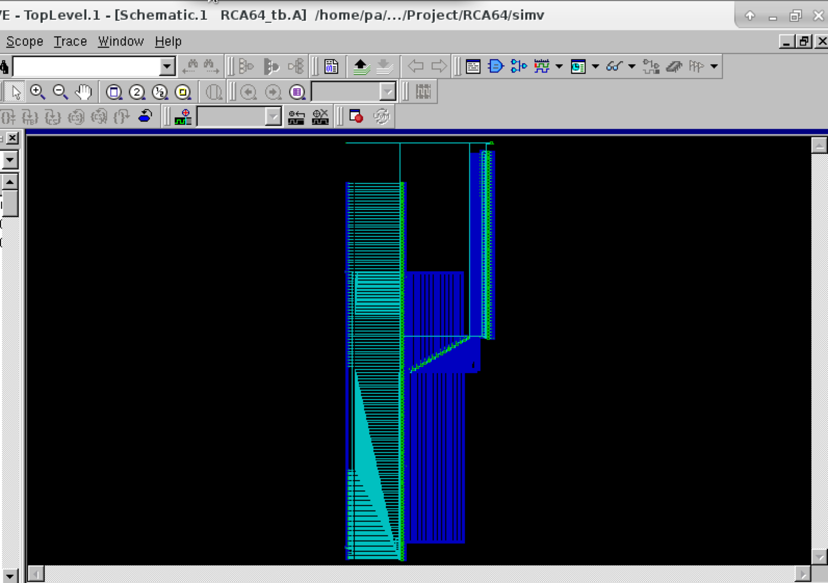

**Carry Look Ahead Adder**

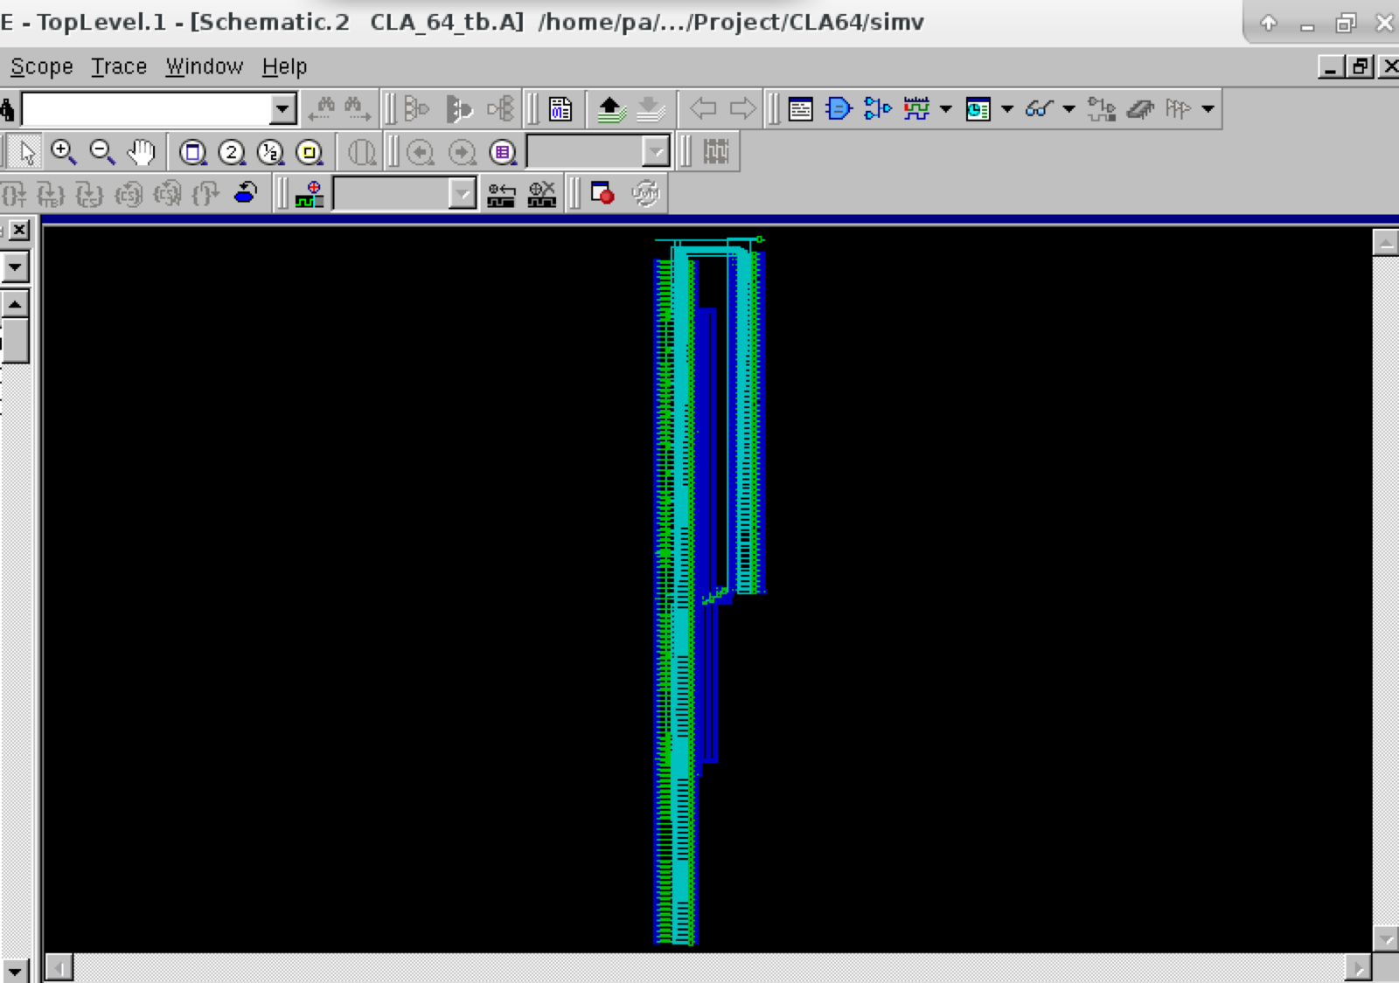

**Carry Select Adder Equal Group**

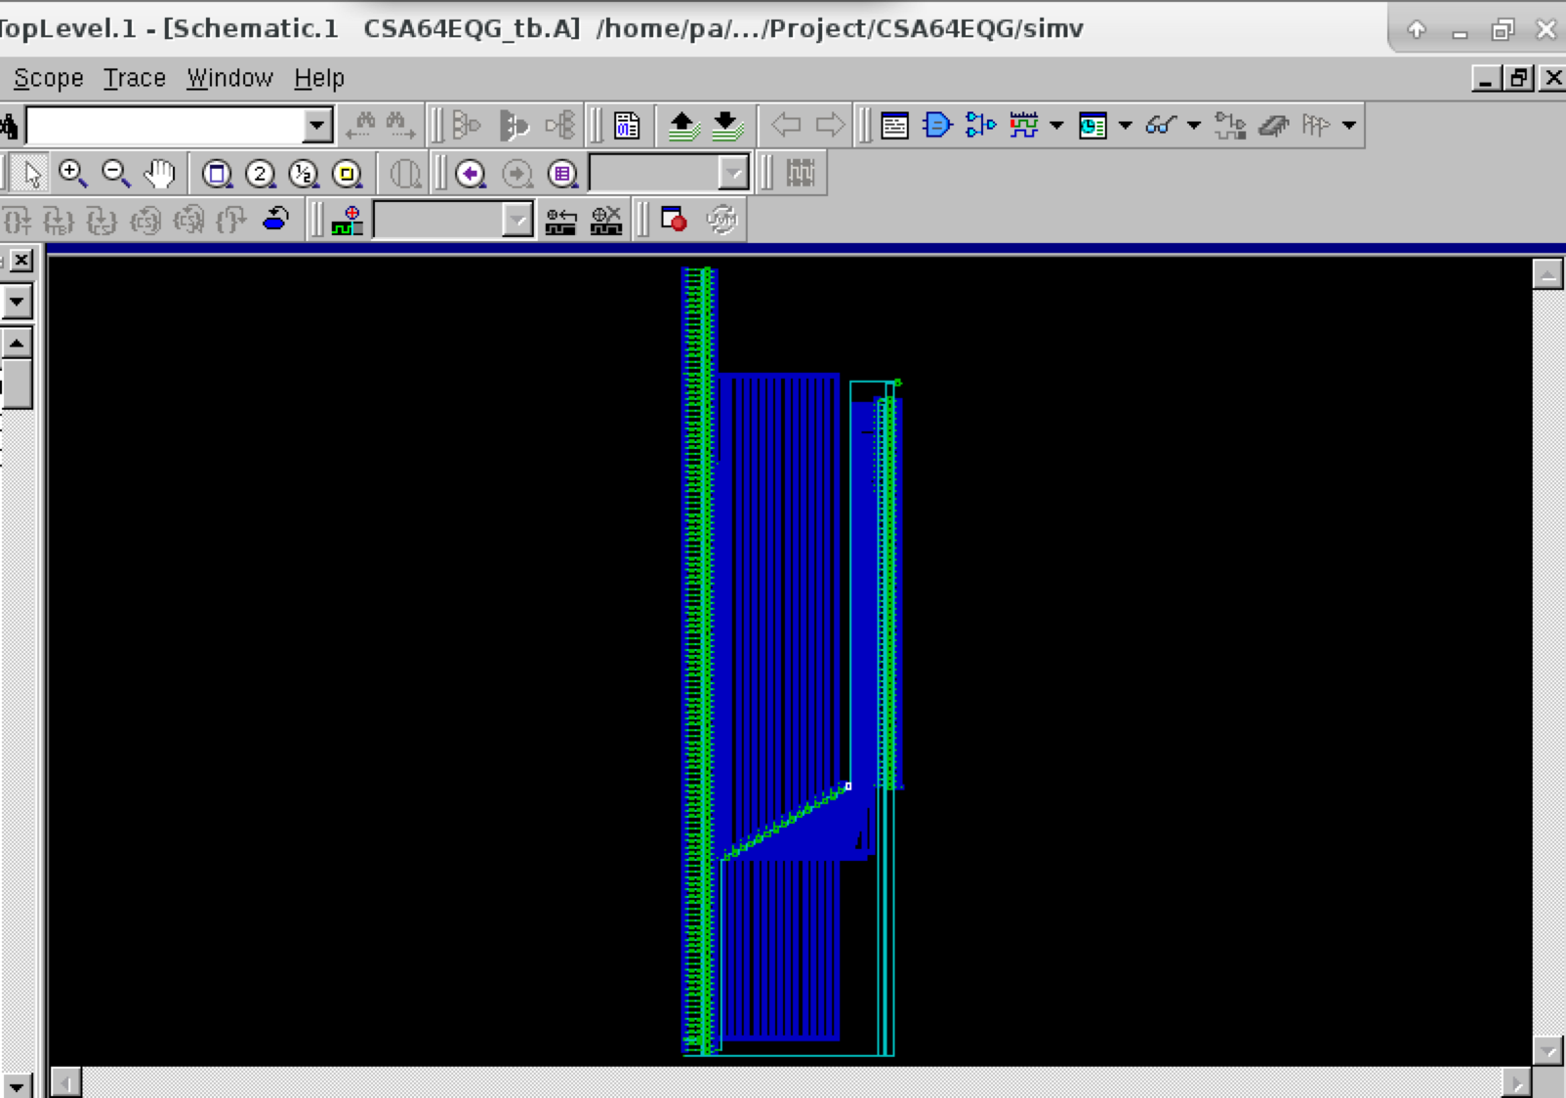

**Carry Select Adder Unequal Group**

